SUBJECT and GRADE | Civil Technology (Civil Services) Grade 12
TERM | TERM 2 (Week 2)
TOPIC | Joining (Specific)
AIMS OF THE LESSON | To develop applying and fixing skills:  - By selecting correct method of application.  - Use proper tools to secure connection.  - Identify correct components for relevant purposes.  - Different methodologies for variety of pipe connecting.  - Variety of means to join sheet metal components.  - Cutting, joining and securing pipes and sheet metal effectively.
RESOURCES | Paper based resources: | Digital resources:
 | In your textbook on page 108– 132 of Chapter 6 | See digital Power Point on the WCED e-Portal.
INTRODUCTION | - Your interest, were triggered with exposure and engagement in GR 10 and Gr 11 with different types of materials and the way they are connected and jointed to form a robust and durable product for the purpose it is used for.  - Some components and agents are used only to secure and decorate, where others are used to carry weight and endure pressure.  - Therefor this is a continuation of advanced methods to join different types of pipes and sheet metal in the specific subject content.  - Learners prior embedded knowledge will be tested to prove proper use of tools and connecting components.  - Select effective and quick fixing tools under severe pressure and conditions.
CONCEPTS AND SKILLS | Key concepts/definitions:  - Use of hand tools and electric machinery to join materials.  - Different methods for different materials.  - Cutting skills through hacksaw, pipe cutter, machine and laser cutting.  - Joining copper, galvanize and PVC pipes  - Practical advance skills are trained and educated to secure certain joining methods.  - Know embedded knowledge to make effective and strong secured connections.  CUTTING (PAGES 108-111)  Cutting, joining and securing pipes:  Prior to any executing of a job accomplishment it is essential that you know the proper method to cut different types of pipes by hand to accomplish cutting, joining and securing of pipes competently.

Please find below a table explaining one method as explained in your textbook cutting pipes effectively.

Method | Copper | Galvanized | uPVC
Cutting copper pipes  PAGE 108, 109 FIG: 6:15) | *Hacksaw  * Pipe cutter | *Machining-using  metal Lathe  *Hacksaw  *Ring-type cutter  *Laser cutting | *Tube cutter for small  Diameter pipes  *Hacksaw  *Mitre saw  *PVC ratchet cutter
Use an alternative method to cut pipes as well.
BY MEANS OF A HACK SAW: Step by step explaining how to cut with a hack saw.
*Stand firm behind the object or pipe to be cut, hold the hack saw with both hands on the handle and the front of the frame respectively.
*Secure the pipe or object firmly in a mitre box or on a firm working surface.
*Use the correct blade teeth as specified for certain projects and material to be cut.
*The teeth of the blade must show forward to ensure maximum cutting effort and competency.
*Position the hack saw blade on the marked line and apply slow gentle movement to get a cutting mark on the pipe.
*Apply firm and gentle forward and backward movements to utilize the entire length of the hack saw blade.
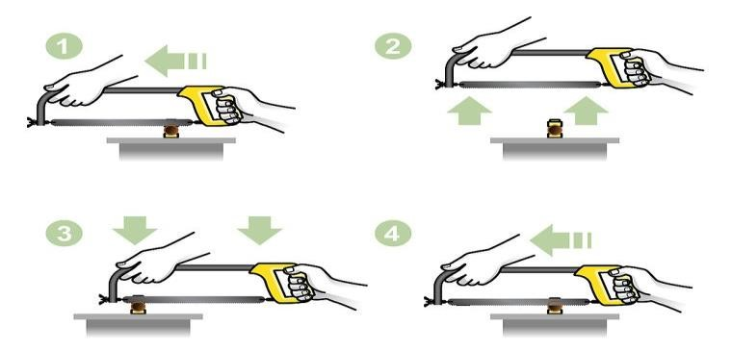
*Controlled slow movement at the end of the cutting process must be executed throughout the entire process, to prevent injuries.

(PAGE 109 –FIG: 6.14 & PAGE 111 – FIG: 6.18 & 6.19)
The above four steps explained and demonstrate, how copper pipe is cut by a hack saw.

- Explain in your own words what is happening in step 2 to step 3, focus on the arrows.
(3)
- What tool do we need to clean the end of the pipe before inserting it in the copper-fitting? (1)
- What do you call the “material removed” as requested in question 2 above? (2)

JOINING (PAGES 111 – 117)
Joining copper pipes with Conex compression fittings (Page 111 -- FIG: 6.20 & Page 115 FIG: 6:30)
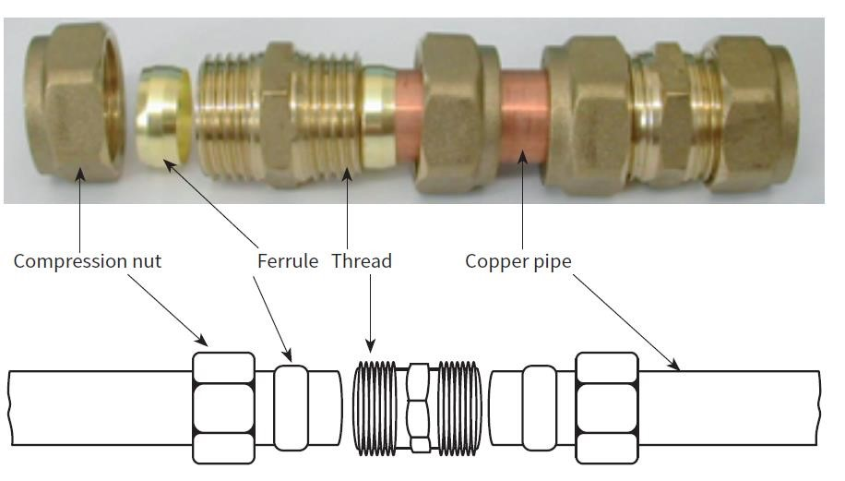
How to join the parts of the fitting over the copper pipe into the compression fitting.
- First slide the compression nut over the pipe followed by the ferrule (compression ring).
- Apply a thin layer of plumber’s thread sealing tape over the ferrule and pipe.
- Push both nut and ferrule backwards and slide the pipe into the Conex compression fitting.
- In this process the thread sealing tape form a secured hand tight joint, repeat the process at all the ends of the fitting.
NB: First hand tight the compression nut over the ferrule to the thread of the fitting before, hand tool fastening.
- PLEASE TAKE NOTE OF THE FOLLOWING: THE HAND TIGHT JOIN IS NOT WATER PRESSURE TIGHT YET:

The following hand tools will secure water tight status to the Conex compression fitting joint.
ASSESSMENT EXERCISE: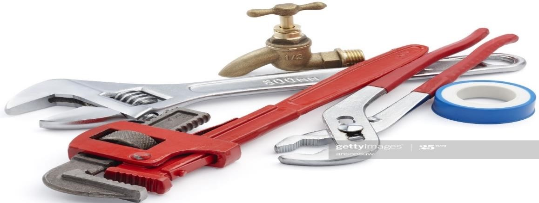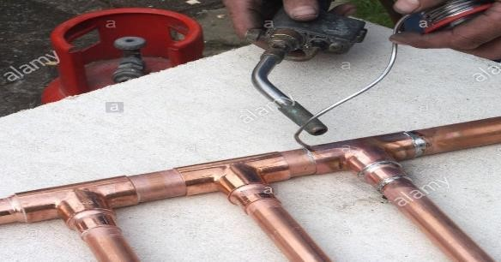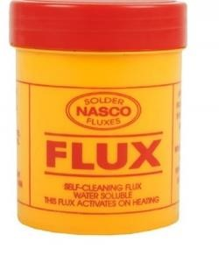

Capillary or soldering joint

111)
PAGE
(

SHITING SPANNER

WATERPUMP PLIERS

STILSON WRENCH

SOLDERING WIRE

GAS
BLOW TORCH

SOLDERED JOINT

UNSOLDERED
JOINT

COPPER PIPE

1) THE LABLES ABOVE INDICATE COMPONENTS THAT MATCH THE DRAWING
ON THE LEFT, REWRITE YOUR ANSWERS, THE COMPONENTS IN THE TABLE BELOW PROVIDED, FROM TOP TO BOTTOM.
JOINING GALVANISED PIPE (PAGE 112)
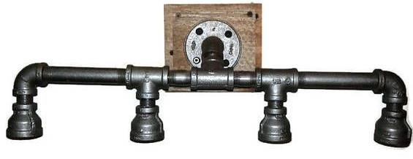
- When connecting galvanized pipes and fittings it should be watertight and secured for severe water pressure. The pipe is a MIC (Male Iron Connection) and the fitting that goes over the pipe is a FIC (Female Iron Connection). The thread of both fitting and pipe should be firm and watertight. Plumbers thread sealing tape are generally use: Give another sealant with adhesive to seal the connection more effective for outside weather and durability. (2)
- After a galvanized pipe is cut and threaded the excess material inside the pipe is removed, what
do we call the excess material. (1)
- What tool is being used to tighten galvanized pipes and fittings? (1)

JOINING (Upvc) unplasticised polyvinylchloride pipes:

Solvent welding:
O-ring compression connection (PAGE 113 -- FIG:6.23, 6.24 & 6.25 / PAGE 115 – FIG:6.29 / PAGE 117 – FIG:6.33)

SHEET METAL: JOINTS
Soldering / Soldering Iron (PAGE 117 –FIG:6.34 & 6.35 / PAGE 118 to 121 FIG:6.36, 6.37, 6.38, 6.39, 6.40 & 6.41)
Grooved seamed joint (PAGE 123 to 124 – FIG:6.49, 6.50, 6.51 & 6.52)
Overlap joints (PAGES 124 to 126 – FIG:6.53 & 6.54)
Pop rivets (PAGES 126 to 128 – FIG:6.55, 6.56, 6.57, 6.58, 6.59, 6.60 & 6.61) Soldering tin (PAGE 128 – FIG:6.62 to 6.67)

ACTIVITIES/ASSESSMENT | Activity 6.2 (NO 1 to 8) --- PAGES: 130 – 131  After completing the Activity 6.2 on page 130 continue as further assessment with the Practical activity 1 on page 131 and Practical activity 2 on page 132.
CONSOLIDATION | Mathematics and Mathematical skills helpful to understand this content.  Correct identification for proper selection and use of material and tools.  Development skills to joint pipes for reality situations where pipes are under municipal pressure.
VALUES | Learners will be able to identify different joints for different types of pipes.  Learners will be able to use different tools to cut different types pipes and joints.  Learners will be able to join different pipes with a variety of fittings.  Learners will be able to secure pipes and sheet metal which they can use in their future career.

