SUBJECT and GRADE | Civil Technology (Woodworking) Grade 12
TERM | TERM 2 (Week 2)
TOPIC | Joining (Specific)
AIMS OF THE LESSON | To develop applying and fixing skills:  - Identify and use of fasteners.  - Use proper tools to secure connection.  - Identify correct components for relevant purposes.  - Different methodologies for variety of connecting.  - Variety of means to join material.
RESOURCES | Paper based resources: | Digital resources:
 | Chapter 6 Page- 102 – 107 (CON) Page – 100 – 105 (CS) Page – 78 – 83 (WW) | See digital Power Point on the WCED e-Portal.
INTRODUCTION | Last week you were exposed to the key concepts and definitions of joining. You had to identify and explain the uses of:  - Bolts and nuts  - Rawl bolts  - Plastic plugs  - Rawl plugs  In order to choose the best way of joining any combination of materials, you need sound knowledge of the methods of joining. Joints can be temporary or permanent. This section deals with the different methods that are used to join timber to timber and/or various other materials•
CONCEPTS AND  SKILLS | Methods of joining the following items:  - Door to a frame  - Ceiling boards to brandering  - Brandering to tie beams  - Adjacent roof members to each other  - Wall plate to wall

- Roof trusses to wall plate
- Roof tiles to battens
- Roof sheeting to purlinsDoor to frame
A door can be fixed to a doorframe by using various types of hinges.
Screws are generally used to secure a hinge onto the frame and the door.
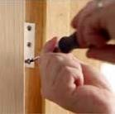
Screwing a hinge onto a doorframe

Ceiling boards to brandering
Ceiling boards are nailed to the brandering with 38 mm clout nails.
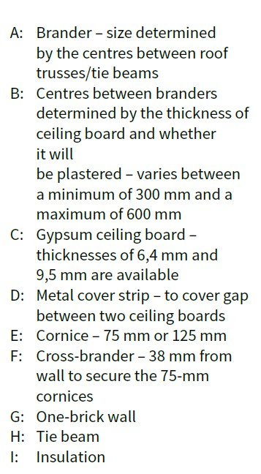
They can also be screwed to brandering with 25 mm chipboard screws. However, this method will take longer than nailing.
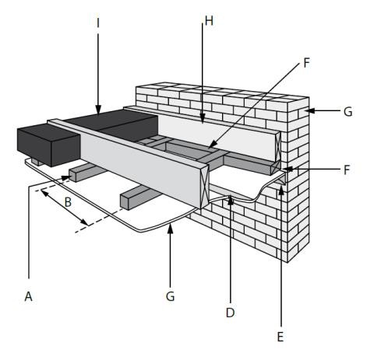

Brandering to tie beams
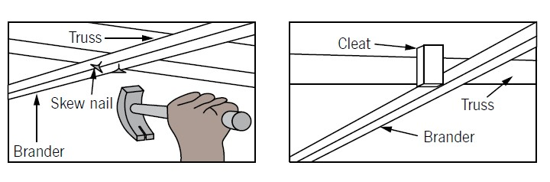
Adjacent roof members to each other
The components of a truss, which have to be uniformly thick, are laid out to form butt joints and a connector plate is placed over each joint. Heavy presses are then used to press the plates into the timber to secure the joint.
It is a much faster and more economical way of assembling trusses than nailing or bolting together the lap joints. Hurricane clips are used to join purlins to rafters. The clips are nailed to the members with clout nails.
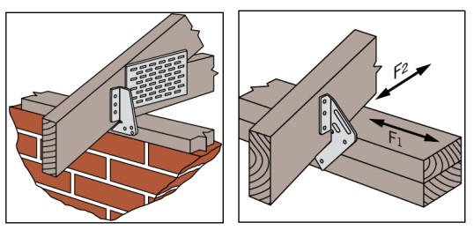

Wall plate to wall
- For centuries wall plates have been laid on top of walls with little fixing.
- However, engineers have now determined that the wall plate should be fixed to the wall.

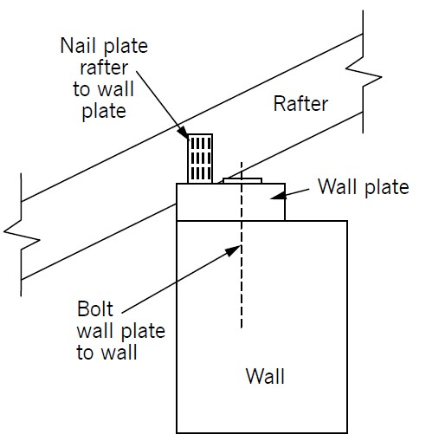
Roof trusses to wall plate
- states that a strap or wire should extend into the wall to a depth of at least 300 mm in case of a heavy roof or
- 600 mm in case of roof sheeting.
- A galvanised strap is built into the wall and strapped over the truss.
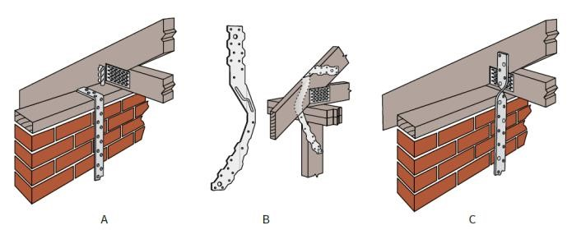

Roof tiles to battens
- Roof tiles are typically nailed to the battens. In most cases, every third row will be fastened with nails, depending on the pitch of the roof.
- The tiles can also be screwed down onto the battens. However, this method is more time consuming.

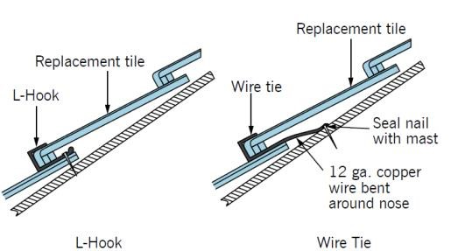
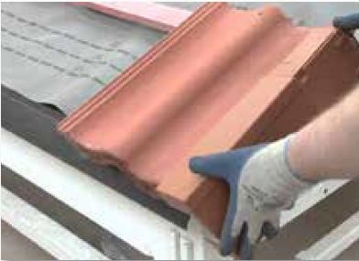
Roof hooks or wires are sometimes used when a tile is broken or needs to be replaced. This clip is manufactured from copper or galvanised mild steel.

Application, uses and drawings of the following woodworking joints (exploded and assembled views):
• Haunched mortice and tenon joint
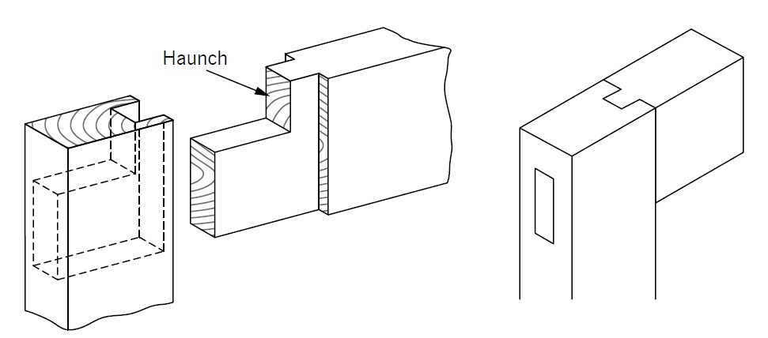
This method is used where a strong joint is required at a corner where two pieces of timber are fixed at a 90˚ angle.

Twin mortice and tenon joint
This joint lends excellent strength to a construction. The proportions of the joint will depend on whether it is used for light or heavy work. It consists of two tenons, cut side by side in one member, which fit into two corresponding mortises.

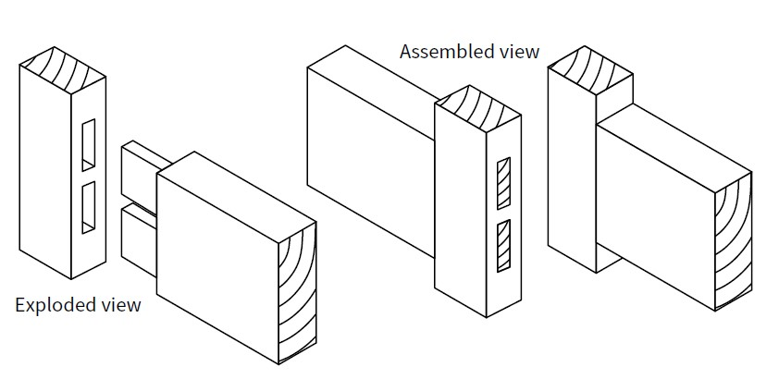

• Double bare face tenon
In this joint, the cheek is cut on only one side. It has only one shoulder. This joint is used where the rail is thinner than the stile and it is best to keep the mortise near the middle of the stile. It can be used for manufacturing doors.

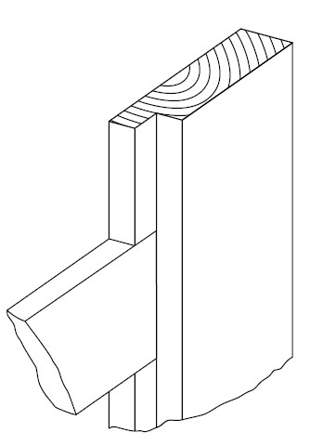
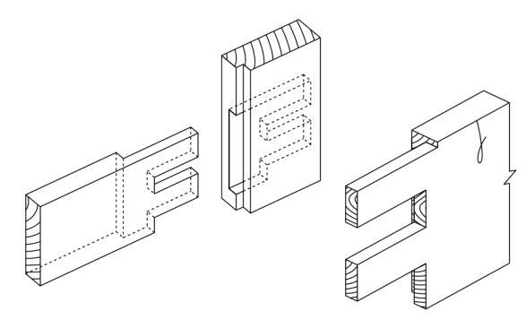 Exploded view Assembled
ACTIVITIES/  ASSESSMENT | On your own do Activity 6.2 in your textbook on page 96-97.  (On completing of the activity, sketch the joints as in this lesson on a A4 page.  Key learning points:  • Do a freehand drawing of the exploded view of a “Haunched Mortice and Tenon Joint” (By sketching you practicing a drawing skill that is needed throughout your schooling)
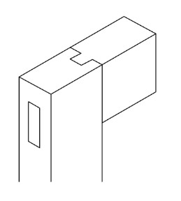

• Label your drawing indicating the haunch and the tenon. (This will ensure that you will know how to do the exploded view and remember the labels.)
CONSOLIDATION | Correct use and identification of joints.  Methods of joining the following items, like Door to a frame, ceiling boards to brandering, brandering to tie beams, adjacent roof members to each other like the wall plate to wall, roof trusses to wall plate and roof tiles to battens.  Identification of the fasteners.  Broaden your knowledge on ways of how to draw / sketch woodworking joints assembled and exploded.
VALUES | Learners will be able to identify, do sketches and or draw joints.  Learners will be able to identify and know different methods of joining items to a structure.

