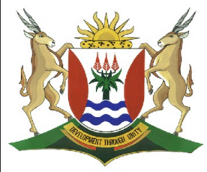
Province of the
EASTERN CAPE
EDUCATION

DIRECTORATE SENIOR CURRICULUM MANAGEMENT (SEN-FET)
HOME SCHOOLING SELF- STUDY WORKSHEET
SUBJECT | ECONOMICS | GRADE | 12 | DATE | 15/05/2020
TOPIC | MICROECONOMICS MARKS: 40 | TERM 1  REVISION |  | TERM 2 CONTENT | X
TIME ALLOCATION | 30 MINUTES MARKS: 40 | TIPS TO KEEP HEALTHY  1. WASH YOUR HANDS thoroughly with soap and water for at least 20 seconds. Alternatively, use hand sanitizer with an alcohol content of at least 60%.  2. PRACTICE SOCIAL DISTANCING – keep a distance of 1m away from other people.  3. PRACTISE GOOD RESPIRATORY HYGIENE: cough or sneeze into your elbow or tissue and dispose of the tissue immediately after use.  4. TRY NOT TO TOUCH YOUR FACE. The virus can be transferred from your hands to your nose, mouth and eyes. It can then enter your body and make you sick.  5. STAY AT HOME.
INSTRUCTIONS | INSTRUCTIONS AND INFORMATION  - Answer ALL questions in the ANSWER BOOK  - Number the answers correctly according to the numbering system used in this question paper.  - Write the question number above each answer.  - Leave 2–3 lines between subsections of questions  - Write neatly and legibly.

QUESTION 1: MICROECONOMICS AND CONTEMPORARY ECONOMIC ISSUES 40 MARKS – 30 MINUTES
1.1 | Answer the following questions.
 | 1.1.1 | Name TWO World Heritage Sites in South Africa. (2 x 1) | (2)
 | 1.1.2 | What is the effect on a business if the average cost is more than the average revenue? (1 x 2). | (2)
1.2 | Study the data below and answer the questions that follow.
 | 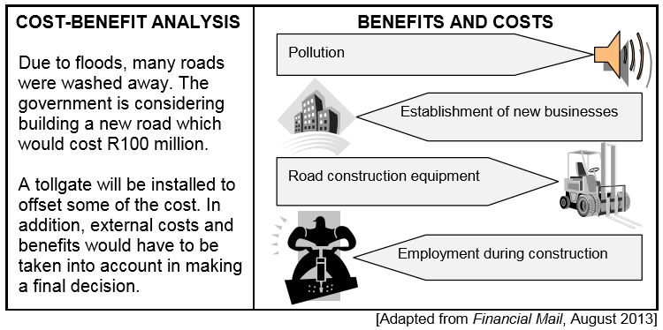
 | 1.2.1 | Identify ONE private cost and ONE external benefit from the data above. (2 x 1) | (2)
 | 1.2.2 | Explain the term cost-benefit analysis. | (2)
 | 1.2.3 | What alternative measure could the government consider instead of building a new road? | (2)
 | 1.2.4 | Should the government proceed with the building of this road? Motivate your answer. | (4)

1.3 | Study the extrct below and answer the questions that follow.
INFLATION TARGETING IN SOUTH AFRICA

South Africa has successfully pursued an inflation targeting monetary policy since February 2000. The policy has ensured a stable and sustainable economy.

It is important to understand that the South African Reserve Bank was created as an autonomous body, but this independent body has been mandated to keep inflation within a target range to encourage long-term growth in the economy.

With the inflation rate breaching the upper end of the range in 2014, a generally unpopular interest rate hike has placed the Reserve Bank's governor and the Monetary Policy Committee under increased pressure. Unions advocate the abandonment of inflation targets for the sake of shortterm job creation.
[Source: Inflation Targeting SARB 2004]

 | 1.3.1 | What is the current inflation target range? | (2)
 | 1.3.2 | What is the main purpose of the South African inflation targeting policy? | (2)
 | 1.3.3 | How can lower interest rates benefit the South African economy in the short term? | (2)
 | 1.3.4 | How successful, in your opinion, was the Reserve Bank in meeting its inflation target? (2 x 2) | (4)
1.4 | Distinguish between economic profit and normal profit in the perfect market. (2 x 4) |  | (8)
1.5 | What is the impact of inflation on investors and savers? (4 x 2) |  | (8)
 | DBE/Feb-Mar. 2016 |  | [40]

