GRADE 12
REVISION MATERIAL
SUGGESTED ANSWERS (SOLUTION BOOKLET)
ECONOMICS PAPER 2
2020

SUGGESTED ANSWERS
MICRO ECONOMICS
DYNAMICS OF PERFECT MARKET
1.1.1 | What will the effect be if one firm in a perfect market decides to increase the price of a product
 | Firm will make a loss, because all firms in the perfect market are price takers and cannot influence the market price | (2)
1.1.2 | What is the effect on a business if the average cost is more than the average revenue?
 | The business will suffer losses (economic losses) | (2)
1.1.3 | Why is the demand curve of the individual producer horizontal (flat)? | (2)
 | Producers are price takers – sell all quantities at the same price | (2)
1.1.4 | How can the consumer benefit from increases competition in the economy?
 | - It provide all South Africans with equal opportunities to participate fairly in the South African economy  - It will provide for markets in which consumers have access to  - It will ensure good quality of service delivery  - It will ensure good quality of products  - Consumers’ choices will be improved  - Consumers will reap the benefits of lower prices  (Accept any other relevant response) | (4)
1.1.5 | Why will output in the goods market increase when businesses in the perfect market make economic profit?
 | More businesses will enter the industry to take advantage of economic profit
1.1.6 | What is the role of the Competition Commission?
- To investigate, control and evaluate restrictive business practices, abuse of dominant positions and mergers in order to achieve equity and efficiency in the SA economy /
- Tries to give all South Africans equal opportunities to participate fairly in economic activities to make the economy more efficient

1.1.7 | Distinguish between economic profit and normal profit in the perfect market.
Normal Profit:
- A firm makes normal profits when total revenue (TR) equals total costs/when average revenue (AR) equals average cost (AC)
- Normal profit is the maximum return the owner of a firm expects to receive to keep on operating in the industry
- The minimum earnings required to prevent an entrepreneur from leaving the industry
- When average revenue equals average cost the firm makes a normal profit
Economic profit:
- Profit that is made in addition to normal profit
- When average revenue is greater than average cost the firm makes an economic profit
- When the average cost per unit is lower than the price
1.1.8 | Briefly discuss the number of businesses and nature of the product as characteristics of a perfect market structure.
Number of businesses
- There are a large number of sellers
- It should not be possible for one seller to influence the price / When there are many sellers the share of each seller in the market is so small that the seller cannot influence the price
- Sellers are price takers; they accept the prevailing market price
- If they increase prices above the market price, they will lose customers

Nature of product
- Products are homogenous (i.e. identical / same)
- There is no differences in style, design and quality
- In this way products compete solely on the basis of price and can be purchased anywhere
(Accept any other relevant response) (2 x 4)
1.1.9 | Motivate why the government implements minimum wages in the labour market.

Pressure was put on the South African government to introduce labour laws which require employers to pay minimum wages

• The application of minimum wage laws is needed to improve a redistribution of income
To redress inequality (Gap between wealthy and poor)
• To improve the standard of living
Government tried to protect domestic workers and farm workers – thus preventing exploitation
(Accept any other relevant fact) (4 x 2)
1.1.10 | What are the objectives of the Competition Act, 1988 (Act of 1998) in South Africa?
To afford all South Africans with equal opportunity to participate fairly in the economy
To restrain particular trade practices such as price fixing
To regulate the transfer of economic ownership in keeping with the public interest
To establish independent institutions to monitor economic competition
To create greater capability and environment for South Africans to compete effectively internationally
(Accept any other relevant answers) (Any 4 x 2)
1.1.11 | With the aid of a graph, explain why marginal cost must be equal to marginal revenue for profits to be maximised.
 | 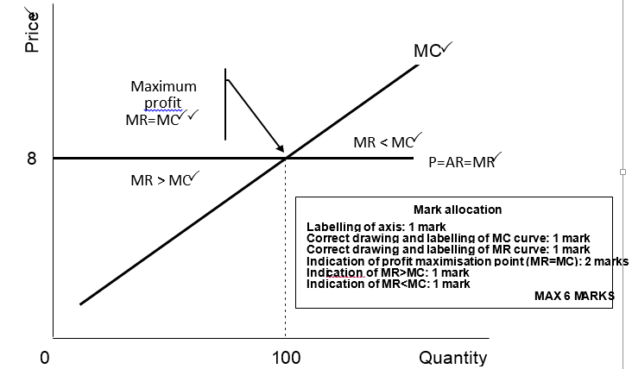
Accept graphs for an imperfect market showing MC and MR curves)

The business maximises profit where MC = MR
- If the business produces less than the average revenue (AR), the marginal revenue obtained will be higher than the marginal cost Therefore the business has room to improve its profit level (MR>MC)
- If the business produces above the average revenue (AR), the marginal revenue is lower than the marginal cost (MR<MC) therefore the business will make a loss per additional unit produce above the MR=MC point (Maximum 6 marks for discussion)
1.1.12 | Explain the long-term equilibrium of a firm under perfect competition
 | - Economic profit in the short term will lead to expansion of current businesses and attract new businesses into the market  - This will increase the supply of goods (pushes the supply curve to the right) which will decrease the price  - The price will decrease to the point where price is equal to AR that equals AC, therefore economic profits of these businesses will diminish  - Due to mass production the cost per unit will be at the lowest point of the LAC curve  - Factors such as specialisation and improved technology leads to economies of scale  - Further expansion will lead to higher unit costs and is called internal diseconomies of scale  - In the long run, individual businesses can only make normal profit  - If individual firms are making economic losses, some firms may leave the industry.  - This will decrease the supply of goods (supply curve shifts to the left) which will increase the price.  - The equilibrium price will increase to a point where the price is equal to AR that equals AC , then firms will earn normal | (8)
1.1.13 | Explain by means of a neatly labelled graph the relationship between the shut-down point and the supply curve (MC) of the individual business in the perfect market.
 | 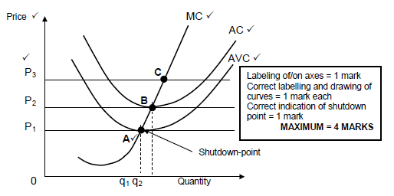
 | - The rising part of the businesses’ marginal cost curve above the minimum of its average variable cost curve represents the supply curve of the business  - The supply curve starts at point A (shutdown-point) and slopes upward from there due to the marginal cost that increases as output increases  - At a market price of P₁ the business is only able to pay its variable costs  - If the market price drops below P₁ the business will be forced to close down and this  point (A) is known as shutdown-point (2 x 4) | (8)
 | IMPERFECT MARKET
1.2.1 | What favourable conditions may the monopolist enjoy in comparison to other market structures?
- The monopoly is the only supplier of that particular product
- At liberty to set own prices
- Decide on production levels
- Laws protection
- Protected by barriers of entry
- Favourable geographical area
Accept any other relevant answer (Any 2 x 2)
1.2.2 | Explain how price leadership works in the oligopoly
 | The dominant firm will initiate a change in price, e.g. increase. They will realise economic profits (abnormal profits).  Other competitors will also increase their prices.  OR  Dominant firm will decrease prices, luring customers away from other firms in the market  Other competitors will decrease price not to lose market their market share | (4)
1.2.3 | Why are oligopolists reluctant to compete with each other on price in order to get a greater share of the market?
 | They act on the behaviour of others: if one business increases its price it loose its market share. When the firm decrease their price, others will follow and a price war might arise
1.2.4 | What prevents monopolies from charging excessively high prices?
 | The demand for the goods will decrease and it will result in lower profits  Due to consumers’ limited budgets the monopolies compete for the consumer’s favour  Monopoly’s prices are sometimes regulated by the government  e.g NERSA is regulating Eskom’s electricity prices | (2)
1.2.5 | Differentiate between the nature of the product under monopolistic competition and under monopoly.

Monopolistic competition
Each firm sells a slightly differentiated product
Differences might be real or imagined/ differences can be based on the opinion of consumers
Producers can compete against one another on the grounds of unique characteristics

Monopoly
The good or service is unique
There are no close substitutes
The consumer does not have a choice between alternative goods and services

1.2.6 | Distinguish between price leadership and cartels as forms of collusion

Cartel
When collusion occurs openly it is referred to as a cartel
A cartel can be defined as an organisation of oligolistic businesses that comes into existence in an industry with the specific aim of forming a collective monopoly (2X2)

Price leadership
This type of price determination is tacitly
A firm will announces its intention to increase prices and hope it's rivals will follow
The price leader is usually the largest or dominant business in the industry (2X2)
1.2.7 | How can firms in an oligopoly increase their market share in the economy?
 | - Through product differentiation, products might slightly differ in terms of physical appearance, packaging etc  - Improve after-sale-services that are far more important to customers and will ensure a long-term relationship with that business  - To spend more money on advertising to lure consumers onto their side  - To establish brand loyalty, because oligopolies want consumers to believe that its brand is the best and to buy only that brand  - Through product proliferation, oligopolies may produce many different ranges of products to cater for many different markets  - By extending shopping hours to encourage greater flexibility to households  - Through online purchases, it becomes easier for customers to shop around without any additional cost/variety of goods available to make comparisons  - Paying loyalty rewards to customers for continued support (4x2) | (8)
1.2.8 | Briefly discuss the demand curve of the monopolist
 | - Monopolist demand curve has a negative slope/downward sloping from left to right (accept graphical representation)  - Slope is inelastic (steep)  - The demand curve is also the market demand curve  - The shape of the curve indicates that there is an inverse relationship between price and quantity demanded  - This means as price increase quantity demanded will decrease/price decrease quantity demanded will increase | (8)
1.2.9 | How will a monopolist be more advantaged than a producer in a perfect market?
- Monopolist produce a unique product which others cannot compete with.
- Protected from competition by patents/legislation. Difficult for others to enter the market.
- Charge a higher price and produce lower quantity.
- Always make economic profit in long run.
- Price-setter - able to manipulate prices to suit himself.

1.2.10 | Why is Eskom regarded as a natural monopoly?
 | - High development costs prevent others from entering the market and therefore the government supplies the product through Eskom
1.2.11 | Explain why the monopolist will not fix the price lower than centre point of the demand curve.
 | - The monopolist’s total revenue will decrease when the price is in the bottom half of the demand curve. A point will be reached where the marginal revenue will become negative.
1.2.12 | Draw a comparison between a perfect market and a monopoly with regard to prices, profit, quantities and cost.
 | Prices: The monopolist produces at higher prices than the perfect competitor  Profit: Under perfect competition, only normal profit will be made in the long term; the monopolist, on the other hand, can make economic profit in both the short and long term  Quantity: The monopolist produces less than the perfect competitor  Cost: The monopolist does not produce at the lowest possible cost due to a lack of competition whilst the perfect competitor will always produce at the lowest possible cost due to competition (Lowest point of LAC curve) | (8)
1.2.13 | Distinguish between natural and artificial monopolies
Natural monopoly
High development costs prevent others from entering the market and therefore the government supplies the product.
 | Artificial monopoly  The barriers of entry are not economic in nature. For example, patent, licensing, create monopolies.  Accept any relevant differentiation | (4)

MARKET FAILURES AND COST BENEFIT ANALYSIS
1.3.1 | Give two reasons for the cost benefit analysis
 | - It assess whether a new project will be feasible  - It calculates and compares the social cost and benefits of an investment  - It gives greater objectivity to decision- making  - Ensures a more equitable distribution of resources (2x1) | (2)
1.3.2 | Analyse productive inefficiency with the aid of a production possibility curve.
 | 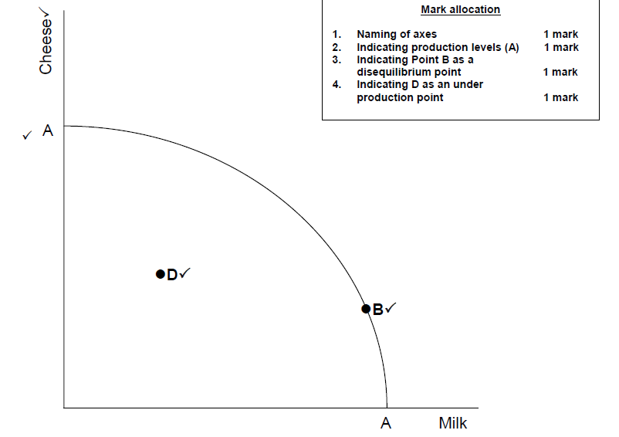 | (4)
 | PRODUCTIVE INEFFICIENCY  Production possibility curve (AA), above, shows a combination of goods that can be produced using all the available resources.  - Any point on the curve shows a combination of goods where resources will be used efficiently (B).  - Therefore, any point on the curve indicates productive efficiency.  - Any point within the curve shows combinations of goods where resources are used inefficiently (D) | (4)
1.3.3 | Explain how the immobility of factors of production can cause market failure
- Markets may not be able to respond to consumer demand immediately if factors of production cannot respond and move around easily
- Resources tend not to be very mobile and do not adjust easily to consumer demand
- Labour may take time to move into new occupations and geographical areas e.g. family ties, friends, convenience, schools
- Physical capital e.g. factory buildings and other infrastructure, cannot easily be moved to places where they are needed
- Technological applications takes time for industries to adapt to new technological changes (Any 4 x 2)
Accept any relevant examples
1.3.4 | What are the effects of the implementation of minimum wages in South Africa?
- The market fails to pay fair increases in salaries of people who are not in a strong enough bargaining position with their employers
- As a result, they are unable to secure real wage increases and their wages remain low and therefore unfair income takes place
- A minimum wage will increase the wage rate, however less workers will be demanded (over supply) in the labour market
- This will lead to an increase in unemployment
Examples of workers that minimum wages are applied: farm workers, domestic workers
 | 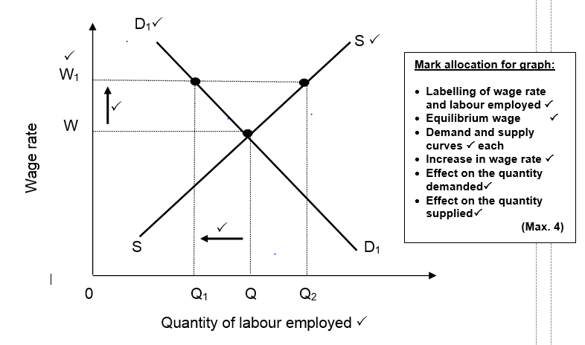
- Minimum wages improve the distribution of income from W to W1
- However quantity of labour demanded will decrease from Q to Q1
- The quantity supply of labour will increase from Q to Q2
- Therefore, an oversupply of labour (increase in unemployment) will occur with the new minimum wage at W1
Accept any other relevant argument
1.3.5 | Explain the uses of the cost-benefit analysis (CBA).
 | The cost-benefit analyses is generally used in the public sector when evaluating large-scale public investment projects eg. New highways, railway lines, airports, dams, ports and public transport  The CBA is used to assess the net social benefit that will accrue to the population from these projects  CBA requires careful definitions of the projects, accurate estimation of projects lives, and comprehensive consideration of externalities  Essentially, CBA concentrates on the economic efficiency benefits from a project  Calculations in a CBA should be done by using market prices or shadow prices to correct distortions which cripple market prices  Due to the fact that costs and benefits occur at different points in time their future value need to be converted to present value  The CBA can be used to redistribute income, by making payments to the losers and expect payment from the gainers through a levy or indirect tax  If the benefits exceed the costs, acceptance of the project is recommended regardless of who benefits and who bears the costs  However where decision makers feel that the redistribution of income associated with a project is unacceptable, they may reject the project despite its benefits  The CBA is a tool/technique that seeks to bring greater objectivity to decision-making | (8)
1.3.6 | Explain, by means of a neatly labelled graph, how negative externality results in the misallocation of resources
Correct drawing and labelling of supply curves=1mark
Correct drawing and labelling of demand curve=1 mark
Correct labelling on axis= 1 mark
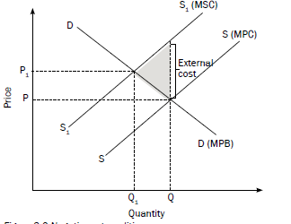

The market produces at Q units. If the cost of a negative externality (pollution) is included in the market price, then Q₁ units will be produced
Because it is not included if the market overproduces at Q which results in a misallocation of resources
1.3.7 | Explain two types of inefficiencies.
a) Productive inefficiency/Technical inefficiency
When resources are not used appropriately to produce the maximum number of goods at the lowest cost and best quality
b) Allocative inefficiency
When resources are not allocated in the right proportions and the product mix does not match consumers' tastesi.e. the quantity and type of goods produced do not cater for consumers' needs.
An allocation of resources is inefficient if it is possible to reallocate resources to make one person better off while not making someone else worse off.
 | .
1.3.8 | Why do externalities not have a price attached to them?
 | The reason is that they do not go through the price mechanism.  It is not part of the market mechanism  Externalities are the result of production or the market mechanism | (4)

ESSAYS
 | The existence and survival of any business depends on how they are conducting themselves.  Compare the market structure of a monopoly with that of a perfect competitor. (26)  • Draw a clearly labelled graph indicating the shut-down point for the perfect competitor. Briefly explain why a business will stop producing goods at this point. (10) | (40)
INTRODUCTION
A perfect competitor has many sellers while a monopolist only has one seller. 
(Accept any suitable introduction) (Max. 2)
BODY
MAIN PART
 | Perfect Competitor | Monopoly
Price: | - Price taker   - The market determines the price for the individual firm  | - Is regarded as a price maker   -Have some control over price   - Prices not determined by market forces of supply and demand but by the business itself 
Output: | - The demand curve for the perfect competitor is horizontal  | - The demand curve for monopolist is downward sloping 
Profit: | - The perfect competitor can realise economic profits in the short term   - -Abnormal profits will attract new entrants into the market for both structures   - Both perfect and monopoly can only realise normal profits in the long term   - -The price for the product for both market structures equals the average cost   - The perfect competitor does produce the ideal production quantity and has no surplus capacity  | - The monopolist also realise economic profits in the short term   - The monopolist will charge a higher price than the perfect competitor   - The monopolist will not produce at the lowest point of the LAC, like the perfect competitor, the output will be less than the perfect competitor   - The monopolist's production will be less than the ideal production quantity where LAC is the minimum and has surplus capacity 
Number  of businesses | So many that no single business can influence the market price  | One business 
Nature of product | Homogeneous e.g. maize  | Unique product without any close substitutes 
Information | Complete  | Complete 
Entry | Completely free  | Blocked 
(Accept any other relevant fact) (Max 26)

 | ADDITIONAL PART
Short
-
term
shutdown point
MC=AVC

0

Q
1

Quantity

MC

AC

P=AR=MR

AVC

Maximum

profit
MR=MC

P
1

Cost/Revenue

Briefly explain why a business will stop producing goods at this point.
- A firm will shut down if it cannot meet its average or total variable costs 
- The firm will not produce here because AR < AVC 
- The firm will not keep on producing from the shut-down point down because the firm cannot meet its operational cost 
- Below the shut-down point, the firm will not sell any goods. A firm will sell goods if the price is above the shutdown price level (supply curve)  (Max 10)

2 | Under perfect market conditions the market price of products is determined through the interaction of supply and demand.  - Discuss perfect competition under the following headings:  - A comparison of the demand curve of the individual producer and industry  - Profit maximisation  Make use of graphs to support your discussion. (26)  - In your opinion, does the Competition Act of South Africa promote fair competition? (10)
INTRODUCTION

An industry consists of all the firms that produce the same product where the output of an industry is the sum of the output of its individual firms.
(Accept any other relevant answer) (Max. 2)

 | 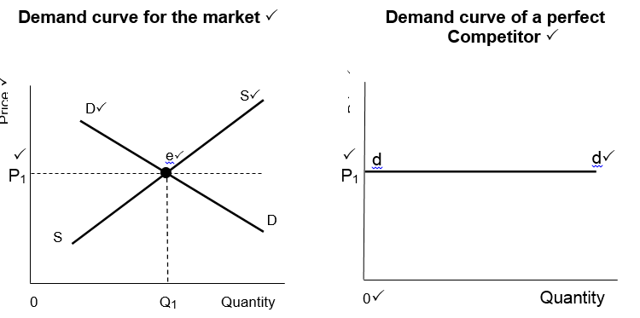
 | 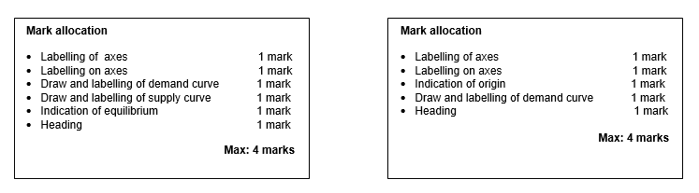
- In a perfectly competitive market the price of a product is determined by the interaction between market demand and market supply for the product.
- The market demand curve is represented by DD which is downward sloping and the supply curve (SS) is upward sloping.
- As a result of the interaction between market demand and market supply, the equilibrium is established at P1.
- Extending this price, the graph of the individual produce. The demand curve for the firm is horizontal that indicates that the individual producer is a price taker.
Max 8 marks for discussion

 | 2. Profit maximisation
 | 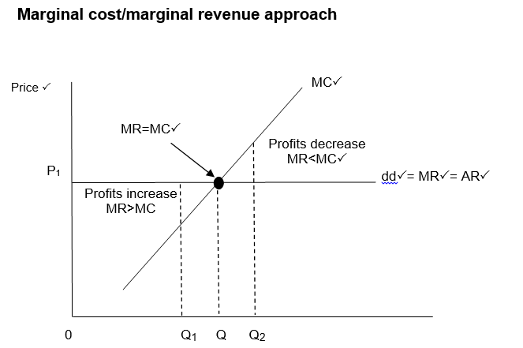
 | 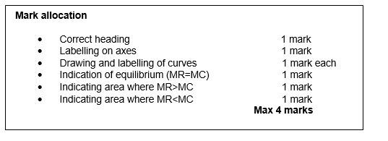
- The firm produces maximum profits if it produces the quantity where the marginal revenue is equal to marginal cost.(MR=MC)
- As long as marginal revenue is greater than marginal cost, the marginal revenue contributes towards total profits.
- By producing an additional unit, the producer gains the additional unit and his profit increases more than it cost to produce. MR>MC: profits increase
- When the marginal revenue is less than marginal cost, total profits will decline.
- It cost the firm more to produce an additional unit than it gets from selling the additional unit it is therefore not in the interest of the firm to produce the extra unit
- MR<MC: profits decline
- If the marginal cost of producing an extra unit is higher than the marginal revenue received, the firm will make a loss
- For the producer to maximise profits, it should expand production to the point where marginal revenue is equal to marginal cost.

OR

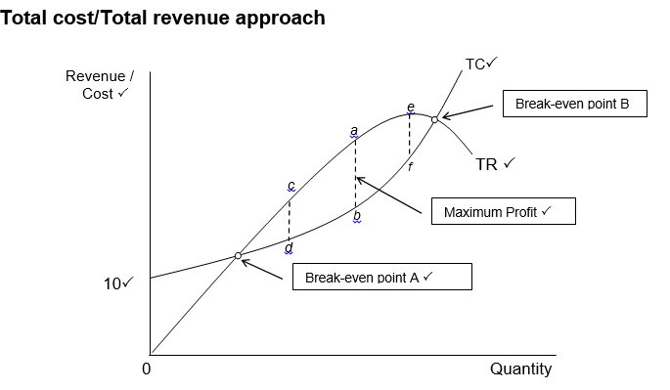
Mark allocation
- Labelling of axis =1 mark
- Positioning and labelling of total cost =1 mark
- Positioning and labelling of total revenue=1 mark
- Indication of break-even points = 1 mark
- Correct indication of maximum revenue =1 mark
Maximum 4 marks
- The firm will realise maximum profit where total revenue and total cost is at its greatest - (a-b) on the graph
- The firm will break-even at the intersections of TR=TC
- The firm starts to realise profits if it produce or increase output to the right of break-even point A.
- Any output beyond (right of break-even point B will realise in a loss; total cost is higher than total revenue.
- If the firm produce up to point e, peak of total revenue, it will still realise profits, however it will not realise maximum profits
- The firm therefore is a sale maximise
- If the firm want to realise maximum output it should produce to point a
- The firm therefore is a profit maximise.
- Provide consumers with competitive prices and product choices
- Ensure that small and medium sized enterprises have an equitable opportunity to participate in the economy
- Promotes the spread of ownership
Three institutions were created to achieve these objectives.
- Competition Commission: to investigate, control and evaluate restrictive business practices, abuse of dominant positions and mergers to achieve equity and efficiency in the South African economy.
- Competition Tribunal: grant exemptions, authorise or prohibit large mergers, adjudicate, grant an order for costs on matters refers by the Commission
- Competition Appeal Court: consider any appeal from or review a decision of the Competition Commission; confirm, amend or set aside a decision by the Competition Tribunal confirm an order for the disinvestment of assets of parties that merged without following the Act.

- Examples of cases investigated by the Competition Commission and/or Competition Tribune or Appeal Court.

- BMW – over pricing cars (outcome fined)
- Tyre industry – collusion amongst tyre manufacturers (outcome fined)
- Construction industry – collusion of bidding prices for building stadiums in 2010 (outcome fined)
- Bread (Tiger Brands) – collusion of bread companies to fixing prices (outcome fined)
- Cellphone companies (rates) as well as interconnection rates (outcome reducing interconnection fees over a few years.
- Telkom – monopolising communication towers (outcome fined)

- Effects of these investigations.

- Install good business practices, deterred for other companies that wanted to apply inappropriate business practices
(accept any other relevant example)
- Any cases investigated by the Competition Commission. The candidate has to mention the parties involved and the outcome of such investigation.
If only cases were mentioned without any deliberation (Max. 5)
(Max. 10)

CONCLUSION

It is critical important to protect the market mechanism of supply and demand by enhancing fair and vibrant competition in the economy, therefor the role of the Competition Act cannot be underestimated.
Any relevant conclusion

A monopoly is the extreme opposite of a perfect competitive market.

• Examine the monopoly as a market structure. (26 marks)

• With the aid of a neatly labelled graph, explain long-run equilibrium of the monopolist.

(10 marks)
 |  | [40]
INTRODUCTION

Monopoly exists when there is only one seller of a product, when the product has no close substitutes, and when barriers block entry into the market completely  (Max. 2)

BODY
MAIN PART
- Number of producers 
- The monopolist has full control over the supply of a product, because it is the only seller 
- The monopoly also represents the total industry e.g. De Beers, Eskom 
- Nature of the product 
  - The product is unique and has no close substitutes 
  - E.g. electricity and rail transport 
- Economic profit 
  - The monopoly makes a short-term loss or profit 
- Technical superiority 
  - A monopoly has technical advantage over potential competitors and their access to resources and technical superiority make it difficult for others to compete 
- Access to scarce resources 
  - A single firm owns and controls a specific scarce resources and excludes other companies from entering the market 
- Demand curve 
- Monopolists are also confronted with a demand curve for their product but because they are the only supplier of the product they can decide at what point on the demand curve they wish to be 
- The monopolist is the only supplier of the product in the market - the demand curve that confronts the monopolist is that of the market as a whole 
- The market demand curve which slopes downwards from left to right / graph 
• Production level 
- Once the monopolist has decided on a price, the quantity sold is determined by market demand - by reducing the price, monopolists can sell more units of the product and vice versa 
- Monopolists influence the product-price combination of the product they sell without any reaction from other market participants 
- Other participants cannot act because a basic requirement for the existence of a monopoly is that entry to the market is blocked 

Market forces 
- Although the monopolist is the only supplier of a product, the product is still influenced by market forces in the economy 
- - Consumers have limited budgets and a monopoly can therefore not demand excessive prices for the product and the monopolist product has to compete for consumer’s favour with all the other products available in the economy 
- E.g. Transnet competes road, air etc. means of transport 
• Control over the price 
- A monopolist has considerable control over the market price – but demand limits it 
- A monopoly does not have control over demand, so demand will influence the final market price 
- A monopoly can only decide at which point on the demand curve it wants to produce 
• Substitutes 
- There are few products that have no close substitutes whatsoever 
- For many years even though there was no competition for telephone services in South Africa, consumers could still use alternative forms of communication such as letters and telegrams 
• Favourable circumstances 
- Sometimes entrepreneur may enjoy favourable circumstances in a certain geographic area 
- E.g. there may be only one supplier of milk in a particular town, a hardware store or hotel 
- There may even be laws that protect them, e.g. Post Offices in South Africa 
- Pure monopolies are a common rarity in South Africa 
- Not only are substitutes available, but there is often nothing to prevent other entrepreneurs from entering the market hence what may be called a quasi- monopoly 
• Market information 
- All buyers and the single seller have full knowledge of all the current market conditions 
• Exploitation of consumers 
- The monopolist may produce fewer products at a higher price compared to businesses under perfect competition 
- E.g. De Beers, because the monopolist is the only producer of the product in the market, there is always the possibility of consumer exploitation. Most governments take steps to guard against such practices and new and existing monopolies are usually well monitored 
• Market entry 
- The barriers prevent other producers from entering the market to supply the same type of product 
➢ Natural monopolies 
- High development cost are frequently a reason - the provision of electricity is often used as an example
- To build a nuclear power station and transmission lines to distribute electricity costs billions of rands 
- E.g. Eskom as a single business in the country that supplies electricity operates as a natural monopoly and is frequently owned and regulated by the government 
➢ Artificial monopolies 
- The barriers to entry are not economic in nature but artificial like patent rights which are legal and exclusive rights of a patent holder to manufacture a product using his or her unique invention 
- Patents are also frequently encountered in the pharmaceutical industry 
- Licensing is another way in which artificial monopoly is applied, e.g. TV and radio licenses 
- licences protect operators against entry of other competitors 
- Economies of scale 
  - These give advantages to large existing companies 
  - Occur when the cost per unit decreases when the output increases 
  - Large businesses production costs per unit are lower than those of small businesses, e.g. Eskom 
- The geographical area 
  - This can cause a natural barrier as well, e.g. only one holiday resort can fit on the seafront as an exclusive beach 
- Size of the market 
  - Sometimes a business enjoys favourable circumstances in a certain small market 
  - E.g. there may be only one hardware store in a particular small town 
(Accept any other relevant facts)
 | ADDITIONAL PART
- In the long term the monopolist makes economic profit 

Price



LMC

Cost

Income

(10)

P

1

B

LAC



(7)

C
1

D

DD = AR



E



MR

0

(100)

Q

1

Quantity




Mark allocation for graph:

•

Labelling of a
xes

–

1
mark

•

Correct drawing and labelling of
cost curves

–

1

mark

•

Correct drawing and labelling of
income curves
-

mark
1
•

Profit Maximisation

–

1

mark

•

Shaded
area (profit)

–

2

mark
s

Max = 6 marks

- The LMC curve intersects the LAC curve at its minimum point 
- Profit maximising point is at point E (LMC = MR) where production is Q1 at a price of P₁ per unit/The monopolist will produce at Q₁ (100) (profit maximisation point E) at a price of P₁ (10) 
- At this production level the average revenue is R10 and average cost is R7 
- Therefore, the monopolist is making a profit of R3 per unit (total economic profit of R300). The total economic profit is represented by the shaded area 
(Accept any other relevant explanation)
CONCLUSION
The monopolist is a price maker but cannot set a price independently of output.
A higher price will always result in less quantity. 
(Accept any other relevant conclusion)
 | Market failure is a common feature of free market economies.  • Discuss the causes of market failure in detail. (26 marks)  • With the aid of a graph (PPC) explain how productive efficiency can be achieved in the market. (10 mark) | [40]

INTRODUCTION

Market failure means that the best available or optimal production outcome has not been achieved/ it is the failure of markets to achieve optimum resource allocation  (Max. 2)

BODY
MAIN PART
Externalities
- these are known as spill-over effects to third party
- These are those costs and benefits that convert private costs and benefits into social costs and benefits
Concepts:
- Private costs: internal costs are known as private costs
They are the usual costs that consumers incur when they buy goods e.g. the price a person pays for a house, R280 000
- Private benefits (internal benefits): these are benefits that accrue to those who
buy the goods and those who produce the goods
- Social costs: this is the cost of goods and services to those who create them and to society at large
Private costs plus external cost are equal to social costs
- Social benefits: external benefits and private benefits are equal to social benefit
As externalities in production and consumption often exist and output is usually based on private costs and benefits, this is a significant cause of market failure
Public goods:
- Significant market failure is to produce some goods and services, despite it being needed or wanted
- Markets can only form under certain conditions and when these conditions are absent, markets struggle to exist
- Public goods are not provided for by the market mechanism because producers cannot withhold the goods for non-payment and since these is often no way of measuring how much a person consumes, there is no basis for establishing a market price
- Community and collective goods together are known as public goods
- Community goods: these are goods such as defence, police service, prison services, street lighting, flood control, storm water drainage and lighthouses
- Collective goods: these are goods and services such as parks, beaches and beach facilities, streets, pavements, roads, bridges, public transport, sewerage systems, waste removals, water reticulation and refuse removals
Features of community and collective goods are:
- Non-rivalry: this feature means that consumption by one person does not in any way reduce the consumption by another person e.g. lighthouse or street lighting
- Non-excludability: this feature refers to the fact that consumption of a good cannot be confined to those who have paid for it, so there can be free-riders
- People can enjoy the product without paying for it e.g. radio and television in South Africa have many free riders
Merit and demerit goods:
- These are related to the desirability of use
- Merit goods: Some goods are highly desirable for the general welfare of the people of a country and are often not highly rated by the market
- If people have to pay market prices for them, relatively little would be consumed
- In this sense, the market fails to detriment of the economy and society • e.g. health care services, education, skills training, safety, inoculations, car seat belts etc.
- Demerit goods: Items such as cigarettes, alcohol and non-prescriptive drugs are examples of demerit goods
- In a free market economy, these goods are over-consumed
- Some consumers may be unaware of the true costs of consuming them that is their negative externalities
- Government can ban their consumption or reduce it by means of taxation (e.g. excise duties) and by providing information about their harmful side effects
Imperfect competition:
• In market economies, competition is often impaired by power
- Power often lies to a greater extent with producers than with consumers
- Most business operate under conditions of imperfect competition that allows them to restrict output, raise prices and produce where price exceeds marginal cost
- They can also prevent new businesses from entering the industry, thereby preventing full adjustment to changes in consumer demand occurring
Lack of information:
- Consumers, workers and entrepreneurs do not always have the necessary information at their disposal to make rational decisions
- Consumers: Although advances in technology increase the amount of information to which people have access, they obviously do not have perfect information
- Workers: They may be unaware of job opportunities outside their current employment
- Entrepreneurs: They may lack information about the costs, availability and productivity of some factors of production, and may be operating on the basis of incorrect information
Immobility of the factors of production:
- Most markets do not adjust rapidly to changes in supply and demand
- While this may be partly due lack of information, it is also true that resources are very often not mobile
- Labour: They may take time to move into new occupations and geographically to meet the changes in consumer demand
- Physical capital: Factory buildings and infrastructure such as telephone lines, bridges, rail links and airports are not moveable at will
- They last for many years, but cannot be moved to fit a change in demand
- Technological applications change production methods: Technology used in the production may change, e.g. the use of robots rather than labour in mines
- However, it takes time for most industries to adapt - with greater technological changes, there is an increasing need for workers to be flexible, to be willing to update their skills throughout their working lives and to change employment, occupations and work patterns
Imperfect distribution of income and wealth:
- Perhaps the most important shortcoming of market systems is that it is neutral in the issue of income distribution
- If the initial distribution is unequal, the final distribution will be too
- For this reason, it is often argued that the market fails
(Allocate a maximum of 8 marks for headings / sub-headings)
(Accept any other relevant response) (Max. 26)
 | ADDITIONAL PART
 | With the aid of a graph (PPC) explain how productive efficiency can be achieved in the market
 | 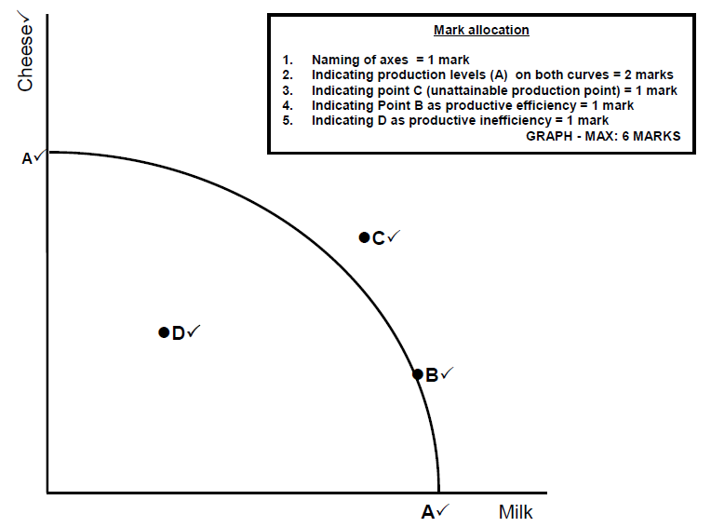
D (a point to the left of the PPC curve) is inefficient – resources are wasted
C (a point to the right of the PPC curve) not possible because of scarcity (lack of resources)
B (a point on the PPC curve) is efficient – production is maximized – no wasted resources
(Accept the explanation of a trade-off if two points appear on the PPC
CONCLUSION
Although the government cannot fulfil the supply of all community goods, there will always be a need to satisfy the aspirations of the entire society
(Any other relevant conclusion)
Governments uses various instruments at their disposal to correct or limit market failures.
- Draw a clearly labelled graph explaining the consequences of government intervention in the market for each of the following:
- Maximum prices
- Taxation (26 marks)
- In your opinion, how has the implementation of minimum wages advantaged the worker in South Africa? (10 marks)
 | Introduction
The purpose of government intervention is to ensure that the right quantity of resources is allocated to the production of output so that society as a whole maximizes its benefits.
(accept any relevant introduction)
 | BODY
 | Maximum prices
Labelling of axes = 1 mark
Correct labelling on axes = 1mark
Correct drawing of curves=1mark
Equilibrium point=1mark
Indication of max price=1 mark
TOTAL= 6 MARKS
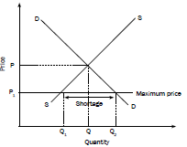
- Sometimes government will set the price of a good or service at a maximum level that is below the market price
- The government intervenes and passes a law that suppliers may not charge more than the maximum price
- The immediate effect is that quantity supply will drop
- The original market equilibrium price and quantity is P and Q respectively
- The price set by the is P₁ , at this price the demand will increase to Q_{2,} and supply will decrease to Q₁
- The difference between Q₁ and Q₂ is the shortfall that will be created on the market
- The shortage caused by the price ceiling creates a problem of how to allocate the good since the demand has increased
- Black markets start to develop
 | Taxation
Mark allocation
Labelling of axes=1 mark
Labelling on axes= 1mark
Original equilibrium point= 1 mark
New equilibrium point = 1 mark
Correct drawing and labelling of original demand and supply curves = 1 mark
New demand curve= 1 mark
TOTAL= 6 MARKS

- The appropriate way to intervene in the market by government is levying taxes as a method to recover external cost
- The original market equilibrium at e, with P as the equilibrium price and Q as the equilibrium quantity
- The tax increase will shift the supply curve to the left
- New equilibrium is at E₁
- A tax would raise the price from P to P₁
- The production will decrease from Q to Q₁
 | In your opinion, how has the implementation of minimum wages advantaged the worker in South Africa?
- They are protected by law and basic human rights. Many farmworkers and domestic workers are better off than before
- They enjoy a better living standard/ensure sustainable income
- They can enjoy unemployment benefits for which they did not qualify before
- They are also entitled for sick leave with pay
- They are also entitled to annual leave with pay
- Women are also entitled to maternity leave without the risk of becoming unemployed
(accept any other correct relevant response)
 | Conclusion
The intervention of government ensures that inefficiencies are eliminated and that the market is operating effectively
(Accept any other relevant response)
 | 'It is often argued that monopolistic competition leads to a less efficient allocation of resources.'  - Discuss the characteristics/features of monopolistic competition in detail. (26)  - How will non-price competition between food outlets like Steers, Wimpy, Spur and other businesses specialising in burgers, ensure their operational success in the monopolistic competitive market? (10) | (40)
 | INTRODUCTION
A market structure with many buyers and sellers where entry is relatively easy but the product is differentiated, e.g. toothpaste (Max. 2)
BODY: MAIN PART
Products are differentiated
- Products are similar but not identical because they satisfy the same consumer need e.g. clothing, shoes
It is a hybrid structure
• It is a combination of perfect competition and monopoly
• The element of perfect competition is that there are many sellers of a particular product
• The monopoly element is that every producer has their own specified brand
• Competition stems from the fact that there are many sellers of differentiated products and each has a relatively small role in relation to the market as a whole
• Businesses are free to enter or leave the market in the long term
• The monopoly elements results from product differentiation in the sense that each producer is the only producer of that specific brand or variant of the product
Control over price
• Business have little control over the price of the product
• Each business sell at their own price
• A single price cannot be determine for the differentiated products
Collusion is not possible
• Because of the number of businesses, collusion between them is not possible. Agreements regarding matters such as prices and production quantities are not characteristic of this market form
Market entry
• It is easy / free to enter or leave the monopolistic market
Information
• Non- price competition: firms use advertising and promotion to win over customers
It is often local
• Occurs in the retail and services sectors of the economy e.g. clothing, wine and furniture
• At the local level examples like the filling station, pharmacy, grocery store, hairdresser and fast-food outlet are good examples
• Each of these enterprises has a certain degree of monopolistic power because of the uniqueness of its product, favourable location, slightly lower prices
Diverse businesses
• Products differ and won’t allow us to derive supply and demand curves for this industry compared to the perfect market. A single price cannot be determined for differentiated products
Accept any other relevant facts and arguments.
 | ADDITIONAL PART
• These businesses engage in non-price competition - when sellers focus on distinctive features of their products rather than the price it may lead to better operational success
• The businesses can use the following methods of non- price competition:
• Branding: This is a marketing tool that businesses use to create a specific perception in the minds of consumers and also identifies a business as being exclusive for a particular market
• Advertising: It is information provided by the company about its product usually through media and is used to achieve product differentiation and market control
• Packaging: It is the way the product is presented to the market that protects the products, differentiate them and provides information about them. Businesses usually bring out the most important feature of their products through packaging
• Service: Businesses always improve their services to ensure that customers come back. Many people eat at restaurants because they enjoy the food and the service. Businesses should avoid treating customers in an incorrect manner
• Information: Businesses strive to provide relevant and precise information which will definitely convince customers to increase their spending

CONCLUSION
Monopolistic competitors as part of imperfect markets often charge higher prices aiming for higher profits that might be due to exclusive brands that consumers prefer. The success of the monopolistic competitor will definitely lie in insignificant factors like packaging and after-sales service that might determine their overall success in the long run, compared to what their opponents offer.
Markets are broadly categorised into perfect and imperfect markets. However, in reality very few examples of perfect markets exist.

- Examine the conditions of a perfect market in detail. (26 marks)
- Draw a clearly labelled graph to show economic profit for an individual producer in the market. (10 marks
Introduction
- It is a market structure with a large number of participants who are price-takers. ✓✓
- The price is determined by the market demand and supply, This market is most efficient in the allocation of resources ✓✓ 
BODY:
Characteristics:
a) Products must be homogenous (i.e. identical).
• Products must be identical. There should be no differences in style, design and quality. ✓✓ 
In this way products compete solely on the basis of price and can be purchased anywhere. ✓✓ 
If products differ, sellers can persuade buyers to buy their more expensive products by grading them. ✓✓ E.g. The markets for maize and coal consist of homogenous products which are graded. Grade 1 fetches a higher price than other grades.
b) There should be a large number of buyers and sellers.
• It should not be possible for one buyer or seller to influence the price.
• When there are many sellers the share of each seller to the market is so small that the seller cannot influence the price. ✓✓ 
Sellers are price-takers, they accept the prevailing market price. If they increase prices above the market price, they will lose customers. ✓✓.
No preferential treatment/discrimination✓ 
• Collusion occurs when buyers and sellers make an agreement to limit competition. In a perfect market no collusion takes place.  
 Buyers and sellers base their actions solely on price, homogenous product fetch the same price and therefore no preference is shown for buying from or selling to any particular person.  
d) Free competition/Unregulated market:
• Buyers must be free to buy whatever they want from any firm and in any quantity.  
 Sellers must be free to sell what, how much and where they wish.  
 They should be no state interference and no price control.  
 Buyers should not form groups to obtain lower prices nor should sellers combine to enforce higher prices. 
e) Efficient transport and communication
• Efficient transport ensures that products are made available everywhere.  
 In this way changes in demand and supply in one part of the market will influence the price in the entire market.  
 Efficient communication keeps buyers and sellers informed about market conditions.  
f) All participants must have perfect knowledge of market conditions.
• All buyers and sellers must be fully aware of what is happening in any part of the market.  
 Technology has increased competition as information is easily obtained via the Internet.  
g) Freedom of entry/exit: ✓ There is complete freedom of entry and exit, that is to say the market is fully accessible.✓✓ Buyers and sellers are completely free to enter or to leave the market. Entry should not be subject to any restrictions in the form of legal, financial, technological or other barriers that curtail the freedom of movement of buyers and sellers. ✓✓ 
h) Mobility of factors of production: ✓ All factors of production are completely mobile, ✓✓ in other words labour, capital and all other factors of production can move freely from one market to another. ✓✓ 
i) No collusion:✓ Collusion between sellers does not occur. ✓✓ In a perfectly
competitive market, each buyer and seller acts independently from one another.
Collusive practices are illegal in South Africa, according to the Competition Act
1998. ✓✓ 
Max. 26
NOTE: A maximum of 8 x 1 marks will be allocated for headings

 | ADDITIONAL PART
 | 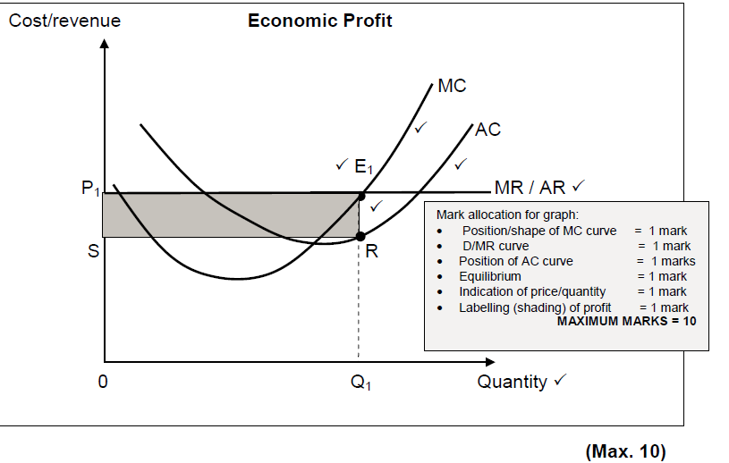
Conclusion
The characteristics above indicate that the market has to meet strict requirements before it can be described as perfectly competitive ✓✓ Although there very few examples, the conditions of a perfect market does serve a frame of reference when studying other markets. ✓✓

SUGGESTED ANSWERS
TOURISM
How can tourism influence the lives of poor people near tourist destinations?

Get employed  
 Sell goods and services to the tourists  

Any other positive or negative arguments e.g. drug trafficking and prostitution, increased crime rates, pollution, led to increased prices for locals. (Any 1 x 2)
Any other relevant answer.

.
Give TWO examples of World Heritage Sites in South Africa.
• Mapungubwe  
 The Vredefort Dome  
 The Sterkfontein Caves / Cradle of Humankind  
 Robben Island  
 Richtersveld Cultural and Botanical landscapes  
 ISimangaliso Wetland Park / Greater St Lucia Wetland Park  
 The Cape Fynbos region/ Table Mountain / Agulhas National Park  
 Ukhahlamba Drakensberg Park  (Any 2 x 1)

Discuss the economic benefits of tourism for the government and infrastructure development.

Government
• To raise revenue: Tourism makes a direct and indirect contribution to the government revenue through taxes  e.g. airport departure taxes, air tickets, VAT, excise duty  
 Advertise the economy: delivers excellent service to tourists and create a good image of the country  
 Create jobs and relieve poverty: especially in the informal sector  e.g. musicians  
 It earns foreign exchange for the country thereby increasing its foreign reserves  e.g. casino's, accommodation and transport form a very profitable source of foreign reserves  
 To recover external cost: It helps the government to recover from tourists a portion that serves as a compensation for providing the infrastructure  
 With excellent service, tourism can create a good image for the country  e.g. public amenities such as showers and toilets on beaches  
 Achieve socio-economic objectives: e.g. black economic empowerment and SMME development  (Max 4)

Infrastructure development
• All infrastructure built to support tourism become assets to the country e.g. information services  
 Residents and tourists enjoy adequate and well maintained physical and basic infrastructure / social infrastructure  such as ambulances, medical clinics, information  
 Security services and police services that are provided for use by tourists are important for use by residents  
 Economic infrastructure is prioritised by government to support tourism growth  e.g. ports, beaches, rivers and lakes  
 Most economic corridors have tourism as an important focus  
• PPP’s are sometimes used for the development of infrastructure  

Accept any other relevant answers (Max 4)
Explain the term tourism.
Activities of people travelling to and staying in places outside their usual environment for no more than one year for leisure, business and other purposes. It does not relate to any work done for money in the place visited. 
(Accept any other alternative definition) (1 x 2)
Why is South Africa such a popular holiday destination?

• Higher disposable income 
 Favourable exchange rates 
 Improved transportation 
 Improved communication 
 Marketing campaigns 

(Accept any other relevant answer) (Any 2 x 1
What is the impact of indigenous knowledge within the South African context on tourism?

• Tourists seek authenticity and uniqueness when they visit places  
 To understand the indigenous culture, history and environment  
 In South Africa, several World Heritage sites are attractions for tourists and they want to know how local people live and work  
 The wide range of indigenous cultural groups offer a wide variety of activities which can be developed through the country to ensure a positive impact on tourism  
 More foreign tourists are attracted to visit and experience South Africa's indigenous sites  

(Accept any other relevant facts) (4 x 2)

How can tourism eradicate poverty in South Africa? (2 x 1)

Job creation – jobs can be provided immediately  
 Entrepreneurial opportunities  
 Tourism allows rural people to share in the benefits of tourism development  

Any other relevant fact

INFLATION
What is the inflation target range set by the SARB?

The inflation target is between 3% and 6%
What negative influence will inflation have on the balance of payments

South African exports will become expensive therefore the country will sell less  
 Imports will be higher than exports, as such the balance of payment will have a deficit                         (1 x 2)

Why is core inflation lower than the CPI?

Products with highly volatile prices are excluded  
 E.g. fresh vegetables / fish / and fresh meat are excluded  
 The CPI headline inflation is calculated by using a selection basket of goods and services that the average household use  
 The reason is that these high volatile price changes will distort the real changes in prices  

(Accept any other relevant argument) Any (2 x 2

How can the government use fiscal policy to combat inflation?

• Increase in direct tax  
 Increase in indirect taxation  
 Reduction in government expenditure  

(Accept any relevant answer)
Why would you exclude food from the CPI basket when calculating core inflation?

Core inflation excludes items that have prices that are highly volatile (substantive increase and decrease in prices) / affected by government intervention 
Give TWO examples of prices that are controlled by the South African government.

• Fuel prices  
 Assessment rates  
 Property taxes  
 Sanitation levies  
 Refuse removal levies  
 Water levies  
 Electricity tariffs  
 Postal stamps  

(Accept any other relevant example)
What will happen to employment when the cost of production increases?
Employment will decline 
Why is inflation regarded as a never-ending process?

• When consumers/workers feel that their earnings are not enough to sustain their livelihood, they will demand higher wages  
 If their demand are successful, wages will increase  
 Businesses will increase their prices to compensate for the higher input cost  
 This will result in higher prices  
 Once prices increase, workers will be in the same financial predicament and will demand higher wages once again  

(Accept any other relevant response) (Any 2 x 2)
What is the current inflation target range?
3%–6 % 
What is the main purpose of the South Africa's inflation targeting policy?
To ensure a stable and sustainable economy  (Any 1 x 2)
What is the impact of inflation on investors and savers?

• Assets with fixed nominal values remain constant, the purchasing power of the nominal values increase, the real value decrease  
 Assets with flexible market value: The holders of shares and fixed property usually gain by price increases because the nominal value of these assets tend to increase at least proportionately to the rate of inflation  
 Often the prices of these assets increase more rapidly than the increase in the general price level  
 In this case, inflation creates wealth, to the advantage of the share holders  
 People who save are disadvantaged by inflation due to the fact that interest earned will be less than the current inflation rate  
 (Accept any other relevant fact) (Any 4 x 2)

Discuss taxation as a fiscal measure to combat inflation.

Direct taxation increased  less money available for consumption expenditure by consumers  
 Indirect taxation increased  as part of a restrictive fiscal policy government can reduce its spending or increase taxation e.g. sins

tax (2 x 4)
Define the concept inflation

Inflation is a sustained and significant increase in the general price level over a period of time and a simultaneous decrease in the value or buying power of money.  

ENVIRONMENTAL SUSTAINABILITY
What are the benefits of using technology in sustaining the environment? (4 x 2)

Technology can facilitate a solution to environmental problems by providing alternative production techniques  
 The development of clean technologies can have lower levels of toxic emissions and stop the existence of high risk chemical waste in the environment  
 It makes it possible for developing countries to comply with emissions targets / Substituting products that are more environmentally friendly e.g. paper bags instead of plastic bags; unleaded petrol  
 Although the production of platinum causes pollution, the use of the platinum reduces pollution  
• Technology facilitates the development of new techniques or equipment to save energy and replace coal and oil with greener energy resources such as wind or sun  
• It enables the recycling of waste material such as bottles, cans, cardboard to ensure a cleaner environment  
• The on-site treatment and controlled disposal of waste can be achieved by using technology 

(Accept any other relevant fact) Any (4 x 2)
How can people reduce transport fuel consumption in order to sustain the environment?

• Using means of transport that carry a large number of passengers such as trains and buses  
 Using lift clubs/ travelling in groups  
 Walking  
 Using bicycles  
 Using energy efficient vehicles e.g. hybrid cars  

Accept any other relevant answer (Any 1 x 2)
In your opinion, why are non-renewable resources referred to as 'dirty'?

• When burnt, they produce greenhouse gases  
 Non-renewable resources cause pollution  
 This will cause damage to the ozone layer / environment  
 Which will lead to global warming  
 Which will cause climate change            (Any 2 x 2)

Accept any other relevant response
Why are industries often accused of contributing to land and water pollution?

• Production process often causes pollution when people introduce foreign matter into the environment.  
 Firms often release chemical and physical materials on land and in water. 
 Water pollution kills the organisms that live in water. 
 Land pollution reduces the fertility of soil.  
 Extraction of natural resources through mining often results in the damage to land.  
 Deforestation often takes place when firms cut trees in preparation for construction of industrial sites. 

Accept any other relevant answers. (4 x 2)
Give TWO examples of the preservation of the environment.

• Ecological system  
 Heritage site  
 Indigenous forest  
 Wetland  
 River mouth system  
 Taxation / subsidies / private ownership / reserves / land expropriation / e.g. West Coast nature reserve

Any other relevant fact. (Any 2 x 1)
.
Explain environmental taxes and marketable permits as intervention strategies to achieve environmental sustainability.

Levying environmental taxes
• Environmental taxes are taxes that are imposed on output of goods that generates external environmental costs (pollution)  
• These taxes are called green taxes / eco taxes  
• Carbon dioxide from wineries and vehicle tyres are taxed.  
• The tax rate is equal to the external marginal costs.  (2 x 2) (4)

Marketable permits
• Government gives each business a licence to pollute to a certain extent.  
 Businesses can sell their licences to other businesses that has a larger or increased pollution level.  
 In South Africa marketable permits are granted by the Department of Minerals and Energy.  (2 x 2) (4)

What is the effect of climate change on weather patterns?
It can cause irregular weather patterns: floods/droughts  

Tourism is the fastest growing industry in the world.  - Examine in detail the effects of tourism on the South African economy.  (26 marks)  - How can indigenous knowledge systems be used to promote tourism in South Africa? (10 marks)  INTRODUCTION  This is the activities of people travelling to and staying in places outside their usual environment for a period not longer than one consecutive year for leisure, business and other purposes and not related to a remunerative activity from within the place visited                      (Max. 2)  BODY  MAIN PART  • Gross domestic product (GDP)    Tourism impacts mostly on the services industry than on agriculture or manufacturing although there are upstream effects when agriculture provides foodstuffs to restaurants and manufacturing provides vehicles for transport    ➢ Direct contribution on GDP    - Statistics South Africa (SSA) shows that in 2010 inbound tourists contributed R69 billion and domestic tourists R99 billion, amounting to R168 billion - about 3% of South Africa's GDP    ➢ Indirect contribution on GDP   - If the indirect contribution is added, tourism add about 7% to GDP    - The WTTC estimated that tourism contributed 9% to the GDP of the world economy in 2011    - In developing economies the service sector is responsible for around 40% of GDP, while it is responsible for more than 65% of GDP in developed economies    - South Africa is similar to that of developed economies and services contributed more than 67 % of GDP in 2011     Employment    Employment    - Tourism has a major effect on employment and this amounted to 1.18 million workers in 2011    - Tourism is the world’s largest generator of jobs    Reasons:  ➢ Tourism is labour intensive    More jobs can be created with every unit of capital invested in tourism than elsewhere    ➢ Tourism employs many skills    It ranges from accountants and hairdressers to tour guides and trackers,  the tourism industry draws upon numerous skills    ➢ Tourism can provide immediate employment    If one quarter of tourists’ accommodation establishment in South Africa starts to offer live entertainment to quests, thousands of entertainers could be employed within days    ➢ Tourism provides entrepreneurship opportunities    The tourism industry accommodates informal sector enterprises, from craft and fruit vendors to pavement vendors, chair rentals    Poverty    - Tourism is widely recognised as one of the fastest and more effective redistribution mechanisms in development    - It brings development to the poor in rural areas    - Tourism provides an alternative to urbanisation, permitting women and youth to continue a rural family lifestyle while giving them business opportunities    - E.g. to start and operate small-scale tourism businesses around community asserts (forests, parks and rivers)     Externalities    - The rapidly expanding tourism industry could have both positive and negative impacts that extend well into the future    - While tourism attracts large amount of revenue, it can also cause undue environmental damage that can harm the very foundation on which it depends    - All other economic resources, tourism uses resources and produces wastes and also creates environmental costs (pollution) and benefits in the process    - Rapid growth in tourism aiming at short-term benefits usually results in more negative effects and these includes the degeneration of traditions and cultural values and environmental damage to sites and setting    Environment    Tourism activities create environmental stress:  - Permanent environmental restructuring which includes major infrastructure    - Waste product generation such as biological and non-biological waste that damages fish production    - Direct environmental stress caused by tourist activities, e.g. the destruction of vegetation and dunes    - Effects on population dynamics such as migration and increased urban densities    Investment    An adequate physical, economic and basic services infrastructure is essential for tourist destinations which means they invest in the following:  - Transport infrastructure, e.g. roads, airports    - Communication and infrastructure including telephone lines, electronic signal stations and radio, TVs’    - Energy infrastructure such electricity and liquid fuel    - Basic service infrastructure such as clean water and sewerage systems  (Max. 26)  ADDITIONAL PART  How can Indigenous Knowledge Systems be used to promote tourism in South Africa?  • More cultural villages can be improved to facilitate and promote tourism  e.g. Shangana in Mpumalanga, Basotho in the Free State and Simunye Zulu Lodge in Kwazulu-Natal where guides explain and demonstrate storytelling and indigenous knowledge practices     Advertising campaigns domestically and internationally by travel agencies, hotels and B & B, lodges and SA Tourism can focus on promoting these heritage sites in brochures and fliers, social media. These actions will make tourists more aware of these attractions     Encourage tourists to experience different cultures and townships - experience life at home with a household and eat at a shebeen or township restaurant     World Heritage Sites of South Africa can be promoted for their cultural significance e.g. the Fossil Hominid Sites of Sterkfontein, Mapungubwe Cultural Landscape, Richtersveld Cultural and Botanical Landscape, Vredefort Dome and Robben Island     Environmental World Heritage Sites of South Africa selected for their natural importance namely the Cape Floral Region Protected Areas, Isimangaliso Wetlands Park as well as uKhahlamba/Drakensberg Park which has been selected for its mixed significance     Arts and culture festivals e.g. the National Arts Festival, the Hermanus Festival, Awesome Africa Music Festival and Macufe African Cultural Festival should more widely be advertised to encourage tourists to attend     According to the World Health Organisation, a large majority of the African population make use of traditional medicines for health, social-cultural and economic reasons and forms part of the unique experience tourists experience when visiting local villages      • In South Africa tourists are made more aware of the important role traditional medicine plays in poverty reduction and employment creation     Relaxation of restrictive tourist visa laws to facilitate easier entry into South Africa    (Accept any other relevant answers) (Max. 10)  Conclusion  South Africa attracted over 7,8 million tourists in 2011/For every 8.1 additional tourist to South Africa, one new job is created/one per cent increase in tourism adds R532 million annually to the SA economy.    (Accept any other relevant higher order conclusion) (Max. 2)   | [40]
Inflation is a phenomenon that many countries in the world have to deal with.
• Examine in detail the causes of cost-push inflation. (26)
• Has South Africa's inflation-targeting policy been beneficial to the economy? Motivate your response. (10)

INTRODUCTION
Inflation is a sustained and significant increase in general price level over a period of time and a simultaneous decrease in the purchasing power of money.  
Accept any other relevant introduction. (Max. 2)

BODY: MAIN PART
Causes of cost-push inflation
• Increase in Wages: 
➢ In South Africa, increase in wages constitute more than 50% of Gross Value Added at basic prices 
➢ If the increase in wages is not accompanied by an increase in production, the cost of production will rise  
➢ Producers will increase the prices of their products to offset the high cost of production  
➢ Strikes and stay-aways / labour union activities  

Key inputs/ increase in prices of imported capital goods  
➢ When the prices of key inputs that are imported increase, domestic cost of production increases especially in the manufacturing sector  
➢ Supply shocks e.g. sudden increase of oil causes a knock-off effect  
 Exchange rate depreciation 
➢ A decrease in the value of the rand will result in an increase in prices of imports  

 Profit margins 
➢ When firms increase profit margins, the prices that consumers pay also increase  ➢ Sometimes firms use their market power to push up prices  


 Productivity  
➢ Less productive factors of production will lead to increased cost per unit  
➢ Strikes and stay-aways often reduce production output and can result in price increases  

 Natural disasters 
➢ Natural disasters such as drought, flood and global warming can impact on the cost of production  
➢ This is often the case in relation to food prices 

Interest rates 
➢ An increase in interest rates results businesses paying more money for capital loaned  
➢ Firms recover these costs by increasing the prices of their products  

 Increase in taxation 
➢ Increase in direct tax like company income tax may lead to businesses increasing their prices to offset the extra burden  
➢ Increase in indirect tax such as custom duty will lead to increase in costs of supplying a particular product, therefore the price will increase  
 Administered prices increase  e.g. fuel prices  
• Shoplifting and losses caused by employees are added to the prices of products  

Accept any other relevant fact. Maximum 8 marks for headings. (Max. 26)

BODY: ADDITIONAL PART
YES / NO 
• Inflation targeting is when a particular percentage is set as an acceptable level for an increase in general price levels  
 The SARB's inflation target is a range of 3% and 6%  
 The aim of inflation targeting policy is to achieve and maintain price stability  
• The implementation of the inflation target is easy to understand – expressed in numbers which makes it very clear and transparent  
 It reduces uncertainty and promotes sound planning in the public and private sectors  

 It provides an explicit yardstick that serves to discipline monetary policy and improves the accountability of the central banks  
 The SARB make use of monetary policy, specifically the repo rate to keep the inflation within the target range  
 The government make use of fiscal policy regarding public sector revenue and expenditure  

Positive effects
• Where demand is higher than supply an increase in interest rates help to bring the demand down  
 The policy can helps businesses to make economic plans without worrying about the effects of high inflation  
 South Africa's price level has been fairly stable since the introduction of the inflation targeting policy in 2000  

Negative effects
• Inflation targeting can cause a reduction in economic growth  
 This is because the raising of interest rates, result in a decrease in total spending which is needed for production to increase  
 Decreased economic growth can increase unemployment  
 South Africa has been experiencing an increase in unemployment since the implementation of the policy in 2000  
Inflation targeting is difficult to implement when the cause of inflation is supply shocks                              (Max. 10)

CONCLUSION
Any relevant higher order conclusion that should include:
• A summary of what has been discussed without repeating facts already mentioned in the body. 
• An opinion or valued judgement on the facts discussed. 
• Additional support information to strengthen the discussion.
• A contradictory viewpoint with motivation.
• Recommendations.

E.g. Inflation can be a threat to the normal functioning of the economy; therefore, measures like monetary and fiscal are vital to keep the phenomenon under control.  
(Max. 2)

The current levels of pollution and environmental degradation are too high and this affects the ability of the environment to survive its use for economic activities.

• Discuss government's attempts (interventions and control) to ensure the sustainability of our environment. (26 marks)

• In your opinion, how effective is pollution control measures in South Africa?
(10 marks)

INTRODUCTION
Environmental sustainability can be defined as development that meets the need of the present without compromising the ability of future generations to meet their own needs.  (Max. 2)
BODY
MAIN PART

• Public sector intervention  
- Because it is difficult to enforce measures to ensure sustainability the government has to intervene  

* Environmental taxes  

- Environmental taxes (green taxes) can be added to the cost of goods and services for the negative impact they have on the environment  
- The government uses the income generated through these taxes to protect the environment  
- Taxes can be imposed on petrol, paper, emission gases etc.  
- In 2003 the government has legislated the use of biodegradable plastic bags which consumers had to pay for  
- The hope is that they will use fewer bags and ensure a litter free environment  

* Charging for dumping of waste  

- A monthly fee as part of municipal accounts is charged for collection of waste, sewage and garbage.
- Households already pay for the collection of rubbish  
- The factory owner might clean up his waste if it cost him to dump it  
- Industries might also pay for emitting gases that can be harmful to people and the environment  

* Subsidies  

- Subsidies can be awarded to businesses that are willing to reduce pollution and waste.  
- Waste can also be reduce by using new techniques or equipment such as solar energy 

Emission gases from factories can be reduced using new technology.  
* Granting property rights  

- Normally owners of properties tend to be more protective over their resources than users who are only interested in the profits the resources offer 
- For this reason the government might grant property rights over a specific area.  
- Property rights empower owners to negotiate contracts with businesses who wish to exploit the area's resources 

* Marketable permits  

- A government can decide on the maximum desired level of pollution in an area  
- It then distribute pollution rights (marketable permits) to factories within that area  
- This means that each factory can pollute to a certain limit  
- It means that marketable permits are licenses that polluters can buy or sell to meet the control levels set by government  

* Education  

- Incorporating topics into the curriculum of school fosters awareness  
- The public is gradually been made aware of this rising problem  
- Plastic, bottles and cartons can be recycled or made biodegradable (13)

Public sector control  
- If the government's intervention does not attain the desired results, then it has to intervene more directly by setting and enforcing limits  

* Environmental Impact Assessment  

- In SA every projected construction, mining or similar development has to undergo an assessment by qualified environmental professionals  
- To prove that it will not cause unwarranted environmental damage and that the damage can be repaired after construction  
- The cost is built into the project  

* Command and control  

- Regulations that are set and enforce environmental limits or standards  
- Quantity: e.g. set the limit to the amount of fish to catch, or limit the season catching certain species of fish  
- Quality: e.g. drinking water quality is carefully monitored and controlled  
- Air quality in workplace is subject to minimum standards  
- Social effect: e.g. noxious fumes from factories, dumping of medical waste near settlements, and noise pollution  

* Voluntary agreements  

- Agreements between government and businesses voluntarily to address negative environmental impacts of industries  
- Businesses voluntary agree to decrease the emissions of pollutants  
- Most prefer negotiations so that they can tailor their specific needs and include it into their planning  
- Agreements can be formal, which is legally binding contract or informal  (13)

(Max .26)

ADDITIONAL PART
In your opinion, how effective are pollution control measures in South Africa?

• Government does not exercise effective control over the continuous dumping of waste because of a lack of coordination between departments  
 The fines imposed on industries that dump waste are too lenient and they continue polluting the environment  
 The minimum standards set for hazardous gas and fuel emissions are not enforced or adjusted  
 The recycling of waste materials is not widely encouraged and promoted and landfill sites are overflowing  
 Government has various laws that is not really effectively implemented  
 Poor service delivery also adds to the problem in certain areas  

(Accept any other relevant answer) (Any 5 x 2)

CONCLUSION
Each and every individual, business and government needs to stand together to save our planet. 
(Accept any other relevant conclusion) (Max. 2)
Tourism is one of the fastest growing industries worldwide.

• Critically discuss the effects of tourism. (26 marks)
• Evaluate how tourism benefits the households in your community by using appropriate
examples. (10 marks)

Introduction
In general we say that tourism involves people moving from their usual place of residence to a destination where they make use of the facilities and take part in activities  
Any other relevant definition. (Max. 2)

BODY: MAIN PART
1.1 GDP  
 Biggest impact on services industry than on agriculture or manufacturing  
 Indirect contribution: service-based industry – responsible for 65% of GDP in developed economies and 40% of GDP in developing countries  
 Direct contribution: contribution of 6,8% of GDP compared to 11.6% worldwide.  

1.2 Employment  
 Employs 7% of SA workforce (1,12 million)  
 largest provider of jobs and earner of foreign exchange, due to:
 Tourism is labour intensive  
 Tourism employs many skills  
 Tourism can provide immediate employment  
 Tourism provides entrepreneurial opportunities  

1.3 Poverty  
 Tourism is fast + effective distribution mechanism in development of rural areas  
 Prime tourism attractions located in rural areas  
 Promote balanced + sustainable form of development  
 Provides alternative to urbanisation, permitting people to continue - a rural family existence, enfranchising both women and youth  
 Offers diversity of income sources to poor people:
 Allowing them a stake 
 Empowering them 
 Creating partnerships  

1.4 Externalities

Has positive and negative impacts:
 Attracts large amounts of revenue, but can cause undue environmental damage (uses resources and produces waste)  
 Rapid growth aimed at short-term benefits has more negative than positive effects: degeneration of traditions + cultural values, environmental damage to sites and natural settings – pollution and waste  
 Global tourism will grow due to increased population, improved living  standards, increased free time and expansion of transportation systems
 Pressure on tourist sites will increase  
 Potential: attract revenue to country, alleviate poverty, conserve cultural and natural assets – needs conscious planning  
 Needs to achieve ethical and sustainable tourism must respect tradition and customs of area, plough back earnings into local community – area must be protected as attractive tourist resort.  

1.5 Environment

Industrial development has impact on physical environment in which it takes place. 
Creates environmental stress – categories:
• Permanent environmental restructuring (construction work on highways, airports)  
 Waste product generation (biological + non-biological waste)  
 Direct environmental stress (destruction of coral reefs)  
 Effects on population dynamics (migration and urban density, declining rural
population)  

1.6 Infrastructure

• Adequate physical, economic + basic services infrastructure essential for tourist destinations:
 Transport infrastructure (roads, railway lines, airports, car parks)  
 Communication infrastructure (telephone lines, electronic signal stations)  
 Energy infrastructure (electricity and liquid fuels)  
 Basic services infrastructure (clean water, reuse removal, sewerage systems).  
 Lack of economic + basic services infrastructure prevents growth of tourism  
 This infrastructure is seen as public investment  
 Seasonality – major problem for infrastructural development      (Max 26)

ADDITIONAL PART
Tourism benefits households' prosperity in THREE ways:
• Income – salaries and wages – due to involvement with tourism  example from the candidate's environment  
 Infrastructure – available for tourists and local people's use  example from candidate's environment  
 Skills – variety required – education + training required – school subject  example from the candidate's environment                (Max. 10)

Accept any other relevant answer

Conclusion
In reality tourism is a much wider concept and can be quite demanding but very interesting when it is related to a specific community  
Any other relevant conclusion (Max. 2)

