Province of the
EASTERN CAPE
EDUCATION

DIRECTORATE SENIOR CURRICULUM MANAGEMENT (SEN-FET)
HOME SCHOOLING SELF-STUDY WORKSHEET
SUBJECT | GEOGRAPHY | GRADE | 12 | DATE | 29/04/20
TOPIC | Settlement geography  Urban settlements | TERM 2  REVISION | ✓ | TERM 2 CONTENT | ✓
TIME ALLOCATION |  | TIPS TO KEEP HEALTHY  1. WASH YOUR HANDS thoroughly with soap and water for at least 20 seconds. Alternatively, use hand sanitizer with an alcohol content of at least 70%.  2. PRACTICE SOCIAL DISTANCING – keep a distance of 1m away from other people.  3. PRACTISE GOOD RESPIRATORY HYGIENE: cough or sneeze into your elbow or tissue and dispose of the tissue immediately after use.  4. TRY NOT TO TOUCH YOUR FACE. The virus can be transferred from your hands to your nose, mouth and eyes. It can then enter your body and make you sick.  5. STAY AT HOME.
INSTRUCTIONS

POSSIBLE QUESTIONS ON URBAN GEOGRAPHY (STUDY IN CONJUCTION
WITH :
- THE ACCOMPANYING POWER POINT SLIDES ON URBAN GEOGRAPHY)
- Mind the GAP study guide
- Your textbook
- The accompanying answer sheet

POSSIBLE QUESTIONS ON URBAN GEOGRAPHY
1.1. | Study FIGURE 1.1 which is a model of a city in a developing country and answer the following questions.  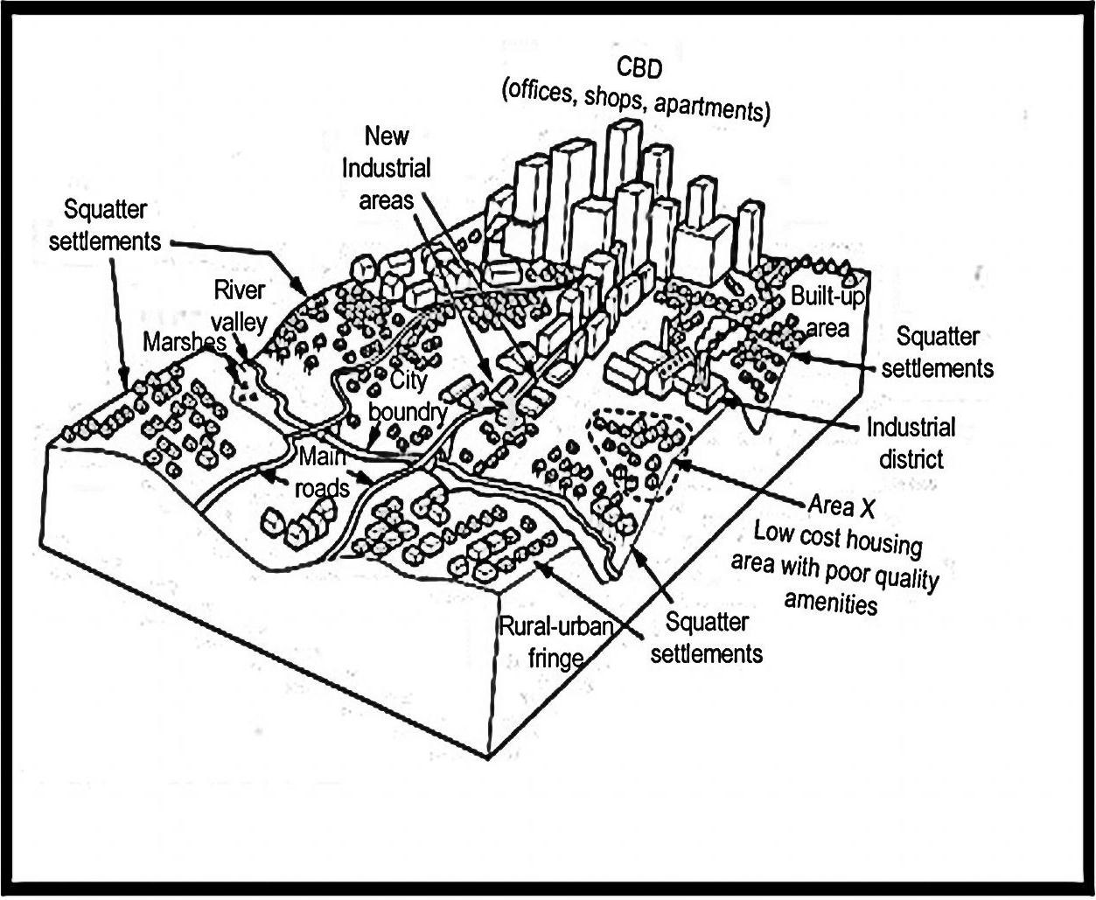
 | 1.1.1 | Identify from FIGURE 4.4 ONE example of land-use in the CBD. | (1 x1) | (1)
 | 1.1.2 | 4.4.2 Suggest TWO examples of services in the area marked X which are likely to be of poor quality. | (2x1) | (2)
 | 1.1.3 | State TWO reasons why large numbers of people live in squatter settlements in cities like FIGURE 4.4. | (2 x 1) | (2)
 | 1.1.4 | Describe the characteristic of the rural-urban fringe. | (2 x 2) | (4)
 | 1.1.5 | In a paragraph (approximately 8 lines) suggest some methods which can be used by city planners to make this city a more sustainable one. | (4x 2) | (8)
 |  |  |  | (17)
FIGURE 2.1
FIGURE 2.1 compares South Africa’s recent and predicted urbanisation levels with global trends. Study this table to answer the following questions.
Region |  | 1995 | 2000 | 2005 | 2010 | 2015 | 2020 | 2025 | 2030 | 2035 | 2040
South Africa |  | 54,5 | 56,9 | 59,3 | 61,5 | 63,8 | 65,9 | 67,9 | 69,8 | 71,7 | 73,5
Africa |  | 33,9 | 35,6 | 37,3 | 39,2 | 41,1 | 43,2 | 45,3 | 47,7 | 50,1 | 52,6
Europe |  | 70,3 | 70,8 | 71,6 | 72,7 | 73,8 | 74,9 | 74,9 | 77,4 | 78,6 | 79,9
World |  | 44,8 | 46,7 | 49,1 | 51,6 | 53,9 | 56,0 | 56,0 | 59,9 | 61,7 | 63,5
 | 2.1.1 | Differentiate between the terms ‘level’ and ‘rate’ of urbanisation. | (2 x1) | (2)
 | 2.1.2 | Name the region (shown in TABLE 3.4) depicting the highest urbanisation level. | (1 x 1) | (1)
 | 2.1.3 | Determine the region (Africa or Europe) that  demonstrates the lowest rate of urbanisation over  the entire period depicted on the table. | (1 x 1) | (1)
 | 2.1.4 | Suggest reasons for the increase in counter urbanisation, especially in developed countries | (2 x 2) | (4)
 | 2.1.5 | Account for the rapid rate of urbanisation in South Africa between 1995 and 2000. | (2 x 2) | (4)
 |  |  |  | (12)
3.1 Read the article about urbanisation in FIGURE 3.3 and then answer that
questions that follow.

FIGURE 3.1 : URBANISATION

URBANISATION: LOW-COST HOUSING NOT LOW-COST ENOUGH

11 APRIL 2014, LAUREN ROYSTON, MICHAEL CLARK

There is still no formal plan to cover the need for cheaper inner-city accommodation.
Approximately 60% of the South African population currently lives in urban areas. This figure will increase as a result of natural population growth and the further migration of people to cities in search of economic opportunities.

In many African countries, including South Africa, the standard government response to poverty associated with urbanisation (where people live in backyard shacks, informal settlements and 'bad' buildings) has been to focus on improving standards of living in rural areas in order to prevent rural-urban migration, and to criminalise poverty in urban areas by evicting people from their shacks and clamping down on informal livelihoods.

[Adapted from http://mg.co.za/article/2014-04-10-low-cost-housing-not-low-cost
enough]

 | 3.1.1 | Define the term urbanisation. | (1x1) | (1)
 | 3.1.2. | Name the percentage of the people living in urban areas in South Africa. | (1 x 1) | (1)
 | 3.1.3 | What are the causes of urbanisation in South Africa? | (2 x 1) | (2)
 | 3.1.4 | Name FOUR problems associated with urbanisation. | (4 x 1) | (4)
 | 3.1.5 | Refer to the 'bad' buildings in the article.  - Discuss TWO causes of 'bad' buildings.  - Suggest TWO possible solutions to the problem of 'bad' buildings. | (2x2)  (2x2) | (4)  (4)
 |  |  |  | (16)
FIGURE 4.1 shows the sphere of influence and range of food stores and motor vehicle retailers in settlements A and B
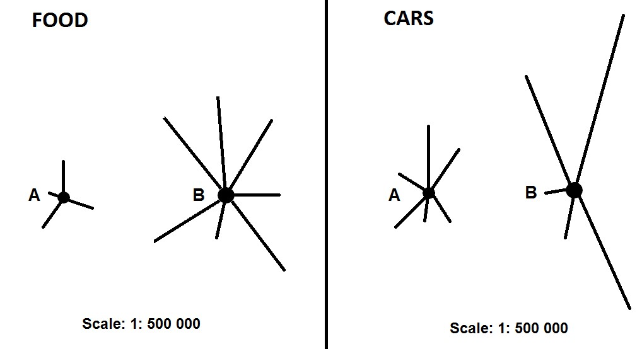
MOTOR VEHICLES
Scale: 1 : 500 000
Scale: 1 : 500 000

 | 4.1.1 | Define the terms sphere of influence and range. | (2 x 1) | (2)
 | 4.1.2 | Which product, food or cars, has a larger range? | (1 x 1) | (1)
 | 4.1.3 | Give a reason for your answer to QUESTION 4.1.2. | (1 x 2) | (2)
 | 4.1.4 | Comment on the threshold population required for motor vehicle sales. | (1 x 2) | (2)
 | 4.1.5 | Describe TWO characteristics of settlement A, which is a low order centre. | (2 x 2) | (4)
 | 4.1.6 | Explain what influences the sphere of influence of a settlement such as B. | (2 x 2) | (4)
 |  |  |  | (15)
5 .1 FIGURE 5.1 represents different urban settlements. Provide a letter from
the sketch that best matches the descriptions below. Write ONLY the letter
of your choice next to the question number (5.1.1-5.1.7)
NOTE: One letter may refer to more than ONE description.
FIGURE 5.1: DIFFERENT URBAN SETTLEMENTS

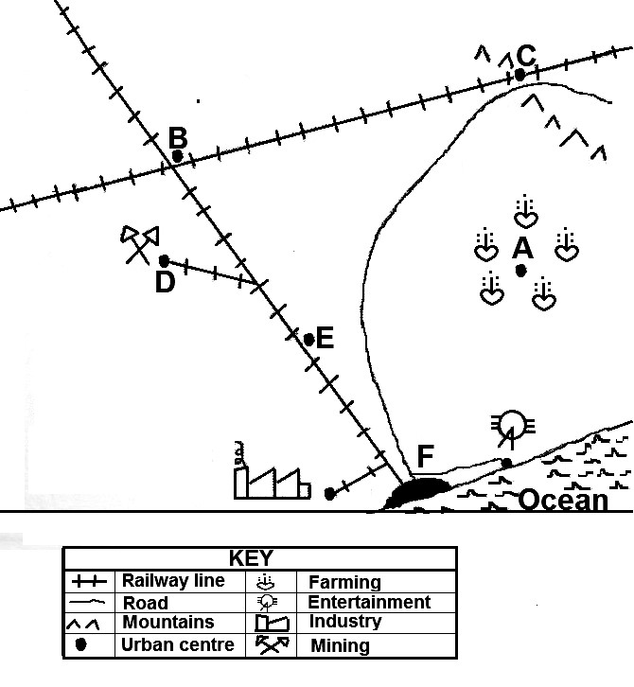

 | 5.1.1 | A settlement which is an example of a typical gateway town
 | 5.1.2 | The settlement that provides services to a predominant farming community
 | 5.1.3 | The settlement where one type of transport is replaced by another
 | 5.1.4 | The settlement which represents a specialised town
 | 5.1.5 | The settlement where a junction town can be found
 | 5.1.6 | The settlement that will never develop into a circular shape
 | 5.1.7 | East London and Port Elizabeth are typical examples of this settlement | (7x1) | (7)
6.1 Study FIGURE 6.1 depicting traffic congestion and answer the questions that follow:

FIGURE 6.1: TRAFFIC CONGESTION IN A CITY
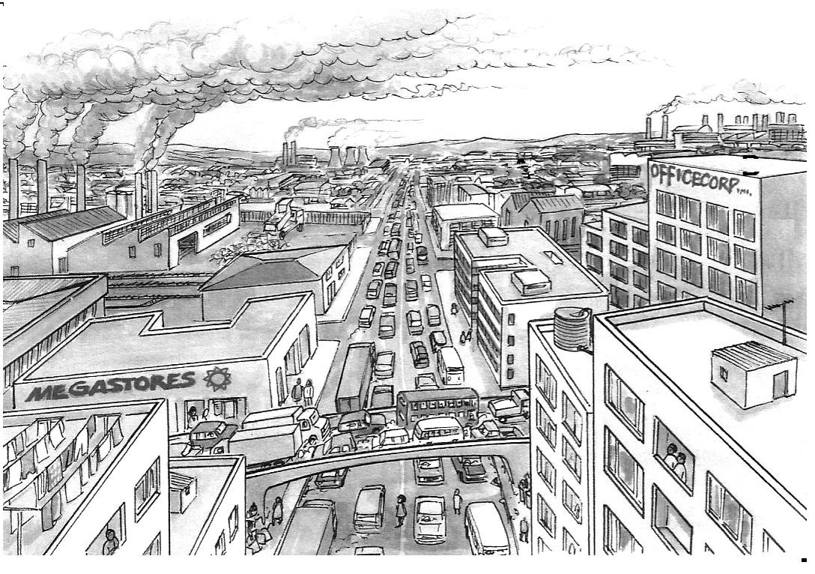

Source: Adapted from understanding Geography]

]

 | 6.1.1 | Identify the dominant street pattern evident in the sketch. | (1 x 1) | (1)
 | 6.1.2 | Give ONE advantage of the street pattern identified in QUESTION 6.1.1 | (1 x 1) | (1)
 | 6.1.3 | Explain how the street pattern mentioned in QUESTION 3.4.1,  contributed to the traffic congestion problem that exists in the illustrated city. | (1x2 | (2)
 | 6.1.4 | Discuss TWO possible solutions for the traffic congestion problems in this particular city. | (2 x 2) | (4)
 | 6.1.5 | Mention ONE impact of traffic congestion on the infrastructure of the illustrated city. | (1 x 2) | (2)
 | 6.1.6 | Support the statement that urban expansion creates environmental problems in the illustrated city. | (2 x 2) | (4)
 |  |  | (14)
7.1
7.1. The photo in FIGURE 7.1 illustrates a major problem which exists in the inner city of big urban areas. Use the photo to answer the following questions.
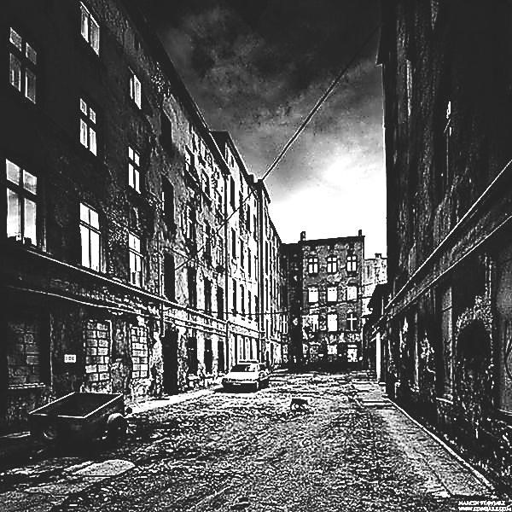
FIGURE 7.1
:
INNER CITY PROBLEMS

 | 7.1.1 | Identify the urban problem illustrated by the photo. | (1 x 1) | (1)
 | 7.1.2 | In which land-use zone is this problem commonly found in big urban areas? | (1 x 1) | (1)
 | 7.1.3 | Mention ONE socio-economic problem that could have worsened the situation illustrated in the photo. | (1 x 1) | (1)
 | 7.1.4 | Despite the poor conditions visible in the photograph, the land-use zone where this photo was taken has high land values. Explain why this is the case. | (2 x 2) | (4)
 | 7.1.5 | The visible poor conditions and the infrastructure is a problem for urban planners, as it discourages investment in cities. In a paragraph of approximately EIGHT lines, outline suggestions you would forward as part of an urban renewable strategy. | (4 x 2) | (8)
 |  |  |  | (15)
8.1.1 Study FIGURE 8.1. Match the descriptions below to the labels in FIGURE 8.1. Write the label next to the question number (8.1.1–8.1.8) in the ANSWER BOOK.

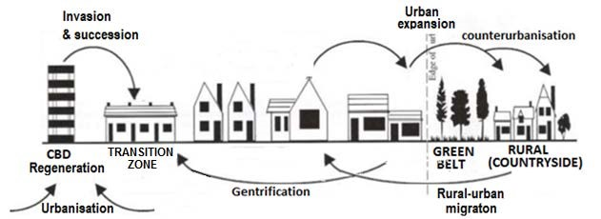

[Adapted from

garsidej.wordpress.co
m
]

Urban expansion

Counteru
r
banisation

 | 8.1.1 | Movement of people from rural areas to cities
 | 8.1.2 | Movement of people from cities to rural areas
 | 8.1.3 | A term that describes the physical growth of a city
 | 8.1.4 | An area of decay on the outskirts of the CBD
 | 8.1.5 | Refers to the modernisation of old houses by wealthy people
 | 8.1.6 | A feature that prevents urban sprawl
 | 8.1.7 | Renovation of buildings to reduce migration and improve the urban environment
 | 8.1.8 | The percentage increase of people living in
 |  |  | (8x1) | (8)
9.1 Choose the correct word(s) from those given in brackets. Write only the word(s) next to the question number 9.1.1 – 9.1.7 in the ANSWER BOOK.
 | 9.1.1 | The dispersal of industries away from core areas is  known as industrial (centralisation/decentralisation).
 | 9.1.2 | An initiative that promotes industrialisation along major routes is called (spatial development initiatives/industrial development zones).
 | 9.1.3 | Industries that are located between the raw material and the customer are called (bridge/footloose) industries.
 | 9.1.4 | An oil refinery will be classified as a (heavy/light) industry.
 | 9.1.5 | 3.2.6 The sector of the economy that is associated with research and development is the (tertiary/quaternary) sector.
 | 9.1.6 | A food-processing factory is a (primary/secondary) economic activity
 | 9.1.7 | A coal-fired power station is (raw-material/market) orientated. | (7 x 1) | (7)

