Province of the
EASTERN CAPE
EDUCATION

DIRECTORATE SENIOR CURRICULUM MANAGEMENT (SEN-FET)
HOME SCHOOLING SELF-STUDY WORKSHEET
SUBJECT | GEOGRAPHY | GRADE | 12 | DATE | 28/04/20
TOPIC | SETTLEMENT GEOGRAPHY  REVISION RURAL SETTLEMENTS | TERM 1  REVISION | ✓ | TERM 2 CONTENT | ✓
TIME ALLOCATION | 1 HOUR | TIPS TO KEEP HEALTHY  1. WASH YOUR HANDS thoroughly with soap and water for at least 20 seconds. Alternatively, use hand sanitizer with an alcohol content of at least 60%.  2. PRACTICE SOCIAL DISTANCING – keep a distance of 1m away from other people.  3. PRACTISE GOOD RESPIRATORY HYGIENE: cough or sneeze into your elbow or tissue and dispose of the tissue immediately after use.  4. TRY NOT TO TOUCH YOUR FACE. The virus can be transferred from your hands to your nose, mouth and eyes. It can then enter your body and make you sick.  5. STAY AT HOME.
INSTRUCTIONS

Instruction to note in question papers
- Illustrate your answers with labelled diagrams, when instructed to do so.

- Mark allocation is as follows:

(2 x 1) (2) means that TWO facts are required for ONE mark each
(2 x 2) (4) means that TWO facts are required for TWO marks each

- If words/action verbs like Name, Identify, Provide and Classify are used in a question, ONE WORD ANSWERS are acceptable.
If words/action verbs like Discuss, Define, Explain, Comment, Evaluate, Justify, Suggest and Substantiate are used in a question, FULL SENTENCES or PHRASES are required.
All paragraph questions must be answered in FULL sentences.

POSSIBLE QUESTIONS - RURAL SETTLEMENTS
1.1 Choose the correct word(s) from those given in brackets. Write only the word(s) next to the question number (1.1.1–1.1.8) in the ANSWER BOOK. (Trial 2019)
 | 1.1.1 | Cattle farming is usually an example of (small  scale/large scale) farming.
 | 1.1.2 | (Dry/Wet) point settlements are located on hills  Because water poses a threat.
 | 1.1.3 | Railways and airports influence the (situation/site) of a settlement.
 | 1.1.4 | The (RDP/Good Hope Plan) was implemented to address social injustice issues in rural areas in the post-apartheid era.
 | 1.1.5 | A decrease in the number of people living in rural areas is referred to as (rural depopulation/rural-urban migration).
 | 1.1.6 | A settlement with both rural and urban functions is known as a (village/hamlet).
 | 1.1.7 | Tradition is a factor that influences (site/situation).
 | 1.1.8 | (Round/Linear) rural settlement patterns usually develop because of security issues. | (8x1) | (8)
2.1 Study FIGURE 2.1, a cartoon on land reform (Rural Settlement Issues) Sept 2019

FIGURE 2.1 : LAND REFORM
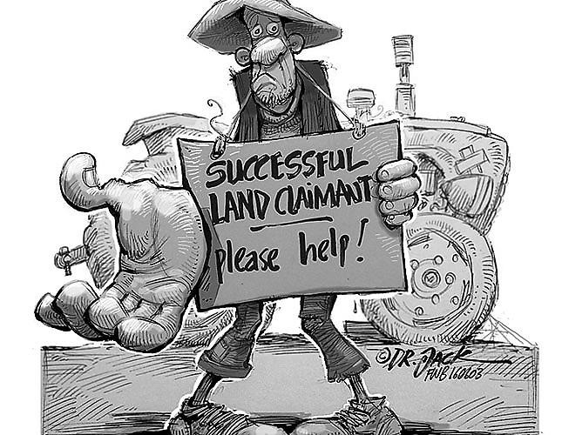

[
Source
:

farmersweekly.co.za
]

 | 2.1.1 | What is the purpose of land reform in South Africa? | (1x1) | (1)
 | 2.1.2 | Name any TWO land reform policies that enabled this claimant to be successful. | (2x1) | (2)
 | 2.1.3 | Discuss the TWO challenges that the government could have faced in effecting land reform policy for this successful claimant | (2x2) | (4)
 | 2.1.4 | Suggest possible reasons why this land claimant, illustrated in the cartoon, needs help. | (2x2) | (4)
 | 2.1.5 | Explain the implications for the country if all land claimants do not get the necessary help. | (2x2) | (4)
 |  |  |  | [23]

3.1 Choose a term from COLUMN B that matches the description in COLUMN A. Write only the letter (A–I) next to the question number (3.1.1–3.1.8), for example 3.1.9 (June 2019)
 | COLUMN A |  | COLUMN B
3.1.1 | A grouping of people, activities, building structures and  communication networks that function as a single integrated system | A | pattern
3.1.2 | The distribution of buildings in a settlement in relation to each other, irrespective of the environment | B | function
3.1.3 | The detailed appearance of an individual settlement with respect to its shape and arrangement of buildings | C | internal structure
3.1.4 | The exact physical land on which settlements are built | D | nucleated
3.1.5 | Where buildings are usually close to one another | E | site
3.1.6 | The fundamental difference between a rural and an urban settlement | F | settlement
3.1.7 | The place where lack of social life is a disadvantage for the inhabitants. | G | situation
3.1.8 | The relationship between a settlement and its immediate surroundings e.g. general relief or transport routes | H | shape
 |  | I | dispersed [8]
4.1 Refer to FIGURE 4.1 , a photograph showing a settlement in KwaZulu-Natal. (June 2019)

FIGURE 4.1 : A SETTLEMENT IN KWAZULU - NATAL

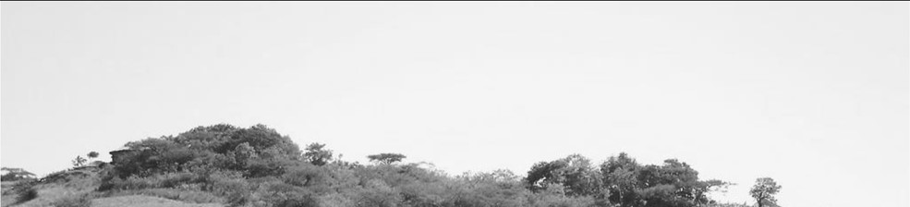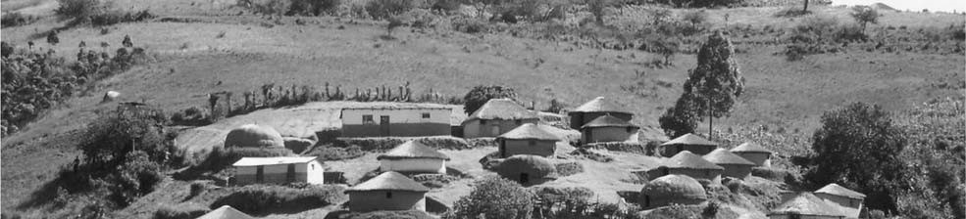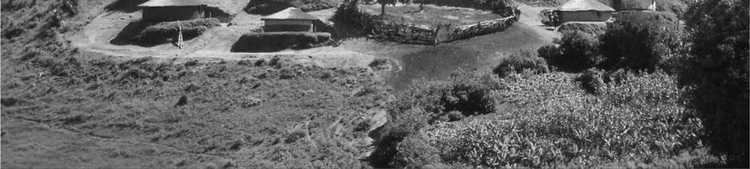

[
Source: jpg. Traditional settlement in KZN]

 | 4.1.1 | Is the settlement in the photograph a rural or urban settlement? | (1x1) | (1)
 | 4.1.2 | State the pattern of distribution evident in this settlement. | (1x1) | (1)
 | 4.1.3 | Classify the settlement identified in QUESTION 4.1.1 according to its size/complexity | (1x1) | (1)
 | 4.1.4 | Name and explain ONE physical factor that influenced the site of this settlement. | (2x2) | (2)
 | 4.1.5 | How has culture and tradition influenced the farming practices of this settlement? | (2x2) | (2)
 | 4.1.6 | Explain how the reduction of cultivated land would impact on the rate of rural depopulation in the depicted settlement | (2x2) | (2)
 |  |  |  | [17]
5.1 Refers to FIGURE 5.1 illustrating a rural process. (June (2019)

FIGURE 5.1 : MOVEMENT OF PEOPLE

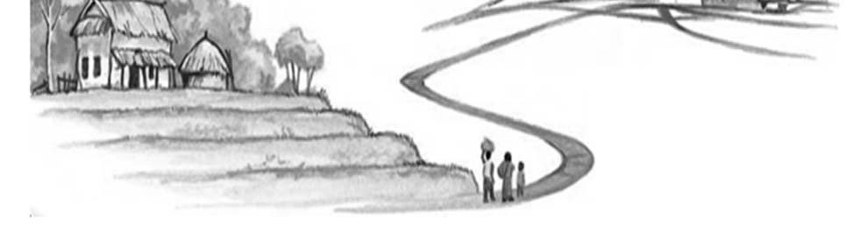
[
Adapted from
http//:
www.Google
images
]
A
 | 5.1.1 | Identify the process indicated by the Movement of people | (1x1) | (1)
 | 5.1.2 | Name a possible social pull factor that may have caused this Movement of people. | (1x1) | (1)
 | 5.1.3 | Rural depopulation is a consequence of this process mentioned in QUESTION 5.1.1  - Define the term rural depopulation.  - How will this depopulation affect local businesses in the area? | (1x1)  (2x2) | (1)  (4)
 | 5.1.4 | The family at A expect to have a better future  by moving to the indicated area. In a paragraph of approximately EIGHT lines, discuss the positive impact on the future standard of living of this family | (4x2) | (8)
 |  |  |  | [15]
6.1. Refer to the article on rural transformation as a solution to poverty in South Africa in FIGURE 6.1 (Sept 2018)

FIGURE 6.1: ISSUE ON RURAL TRANSFORMATION

RURAL TRANSFORMATION AS A SOLUTION TO POVERTY IN SOUTHAFRICA
Around a third of South Africa’s population lives in rural areas. Amongst these people are the country’s most vulnerable. They are excluded from the formal economy and are denied the proceeds of profitable agriculture and mineral resources and access to land. However, land reform remains a central factor in determining the success of rural transformation and achievement of a more sustainable and inclusive development agenda

[Source: Article by Mthadazo Ndlkovu, 28 August 2017]

 | 6.1.1 | How many people live in rural areas in South Africa? | (1 x1) | (1)
 | 6.1.2 | Define the term social justice. | (1X1) | (1)
 | 6.1.3 | Mention TWO injustices from the article that South Africans are currently facing. | (2X1) | (2)
 | 6.1.4 | Name and explain ONE land reform policy that was implemented in South Africa, to ensure rural transformation. | (1+2) | (3)
 | 6.1.5 | In a paragraph of approximately EIGHT lines, explain how land reform in South Africa may reduce poverty | (4X2) | (8)
 |  |  |  | [15]
7.1 Refer to the photograph of a rural settlement pattern in FIGURE 7.1
(Sept 2018)
FIGURE 7.1 : RURAL SETTLEMENT PATTERNS
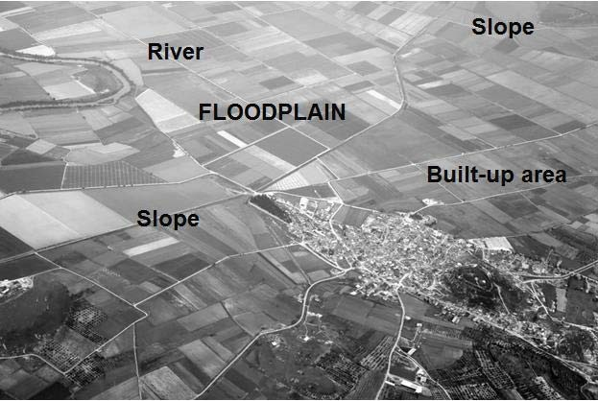

[
Source:
www.google/images
]

 | 7.1.1 | Name the shape of the settlement in the photo | (1X1) | (1)
 | 7.1.2 | Give evidence from the photograph to support your answer mentioned in QUESTION 7.1.1. | (1X2) | (2)
 | 7.1.3 | Why is this settlement a nucleated rural settlement? | (2X1) | (2)
 | 7.1.4 | Explain how relief (topography) and water influenced the nucleated pattern of the settlement. | (2X2) | (4)
 | 7.1.5 | Comment on the fact that the river will have a negative economic impact on the inhabitants of the settlement. | (3X2) | (6)
 |  |  |  | [15]
8.1. Study FIGURE 8.1 which illustrates rural-urban migration. (September 2019)

FIGURE 8.1 : RURAL-URBAN MIGRATION

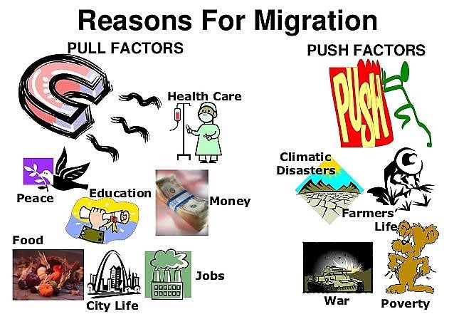

 | 8.1.1 | What is rural-urban migration? | (1x1) | (1)
 | 8.1.1. | List ONE physical ‘push’ factor evident in the illustration. | (1x1) | (1)
 | 8.1.3 | State ONE service evident in the illustration that would ‘pull’ people to urban areas. | (1x1) | (1)
 | 8.1.4 | Discuss a negative economic consequence that rural areas will experience as a result of rural-urban migration | (1x2) | (2)
 | 8.1.5 | Suggest a possible strategy that municipalities in rural areas could implement to encourage counter urbanisation | (1x2) | (2)
 | 8.1.6 | In a paragraph of approximately EIGHT lines, explain why rural-urban migration generally results in negative outcomes for most urban immigrants. | (4x2) | (8)
 |  |  |  | [15]
9.1 FIGURE 9.1 is a cycle of stagnation in rural areas. Match the descriptions below with a phrase from the sketch (except QUESTION 9.1.1). Write ONLY the term/word of your choice next to the question number (9.1.1–9.1.8) in the ANSWER BOOK. (September 2019)
FIGURE 9.1 :RURAL STAGNATION
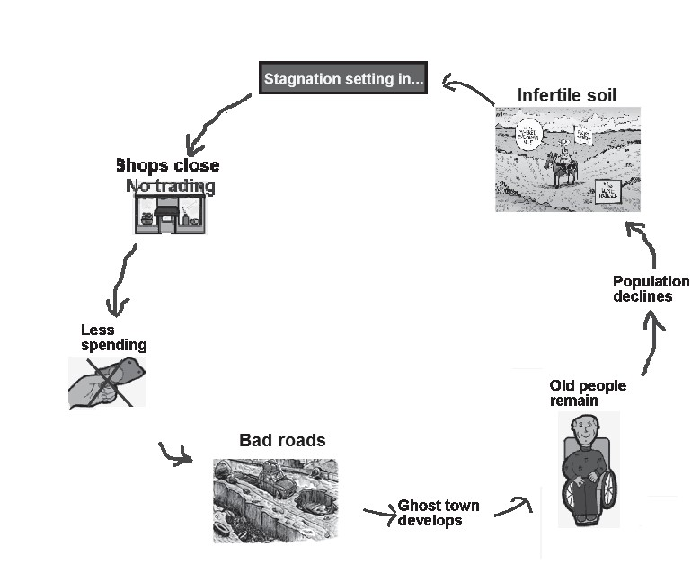

 | 9.1.1 | Name the process responsible for the stagnation as illustrated in the sketch.
 | 9.1.2 | The buying power of the area declines
 | 9.1.3 | The rural area becomes abandoned
 | 9.1.4 | An unproductive workforce remains behind
 | 9.1.5 | Effect of rural depopulation
 | 9.1.6 | Infrastructure is not properly maintained
 | 9.1.7 | Businesses become bankrupt
 | 9.1.8 | Decline of agricultural activities
 |  |  | (8X1) | (8)

