Province of the
EASTERN CAPE
EDUCATION

DIRECTORATE SENIOR CURRICULUM MANAGEMENT (SEN-FET)
HOME SCHOOLING SELF-STUDY WORKSHEET
SUBJECT | GEOGRAPHY | GRADE | 12 | DATE | 25/05/20
TOPIC | URBAN SETTLEMENTS:  URBAN STREET PATTERNS | TERM 1  REVISION | ✓ | TERM 2 CONTENT | ✓
TIME ALLOCATION | 1HOUR | TIPS TO KEEP HEALTHY  1. WASH YOUR HANDS thoroughly with soap and water for at least 20 seconds. Alternatively, use hand sanitizer with an alcohol content of at least 60%.  2. PRACTICE SOCIAL DISTANCING – keep a distance of 1m away from other people.  3. PRACTISE GOOD RESPIRATORY HYGIENE: cough or sneeze into your elbow or tissue and dispose of the tissue immediately after use.  4. TRY NOT TO TOUCH YOUR FACE. The virus can be transferred from your hands to your nose, mouth and eyes. It can then enter your body and make you sick.  5. STAY AT HOME.
INSTRUCTIONS

WORKSHEETS ON STREET PATTERNS
Radial Street Pattern
Gridiron Street pattern

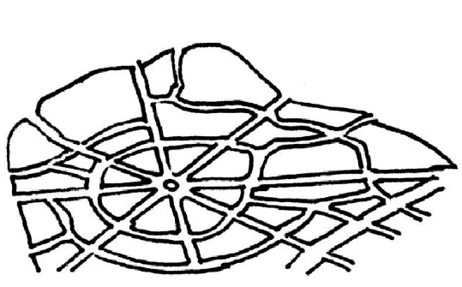
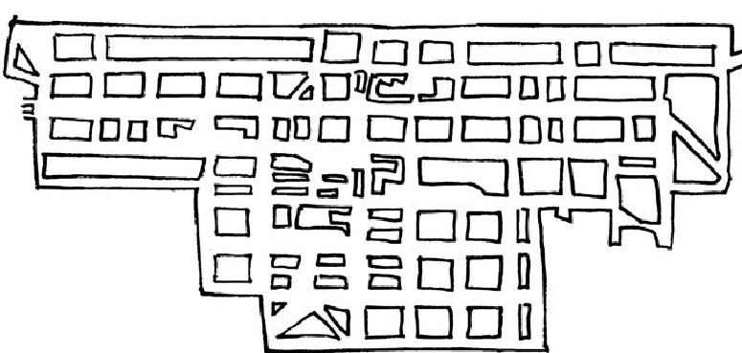

URBAN STREET PATTERNS

Unplanned irregular Street Pattern
Planned Irregular Street pattern

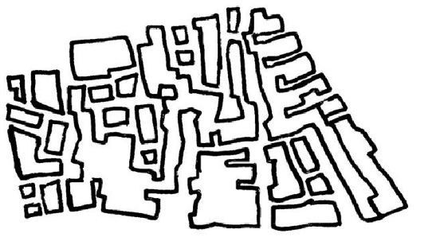
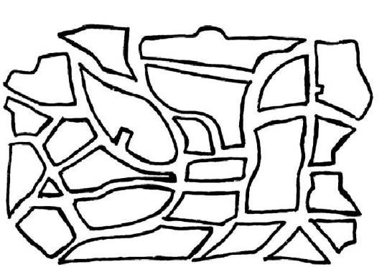

Resources to be used:
- Your textbook
- Past exam papers

You must know the following related to Street patterns:
- To identify the street pattern
- Name its characterictics
- Advantages and disadvantages
In Paper 1 or Paper 2 you may be asked to identify the street pattern and state the advantages and disadvantages of the street pattern

ACTIVITY: This question comes from the November 2017 Geography Question paper.

  - Refer to FIGURE 1.1 on street patterns. Match the description below
with street pattern A or B. Choose the answer and write only the letter A or B next to the question number (1.1.1–1.1.8) in the ANSWER BOOK, for example 1.1.9 A.
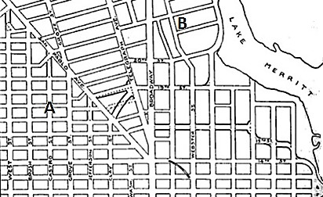

[
Source
:

www.planetizen.co
m
]

1.1.
 | 1.1.1 | Longer streets with fewer intersections
 | 1.1.2 | Planned to facilitate a smooth flow of traffic
 | 1.1.3 | A feature of new urban developments
 | 1.1.4 | Makes building easier due to the regular shaped plots
 | 1.1.5 | Not suitable for steep and hilly land
 | 1.1.6 | Saves fuel and travelling time
 | 1.1.7 | Easier to find places
 | 1.1.8 | Associated with the oldest part of a settlement | (8 x 1 | (8)
ACTIVITY: This question comes from the November 2018 Geography Question paper.
2.1 | Refer to FIGURE 2.1 on different street  patterns. Match the descriptions below with street patterns A, B or C. Choose the answer and write only the letter A, B or C next to the question numbers (2.1.1 to 2.1.7) in the ANSWER BOOK, e.g. 2.1.8 A. You may choose the same letter more than once.
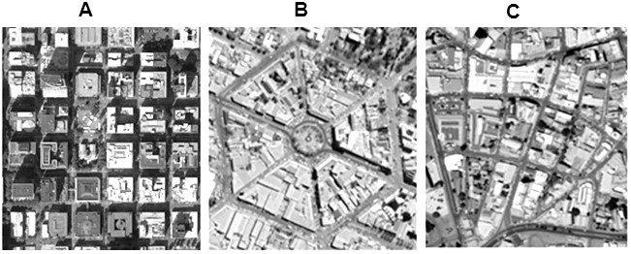

 | 2.1.1 | Commonly found in the oldest parts of South African cities
 | 2.1.2 | Transport routes radiate from a central point
 | 2.1.3 | Streets intersect at right angles and planning is made easy
 | 2.1.4 | Associated with ancient cities with ring roads as a feature
 | 2.1.5 | Associated with new urban developments
 | 2.1.6 | Can result in traffic congestion
 | 2.1.7 | 7 Suburbs with this street pattern will have irregular roads for the smooth flow of traffic | (7 x 1) | (7)

