Province of the
EASTERN CAPE
EDUCATION

DIRECTORATE SENIOR CURRICULUM MANAGEMENT (SEN-FET)
HOME SCHOOLING SELF-STUDY ANSWER SHEET
SUBJECT | ECONOMICS | GRADE | 12 | DATE | 26/05/2020
TOPIC | MICROECONOMICS | TERM 1  REVISION |  | TERM 2 CONTENT | X

QUESTION 1: MICROECONOMICS 40 MARKS – 40 MINUTES
Your answer will be assessed as follows.
 | STRUCTURE OF ESSAY | MARK ALLOCATION
 | Introduction  The introduction is a lower-order response.  - A good starting point would be to define the main concept related to the question topic.  - Do not include any part of the question in your introduction.  - Do not repeat any part of the introduction in the body.  - Avoid saying in the introduction what you are going to discuss in the body. | Max. 2
 | Body  Main part: Discuss in detail/In-depth discussion/Examine/Critically discuss/  Analyse/Compare/Evaluate/Distinguish/Differentiate/Explain  Additional part: Give own opinion/Critically discuss/Evaluate/Critically evaluate/Draw a graph and explain/Use the graph given and explain/ Complete the given graph/Calculate/Deduce/Compare/Explain/Distinguish/ Interpret/Briefly debate/How/Suggest | Max. 26
 |  | Max. 10
 | Conclusion  Any higher-order conclusion should include:  - A brief summary of what has been discussed without repeating facts already mentioned  - Any opinion or value judgement on the facts discussed  - Additional support information to strengthen the discussion/analysis  - A contradictory viewpoint with motivation, if required  - Recommendations | Max. 2
 | TOTAL | 40

‘Reliance on markets is not always a best decision.’
- With the aid of graphs, discuss in detail state intervention as a consequence of market failures, under the following headings:
- minimum wages
- maximum prices (26)
- How successful is the South African government in solving income inequality?. (10) | [40]
INTRODUCTION  - Market failure occurs when the forces of demand and supply do not ensure the correct quantity of goods and services are produced to meet demand at the right time. √√  Accept any relevant introduction (2) | (2)
BODY
Minimum wages
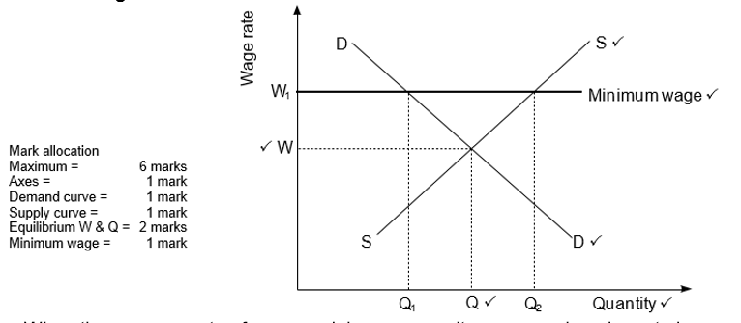
- When the government enforces a minimum wage, it means workers have to be paid a certain wage amount and not anything less than this. √√
- The graph above shows that if the wage rate is set at W, the corresponding demand and supply of labour will be Q. √√
- If a minimum wage of W1 is set, the demand for labour will decrease from Q to Q1. √√
- Some people may become unemployed due to the introduction of a minimum wage. √√
- However, the quantity of labour supplied will increase from Q to Q2 √√
- More people will offer their labour because of the higher wage. √√ (Max 13)
Setting maximum prices/price ceilings
- The government sets a maximum price ceiling below the market price to make goods more affordable√√
- Maximum prices allow the poor greater access to certain goods and services. √√
- A maximum price is set on goods such as basic foods, housing and transport. √√
- In South Africa the price of petrol, diesel fuel and paraffin are controlled at their maximum prices. √√
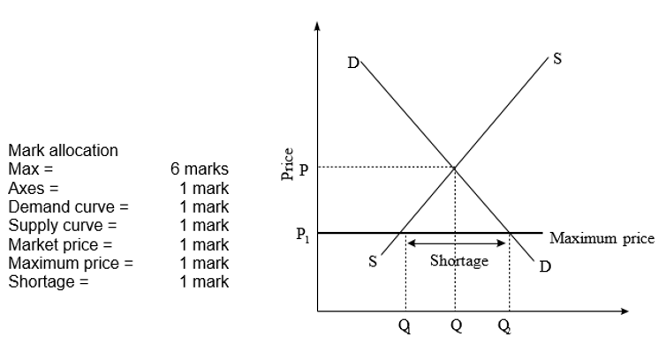
- Initially the market equilibrium price is P and equilibrium quantity is Q. √√  - The government intervenes and passes a law that a product cannot be sold for more than P1. √√  - The effect of this maximum price is that quantity supplied decreases to Q1 and quantity demanded increases to Q2. √√  - There is a shortage equal to the difference between Q1 and Q2. √√  - A shortage creates a problem of how to allocate the product to consumers. √√  - Black markets often develop where people can obtain the product. A black market is an illegal market in which either illegal goods are bought and sold or illegal prices are charged. √√  - Maximum prices may cause a shortage of goods but they do improve the welfare of some consumers since goods can be purchased at lower prices. √√ (Max 13) | (26)
ADDITIONAL PART  How successful is the South African government in solving income inequality?  The South African government has been successful in the following:  - Transferring income directly to the poor √√ e.g. child support grants, unemployment benefits etc. √  - Implementing a progressive system of taxation, which reduces the gap between high and low income earners √√  - Providing free primary health care in provincial hospitals and clinics√√  - Offering free basic education to those who cannot afford to pay-√√ no fee schools. √  - Excluding VAT in basic items that the poor often consumes √√ e.g. maize √  Accept any relevant correct argument. (5 × 2) | (10)
CONCLUSION  It is important for the government to intervene, when markets fail, for the benefit of the society. √√ Accept any relevant conclusion. (2) | (2)
 | [40]
(EC/JUNE 2017)

QUESTION 2 40 MARKS – 40 MINUTES
‘Reliance on markets for the provision of goods and services is not always a good decision.’
- Discuss the following factors that lead to misallocation of resources in the market.:
- Imperfect competition (8)
- Merit and demerit goods (10)
- Immobility of factors of production (8) (26)
- With the aid of a well-labelled graph explain productive inefficiency as a consequence of market failure. (10) | [40]
INTRODUCTION  Market failure occurs when the forces of demand and supply fail to allocate resources efficiently. √√ (Accept any relevant introduction.) (2) | (2)
BODY
Imperfect competition
- Competition in market economies is limited by the power of certain producers to prevent new businesses from entering the market. This is imperfect competition. √√
- Barriers to entry are created because of advertising, a lack of capital and the controlling of resources. √√
- The imperfect market does not allow for price negotiations. √√
- Advertising is used to promote producer sovereignty (dominance), which encourages consumers to buy existing products and allows producers to delay new products from entering the market until it is in their own interest √√ (e.g. businesses have had the technology to produce long-life light bulbs for many years but have chosen not to launch them in the market). √√ (8)
Merit and demerit goods
Merit goods:
  - These are highly desirable for general welfare, but not highly rated by the market, e.g. health care, education and safety. √√
  - If people had to pay the market price for them, very little would be consumed. √√
  - The market fails because the market produces less than the desired quantity. √√
Demerit goods:
  - These are over-consumed goods, √√ e.g. cigarettes, alcohol and drugs. √
  - Thus more of the goods are produced than is socially desirable. √√
  - The government bans or reduces consumption of these products through taxation, and provides information to the population on their harmful effects. √√
(Max. 10)
Immobility of factors of production  - Labour takes time to move from one area to another. √√  - The supply of skilled labour cannot be increased because of the time it takes to be trained or educated. √√  - Physical capital, like factory buildings or infrastructure such as telephone lines cannot be reallocated easily. √√  - Structural changes like a change from producing plastic packets to paper packets or shifting from labour-intensive production to computer based production requires a change in labourers’ skills, employment and work patterns. √√  - This takes time to change. √√ (Max. 8)  NOTE: A maximum of 8 x 1 marks will be allocated for headings. | (26)
ADDITIONAL PART
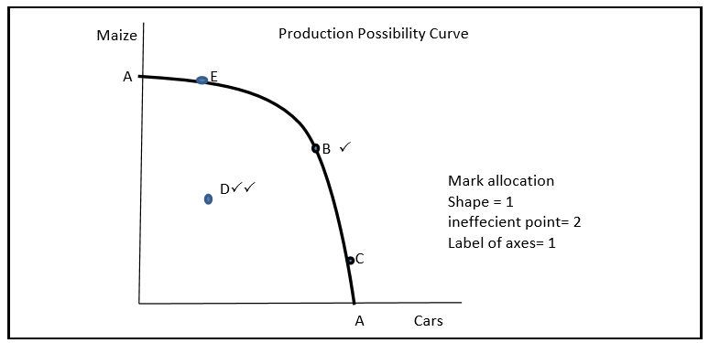
- Productive inefficiency can be explained with the aid of the productive possibility curve. √√  - The Production Possibility Curve (AA), above shows a combination of goods that can be produced using all the available resources. √√  - Any point on the curve shows a combination of goods where resources will be used efficiently. √√  - Therefore any point on the curve indicates Productive/Technical efficiency √√  - Any point to the left of the curve such as D, indicates that some resources are unused. If this occurs some customers may be deprived of goods. √√  - This depicts productive inefficiency. √√ (Max. 10) | (10)
CONCLUSION  When market failures occur, it causes inefficiency and misallocation of resources and the government will have to intervene to recover the instability. √√  (Accept any relevant conclusion.) (2) | (2)
 | [40]
TOTAL MARKS [80]
(EC/JUNE 2018)

