DIRECTORATE SENIOR CURRICULUM MANAGEMENT (SEN-FET)
HOME SCHOOLING SELF-STUDY WORKSHEET
SUBJECT | GEOGRAPHY | GRADE | 10 | DATE | 26/06/20
TOPIC | POPULATION GEOGRAPHY | TERM 3  REVISION | √√ | TERM 3 CONTENT | √√
TIME ALLOCATION | 1HOUR | TIPS TO KEEP HEALTHY  1. WASH YOUR HANDS thoroughly with soap and water for at least 20 seconds. Alternatively, use hand sanitizer with an alcohol content of at least 60%.  2. PRACTICE SOCIAL DISTANCING – keep a distance of 1m away from other people.  3. PRACTISE GOOD RESPIRATORY HYGIENE: cough or sneeze into your elbow or tissue and dispose of the tissue immediately after use.  4. TRY NOT TO TOUCH YOUR FACE. The virus can be transferred from your hands to your nose, mouth and eyes. It can then enter your body and make you sick.  5. STAY AT HOME.
INSTRUCTIONS

REVISION BOOKLET POPULATION GEOGRAPHY
GEOGRAPHY GRADE 10
TERM 3

1.1 Match the Population Indicators in COLUMN B with the Descriptions in COLUMN A.
Write only the letter (A–I) next to the question number (1.1.1–1.1.8) in the ANSWER
BOOK. You may use each letter only ONCE.

 | COLUMN A | COLUMN B
1.1.1  1.1.2  1.1.3  1.1.4  1.1.5  1.1.6  1.1.7 | The Number of babies born per 1 000 of the Population per year  The number of deaths per year per 1 000 of the Population  The average number of years a person can expect to live  The number of deaths of children under one year of age per 1 000 live births  The percentage of the Total Population who can read and write  The rate at which country’s population is growing, excluding migration into or out of the country  The average number of children an average woman would have if she was to live to the end of her child-bearing years | - Percentage of  Population Urbanized  - GDP Per Capita  - Literacy rate  - Fertility rate  - Natural increase  - Infant mortality rate  - Life expectancy  - Death (Mortality) rate  I Birth (Natality) rate
1.1.8 | The percentage of the total Population living in towns and cities
(8 x 1) (8)

1.2 Refer to FIGURE 1.2 Illustrating a Type of Migration and answer the questions that follow.

1.2.1 Classify QIMA LOCATION as an urban or rural area. (1 x 1)

1.2.2 Name the type of migration taking place in FIGURE 3.3. (1 x 1)

1.2.3 Give the term that describes the decrease of population in rural areas.
(1 x 1)

1.2.4 Mention TWO push factors resulting in people leaving their villages like Qima to move to cities. (2 x 1)
1.2.5 Suggest ONE reason for rural areas to remain with mainly older people.
(1 x 2)

1.2.6 Discuss TWO problems experienced by a city because of many people
moving there. (2 x 2)
1.2.7 Suggest TWO solutions that can be used to reduce the number of people
leaving the rural areas. (2 x 2)
(15)

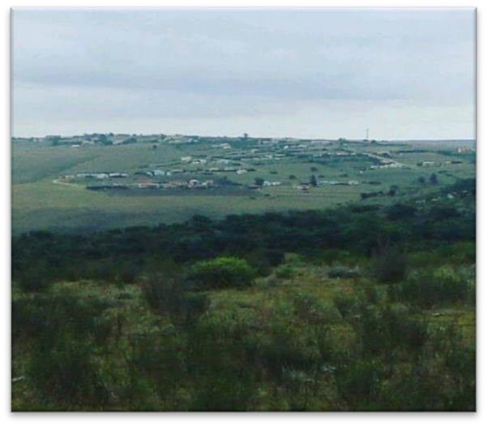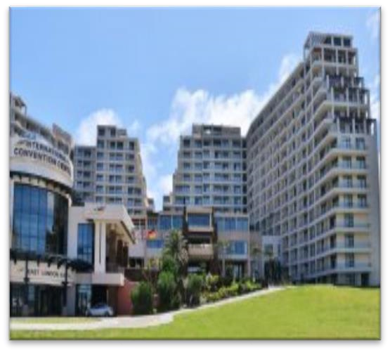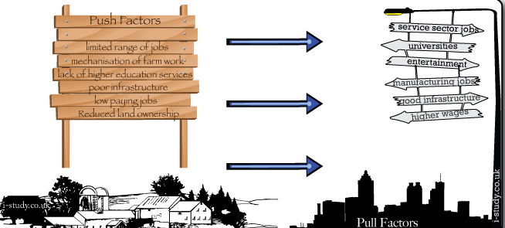

]

[

Movement

Movement

QIMA LOCATION

EAST LONDON

Movement

Movement

1.3 Refer to FIGURE 1.3 showing different countries with their HIV/Aids infection rates and answer the questions that follow.

1.3.1 What does the Abbreviation HIV stand for? (1 x 1)
1.3.2 Name THREE countries with high Infection rates. (3 x 1)
1.3.3 Identify the country with lowest infection rate. (1 x 1)

1.3.4 Refer to Mozambique’s infection rate:

- Suggest ONE reason for the trend in Mozambique’s infection rate. (1 x 2)

- Discuss TWO social impacts of HIV/Aids in Mozambique’s Population
Structure. (2 x 2)

1.3.5 Explain TWO methods that can be put in place to reduce the world’s high
HIV/Aids infection rate. (2 x 2)
(15)

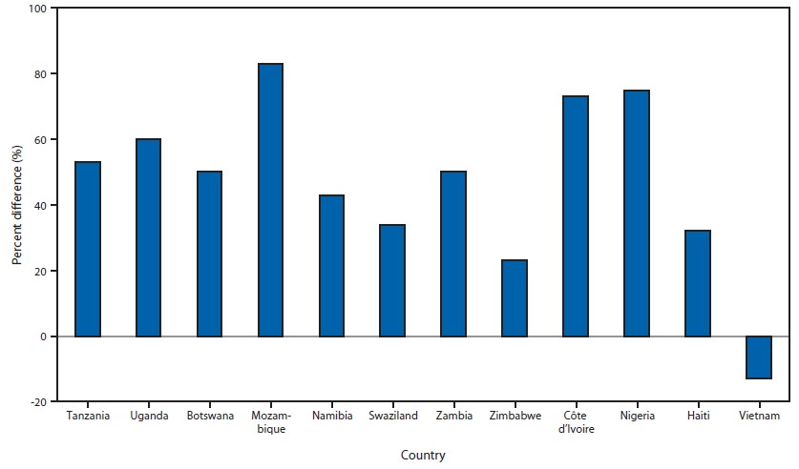

1.4 Choose a term from COLUMN B that matches the description in COLUMN A. Write ONLY the letter (A–H) next to the question number (1.4.1 – 1.4.7), for example 1.4.1 (H). You may use each letter only ONCE.

 | COLUMN A |  | COLUMN B
1.4.1  1.4.2  1.4.3  1.4.4  1.4.5  1.4.6 | The movement of people away from their home country  Parts of the earth that is suitable for people to live in  People who are forced to flee their home countries to survive  The study of population statistics  A strong dislike of people from other countries  A type of graph showing the structure of a country’s population according to gender and age | A  B  C  D  E  F  G  H | Immigration  Antiretroviral  Population  pyramid  Xenophobia  Ecumene  Refugee  Emigration  Demography
1.4.7 | Medication to help people who are HIV positive to remain healthy
(7)

1.5 Refer to FIGURE 1.5 showing population pyramid of Afghanistan (2015) and answer the questions that follow.

1.5.1 Use the Population Pyramid to determine the following:

- Number of males aged 25 to 29 years (1 x 1)

- Number of females aged 45 to 49 years (1 x 1)

- Total number of people aged 0 to 4 years (1 x 1)

1.5.2 Identify the age group that makes up the biggest portion of the total
population. (1 x 1)
1.5.3 Would you classify Afghanistan as a developing or developed country?
(1 x 1)

1.5.4 Provide ONE piece of evidence from the pyramid to support your answer
in QUESTION 1.5.3. (1 x 2)
1.5.5 In a paragraph of approximately EIGTH lines, describe negative effects
of overpopulation in a country such as Afghanistan. (4 x 2)
(15)
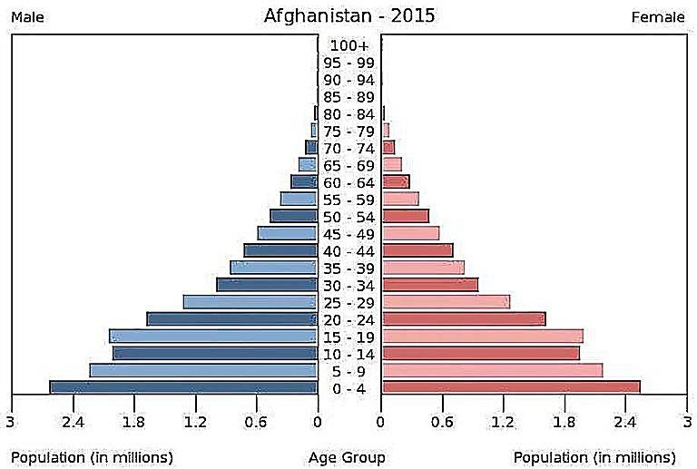

]

1.6 Carefully read the extract in FIGURE 1.6 (Xenophobic attacks) and answer the questions that follow.

1.6.1 Define the following terms:

- Xenophobia (1 x 1)
- Refugee (1 x 1)
1.6.2 Name Brian’s country of birth. (1 x 1)
1.6.3 Provide TWO reasons from the extract why Brian left his country of birth.
(2 x 1)
1.6.4 Explain a possible reason why many South Africans do not like refugees.
(1 x 2)

1.6.5 Discuss TWO positive impacts that refugees might have on South Africa.
(2 x 2)
1.6.6 Suggest TWO strategies that can be implemented (applied) by the South
African government to assist refugees. (2 x 2)
(15)

Xenophobic attacks in South Africa
Each year there are reports of xenophobic attacks in various parts of the country. These attacks were particularly violent and widespread in May 2008. In a period of just two weeks, more than 60 people were killed, several hundred, and many thousands displaced when homes and businesses were attacked by angry crowds accusing foreigners of taking their jobs.
Brian left Somalia hoping for getting job and better standard of living in South Africa. Now he fears for his life. 'I left home to try and support my family. But it is better to starve at home than to die here.' A crowd had attacked him in Johannesburg. They took all his belongings.
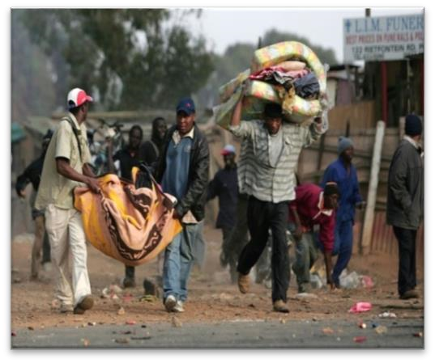  Victims of xenophobic attacks in SA | 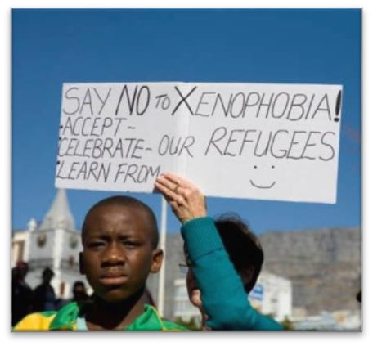  A protest against xenophobia in May 2008

1.7 Read the case study in FIGURE 1.7 carefully before you answer the questions that follow.

1.7.1 Give the geographical term that best describes the movement of the Tsitsa from one place to another. (1 x 1)
1.7.2 Choose the correct word in relation to the Tsitsa family’s relocation from South Africa to England:

- Regional / International

- Voluntary / Forced

- Permanent / Temporary (3 x 1)
1.7.3 Explain why the Tsitsa family moved from South Africa to England. (1 x 1)

1.7.4 Discuss TWO pull factors that attracted the Tsitsa family to England (2 x 2)

1.7.5 Suggest THREE negative impacts of the voluntary migration on the
Tsitsa’s place of origin (South Africa). (3 x 2)
(15)

Mandla Tsitsa (pseudonym) with his wife (Violet) and their two children (Phokie and Lazie) in 2016 moved to England. The following are his reasons for their move:

I was twice overlooked for promotion because the company where I worked followed a policy of affirmative action. After two armed robberies took place at our house and our car was hijacked, it made me realise that there are no prospects for me and my family and as I did not feel safe, I began to look for other options.

After I started finding out about other possibilities, I saw that there were many opportunities for me in England, as an electrical engineer. England needs more skilled people like me. It did not take long for me to find an excellent job in London and they were willing to carry our relocation costs (even for our pets). All necessary documentation was also handled by the firm in England.

Our children can now safely roller-skate, ride on their bikes, and can make use of an excellent public transport system. The weather is not the same as in Butterworth and we miss our relatives a lot, but if I consider everything, I feel that England has a better future for us.

Final Total: 90 Marks

……………………………………………………………………………………….

