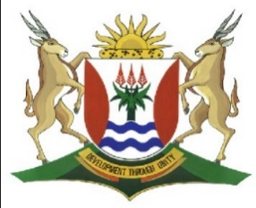
Province of the
EASTERN CAPE
EDUCATION

DIRECTORATE SENIOR CURRICULUM MANAGEMENT (SEN-FET)
HOME SCHOOLING SELF-STUDY WORKSHEET ANSWER SHEET
SUBJECT | GEOGRAPHY | GRADE | 10 | DATE | 6/07/20
TOPIC | FOLDING,FAULTING AND EARTHQUAKES | TERM 2  REVISION | √√ | TERM 2 CONTENT | √√

QUESTION 1
- Igneous
- Sedimentary
- Metamorphic
- Sedimentary
(4x1) (4)
1.2.1 Tsunami is a wave of water produced when an earthquake occurs
Under the ocean. (Concept)
Earthquake is a violent shaking of the earth’s crust caused by movement
along a fault. (Concept) (2 x 1) (2)

1.2.2 Sri Lanka
Indonesia (2 x) (2)

1.2.3 8 people (1 x 1) (1)

1.2.4 South Africa is far away from the epicentre (8 000 km away) (1 x 2) (2)
    - Survivors were left homeless as the houses were destroyed
Crops were destroyed that resulted in food shortages
Poor infrastructure as roads and bridges collapsed
No health care facilities
Businesses were affected as many survivors may have lost their jobs.
(Any 2 x 2) (4)
    - Build specially strengthened buildings
Educate people
Having disaster supplies on hand
Early warnings must be issued (Any 2 x 2) (4)
[19]

