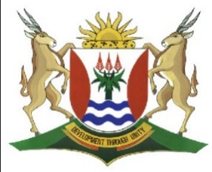
Province of the
EASTERN CAPE
EDUCATION

DIRECTORATE SENIOR CURRICULUM MANAGEMENT (SEN-FET)
HOME SCHOOLING SELF-STUDY WORKSHEET
SUBJECT | GEOGRAPHY | GRADE | 10 | DATE | 6/07/20
TOPIC | FOLDING AND MAJOR PLATES | TERM 2  REVISION | √√ | TERM 2 CONTENT | √√
TIME ALLOCATION | 1HOUR | TIPS TO KEEP HEALTHY  1. WASH YOUR HANDS thoroughly with soap and water for at least 20 seconds. Alternatively, use hand sanitizer with an alcohol content of at least 60%.  2. PRACTICE SOCIAL DISTANCING – keep a distance of 1m away from other people.  3. PRACTISE GOOD RESPIRATORY HYGIENE: cough or sneeze into your elbow or tissue and dispose of the tissue immediately after use.  4. TRY NOT TO TOUCH YOUR FACE. The virus can be transferred from your hands to your nose, mouth and eyes. It can then enter your body and make you sick.  5. STAY AT HOME.
INSTRUCTIONS

QUESTION 1
Study figure 1.1 showing different types of folds that can occur

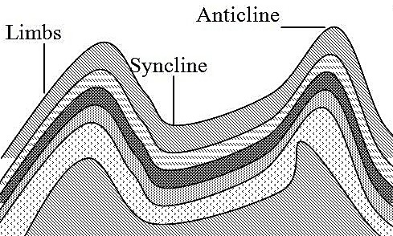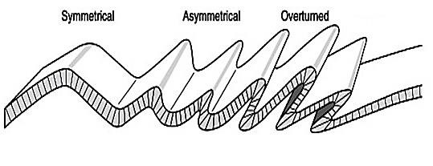

[
Source:
New windows of the world
]

1.1. Match the following statements with the correct label from the diagram.

1.1.1 A down fold

1.1.2 An up fold

    - The side of either an up fold or down fold

    - A fold where one side is steeper than the other

    - A fold where one side is pushed over the top of the other side

    - A fold where one side is thrust forward over the other side along a fault
(6 x 1) (6)

  - Refer to FIGURE 1.2 which illustrates the boundaries of seven major plates and answer the questions based on it.

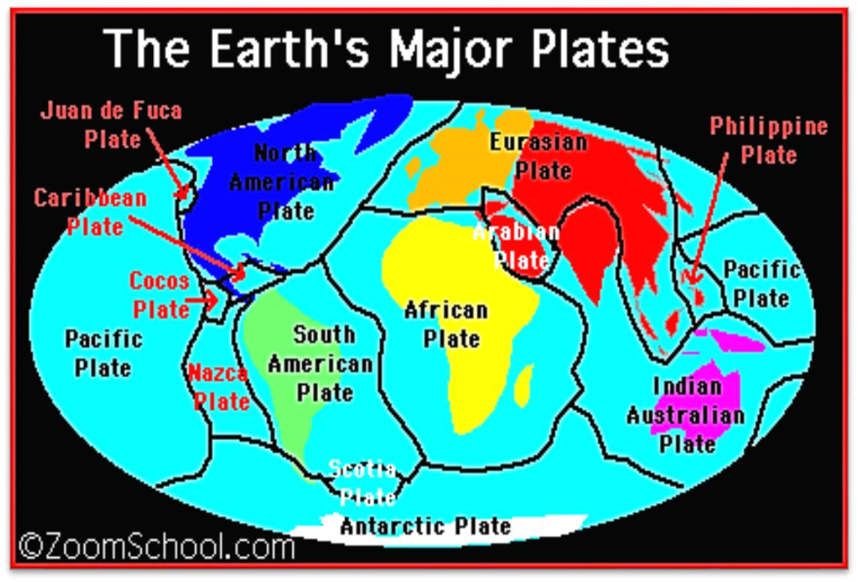
FIGURE 1.2:

EARTH’S

MAJOR PLATES

[
Source:
Google Images/ZoomSchool.com
]

1.2.1 Name the plate that contains Australia. (1 x 1) (1)

    - What was the name of the first supercontinent that existed before?
(1 x 1) (1)
    - Give the name of the scientist that suggested that the earth’s crust is
moving. (1 x 1) (1)

1.2.3 Explain what happens to plates at convergent plate boundaries. (1 x 2) (2)

1.2.4 Draw a simple sketch diagram showing a passive plate boundary.
(2 x 2) (4)
[15]

