Province of the
EASTERN CAPE
EDUCATION

DIRECTORATE SENIOR CURRICULUM MANAGEMENT (SEN-FET)
HOME SCHOOLING SELF-STUDY
NOTES AND ACTIVITIES
SUBJECT | ACCOUNTING | GRADE | 10 | DATE
TOPIC | FINANCIAL ACCOUNTING OF A SOLE TRADER- FINAL ACCOUNTS AND YEAR ADJUSTMENTS |  |  |  | Term | 2 | Week | 6
TIME ALLOCATION | One week | TIPS TO KEEP HEALTHY  1. WASH YOUR HANDS thoroughly with soap and water for at least 20 seconds. Alternatively, use hand sanitizer with an alcohol content of at least 60%.  2. PRACTICE SOCIAL DISTANCING – keep a distance of 1m away from other people.  3. PRACTISE GOOD RESPIRATORY HYGIENE: cough or sneeze into your elbow or tissue and dispose of the tissue immediately after use.  4. WEAR A MASK AND TRY NOT TO TOUCH YOUR FACE. The virus can be transferred from your hands to your nose, mouth and eyes. It can then enter your body and make you sick.  5. STAY AT HOME.
INSTRUCTIONS | See requirements per activity
RESOURCES | USE YOUR TEXTBOOK (S)

GAAP PRINCIPLES AND ACCOUNTING CYCLE

NB : Accounting cycle and GAAP principles are already done in term one .

GENERALLY ACCEPTED ACCOUNTING PRINCIPLES

- Common set of measurement principles to record financial information
- It includes the standards, conventions, and rules accountants follow in recording and summarizing transactions, and in the preparation of financial statements

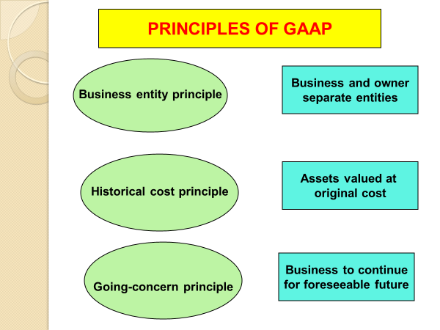

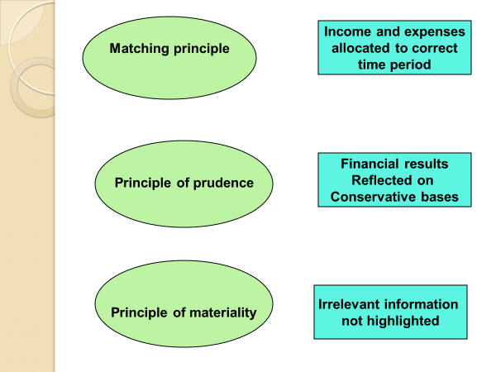

ACCOUNTING CYCLE IS AS FOLLOWS :

1. Source documents > 2. Subsidiary journal > 3. Posting to ledgers >

4. Pre-adjustment > 5. Year – end adjustment > 6. Post – adjustment trial balance >

7. Closing transfers and final accounts > 8. Post – closing trial balance >

9. Financial statement

IN GRADE 10 YOU WILL DO THE FOLLOWING YEAR-END ADJUSTMENT

Trading stock deficit / surplus; Consumable stores on hand; Depreciation (on cost price; on diminishing balance methods); Bad debts; Bad debts recovered; Correction of errors / omissions; Accrued income (receivable); Income received in advance (deferred income); Expenses prepaid; Accrued expenses (payable); Interest on mortgage loan (capitalised

ACTIVITY 1 GAAP PRINCIPLES

Match the explanations in column A to the principle in column B by writing the correct letter next to the correct question number .

COLUMN A |  | COLUMN B
1. | The financial affairs of the business should be kept separate from that of the owner | A | Going concern
2. | Assets must be recorded using amount that was originally paid for them | B | Matching
3. | The assumption is that, business will continue operating in the foreseeable future | C | Prudence
4. | Income and expenses must be accounted for in the correct period | D | Business entity
5. | Financial results are reflected in a conservative manner | E | Materiality concept
6. | Significant items must be shown in the financial statement | F | Historical cost

Match the explanations in column A to the principle in column B by writing the correct letter next to the correct question number | 6
1.
2.
3.
4.
5.
6.

YEAR END ADJUSTMENTS

- Depreciation

Value of an asset decreases as you use the asset as result of tear and wear .
Tear and wear is called depreciation .
Depreciation is calculated annually and is written off against the asset .
Annual depreciation is an expense within the financial year
Depreciation is what it costs to use the asset but no physical amount is paid hence depreciation is considered an imputed expense ( non-cash item )
Imputed expense is a cost that is incurred by using an asset , not actual money spent
Depreciation from different financial years combined is accumulated depreciation
The worth of an asset ( cost price less accumulated depreciation ) is called carrying value or
book value
There are two methods by which depreciation can be calculated :

- Fixed amount method or straight line method
- Diminishing balance method or Reducing balance method

- Fixed amount method or straight line method / cost price method

According to this method , a certain percentage of the cost is written off annually and the amount of depreciation is the same every year.

If , for example , a vehicle was bought by Akhona Traders from Lizo car dealers for R 70 000 ( a cheque was used ) on 1 July 2020, and depreciation is calculated at 15% per annum on the cost price .
Calculation are shown

Date | Cost price | Annual depreciation | Accumulated depreciated | Carrying value
01/07/2020 | R 70 000 |  |  | R 70 000
30/06/2021 | R 70 000 X 15% | R 10 500 | R 10 500 | R 59 500
30/06/2022 | R 70 000 X 15% | R 10 500 | R 21 000 | R 49 000
30/06/2023 | R 70 000 X 15 % | R 10 500 | R 31 500 | R 38 500

ACTIVITY 2

2.1 Complete the below asset register

Asset register – Akhona traders  Item : Toyota truck ( CLK3456EC) Date purchased : 1 July 2020  General ledger account : vehicles ( B4 ) Cost Price : R 100 000  Purchased from : Lizo motors by cheque  Depreciation : 15 % per annum on cost price | 13
Date | Cost price | Annual depreciation | Accumulated depreciation | Carrying Value
1/07/2020
30/06/2021
30/06/2022
30/06/2023

- Diminished balance or Reduced balance method

According to this method , depreciation is calculated on the diminished balance or carrying value , where carrying value equals cost price less accumulated depreciation
With this method, the depreciation written off annually will initially be high and then decrease every year .
If , for example , equipment was bought by Akhona Traders for R 20 000 ( a cheque was used ) on 1 July 2020, and depreciation is calculated at 10% per annum on the cost price .
Calculation are shown

Date | Cost price | Annual depreciation | Accumulated depreciated | Carrying value
01/07/2020 | R 20 000 |  |  | R 20 000
30/06/2021 | R 20 000 X 10% | R 2 000 | R 2 000 | R 18 000
30/06/2022 | R 18 000 X 10% | R 1 800 | R 3 800 | R 16 200
30/06/2023 | R 16 200 X 10 % | R 1 620 | R 5 420 | R 14 580

ACTIVITY 3

3.1 Complete the below asset register

Asset register – Akhona traders  Item : Computer Date purchased : 1 July 2020  General ledger account : Equipment ( B5 ) Cost Price : R 30 000  Purchased from : Lizo motors by cheque  Depreciation : 10 % per annum on the diminishing balance | 10
Date | Cost price | Annual depreciation | Accumulated depreciation | Carrying Value
1/07/2020
30/06/2021
30/06/2022
30/06/2023

RECORDING OF DEPRECIATION IN SUBSIDIARY JOURNAL , GENERAL LEDGER, & ACCOUNTING EQUATION

The first example on vehicle is used for the financial year ended on 30 June 2021 to show how depreciation is recorded :

CASH PAYMENTS JOURNAL OF AKHONA TRADERS – JULY 2020

DAY | Name of payee | F | Bank | Sundry Accounts
 |  |  |  | Amount |  | Details
01 | Lizo |  | 70 000 | 70 000 |  | Vehicle

GENERAL JOURNAL OF AKHONA TRADERS – JUNE 2021
DAY | DETAILS | DEBIT | CREDIT
 | Depreciation  Accumulated Depreciation  ( Depreciation at 15 % on cost ) | 10 500 | 10 500

Dr. GENERAL LEDGER OF KHONA TRADERS Cr.
BALANCE SHEET ACCOUNT
VEHICLE
Date |  | Details | F | Amount | Date |  | Details | F | Amount
2020  JULY | 1 | Bank | CPJ1 | 70 000

Dr. GENERAL LEDGER OF AK TRADERS Cr.
BALANCE SHEET ACCOUNT
ACCUMULATED DEPRECIATION ON VEHICLE
Date |  | Details | F | Amount | Date |  | Details | F | Amount
 |  |  |  |  | 2021  June | 30 | Depreciation | GJ | 10 500

NB : The entry is on the credit , because accumulated depreciation on vehicle is a negative – it decreases the value of assets ( assets decrease on the credit )

Dr. GENERAL LEDGER OF AK TRADERS Cr.
NOMINAL ACCOUNT
DEPRECIATION
Date |  | Details | F | Amount | Date |  | Details | F | Amount
2021  June | 30 | Accumulated depreciation | GJ | 10 500 | 2021 | 30 | Profit & loss account | GJ | 10 500

NB : Depreciation is debited , because it is an imputed expenses and expenses decrease owner’s equity on the debit side
The Depreciation account is closed off to the profit and loss account because it is an expense

EFFECT ON THE ACCOUNTING EQUATION

 | ASSETS |  | OWNER’S EQUITY |  | LIABILITIES
Date | Effect | Reason | Effect | Reason | Effect | Reason
2020  July 01 | + 70 000  - 70 000 | Vehicles increased  Cash decreased
2021  June 30 | -10 500 | Carrying value of vehicles decreased | -10 500 | Depreciation- expense

ACTIVITY 4

Use the asset register in Question TWO to prepare the following :

CASH PAYMENTS JOURNAL OF AKHONA TRADERS – JULY 2020

DAY | Name of payee | F | Bank | Sundry Accounts
 |  |  |  | Amount |  | Details

GENERAL JOURNAL OF AKHONA TRADERS – JUNE 2021
DAY | DETAILS | DEBIT | CREDIT

Dr. GENERAL LEDGER OF KHONA TRADERS Cr.
BALANCE SHEET ACCOUNT
VEHICLE
Date |  | Details | F | Amount | Date |  | Details | F | Amount

Dr. GENERAL LEDGER OF AK TRADERS Cr.
BALANCE SHEET ACCOUNT
ACCUMULATED DEPRECIATION ON VEHICLE
Date |  | Details | F | Amount | Date |  | Details | F | Amount

Dr. GENERAL LEDGER OF AK TRADERS Cr.
NOMINAL ACCOUNT
DEPRECIATION
Date |  | Details | F | Amount | Date |  | Details | F | Amount

EFFECT ON THE ACCOUNTING EQUATION

 | ASSETS |  | OWNER’S EQUITY |  | LIABILITIES
Date | Effect | Reason | Effect | Reason | Effect | Reason

