EC - LEARNER SUPPORT MATERIAL: CIVIL TECHNOLOGY CONSTRUCTION: GRADE 11

CONTENT TO BE COVERED:

TOPIC: EXCAVATIONS (SPECIFIC)

Describe and discuss with the aid of sketches:
- Horizontal checks of foundation excavations with the aid of instruments
- The purpose of datum peg,

Keeping excavations free from water using the following methods:
- Pumping out water
- Creating drains
- Baling

Describe and discuss by means of freehand sketches methods of keeping excavations from collapsing in the following types of soil:
- Loose soil
- Dry soil
- Loose, wet soil

TOPIC: FOUNDATIONS (SPECIFIC)

Description, sketches and location of:
- Pad foundations
- Wide strip foundations
Short bored (auger) pile foundations.

Description, sketches and location of:
- Pad foundations
- Wide strip foundations
Short bored (auger) pile foundations.

TOPIC: FORMWORK (SPECIFIC)

- Definition of formwork
- Purpose of formwork
- Form oils and emulsions
Properties of good formwork,

Materials used and the identification of different parts of formwork used for:
- Columns
- Arches
- Stairs
- Methods of erecting of formwork
- Constructional details.

Lintels:
Drawing of formwork and methods of erecting and supporting
- Purpose
- Use
- Types
Sizes of pre-stressed lintels

TOPIC: CONSTRUCTION STEEL (SPECIFIC)
Identification, use, sketches and properties of the following steel sections:
- I – beam
- H – beam
- U – channel
- Lip channel
- Angle iron

EXAMPLE 1: QUESTION 1: EXCAVATIONS AND FOUNDATIONS

1.1 Draw an isometric view of a queen closer to scale 1: 2. Show ONE dimension on your drawing using the correct drawing technique. (5)

1.2 State TWO uses of malleable cast iron. (2)

1.3 Distinguish between copper and lead according to their use and colour.
Tabulate your answer as follows:

MATERIAL | COLOUR | USE
Copper
Lead
(4)
1.4 FIGURE 1.4 below shows a rammer. Refer to the figure and answer the questions that follow.
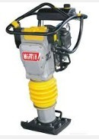

FIGURE 4.4

1.4.1 Name TWO pieces of personal safety equipment that a worker may
use when working with a rammer. (2)

1.4.2 State TWO uses of the rammer. (2)

1.5 FIGURE 1.5 shows an incomplete vertical sectional view of an open-eaves roof construction. Complete the drawing of the vertical sectional view.

FIGURE 4.5
Show the following on your drawing:
- Roof covering
- Tie beam
- Wall plate
- Purlin
- Fascia board
- Galvanised roof covering (5)

1.6 You want to build a boundary wall on one side of your site. The height of the wall is 2 m and the length is 15 m. The wall is a one-brick wide wall. Fifty bricks are needed to build one square metre of a half-brick wall.

    - Calculate the area of the wall. (2)
1.6.2 Calculate the total number of bricks required to build the wall. (2)

  - Name TWO types of reinforced-concrete suspended floors. (2)

  - Many accidents happen during excavations. State TWO causes of accidents that may occur during excavations. (2)

  - Explain under what circumstances you would use the following foundations:
Pad foundation (1)

    - Short-bored pile foundation (1)
[30]

ANSWER 1:

1.1

75

√

√

√

√

ASSESSMENT CRITERIA | MARKS | LEARNER'S MARK
Front view | 1
Top view | 1
Left view | 1
One dimension | 1
Application of scale 1: 2 | 1
TOTAL: | 5

1.2 • Security gates √
- Fences √ • Water pipes √ (2)

MATERIAL | COLOUR | USE
Copper | Reddish √ | Water pipes √  Electrical wiring  Electrical conductors  Decorative articles  Tubing  Hot-water pipes and fittings Flashings
Lead | White/Silver √ | Solder √  Plumbing  Casting of sculptures Roof flashings
1.3

(4)
1.4 1.4.1 • Safety shoes √
- Ear protection √
- Safety goggles
- Hard hat
- Gloves
- Overall

ANY TWO OF THE ABOVE OR ANY OTHER ACCEPTABLE ANSWER (2)

1.4.2 • Compacting displaced and loose soil √
• Tamping fillings for a hard-core layer underneath concrete
floors √ (2)

1.5

Roof covering

Tie beam

Wall plate

Purlin

Fascia board

√

√

√

√

Neatn
ess
√

ASSESSMENT CRITERIA | MARK | LEARNER'S MARK
Any correct labels | 1
Roof covering drawn correctly | 1
Wall plate drawn correctly | 1
Purlin drawn correctly | 1
Neatness | 1
TOTAL: | 5
(5)

1.6 1.6.1 Area of wall= ℓ x b
= 2 m x 15 m √
= 30 m² √ (2)

1.6.2 Total number of bricks = 30 x 100 √
= 3 000 bricks √ (2)
1.7 • In situ cast-concrete suspended floor √
  - Rib and block floor
  - Hollow-core pre-cast floor slabs (2)
1.8 • Excavated earth on the edge of a trench may cause the sides to
collapse √
  - Poor soil conditions (precautions should be taken in respect of poor soil) √
  - Buildings, utilities or heavy traffic routes nearby and any source of vibration may cause sides of trenches to collapse.
  - Whether the ground was disturbed before
  - Nearness of streams, old sewers and underground cables
  - The availability of adequate equipment, protective gear, shoring materials and warning signs and lights

ANY TWO OF THE ABOVE OR ANY OTHER ACCEPTABLE ANSWER (2)

1.9 1.9.1 Pad foundations are generally used to transfer loads from a column, pier
or heavy machinery to the ground. √ (1)

1.9.2 These piles are frequently used to counter ground movement (the expanding and contraction of clay soil) (1)

EXAMPLE 2: QUESTION 2: EXCAVATIONS, FOUNDATIONS AND STEEL (SPECIFIC)

2.1 Name TWO reasons why the topsoil must be removed for foundation
excavations. (2 x 1) (2)
2.2 Answer the following questions with regard to the foundation excavation in
FIGURE 2.2.

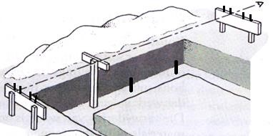
SIGHTING LINE

5.2
.B

5.2
.A

PEGS

FIGURE 2.2

2.2.1 Name parts 2.2.A and 2.2.B. (2 x 1) (2)

2.2.2 Which measurements must be marked out on part 2.2.B? (2 x 1) (2)

2.2.3 What is the purpose of the pegs in the foundation trench? (1)

2.3 Name THREE methods of dewatering of excavations. (3 x 1) (3)

2.4 Indicate whether the following statements are TRUE or FALSE. Write only the word ‘true’ or ‘false’ next to the number

2.4.1 Keep excavated material more than 500 mm from edges of
trenches. (1)

2.4.2 Hardboard with a thickness of 3 mm can be used for formwork of
excavation in hard soil. (1)

2.4.3 Open formwork is only used in excavations of hard soil. (1)

2.4.4 The boards that are placed vertically against the sides of the
trenches are called poling boards. (1)

2.5 Briefly describe the function of a foundation. (2)

2.6 Answer the following questions with regard to the foundation in FIGURE 2.6.
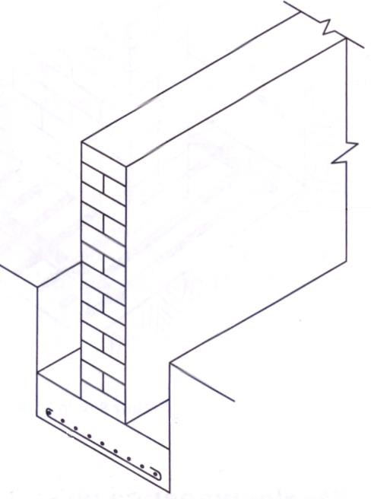

FIGURE 2.6

2.6.1 What is the foundation called? (1)

2.6.2 In what type of soil will the foundation be used? (1)

2.6.3 Fully motivate why steel reinforcement is placed at the bottom of the
foundation. (2)

2.7 Name THREE factors that will require the use of foundation piles. (3 x 1) (3)

2.8 Briefly describe the steps of installing a short-bored pile. (3)

2.9 Make a neat sketch to illustrate the difference between the steel sections of an I-beam and an H-beam.
Show the flanges and webs of the steel sections. (4)

[30]

ANSWER: EXAMPLE 2: QUESTION 2: EXCAVATIONS, FOUNDATIONS AND STEEL (SPECIFIC)

2.1 (1) Topsoil contains vegetation remains that may weaken foundations as they decay
(2) Topsoil is rarely firm enough to bear any load (2)

2.2 2.2.1 2.2. A – Boning rod
2.2.B – Profile board (2)

2.2.2 (1) Brickwall thickness and (2) foundation width (2)

2.2.3 Ensure that the top surface of the foundation is level (1)

2.3 Pumping out of water
    - Creating drains
    - Bailing of water (3)

2.4 2.4.1 False
2.4.2 False
2.4.3 True
2.4.4 True (4)

2.5 (1) To withstand all the loads from the building and (2) to transfer the loads to the soil, that settlement is restricted and that failure is avoided (2)

2.6 2.6.1 Reinforced concrete strip foundation / wide strip foundation (1)

2.6.2 Soil with a soft / a low load-bearing capacity (1)

2.6.3 (1) Concrete is weak under tensile force and (2) the tensile force is
at the bottom of the foundation (2)

2.7 Any THREE factors that will require the use of foundation piles. Low carrying capacity of the soil
    - New filling material that has not been thoroughly
compacted
    - An extremely high-water table
    - Clay subsoil that is subject to movement (expanding and
shrinking)
    - High moisture content
(3 x 1) (3)
2.8 (1) The hole is drilled to the required depth. (2) The previously prepared reinforcing is lowered into the hole. (3) Concrete is poured into the hole. (3)
2.9

WEB / RIB

FLANGE

I-beam H-beam (4)

[30]

EXAMPLE 3: QUESTION 3: EXCAVATIONS, FOUNDATIONS AND STEEL (SPECIFIC)

3.1 Answer the following questions with regard to the excavation of foundations.

3.1.1 To what depth must the topsoil be removed? (1)

3.1.2 Name TWO methods of checking the depth of excavations. (2 x 1) (2)

3.1.3 What is the purpose of the pegs in a trench excavation? (1)

3.1.4 To what depth must the pegs be driven in at the trench excavations? (1)

3.2 What is the purpose of a datum peg? (1)

3.3 Indicate whether the following statements are TRUE or FALSE. Write only the word ‘true’ or ‘false’ next to the question number (3.3.1–3.3.3)

3.3.1 Excavation boards must have a moisture content of between
5% and 10%. (1)

3.3.2 Chipboard is not resistant to moisture. (1)

3.3.3 Steel formwork is more expensive than timber formwork. (1)

3.4 Name THREE causes of trench accidents. (3 x 1) (3)
3.5 Answer the following question with regard to the formwork in FIGURE 5.5.

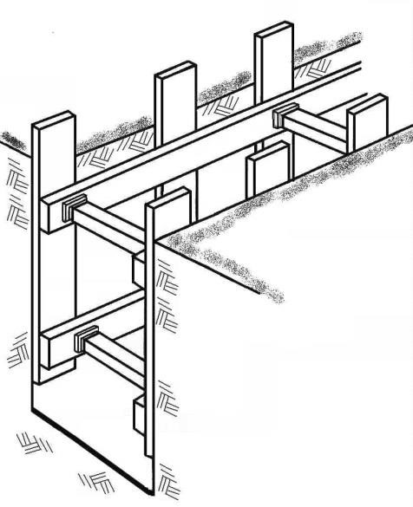

FIGURE 3.5

3.5
.D
3.5
.C
3.5
.A
3.5
.B

3.5.1 In what type of soil will this formwork be used? (1)

3.5.2 Name parts 3.5.A to 3.5.D. (4)

3.6 Choose a description from COLUMN B that matches an item in COLUMN A. Write only the letter (A–F) next to the question number (3.6.1–3.6.4), e.g. 3.6.5 G.

 | COLUMN A |  | COLUMN B
3.6.1 | Strip foundation | A | Carries the load of a pier
3.6.2 | Concrete | B | High tensile strength
3.6.3 | Pad foundation | C | Maximum depth of 5 metres
3.6.4 | Auger drill for piling | D | Carries the load of a brick wall
 |  | E | Maximum depth of 15 metres
 |  | F | High compressive strength
(4 x 1) (4)

3.7 Name TWO materials with which to fill the holes of piles. (2 x 1) (2)

3.8 Name THREE advantages of piles. (3 x 1) (3)

3.9 Answer the following questions with regard to the steel profiles in FIGURE 3.9.

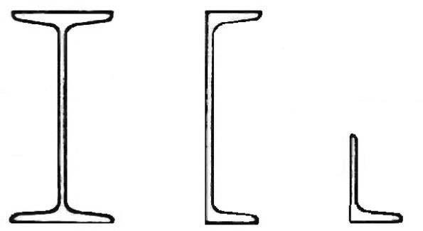

3.9.A 3.9.B 3.9.C

FIGURE 3.9

3.9.1 Name the steel profiles 3.9.A to 3.9.C. (3)

3.9.2 What type of steel profile in FIGURE 3.9 is most commonly used? (1)

[30]

ANSWER: EXAMPLE 3: EXCAVATIONS, FOUNDATIONS AND STEEL (SPECIFIC)

3.1 3.1.1 300 mm (1)

3.1.2 Any TWO methods of checking the depth of excavations:
- Spirit level
- Boning rods (measuring stick)
- Dumpy level (2 x 1) (2)

3.1.3 Ensuring that the concrete is level and poured to the correct depth. (1)

3.1.4 150 mm (below the edge of the trench) (1)

3.2 All heights on a building site are determined from the datum peg. (1)

3.3.1 False (1)
3.3.2True (1)

3.3.3True (1)

3.4 Any THREE causes of trench accidents.
- Excavated earth on the edge of the trench (may cause a collapse)
- Poor soil conditions
- Buildings, utilities or heavy traffic routes nearby (vibrations)
- Soil disturbed previously
- Proximity of streams, old sewer and underground cables
- Absence of sufficient equipment, protective gear, shoring materials, warning signs and lights (3 x 1) (3)
3.5 3.5.1 Firm / Hard / Dry soil (1)

3.5.5.2 3.5.A – Formwork boards / vertical plank / boards (1)

3.5.B - Strut (1)

3.5.C – Yoke / waling (1)

3.5.D – Wedge (1)

3.6 3.6.1 D – Carries the load of brick wall (1)

    - F – High compressive strength (1)

    - A – Carries the load of pier (1)

    - E – Maximum depth of 15 metres (1)

3.7 Any TWO materials with which to fill holes of piles. (2 x 1) (2)
- Reinforced concrete
- Tarred poles
- Prefabricated piles

3.8 Any THREE advantages of piles. (3 x 1) (3)
- Can be used in poor soil
- Can be used anywhere, even in water
- Larger base ensures stability
- Relatively quick and easy to install, if equipment is available
- If prefabricated piles are used, much time is saved
- Resists tensile stress well
- Quick and less expensive to produce
- Can be manufactured elsewhere beforehand
- Installation can continue, even in poor weather conditions
- Length of piles can easily be adjusted, depending on circumstances
- Offers sound resistance against moving soil

3.9 3.9.1 3.9. A – I-beam (1)

3.9.B – U-channel (1)

3.9.C – Angle iron (1)

3.9.2 3.9.C – Angle iron (1)

[30]

