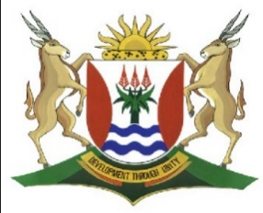
Province of the
EASTERN CAPE
EDUCATION

DIRECTORATE SENIOR CURRICULUM MANAGEMENT (SEN-FET)
HOME SCHOOLING SELF-STUDY WORKSHEET ANSWER SHEET
SUBJECT | GEOGRAPHY | GRADE | 11 | DATE | 27/07/20
TOPIC | FRAMEWORK FOR DEVELOMENT | TERM 3  REVISION | √√ | TERM 2 CONTENT | √√

Answer sheet to Framework for Development

1.1 | 1.1.1. | The Democratic Republic of Congo has an advantage over Japan when it comes to mineral resources. (1) | (1x1) | (1)
 | 1.1.2 | Because it exports a high volume of valuable minerals to  Developed and developing countries. (2) | (1x2) | (2)
 | 1.1.3 | Key environmental problems in DRC include land degradation, deforestation, loss of biodiversity, water pollution, and in Kinshasa air pollution. (2)  The conflicts are in themselves a source of environmental degradation. (2) | (2x2) | (4)
 | 1.1.4 | Negative environmental effects include air pollution, acid rain and decreased water quality. (2)  Japans high consumption of fish and timber is contributing to the depletion of these resources. (2) | (2x2) | (4)
 | 1.1.5 | High population growth puts pressure on the resources in a country. (2)  Increases Pollution (2)  Leads to food insecurity (2) | (3x2) | (6)
 | 1.1.6 | Improve their technology (2)  Improve Education (2)  Increase the exports of other resources other than minerals. (2) (Any TWO) | (2x2) | (4)
 |  |  |  | [21]

