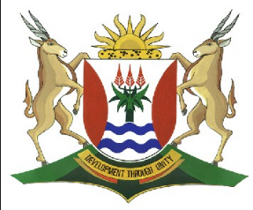
Province of the
EASTERN CAPE
EDUCATION

DIRECTORATE SENIOR CURRICULUM MANAGEMENT (SEN-FET)
HOME SCHOOLING SELF-STUDY WORKSHEET
SUBJECT | GEOGRAPHY | GRADE | 11 | DATE | 27/07/20
TOPIC | FRAMEWORK FOR DEVELOPMENT  - Factors that affect Development:  - Approaches to rural and urban development (case studies – Japan and the Democratic Republic of Congo | TERM 3  REVISION | √√ | TERM 3 CONTENT | √√
TIME ALLOCATION | 1HOUR | TIPS TO KEEP HEALTHY  1. WASH YOUR HANDS thoroughly with soap and water for at least 20 seconds. Alternatively, use hand sanitizer with an alcohol content of at least 60%.  2. PRACTICE SOCIAL DISTANCING – keep a distance of 1m away from other people.  3. PRACTISE GOOD RESPIRATORY HYGIENE: cough or sneeze into your elbow or tissue and dispose of the tissue immediately after use.  4. TRY NOT TO TOUCH YOUR FACE. The virus can be transferred from your hands to your nose, mouth and eyes. It can then enter your body and make you sick.  5. STAY AT HOME.
INSTRUCTIONS

FRAMEWORK FOR DEVELOPMENT
FACTORS THAT AFFECT DEVELOPMENT – Development should also be viewed from a broad perspective looking physical, economic, political and social aspects of development.
Po
Political
Power, policy and decisions

A broader perspective of the developed environment

Economic
Job and Money
Social
People interacting

Biophysical
Climate, relief, soils, vegetation, and animals

A broader perspective of the development environment

Trade imbalances

History
Energy

Education and Training
Natural Resources
Environmental Degradation
Population Growth
Natural Resource Limitations
Factors that affect Development

FACTORS THAT AFFECT DEVELOPMENT
Learners please read this section of your work with the aid of your textbook.

Political Factors | Social Factors | Economic Factors | Natural Resources
History  - Factors such as colonialization, migration and wars affect levels of development.  - Former colonies are generally less developed than the countries that colonized them.  - Mass Migration such as that caused by slavery,farming or a ‘Gold rush; affects the the human resource balance between and within countries. | Population Growth  - The world’s population is increasing at a rapid rate.  - This puts pressure on resources such as water, wood and soil.  - When the growth rate of a population outstrips its ability to feed, house and employ itself, levels of development will decrease.  Education and Training  - Access to education and training will determine whether a country is referred to as traditional or modern.  - Without adequate education,the labour force cannot shift from being engaged mainly in agriculture to focusing on industry and services.  - Levels of education influences innovation, the appropriate use of of existing technology as well as the creations of new technology. | Trade Imbalances  - The number of trade partners and the items traded has a direct impact on development.  - More trading partners allow for a greater choice and finished products fetch higher prices than raw materials.  - More developed countries generally earn more from their exports than they spend on their imports.  Energy  - The source of energy as well as the amount consumed per capita is a good indicator of development.  - Many of LEDC’s rely on wood as a source of heat for cooking and sterilizing water.  - They make use of human and animal labour in the fields as well as a means of transport.  - People in MEDC’s use fossil fuels to meet their basic needs. | Natural resource limitations  - The carrying capacity is exceeded.  - Large populations put pressure on natural resources  Environmental Degradation  - Lack of environmental Education.  - There is a lack of government policy  - There is an objective of profit at all costs.  - There is a lack of effective pollution control.  Access to resources  - There is an uneven distribution of the world’s natural resources.  - Developed countries need more resources that developing countries,  - There is a lack of access to water, electricity and sanitation in many developing countries.  - There is a lack of business opportunities owing to government policies.

- APPROACHESTO URBAN DEVELOPMENT
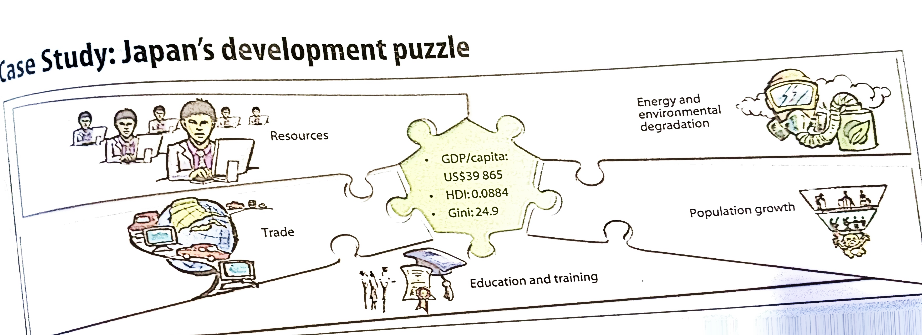

Japan’s development Puzzle
Community Based development: Sustainable urban development
Japan’s Development Puzzle
Resources
- Japan has very few natural resources and as a result it must import almost 60% of its food and most raw materials.
- The lack of raw materials is counter balanced by a large, highly skilled labour force (48.9% of the population) and extremely high levels of education.
Trade
- Japan is one of the world’s largest global economies.
- This was made possible through trade.
- Japan imports (low cost) raw materials, processes them, and turns them into other items(high cost) that it then exports. Eg. Imports iron ore and turns it into machinery.
Education and training
- The Japanese government invests the money it earns from trade into its people: 3,5% of the GDP is spent on Education, and 9,3% on health.
- The average citizen obtains 15 years of education and the literacy rate is more than 90%.
- This translates into a labour force that is able to use technology to a great advantage.
Population Growth
- Unlike many other nations, Japan is currently experiencing a negative population growth rate.
- However pressure on resources are still high.
Energy and environmental Degradation
- Domestic and industrial demand for electricity was the fourth highest in the world.
- The advanced public transport and private transport system also requires large amounts of oil to be imported.
- Negative environmental effects include air pollution, acid rain and decreased water quality
- Japans high consumption of fish and timber is contributing to the depletion
Of these resources.

APPROACHES TO RURAL DEVELOPMENT

Case Study : Congo’s Development Model

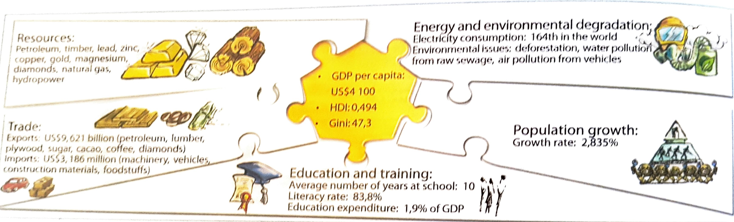

Resources

- In 2018 Democratic republic of Congo exported a total of 10.8 billion ,making it the 85th exporter in the World.
- During the last five reported years the exports of Democratic republic of Congo have changed by 3.32 billion from 7.39 Billion rand in 2013 to 10 .78Billion dollars in 2018.
- The most recent exports are led by refined copper(3.63B dollars :,Copper ore(1.18B) dollars,Cobalt ore(853 million dollars),and Crude Petroleum(386 million dollars.the most common destination for the export s of Democratic republic of Congo are China(5,51 billion, (5.51 billion dollars),Zambia (1.36 bilion dollars),UnitedArab emirates (838 million dollars(,South Korea (612million dollars), and Saudi Arabia (518 million dollars)
Education and Training
- The Democratic Republic of the Congo (DRC) education system is plagued by low coverage and poor quality. 3.5 million children of primary school age are not in school, and of those who do attend, 44 percent start school late, after the age of six. National data indicate that only 67 percent of children who enter first grade will complete sixth grade.
Trade
- For much of the first decade of the 21st century, Congo faced an increasingly negative balance of trade.
- Mineral products constitute most of the country’s total exports: diamonds, which account for almost one-half of trade revenue, are the country’s most valuable export; crude petroleum, cobalt, and copper are also significant.
- Coffee is the country’s most important agricultural export product. Exported manufactures are of limited value and volume. Imports consist primarily of foodstuffs, consumer goods, machinery (largely mining and transport equipment), and fuel.
- Although Belgium traditionally has been a primary trade partner, Congo has developed significant trade relationships with other countries of the European Union, South Africa, and China.

Population Growth

- The Democratic Republic of the Congo has one of the highest population growth rates in the world of 3.19%. With a current population of about 89.56 million, DR Congo is projected to surpass 100 million in 2024 and double its population by 2047.
- DR Congo has one of the highest fertility rates in the world of 6.11 births per woman. The 2019 birth rate for DR Congo was 40.6 births per 1,000 people.
Energy and environmental Degradation
- Key environmental problems in DRC include : land degradation, deforestation, loss of biodiversity, water pollution, and in Kinshasa air pollution.
- The conflicts are in themselves a source of environmental degradation.

WORKSHEET: EXPLORING FACTORS FOR DEVELOPMENT – CASE STUDY OF DRC AND JAPAN

- Study the development puzzles of the Democratic republic of Congo and Japan above and answer the following questions:

    - In which area does the Democratic republic of Congo have an advantage over Japan. (1) (1x1) (1)
    - What do the exports and imports of the DRC tell us about the level of industrialization in this country? (2)
(1x2) (2)
    - What do the environmental issues experienced by the Democratic Republic of Congo tell us about its overall level of development? (4) (2x2) (4)
    - How is Japan’s economic success negatively impacting the environment? (4) (2x2) (4)
    - Explain how the population growth rate in each country could become a negative factor of development.
(3x2) (6)
    - What lessons could the Democratic Republic of Congo learn from Japan in order to increase its level of development? (2x2) (4)
Total [21]

