EC - LEARNER SUPPORT MATERIAL: CIVIL TECHNOLOGY
CIVIL SERVISES: GRADE 11

CONTENT TO BE COVERED:

- TOPIC: GRAPHICS AS MEANS OF COMMUNICATION (SPECIFIC)
Scale drawings of the following:
- Semi-circular arch
- Segmental rough arch
- Gauged segmental arch.
Freehand sketches of the following:
- floor plan of a house with 3 bedrooms, a sitting room, a kitchen, a toilet and a bathroom

- TOPIC: QUANTITIES (SPECIFIC)
Calculate quantities of materials:
Calculate the following materials required for a one room building with a door and a window excluding the roof. Use dimension paper to do the calculation.
- The number of bricks required
- The square metres of plaster required for the internal walls
- Length of lintel required.
Floor covering in square metres.

- TOPIC: JOINING (GENERIC)
Properties, use precautions and applications of the following:
- Contact glue
- PVC adhesives
- Silicone
- PVA-wood glue
Joining bricks to:
- Steel doors and windows
- Aluminum doors and windows
- Wooden doors and windows
- Cavity walls: Different types, materials and spacing of ties

EXAMPLE 1: QUANTITIES, JOINING AND GRAPHICS
1.1 Draw to scale 1: 2 an isometric view of a common brick.
1.2 Make a neat freehand drawing, in good proportion, of the sectional view part
of the superstructure of a building.

Show the following on your drawing:

- Part of the wall below the window
- External window sill
- Internal window sill
- Window frame
- TWO lintels above the window
- Part of the wall above the window (9)

  - FIGURE 1.3 below shows the floor plan of a building. Study the drawing and
answer the questions that follow.

FIGURE 1.3
8 000

5

000

A

C

B

W 2

W 1

Identify parts A, B and C. (3)

Develop and draw, to scale 1: 50, the east elevation of the building.

Use the following specifications:

- The building has a gable roof with a pitch of 30°.
- Window 1 is 1 500 mm wide and 1 200 mm high.
- Window 2 is 2 000 mm wide and 1 200 mm high.
- All windows are placed in the middle of the walls.
- The door is 2 000 mm high and 900 mm wide.
- The height from the natural ground level to the finished floor level is 300 mm.
- The height of the superstructure is 2 700 mm.
- The roof is finished off with 220 mm barge boards and no gutters are fitted. (8)

1.4 Formulas are used to calculate quantities. Write down the formula that you
will use to calculate:

1.4.1 Area (1)

1.4.2 Volume (1)

1.5 In which unit are the lengths of skirtings and quarter round mouldings
measured? (1)

  - A foundation with a length of 28 m, width of 450 mm and a thickness of
150 mm need to be cast with concrete. Calculate the volume of
concrete required for the foundation in m³. (4)

1.6 FIGURE 1.6 below shows the floor plan of a single-room building.

8 440

6 440

FIGURE 1.6

Specifications:
The width of the wall is 220 mm.
The opening for the door is 2 100 mm x 900 mm
The opening for the window is 2 000 mm x 1 200 mm
The height of the superstructure is 2 700 mm
Use 50 bricks per square metre for a half-brick wall.

1.7 Calculate the following:

1.7.1 Centre lines of the walls in metres (5)

1.7.2 Number of bricks required to build the walls of the superstructure (10)

A | B | C | D
 |  |  | Centre lines of walls:
 |  |  | 2/ ___________= _________
 |  |  | 2/___________ = _________
 |  |  | = ______________
 |  |  | Minus 4/_______= ________
 |  |  | Total length of centre line =________ (5)
 |  |  | = ______________
 |  |  | Area of walls before deductions
1/ | _______ |  | Centre line of wall = __________
 | _______ | ____________ | Height of wall =______________ (2)
 |  |  | Area of door
1/ | ______ |  | Door opening is 2 100 mm x 900 mm (2)
 | ______ | ____________
 |  |  | Area of window
1/ | ______ |  | Window opening is 2 000 mm x 1 200 mm (2)
 | ______ | ____________
 |  |  | Area of walls after deductions
 |  |  | Area of walls – area of window – area of door (1)
 |  |  | ________ - _______ - ________
 |  |  | = _________
2/ | ________ |  | Number of bricks required
 | ________ | ______ bricks | 50 bricks per m² for a half-brick wall (3)

1.8 Complete the following sentences by using the words in the list below.
Write down the word next to the question number (3.5.1–3.5.5)

PVC adhesives; contact glue; water; timber; epoxy

1.8.1 PVA glue is used to join … (1)
1.8.2 … glue consists of a resin and a hardener. (1)

1.8.3 Silicone glue may be used as a basic sealant against the penetration
of … (1)

1.8.4 … glue dries quickly and once the parts come together, they cannot
be separated. (1)

1.8.5 Plastic pipes are bonded by means of … (1)

1.9 State ONE property of EACH of the following adhesives:

1.9.1 Contact glue (1)

1.9.2 PVA glue (1)

1.9.3 Silicone (1)
[50]

FORMULA SHEET

FORMULAE

AREA OF | FORMULA  (in words) | FORMULA  (in symbols)
Square | side x side | s x s
Rectangle | length x breadth | ℓ x b
Right-angled triangle | ½ x base x height | ½b x h
Equilateral triangle/ Isosceles triangle | ½ x base x height | ½b x h

Calculation of volumes of individual aggregates for concrete:
Volume of material = Volume of concrete required x Mix ratio of material
Total mix ratio

ANSWER: EXAMPLE 1: QUANTITIES, JOINING AND GRAPHICS
1.1
√

√

√

√

√

SCALE 1: 2  NOT TO SCALE: USE A MASK TO MARK THIS QUESTION. | (5)
1.2
√  √  √  √  √  √  √  √  √ | ASSESSMENT CRITERIA MARKS LEARNER'S MARK  Wall above window 1  Wall below window 1  Lintels 2  Window frame 1  External window sill 1  Internal window sill 1  Reveals 2  TOTAL 9

(9)
1.3 1.3.1 A- Door √ B- Window √ C- North point √ (3)

√

√

√

√

√

√

√

√

ASSESSMENT CRITERIA | MARKS | LEARNER'S MARK
External walls | 2
Natural ground level | 1
Finished floor level | 1
Window | 1
Window sill | 1
Barge board | 1
Verge overhang | 1
TOTAL | 8

NOT TO SCALE: USE A MASK TO MARK THIS QUESTION. (8)

1.4 1.4.1 Length x breadth – ℓ x b √ (1)

1.4.2 Length x breadth x height – ℓ x b x h √ (1)

1.5 linear metre (1)

1.6 Volume of concrete = ℓ x b x h
= 28 m x 0,45 m √ x 0,15 m √
= 1,89 √ m³ √ (4)

1.7
A | B | C | D
 |  |  | Centre line of wall:
 |  |  | 2/8 440 = 16 880 mm √
 |  |  | 2/6 440 = 12 880 mm √
 |  |  | = 29 760 mm √
 |  |  | Minus 4/220 = 880 mm √
Total length of centre line =
28 880 mm = 28,88 m √
 |  |  | Area of walls before deductions
1/ | 28,88 |  | Centre line of wall = 28,88 m
 | 2,7 √ | 77,97 m² √ | Height of wall = 2,7 m
 |  |  | Area of door
1 | 2,1 |  | Door opening is 2 100 mm x 900 mm
 | 0,9 √ | 1,89 m² √
 |  |  | Area of window
1 | 2.0 |  | Window opening is  2 000 mm x 1 200 mm
 | 1,2 √ | 2,4 m² √
 |  |  | Area of walls after deductions
 |  |  | Area of walls – area of window – area of door
 |  |  | 77,97 m² - 1,89 m² - 2,4 m²
 |  |  | = 73,68 m² √
2/ | 73,68 m² √ |  | Number of bricks required
 | 50 √ | 7 368 bricks √ | 50 bricks per m² for a half-brick wall
1.7.1

(5)

1.7.2

(2)

(2)

(2)

(1)

(3)

1.8 1.8.1 Timber (1)

1.8.2 Epoxy (1)

1.8.3 Water (1)

1.8.4 Contact (1)

1.8.5 PVC adhesives (1)

1.9 1.9.1
  - Adheres well to most materials, e.g. plastics, rubber, paper, particle board, wood, etc. √

- Sticks to most non-porous materials
- Rubbery and has a creamy colour

  - Flexible, yet keeps bonded surfaces together
  - Flammable
  - Water-resistant
  - Dries quickly and can bond immediately

ANY ONE OF THE ABOVE OR ANY OTHER ACCEPTABLE ANSWER. (1)

1.9.2
- Water-based √
- For interior or exterior use
- White or yellowish colour before it dries, clear when dry
- Yellow PVA is not completely clear on drying
- Super strong when used on wood
- Dries quickly
- Inexpensive

ANY ONE OF THE ABOVE OR ANY OTHER ACCEPTABLE ANSWER (1)

1.9.3
- Heat resistant √
- Conductive or insulating
- Rubbery
- Low heat conductivity
- Resist chemicals/low chemical reactivation
- Low toxicity
- Forms waterproof joins because it repels water
- Excellent to use in electrical connection because of its insulating properties
- May exhibit defoaming/anti-foaming properties

ANY ONE OF THE ABOVE OR ANY OTHER ACCEPTABLE ANSWER (1) [50]

EXAMPLE 2: QUANTITIES, JOINING AND GRAPHICS (GENERIC)

2.1 Answer the following questions with regard to the plan elevation in FIGURE 2.1.

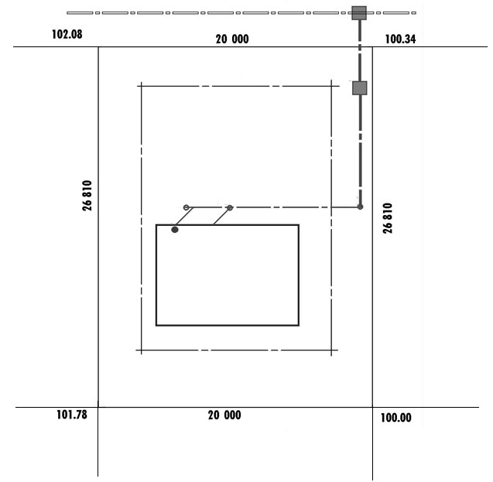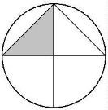

FIGURE

2.1

PROTEA STREET

PLOT 126

PLOT 124

PLOT 128

PLOT 137

PLOT 135

.A11
2.1

.B
2.1

.C
2.1

2.1.1 What is the plan elevation called? (1)

2.1.2 What is the plot number of the plot on the west side of plot 126? (1)

2.1.3 What are the lines at 2.1.A called? (1)

2.1.4 Identify the symbols at 2.1.B and 2.5.C. (2)

2.2 FIGURE 2.2, shows an incomplete section view of a single brick wall.
Complete the section view to scale 1: 20 and show the following parts with
symbols and labels:

2.2.1 A strip foundation of 700 x 250 mm with the invert level of 400 mm (3)

2.2.2 A single brick wall with a height of 2 700 mm from the floor level
and 10 mm plaster work on the outside and inside (5)

2.2.3 The hardcore filling of 250 mm (1)

2.2.4 The dampproof course (2)

2.2.5 The blinding layer of 50 mm (1)

2.2.6 The concrete floor slab of 90 mm (1)

2.2.7 A door opening with a height of 2 100 mm (1)

2.2.8 A concrete lintel with a thickness of 70 mm above the door
opening (2)

2.2.9 A wall plate of 114 x 38 mm (2)

2.2.10 Show any TWO labels. (2 x 1) (2)

2.3 FIGURE 2.3 shows the foundation wall of a building. The width of the wall is
220 mm and the height 450 mm.

9

000

6

000

FIGURE 2.3

Calculate the following:

2.3.1 Determine the centre line of the foundation wall. (6)

2.3.2 Determine the quantity of bricks needed to build the foundation
wall. Make provision for 5% brick breakages. (9)
2.4 Fully describe the purpose of the description column on the dimension
paper for quantities. (3)

2.5 Describe, in point form, the application process of contact glue. (3)

2.6 Which joining glue/material consists of resin and a hardener? (1)

2.7 Name TWO properties of mastic sealant. (2 x 1) (2)

2.8 Make neat sketches to illustrate the following symbols on a floor plan:

2.8.1 Gully (2)

2.8.2 Check valve (2)

2.8.3 Dressed wood (2)

[55]

ANSWER: EXAMPLE 2: QUANTITIES, JOINING AND GRAPHICS (GENERIC)

2.1 2.1.1 Site plan (1)

2.1.2 124 (1)

2.1.3 Building boundary (1)

2.1.B – Manhole
2.1.C – Rodding eye (2)

FIGURE 2.2 shows an incomplete section view of a single brick wall. Complete the section view on scale 1: 20 and show the following parts with symbols and labels:

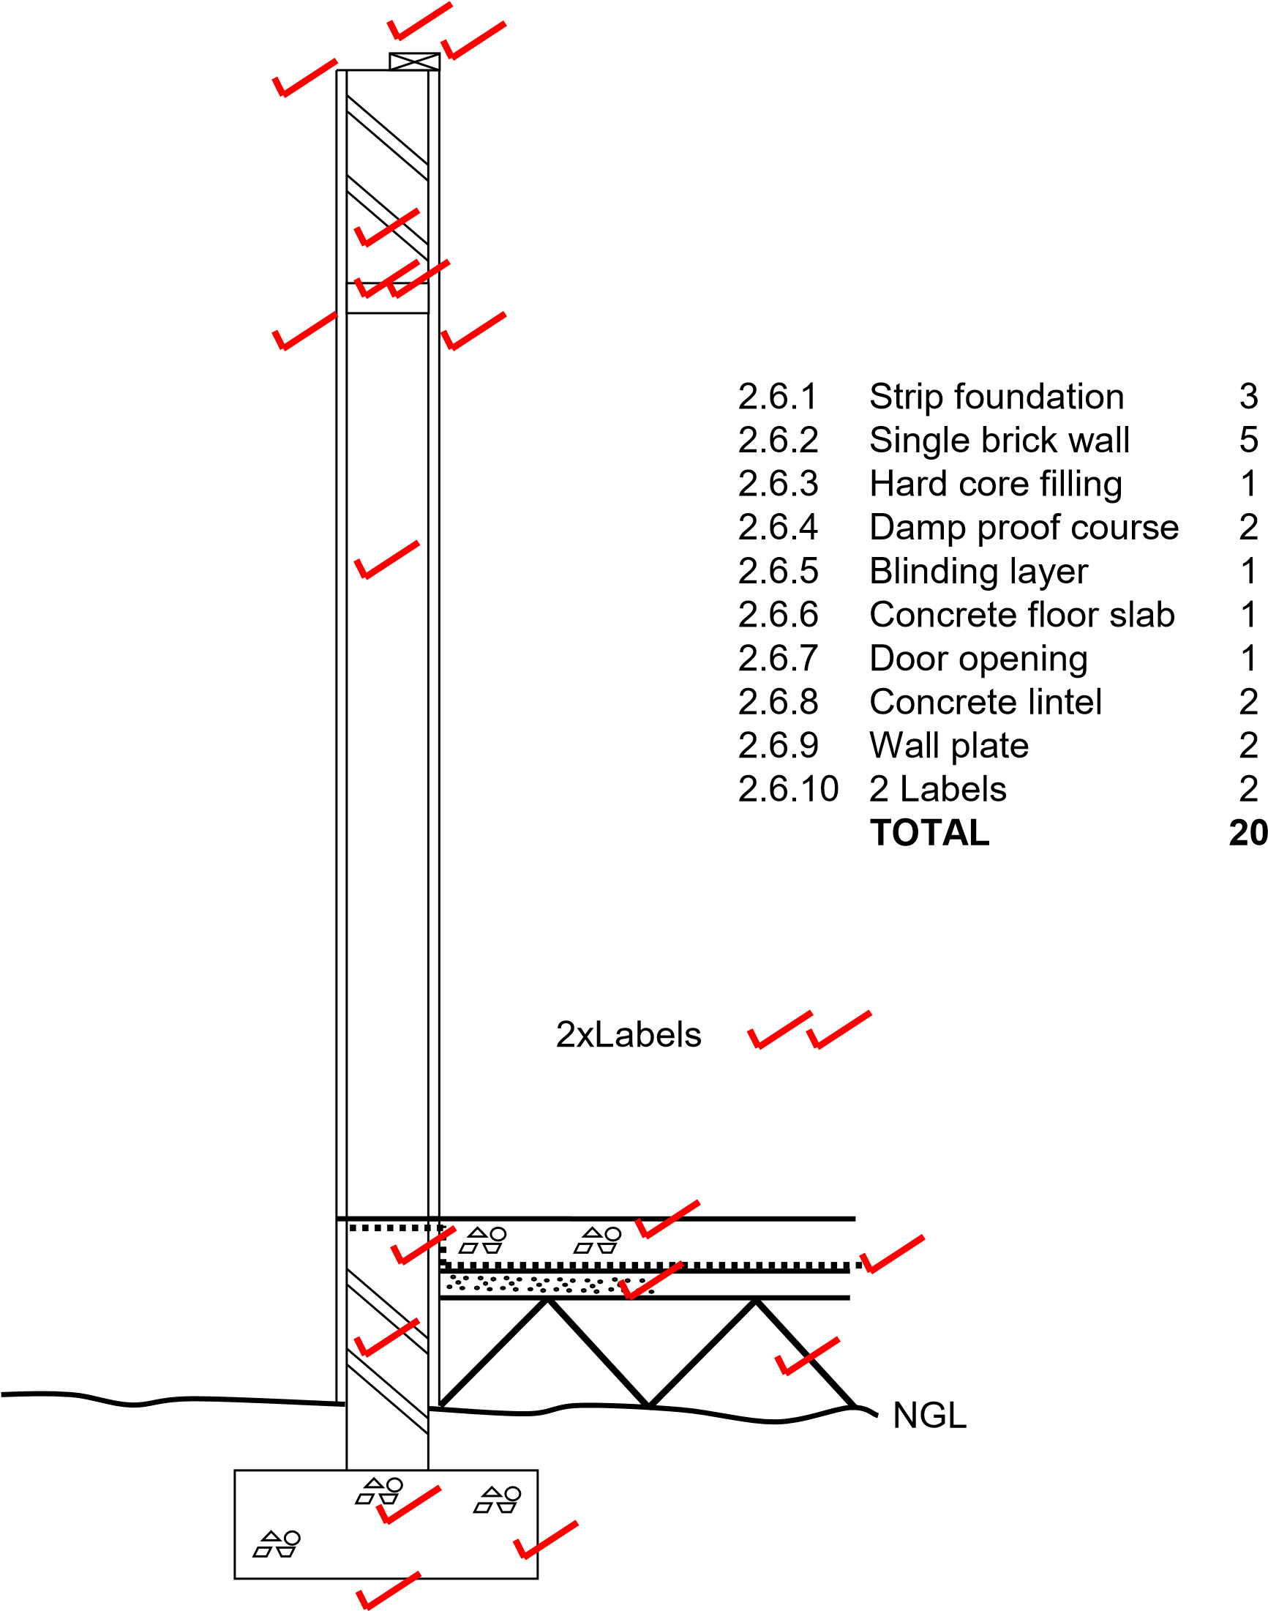

2.2
2.2.1 A strip foundation of 700 x 250 mm with the invert level of 400 mm (3)

2.2.2 A single brick wall with a height of 2 700 mm from the floor level and 10 mm
plaster work on the outside and inside (5)

2.2.3 The hard-core filling of 250 mm (1)

2.2.4 The damp proof course (2)

2.2.5 The blinding layer of 50 mm (1)

2.2.6 The concrete floor slab of 90 mm (1)

2.2.7 A door opening with a height of 2 100 mm (1)

2.2.8 A concrete lintel with a thickness of 70 mm above the door opening (2)

2.2.9 A wall plate of 114 x 38 mm (2)

2.10 Show any TWO labels. (2 x 1) (2)

2.3 FIGURE 2.3 shows the foundation wall of a building. The width of the wall is 220 mm and the height 450 mm.

9

000

6

000

FIGURE 2.3

Calculate the following:

2.3.1 Determine the centre line of the foundation wall. (6)

2.3.2 Determine the quantity of bricks needed to build the foundation
wall and make provision of 5% brick breakage damage. (9)

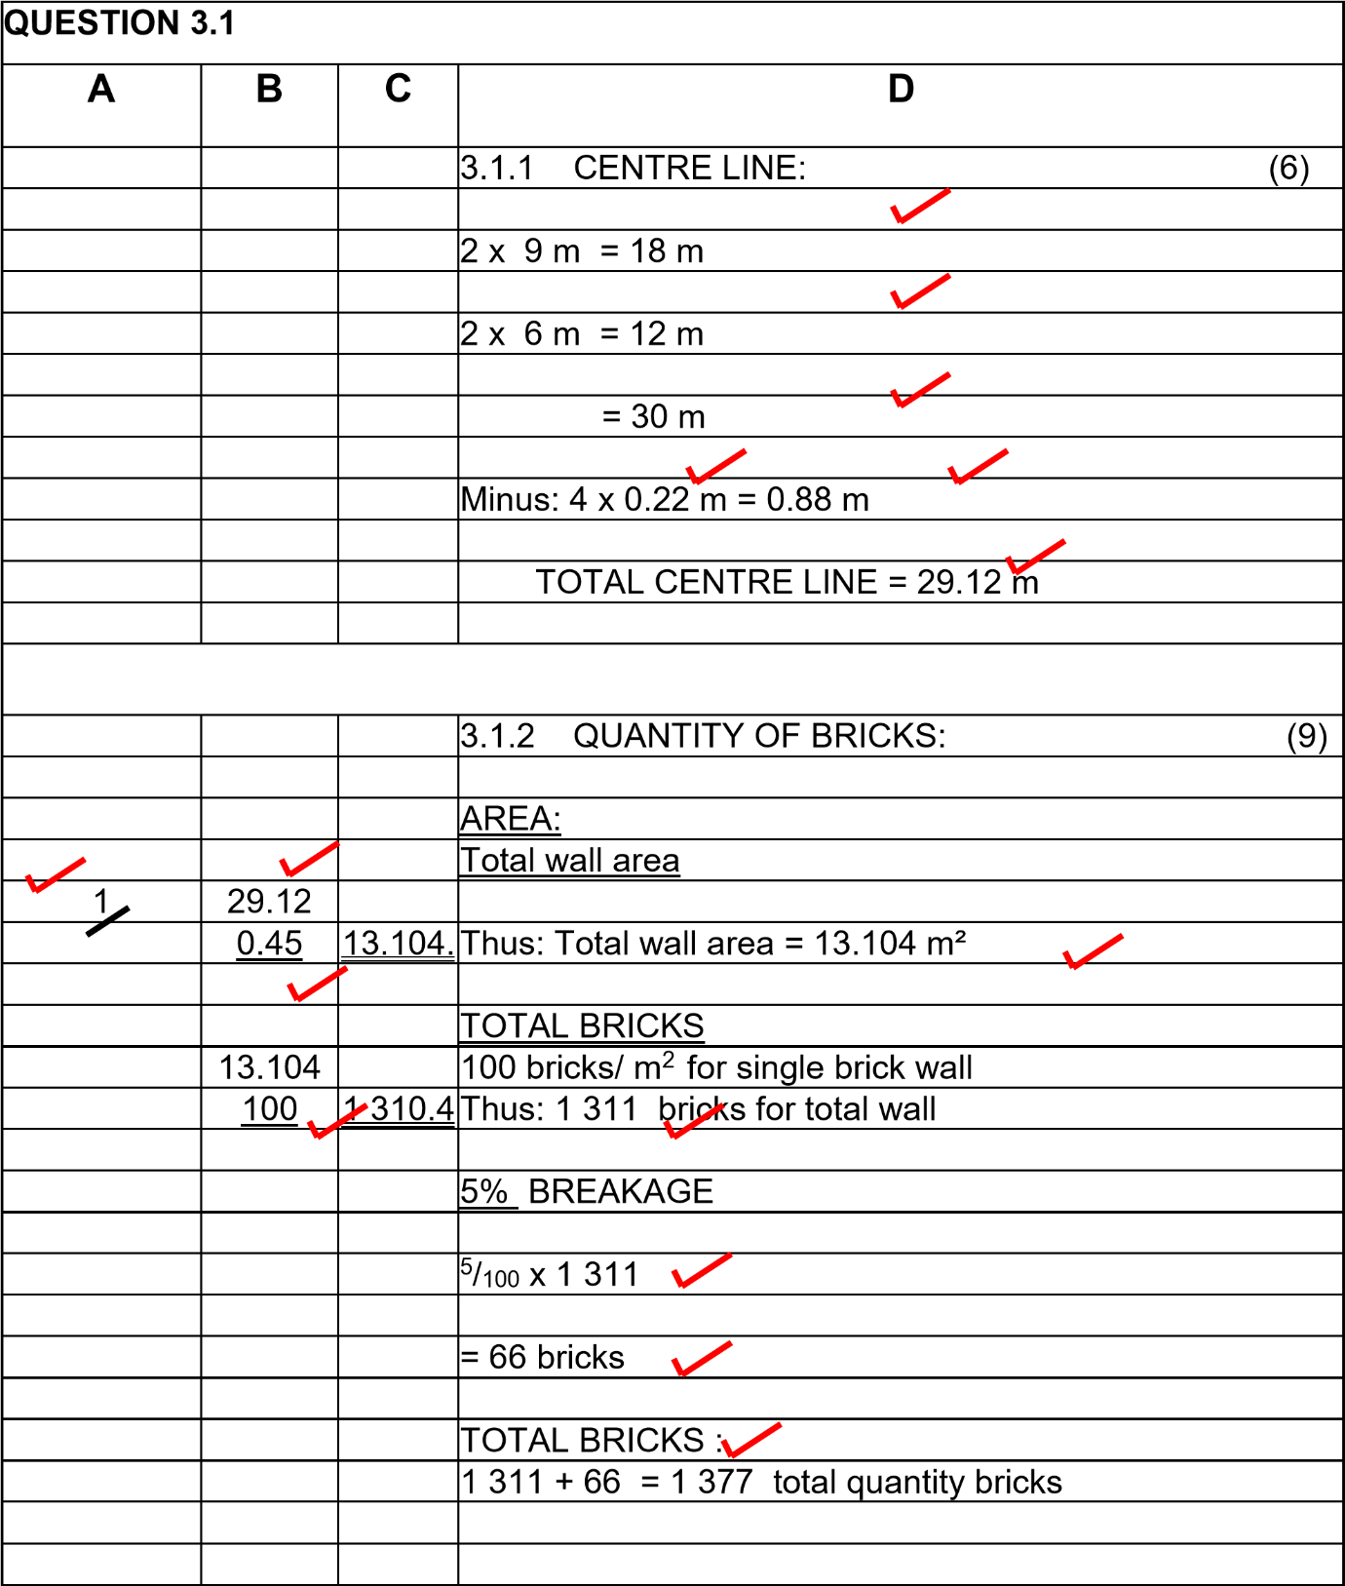

2.4
- Thorough description of the
- item that was measured and
- (3) any preliminary calculations or sketches (3)

2.5
- Apply adhesive to both surfaces
- allow to dry and
- (3) when almost dry, clamp parts together (3)
2.6 Epoxy (1)

2.7
Any TWO properties of mastic sealant.
- Works well on metals
- Prevents dust penetration in joints
- Flexible, yet keeps surfaces together
- Adhesion for 5 years
- Smooth exterior
- Can be used outdoors
- Water tight
- Withstand low and high temperatures
- Not weakened by exposure to sun (2 x 1) (2)

2.8
2.8.1 Gully

(2)

2.8.2 Check valve

(2)

2.8.3 Dressed wood
(2)

[55]

EXAMPLE 3: QUANTITIES, JOINING AND GRAPHICS (GENERIC)

Answer the following questions with regard to the elevation in FIGURE 2.6.

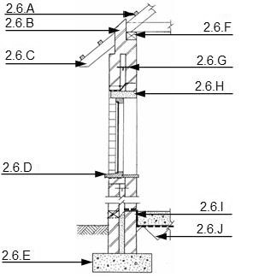

FIGURE 2.6

2.6.1 Name the type of elevation. (1)

2.6.2 Name the parts labelled 2.6.A to 2.6.J. (10)

2.6.3 What are the width and thickness dimensions of part 2.6.F? (2)

2.6.4 What is the purpose of part 2.6.G? (1)

2.7 Name FOUR particularities with regard to roof constructions which must be
indicated in elevations. (4 x 1) (4)

2.8 Make neat sketches to illustrate the following symbols:

2.8.1 Plaster (2)

2.8.2 Undressed wood (2)

2.8.3 Invert level (2)

3.1 Make neat sketches to illustrate the following symbols on a floor plan:

3.1.1 Grease trap (2)

3.1.2 DPC (Damp-proof course) (2)
3.1.3 Staircase (2)

3.2 FIGURE 3.2 below shows the floor plan of the foundation walls of a single room.

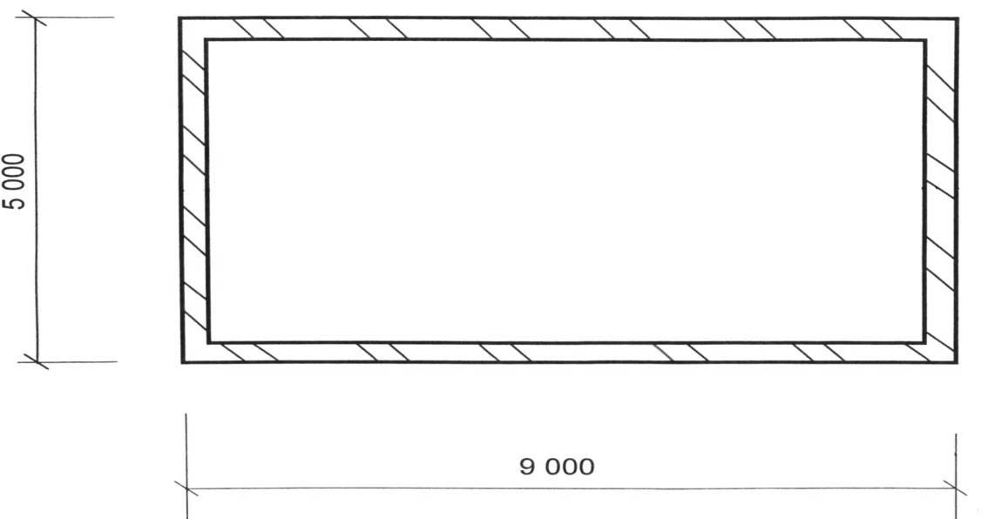

FIGURE 3.2

Use the following specifications: ……. x The floor slab is 85 mm thick x Walls are 220 mm thick

Calculate the volume of concrete needed to cast the floor slab between the external walls. (12)

3.3 Name THREE properties of silicone. (3 x 1) (3)

3.4 Describe the application process of contact glue. (3)

3.5 Name ONE property of PVC–adhesive. (1)

3.6 Name THREE functions of glass. (3 x 1) (3)

3.7 Discus the difference between polythene and polyvinyl chloride. (2)
[50]

ANSWER: EXAMPLE 3: QUANTITIES, JOINING AND GRAPHICS (GENERIC)

2.6 OF FIGURE 2.6

2.6.1 Section view (1)

2.6.2 2.6. A – Purline

- Beam filling
- Rafter
- Window sill
- Foundation
- Wall plate
- Wall tie
- Lintel
- Damp proof coarse
- – Hard core (10)

2.6.3 114 x 38 (2)

2.6.4 Bind 2 wall leaves (1)

2.7
- Pitch of roof
- Type of roof covering
- Barge board
- Facia board
- Gutters
- Downpipes (Any 4 x 1) (4)
2.8
2.8.1 Plaster
(2)

2.8.2 Undressed wood
(2)

2.8.3 Invert level
(2)

3.1 Make neat sketches to illustrate the following symbols on a floor plan:

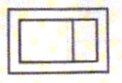
3.1.1 Grease trap

(2)

3.1.2 DPC (Damp-proof course)

(2)

3.1.3 Staircase

(2)

3.2

A | B | C | D
 |  |  | Internal measurements of long walls
 |  |  | = 9 000 mm – 220 mm √ – 220 mm √
 |  |  | = 8 560 mm √ (3)
 |  |  | Internal measurements of short walls
 |  |  | = 5 000 – 220 mm √ – 220 mm √
 |  |  | = 4 560 mm √ (3)
 |  |  | Volume of concrete needed
1/ √ | 8,56 √ |  | Length of floor slab = 8 560 mm
 | 4,56 √ |  | Width of floor slab = 4 560 mm
 | 0,085 √ | 3,318 m³ √√ | Thickness of floor slab = 85 mm (6)
 |  |  | (12)

3.3
- Basic sealant against air and leakage
- Enhance materials
- Used in aviation
- Construction repairs (Any 3 x 1) (3)

3.4 Apply enough adhesive to both sides of the areas to be bonded Allow to dry
After drying, hold the two pieces of material together or clamp, roll or press them together (3)

3.5
- Joins PVC pipes
- Clear / transparent
- Dries quickly (Any 1 x 1) (1)

3.6
- To allow light into a building
- To prevent rain, wind, dust and insects from entering
- Enhance the aesthetic qualities of a structure (3)

3.7 Polythene: strong and light / becomes brittle when exposed to sunlight / can be used in underground waterproofing / can be reshaped / remoulded after heating
Polyvinyl chloride: can be reshaped / solid material / two types available flexible and rigid / good insulating properties / not dissolved by alcohol. (2)
[50]

