Province of the
EASTERN CAPE
EDUCATION

DIRECTORATE SENIOR CURRICULUM MANAGEMENT (SEN-FET)
HOME SCHOOLING SELF-STUDY ANSWER SHEET
SUBJECT | ECONOMICS | GRADE | 12 | DATE | 25/06/2020
TOPIC | MICROECONOMICS | TERM 1  REVISION |  | TERM 2 CONTENT | X

QUESTION 1 40 MARKS − 40 MINUTES

- With the aid of graphs, discuss how economic profit and economic loss are determined in a monopoly market.
(26 marks)
- Why does the performance of natural monopolies contradict (deny) the long-run equilibrium position of a monopoly?
(10 marks) (NSC DBE/November 2019) [40]
INTRODUCTION
A monopoly is a market structure where only one seller operates. Entry is blocked and the product has no close substitutes √√
(Accept any other correct relevant response) Max (2)

BODY: MAIN PART

Economic profit
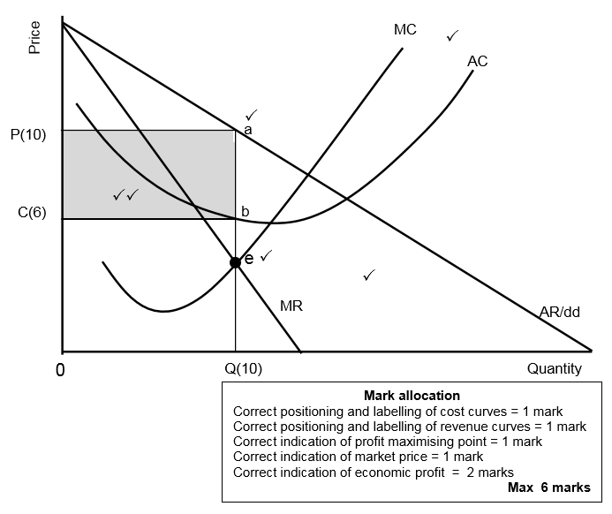
  - Monopoly is subject to same technological and cost constraints as other market structures √√
  - The cost structure of the monopoly is the same than that of competitive businesses where the monopolist will try to maximize both short and long-term profit √√
  - Location of SAC in relation to market price determines profit or loss √√
  - The MR curve lies below the AR curve, halfway between the AR and the origin √√
  - The MC curve intersects the AC curve at its minimum point √√
  - Determine point where SMC = MR – point where production cost of last unit is equal to revenue it earns (point e) – profit-maximising production quantity of Q on horizontal axis √√
  - The monopolist will produce at the output (Q[10]) where MR=MC, because it can maximise profit at this level √√
  - Point a represents the average revenue at selling price (P[10]) while point b represents the average cost at the cost price (C[6]) √√
  - When the average revenue is more than the average cost, it results in an economic profit for the business / When the TR is more than TC it will result in an economic profit for the business √√
  - The monopoly makes economic profit when AC curve is below market price (AR) √√
  - The monopoly blocks new entries so that competing businesses cannot reduce short run economic profit √√
  - Total income = Price x Quantity = OP(10) x OQ(10) = OPaQ (100) √√
Total cost = Cost x Quantity = Oc(6) x OQ(10) = OCbQ (60)
Economics profit = Income – Cost = 100 – 60 = CPab (40) √√ (Max 10)

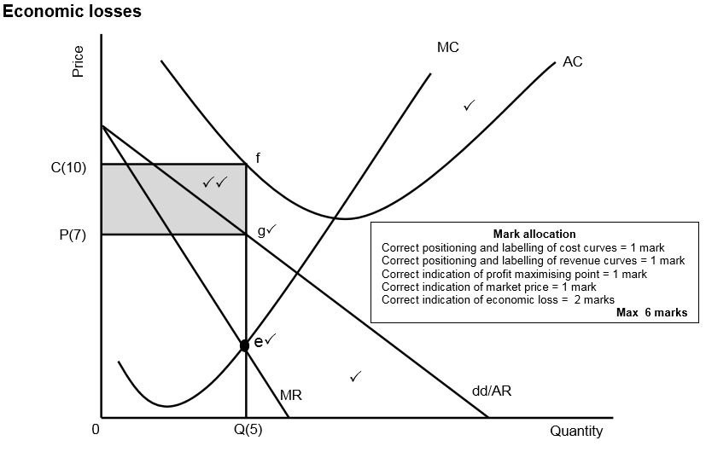

- The minimum point of SAC is higher than market price √√
- A monopoly makes an economic loss when its revenue is less than its costs √√
- The monopoly will produce at the output level where MR=MC, because it can minimise losses at this level √√
- Point g represents the average revenue at selling price (P[7]) while point f represents the average cost at the cost price (C[10]) √√
- The average cost is more than the average revenue, resulting in an economic loss for the business / When the TC is more than TR it will result in an economic loss for the business  • The shaded area PCef shows the economic loss √√
- The monopoly suffer an economic loss in the short run when the AC curve is above the market price (g) √√
- Total income = Price x Quantity = OP(7) x OQ(5) = OPgQ (35)
Total cost = Cost x Quantity = OC(10) x OQ(5) = OCfQ (50) √√
Economic loss = (PCfg)15 √√ (Max 10)
(Max 26)
ADDITIONAL PART
Why does the performance of natural monopolies contradict the long-run equilibrium position of a monopoly? (10 marks
Natural monopolies' performances are not always in line with the long-run equilibrium position of a monopoly because:
- compared to a typical monopoly where economic profit always prevails over the long run, natural monopolies do not enjoy the benefits experienced by other monopolies √√
  - natural monopolies require high development cost which prevent others from entering the market √√
  - natural monopolies supply goods and services to the nation as a whole and therefore it is difficult to set very high prices √√
  - Eskom is subjected to the National Energy Regulator in South Africa (NERSA) that determines the selling price of electricity in South Africa √√
  - a natural monopoly has experienced high maintenance cost compared to artificial monopolies, that compromises profit √√
  - natural monopolies cannot manipulate its quantities to increase prices √√
  - revenue seems to be less than cost due to corruption, non-payment by a large number of electricity users √√
  - under normal circumstances, a monopoly will shut down if average cost exceeds average revenue in the long run, but natural monopolies like SAA are often bailed out by the government due to its strategic position in the country √√
  - the internal (private cost) structure of natural monopolies have increased, but the private benefits (revenue of sales) stagnated due to poor maintenance of infrastructure√√
(Accept any other correct relevant response (Max 10)

CONCLUSION
The monopoly can continue to earn economic profit for as long as the demand for its product continues and its production costs stay the same √√ Max (2)
(Accept other correct relevant higher order conclusion)
[40]

