- Three Phase Transformers

  - Introduction to 3-Phase (3ϕ)Transformers

    - Principle of operation and connections of three phase transformers.

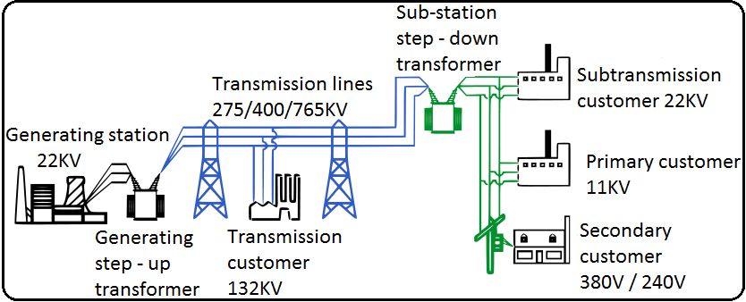
Figure: 4.1 General format of generation, transmission and distribution of power to the consumer
Before three phase transformers are discussed, it is important to know where they fit into the national distribution of power in South Africa. On one side, there is the provider (Electricity Supply Commission of South Africa – Eskom) and they generate three phase electricity. The consumers many of them use three phase machines. Getting the generated power from the provider to the consumer is where the three transformers fits in. the process of generating power from the supplier to the consumer is called the transmission and distribution of electricity.

Electricity is transmitted at a high voltages (110KV or above) to reduce the energy lost in long distance transmission. Power is usually transmitted through overhead power lines underground power transmission has a significantly higher cost and greater operational limitations but is sometimes used in urban areas or sensitive locations.

A key limitation to the distribution of electric power is that, with minor exceptions, electrical energy cannot be stored and therefore must be generated as needed. A sophisticated control system is required to ensure electricity generation very closely matches the demand If the demand for the power exceeds the supply, generation plants and transmission equipment can shut down which in the worst cases can lead to a major regional blackout, as has occurred in South Africa time to time. To reduce the risk of such failures, electricity transmission networks are interconnected into regional, national or continental networks, thus providing alternative routes for power to flow should failures occurs.

High voltage overhead conductors are not covered by insulation. The conductor material is nearly always an aluminium alloy, made into several strands and possibly reinforced with steel strands. Copper used to be used for overhead transmission but aluminium is lighter, yields only marginally reduced performance and costs much less. Overhead conductors are commodity supplied by several companies worldwide.

In order for the electricity to be transmitted safely and efficiently, it must be at a high voltage and a low current. If the current is too high, the cable would heat up too much and even melt. If the voltage is too low, hardly any energy would be carried.

The generation in the power stations produce 22KV. This voltage is raised by transformers before it’s sent out at 275KV, 400KV or even 7654KVonto transmission grid.

The electricity is transformed down to 11KV for load distribution and then further reduced according to the need, for example, 380v and 240V for domestic use. The electricity entering consumers at 240v has had an eventful journey, from the initial high voltage transmission grid to a lower distribution network. Travelling over ground and underground for a great many kilometres, it has been transformed many times along the way.

You have probably seen some of the equipment which performs these operations in your local area. They are known as substations which can be found in may sizes, with small transformers mounted on wooden poles and larger transformers mounted behind high fences and huge arrays of strangely shaped devices on sites occupying several hectors.

Eskom is the first utility in the world to successfully operate transmission lines at 765Kv at high altitude above the sea level.

    - Concept and understanding of losses.
The main source of heat generation in transformer is its copper loss or I2R loss. Although there are other factors contribute heat in transformer such as hysteresis & eddy current losses but contribution of I2R loss dominate them.

In an ideal transformer, the input power would match the output power 100%. However no transformer is 100% efficient. This is simply means that the power at the output is always less than the input. For example, if the transformer is rated at 100 kw, but only 97 kw is measured at the output, the transformer is 97% efficient. There are number of reasons for this and for the sake of keeping things simple will focus on the obvious ones.

Transformer losses
- Copper losses
The power losses which occur in the primary and secondary windings are as a result of resistance of the windings. These losses are converted to heat.
- Iron losses
These are heat losses that occur in the iron core due to hysteresis of the core materials and induced eddy currents in the laminated plates.
- Dielectric losses
The cooper wire used for windings of the primary and the secondary windings are covered with a thin layer of lacquer to insulate them and prevent shorting between coils. If this lacquer is damaged or not sufficient, a small leakage current will flow.
- Stray losses
Some of the magnetic field from the primary coil cut the surrounding metal parts of the transformer casing. This means that some of the magnetic field does not cut the secondary windings to induce current. It is considered as a loss.
- Magnetostriction
Magnetic flux in a ferromagnetic material, such as the core, causes it to physically expand and contract slightly with each cycle of the magnetic field, an effect known as magnetostriction. This produces the buzzing sound commonly associated with transformers, and in turn causes losses due to frictional heating in susceptible cores.
- Mechanical losses
In addition to magnetostriction, the alternating magnetic field causes fluctuating electromagnetic forces between the primary and secondary windings. These incite vibrations within nearby metalwork, adding to the buzzing noise, and consuming a small amount of power.

    - Three phase transformers compared to Single phase Transformers(delta/star, star/delta, delta/delta, star/star)

Single Phase Transformers | Three Phase Transformers
Has one coil on the primary and one on the secondary | Has three coils on the primary and three on the secondary
Has two wires on the primary and two on the secondary | Has six wires on the primary and six on the secondary
Has only one way to connect the primary and one way for the secondary | Can be connected in two formats (delta/star or star/delta) on the primary and secondary
Has a third of power | Has three times the power
cheaper | More expensive
Weigh less | Weighs much more
Provides less loading compared to three phase transformers | Provides better loading
Less skill is required to wire | Need to understand star and delta before connecting to supply
Reduced labour to install. Only live and neutral on the primary | Must first wire in star or delta before connecting to supply
Only one operating voltage on the secondary | Two operating voltages if connected in star
Cheaper to replace | If just one wire broken the whole transformer must be replaced

    - Construction of Transformers

In grade 11, have looked at the construction and operation of the single-phase, two winding voltage transformer which can be used increase or decrease its secondary voltage with respect to the primary supply voltage. But voltage transformers can also be constructed for connection to not only one single phase, but for two-phases, three-phases, six-phases and even elaborate combinations up to 24-phases for some DC rectification transformers.

If we take three single-phase transformers and connect their primary windings to each other and their secondary windings to each other in a fixed configuration, we can use the transformers on a three-phase supply.

A transformer cannot act as a phase changing device and change single-phase into three-phase or three-phase into single phase. To make the transformer connections compatible with three-phase supplies we need to connect them together in a particular way to form a Three Phase Transformer Configuration.

A three phase transformer or 3φ transformer can be constructed either by connecting together three single-phase transformers, thereby forming a so-called three phase transformer bank, or by using one pre-assembled and balanced three phase transformer which consists of three pairs of single phase windings mounted onto one single laminated core.

The advantages of building a single three phase transformer is that for the same kVA rating it will be smaller, cheaper and lighter than three individual single phase transformers connected together because the copper and iron core are used more effectively. The methods of connecting the primary and secondary windings are the same, whether using just one Three Phase Transformer or three separate Single Phase Transformers. Consider the circuit below (figure 4.2):

Star / Delta Transformer
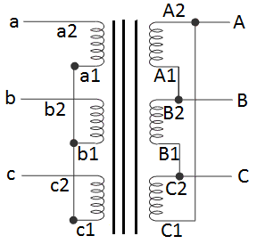
Figure: 4.3 (a) star / delta transformer by means of three single phase transformers

Figure: 4.3 (b) star / delta transformer by means of single three phase transformer
L₂
L₁
L₃
L₂
L₁
L₃
Here in star-delta transformer, star connection in HV side is formed by connecting all the 1 suffixed terminals together as common point and transformer primary leads are taken out from 2 suffixed terminals of primary windings.

The delta connection in LV side is formed by connecting 1 suffixed terminals of each phase LV winding with 2 suffixed terminal of next phase LV winding. More clearly, A₁ is connected to B₂, B₁ is connected to C₂and C₁ is connected to A₂. The secondary (here it considered as LV) leads are taken out from 2 suffixed ends of the secondary windings of transformer. The transformer connection diagram is shown in figure 4.3 (a).

Characteristics of a star-delta or delta-star connection
- Combines advantages of both star and delta in one transformer
- Used in power distribution system where voltage must be stepped up or down
- No neutral displacement under unbalanced loads
- The star can provide a neutral
- Polarity conscious due to an inherent electrical 30⁰ phase shift between primary and secondary

Delta / Star Transformer
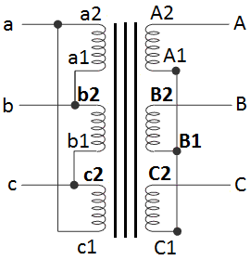
Figure: 4.4 (a) delta / star transformer by means of three single phase transformers
Figure: 4.4 (b) delta / star transformer by means of single three phase transformer
L₁
L₂
L₃
L₂
L₃
L₁
Delta-star transformer connection of three phase transformer is similar to star – delta connection. If anyone interchanges HV side and LV side of star-delta transformer in diagram, it simply becomes delta/star connected 3 phase transformer. That means all small letters of star/delta connection should be replaced by capital letters and all small letters by capital in delta-star transformer connection.

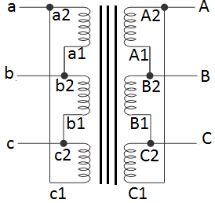
Delta / Delta Transformer
Figure: 4.5 (a) delta / delta transformer by means of three
single phase transformers

L₂
L₃
L₁
L₂
L₃
L₁
Figure: 4.5 (b) delta / delta transformer by means of single three phase transformer

In delta-delta transformer, 1 suffixed terminals of each phase primary winding will be connected with 2 suffixed terminal of next phase primary winding.

If primary is HV side, then A₁ will be connected to B₂, B₁ will be connected to C₂ and C₁ will be connected to A₂. Similarly in LV side 1 suffixed terminals of each phase winding will be connected with 2 suffixed terminals of next phase winding. That means, a₁ will be connected to b₂, b₁will be connected to c₂ and c₁ will be connected to a₂. If transformer leads are taken out from primary and secondary 2 suffixed terminals of the winding, then there will be no phase difference between similar line voltages in primary and secondary. This delta delta transformer connection is zero degree connection or 0°-connection.

But in LV side of transformer, if, a₂ is connected to b₁, b₂ is connected to c₁ and c₂ is connected to a₁. The secondary leads of transformer are taken out from 2 suffixed terminals of LV windings, and then similar line voltages in primary and secondary will be in phase opposition. This connection is called 180°-connection, of three phase transformer.

Characteristics of a delta-delta connection
- Relatively large, low line voltage applications
- No possibility of a neutral on either side
- Phase current under balanced conditions only 57,7% of the line current
- Continuous service even if one phase is removed (open VEE system)
- No phase shift displacement between primary and secondary

Star / Star Transformer
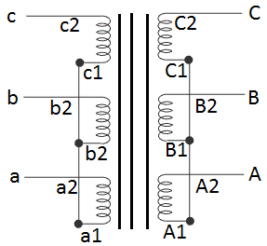
Figure: 4.5 (a) star / star transformer by means of three single phase transformers

L₂
L₃
L₁
L₂
L₁
L₃
Figure: 4.5 (b) star / star transformer by means of single three phase transformer

Star-star transformer is formed in a 3 phase transformer by connecting one terminal of each phase of individual side, together. The common terminal is indicated by suffix 1 in the figure below. If terminal with suffix 1 in both primary and secondary are used as common terminal, voltages of primary and secondary are in same phase. That is why this connection is called zero degree connection or 0° - connection.

If the terminals with suffix 1 are connected together in HV side as common point and the terminals with suffix 2 in LV side are connected together as common point, the voltages in primary and secondary will be in opposite phase. Hence, star-star transformer connection is called 180° connection, of three phase transformer.

Characteristics of a star-star connection
- Used for small high voltage applications
- It gives a V_{L} of $√3$ times V_{PH}
- Most economical due to minimum insulation required
- Smallest number of windings required
- Lowest insulation and smallest number of turns per phase
- No phase shift between V_{Prim} and V_{Sec}
- Possibility of a star point forming a neutral on both the primary and secondary sides

Types of three phase transformers – basic types of construction

- Core type transformer
In the core type transformer, the windings are given to a major part of the core. This means a lots of windings and less core. The coils used for this transformer are form wound and are cylindrical in shape. This type can be used in small sized and large sized transformers.The cylindrical coils will have different layers and each layer will be insulated from each other with materials such as lacquer, paer,cloth etc. The general arrangement of the core type transformer is shown in figure: 4.6 (a).
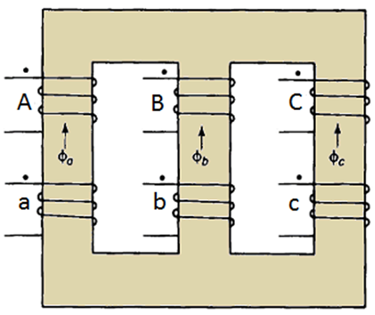
Figure: 4.6 (a) core type transformer
- Shell type transformer
In the transformer, the core surrounds a considerable portion of the windings. This mean more of the core is visible compare to the core type. The whole winding consists of discs stacked with insulation spaces between the coils. Most shell type tranformers may have the shape of a rectangle.

A strong mechanical support must be given to the core and colis of the shell type transformer. A transformer with good support will not produce any humming noise while working and will reduce vibration of the laminated plates

These transformers are placed in tightly fitted sheet metal tanks filled with special insulating oil. The arranement the shell type transformer is shown in figuredf 4.6 (b)

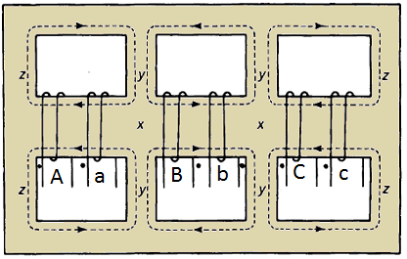
Figure: 4.6 (b) shell type transformer
Types of three phase transformers
There are several different types of transformers available in the world market, mainly divided by Power and tension supplied, but also depending on its application. Here we list the major differences trying to explain in general their advantages and applications.
- SDT Small Distribution Transformers
- DST Distribution Transformers
- CRT Cast Resin Transformers
- DTH Dry Type Transformers H class insulation
- LDT Large Distribution Transformers
- MPT Medium Power Transformers
- LPT Large Power Transformers

Small Distribution Transformers

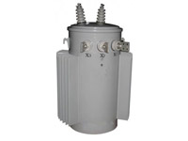
Power range: Usually from 50 to 200 Kva within 35 Kv
Main use: Distribution in rural areas and countryside
Main advantages: Small production costs with possibility of good automation

Distribution Transformers

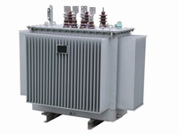
Power range: Usually from 250 to 2500 Kva within 35 Kv
Main use: Distribution of energy in cities and centre with different houses
Main advantages: Great extension of use in different outdoor application

Cast Resin Transformers

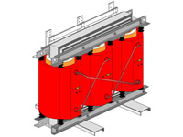
Power range: Usually from 250 to 4000 Kva within 35 Kv
Main use: Underground systems, mines and skyscrapers.
Main advantages: Fireproof and explosion-proof, particularly adapted for Indoor applications

Dry Type Transformers
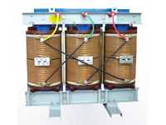
Power range: Usually from 250 to 4000 Kva within 35 Kv
Main use: Underground systems, mines and skyscrapers.
Main advantages: Fireproof and explosion-proof, particularly adapted for Indoor applications

Large Distribution Transformers
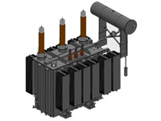
Power range: Usually from 2500 to 20000 Kva within 35 Kv
Main use: Grid interconnections, Industrial application, special application as furnace or railway..
Main advantages: Big power within the tension of distribution 35 Kv

Medium Power Transformers
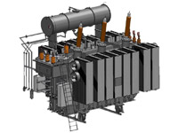
Power range: Usually from 250 to 4000 Kva
Main use: Interconnecting grids.
Main advantages: Big power and high tension

Large Power Transformers
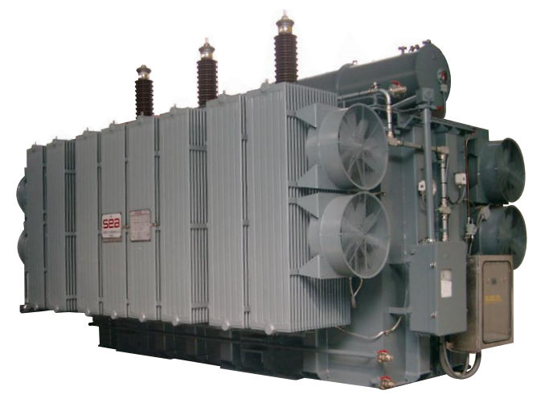
Power range: Usually from 250 to 1000 MVA
Main use: Interconnecting grids and main power station.
Main advantages: Big power and high tension

    - Application of Transformers

- Star-star
- They are used for small high voltage applications

- Delta-delta
- Relatively large, low line voltage applications
- They handle large current at low voltages
- No need for stable neutral
- Isolation transformers in power converters
- They are used in industrial appplications if there is no need for neutral
- Delta-star and Star-delta
- Sbstation transformers, with the delta connected to the grid and the star connected to the load substation
- Used in power distribution systems, where voltage must be stepped up or down
- Most common for commercial and inde=ustrial delta-star high voltage transmissions

    - Cooling
The main source of heat generation in transformer is its copper loss or I²R loss. Although there are other factors contribute heat in transformer such as hysteresis & eddy current losses but contribution of I²R loss dominate them. If this heat is not dissipated properly, the temperature of the transformer will rise continually which may cause damages in paper insulation and liquid insulation medium of transformer. So it is essential to control the temperature with in permissible limit to ensure the long life of transformer by reducing thermal degradation of its insulation system. In electrical power transformer we use external transformer cooling system to accelerate the dissipation rate of heat of transformer. There are different transformer cooling methods available for transformer, we will now explain one by one.

ONAN "Oil Natural Air Natural" Cooling of Transformer
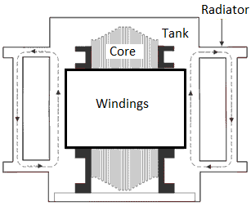
Figure: 4.1.6 (a) direction of convectional flow of oil in a transformer

This is the simplest transformer cooling system. The full form of ONAN is "Oil Natural Air Natural". Here natural convectional flow of hot oil is utilized for cooling. In convectional circulation of oil, the hot oil flows to the upper portion of the transformer tank and the vacant place is occupied by cold oil. This hot oil which comes to upper side will dissipate heat in the atmosphere by natural conduction, convection & radiation in air and will become cold. In this way the oil in the transformer tank continually circulate when the transformer put into load. As the rate of dissipation of heat in air depends upon dissipating surface of the oil tank, it is essential to increase the effective surface area of the tank. The additional dissipating surface in the form of tubes or radiators connected to the transformer tank. This is known as radiator of transformer or radiator bank of transformer.

- ONAF Cooling of Transformer
Heat dissipation can obviously be increased, if dissipating surface is increased but it can be make further faster by applying forced air flow on that dissipating surface. Fans blowing air on cooling surface is employed. Forced air takes away the heat from the surface of radiator and provides better cooling than natural air. The full form of ONAF is "Oil Natural Air Forced". As the heat dissipation rate is faster and more in ONAF transformer cooling method than ONAN cooling system, electrical power transformer can be put into more load without crossing the permissible temperature limits.
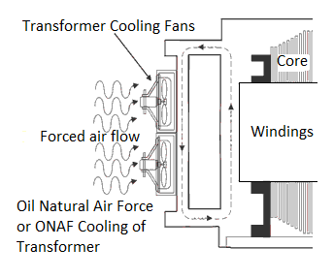
Figure: 4.1.6 (b) ONAF cooling of a transformer

- OFAF Cooling of Transformer
In oil forced air natural cooling system of transformer, the heat dissipation is accelerated by using forced air on the dissipating surface but circulation of the hot oil in transformer tank is natural convectional flow.

The heat dissipation rate can be still increased further if this oil circulation is accelerated by applying some force. In OFAF cooling system the oil is forced to circulate within the closed loop of transformer tank by means of oil pumps. OFAF means "Oil Forced Air Forced" cooling methods of transformer. The main advantage of this system is that it is compact system and for same cooling capacity OFAF occupies much less space than farmer two systems of transformer cooling. Actually in oil natural cooling system, the heat comes out from conducting part of the transformer is displaced from its position, in slower rate due to convectional flow of oil but in forced oil cooling system the heat is displaced from its origin as soon as it comes out in the oil, hence rate of cooling becomes faster.
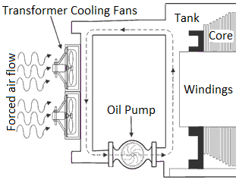
Figure: 4.1.6 (c) Oil Forced Air Forced or OFAF Cooling of Transformer

OFWF Cooling of Transformer
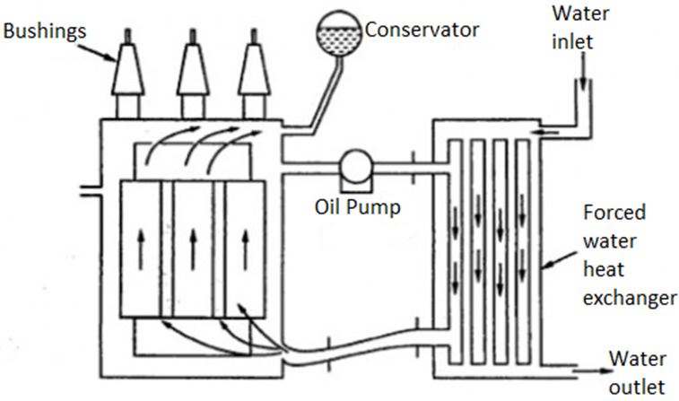
Figure: 4.1.6 (c) Oil Forced Water Forced Cooling of Transformer

We know that ambient temperature of water is much less than the atmospheric air in same weather condition. So water may be used as better heat exchanger media than air. In OFWF cooling system of transformer, the hot oil is sent to “an oil to water heat exchanger” by means of oil pump and there the oil is cooled by applying sowers of cold water on the heat exchanger's oil pipes. OFWF means "Oil Forced Water Forced" cooling in transformer.

ODAF Cooling of Transformer
ODAF or oil directed air forced cooling of transformer can be considered as the improved version of OFAF. Here forced circulation of oil directed to flow through predetermined paths in transformer winding. The cool oil entering the transformer tank from cooler or radiator is passed through the winding where gaps for oil flow or pre-decided oil flowing paths between insulated conductors are provided for ensuring faster rate of heat transfer. ODAF or oil directed air forced cooling of transformer is generally used in very high rating transformer.

ODWF Cooling of Transformer
ODAF or oil directed water forced cooling of transformer is just like ODAF only difference is that here the hot oil is cooled in cooler by means of forced water instead of air. Both of these transformer cooling methods are called forced directed oil cooling of transformer.

Summary Methods of Cooling Transformers
Based on the coolant used the cooling methods can be classified into:
- Air cooling
- Oil and Air cooling
- Oil and Water cooling
1. Air cooling (Dry type transformers)
- Air Natural(AN)
- Air Blast (AB)
2. Oil cooling (Oil immersed transformers)
- Oil Natural Air Natural (ONAN)
- Oil Natural Air Forced (ONAF)
- Oil Forced Air Natural (OFAN)
- Oil Forced Air Forced (OFAF)
3. Oil and Water cooling (For capacity more than 30MVA)
- Oil Natural Water Forced (ONWF)
- Oil Forced Water Forced (OFWF)
    - Safety
Power transformers require periodic inspection to ensure proper operation and safety, not only for persons nearby, but also for the equipment itself and the environment. Electrocution is the most prevalent danger, but the environment of transformers may also cause injury. Oil spills can make slippery surfaces and sharp edges can cause cuts. Also other work going on in industrial areas can cause accidents, so always stay alert.

Inspection Precautions: Inspect with your eyes only as far as possible. Keep your hands behind your back as much as you can and don't touch anything if you don't have to. If you have to touch a transformer, make sure it's properly grounded. If you need to use an inspection mirror, use one with a plastic or fiberglass case and handle. Never use metal. Never assume a transformer is turned off. Make absolutely sure it is de-energized before touching any connections.

Clothing: Remove all metal objects from your body and your pockets: jewellery, wristwatches, pens, coins or any other metal objects, including badges. Don't wear loose-fitting clothing that could get caught on sharp edges of equipment, and don't wear clothes with metal buttons or fasteners. Remove your belt buckle before inspecting transformers.

    - Protection
Improper inspection procedures can also damage the transformer. Do not tamper with interlocks or safety or control devices or circuits. If you must open a liquid-filled transformer, make sure the outside temperature is cooler than the coolant inside to prevent condensation inside. If you need to open any inspection ports such as hand holes, make sure no moisture enters the transformer. Even small amounts could cause severe damage. Be careful not to drop any foreign objects into cooling tanks.

  - Calculations (Balanced Loads Only)
Three phase transformer formulae (revision)
$$In a star connected system$$
$$V_{L}=√3V_{P}$$
$$I_{L}=I_{P}$$

$$In delta connected system$$
$$I_{L}=√3I_{P}$$
$$V_{L}=V_{P}$$

$$Power per phase in a star connected system$$
$$Total power=3×power in one phase$$
$=3×V_{P}×I_{P}cos∅$
$=3×\frac{V_{L}}{\sqrt{3}}×I_{L}cos∅ (V_{P}=\frac{V_{L}}{\sqrt{3}} and{{ I}_{P}= I}_{L})$
$$∴P_{T}=√3V_{L}I_{L}cos∅$$

$$Note that \frac{3}{√3}=√3$$

$$Power per phase in a delta connected system$$
$$Total power=3×power in one phase$$
$=3×V_{P}×I_{P}cos∅$
$=3×V_{L}×\frac{I_{L}}{√3}cos∅ (V_{P}=V_{L} and I_{P=}\frac{I_{L}}{√3})$
$$∴P_{T}=√3V_{L}I_{L}cos∅$$

$$Apparent Power for both delta and star$$

$$S=√3V_{L}I_{L}$$

$$Reactive Power for both star and delta$$

$$∴P_{R}=√3V_{L}I_{L}sin∅$$

    - Ratio
Example 4.2.1 (a)
The transformer supplying Tetelo Comprehensive School with power is connected in delta to an 11 kV supply. The secondary side supplies the school with a three-phase four-wire system. The school receives a single-phase voltage of 220 V and three-phase line voltage of 380 V from the transformer. Calculate the transformation ratio.

$$\frac{V_{1}}{V_{2}}=\frac{N_{1}}{N_{2}}=\frac{I_{2}}{I_{1}}$$

$$T.R=\frac{V_{1PH}}{V_{2PH}}$$

$$=\frac{11000}{220}$$

$$∴T.R=50:1$$
Example 4.2.1 (b)
A 250 kVA, three-phase transformer with 400 turns on the primary is connected in delta-star. The supply voltage is 6 600 V. The secondary line voltage is 415 V. Calculate the turns ratio.

Given: $V_{1PH}=6 600V$
$$V_{2L}=415V$$

$$V_{2PH}=\frac{V_{2L}}{√3}$$

$$=\frac{415V}{√3}$$

$$∴V_{2PH}=239.6V$$

$$T.R=\frac{V_{1PH}}{V_{2PH}}$$

$$=\frac{6 600}{239.6}$$

$$∴T.R=28:1$$

    - Line and Phase Current, Voltage and Power

Example 4.2.2
A 240V kVA three phase transformer supplies power to Orlando stadium. The transformer is connected in delta –star. The input voltage is 11 kV and the output line voltage is 450 V at a lagging power factor of 0,85.

Given
S = 240 KVA
V_{L(P)} = 11 000 V
V_{L(S)} = 415 V
Cos ø = 0,85

Calculate
- The secondary phase voltage
- The current drawn from the supply by transformer at full load
- The power delivered at full to the stadium

Solution
- $V_{L\left(S\right)}=\sqrt{3}V_{PH(S)}$

$$V_{PH(S)}=\frac{V_{L(S)}}{√3}$$

$$=\frac{415 V}{√3}$$

$$=239,6 V$$

- $S=√3×V_{L(P)}×I_{L(P)}$

$$I_{L(P)}=\frac{S}{√3V_{L(P)}}$$

$$=\frac{240 000VVA}{\sqrt{3}×11 000V}$$

$$=12,597 A$$

- $P_{Out}=√3×V_{L(P)}×I_{L(P)}Cos∅$
$$=\sqrt{3}×11000×12,597×0,85$$
$$=204 KW$$

    - Power Factor

Example 4.2.3
A 500 kVA three phase transformer supplies power to Sci-Bono Discovery Centre. The transformer output power is 450 kW. Calculate the power factor of the transformer.

Given:
S = 500 kVA
P_{OUT} = 250 kW

Solution:
$$P_{OUT}=S ×Cos∅$$
$$∴Cos∅=\frac{P_{OUT}}{S}$$

$$=\frac{450}{500}$$

$$=0,9$$

    - Power
A three-phase 250 kVA transformer has a star-connected secondary with a phase voltage of 220 V. Calculate the output power of the transformer at a power factor of 0,8 lagging.

Solution

$$P_{out}=S×Cos∅$$

$$=250 000×0,8$$

$$=200kW$$

    - Load including losses and efficiency.

Example 4.2.5

Three identical single-phase transformers, each having turns ratio of 50:1 are connected in star-delta across a 33kV supply. The load connected to the transformers is a three phase star connected motor with power factor of 0,8 an efficiency of 90%.

- Draw a fully labelled circuit diagram of transformers, the motor and show all interconnections.
- Calculate the voltage across each motor winding
- Calculate the current through each motor winding if the output power of the motor is 20 kW.

Solution

star / delta transformer by means of single three phase transformer
L₂
L₁
L₃
L₂
L₁
L₃

Star connected motor
(Balanced load)
Star / Delta Transformer
N_{P}:N_{S} = 50:1
33kV

- The transformer primary winding is in star, therefore the transformer primary phase voltage calculated is as follows:-

$$V_{L(P)}=√3V_{p(p)}$$

$$V_{p(p)}=\frac{V_{L(P)}}{√3}$$

$$=\frac{33kV}{√3}$$

$$=19kV$$

The transformer secondary winding is in delta, therefore the transformer secondary phase voltage is calculated as follows:-

$$\frac{V_{p(S)}}{V_{P(P)}}=\frac{N_{P(s)}}{N_{P(p)}}$$

$$V_{P(s)}=\frac{N_{P(s)}}{N_{P(p)}}×V_{P(P)}$$

$$=\frac{1}{50}×19000V$$

$$∴V_{P(s)}=380V$$

The load (motor) winding is in star, therefore the motor phase voltage is calculated as follows:-

$$V_{L(M)}=√3×V_{P(M)}$$

$$V_{P(M)}=\frac{V_{L(M)}}{√3}$$
$$=\frac{380V}{√3}$$

$$=220V$$

$$η=\frac{P_{OUT}}{P_{IN}}$$

$$P_{IN}=\frac{P_{OUT}}{η}$$
$$=\frac{20kW}{0,9}$$

$$=22,2kW$$

$$P_{IN}=√3×V_{L(M)}×I_{L(M)}Cos∅$$

$$I_{L(M)}=\frac{P_{IN}}{√3×V_{L(M)}Cos∅}$$

$$=\frac{22,2×{10}^{3}}{\sqrt{3}×380×0,8}$$

$$∴I_{L(M)}=42,162A$$

  - Practical: Wiring of Single Phase transformers to 3 Phase: Star/Star; Star/Delta; Delta/Star; Delta/Delta

Electrical - 1

Simulation 1 Time: 1 hour

Learner Name:

School:

Examination Number:

Connecting three single-phase transformers to three-phase supply

1. | Purpose  To examine how star- and delta-connected transformers react in respect of voltage and current.

2. | What you are going to do  Connect and test three single-phase transformers using a three-phase supply.

3. | What you will need  - Three identical single-phase transformers, step down  - A three-phase supply  - Multi-meter  - Connecting wires  - Three lamp holders  - Three 55-60 W lamps or smaller (12V downlighters work well)

NOTE: The secondary voltage of the transformer is not critical. The only requirement is that the secondary voltage and the voltage of the lamps are compatible.

It is the duty of the teacher to verify that the learners are connecting the transformers correctly, before connecting the mains supply. If you are not entirely sure of your connections do not switch on. Test for short circuits.
Mains supply can be lethal. Be extremely careful.

4. | What you must do

1. | Draw the circuit diagram in which the transformers are connected in a star/star connection. Number each phase. Now wire the circuit up. | (3=Drawing)  (5=Wiring)

2. | Now change the secondary configuration to a star/delta configuration. Draw the circuit diagram to show the changes. |  | (3=Drawing)  (5=Wiring)

3. | Now change the secondary configuration to a delta/star configuration. Draw the circuit diagram to show the changes. |  | (3=Drawing)  (5=Wiring)

4. | Now change the secondary configuration to a delta/delta configuration. Draw the circuit diagram to show the changes. |  | (3=Drawing)  (5=Wiring)

  - Practical: Testing Transformers

1. | Complete the following table by measuring the primary and secondary voltages and current. |  | (12)

Star/Star Connection

 | Primary  Supply to each transformer |  | Secondary  Supply to each lamp
 | Voltage | Current | Voltage | Current
Phase 1
Phase 2
Phase 3

2. | Complete the following table by measuring the primary and secondary voltages and current. |  | (12)

Star/Delta Connection

 | Primary  Supply to each transformer |  | Secondary  Supply to each lamp
 | Voltage | Current | Voltage | Current
Phase 1
Phase 2
Phase 3

3. | Complete the following table by measuring the primary and secondary voltages and current. |  | (12)

Delta/Star Connection

 | Primary  Supply to each transformer |  | Secondary  Supply to each lamp
 | Voltage | Current | Voltage | Current
Phase 1
Phase 2
Phase 3

4. | Complete the following table by measuring the primary and secondary voltages and current. |  | (12)

Delta/Delta Connection

 | Primary  Supply to each transformer |  | Secondary  Supply to each lamp
 | Voltage | Current | Voltage | Current
Phase 1
Phase 2
Phase 3

  - Homework Exercises

Exercise 4.5.1
- A 30 kVA transformer with a winding ratio of 50:1 is connected in delta-star formation to supply a farm with a line voltage of 380 V. Calculate the following:
- Secondary phase voltage
- Primary line voltage
- Power delivered at full-load at a power factor of 0,85 lagging

- With a three-phase system, three single-phase transformers may be used to step the voltage up or down.

With the aid of a diagram, show how three single-phase transformers may be connected to act as a star-delta unit.

- Name TWO methods that may be used to reduce the magnetic leakage flux of a transformer.

Exercise 4.5.2
- The oil used in tanks of large transformers serves a dual purpose. Name the dual purpose of the oil.

- A new school is under construction. The school will be fed from an 11 kV supply. The school requires a single-phase and a three-phase supply.

Draw a schematic diagram to show how the primary and the secondary of the transformer supplying the school will be connected.

- Three single-phase transformers are connected in delta-star to form one three-phase transformer. The supply voltage is 11 kV and the turns ratio is 45:1. Ignore the transformer losses and calculate at full load:
    - The secondary phase voltage
    - The secondary line voltage

Exercise 4.5.3

Circle one correct answer

- Which of the following does not change in a transformer?
- Current
- Voltage
- Frequency
- All of the above

- In a transformer the energy is conveyed from primary to secondary
- through cooling coil
- through air
- by the flux
- none of the above

- A transformer core is laminated to
- reduce hysteresis loss
- reduce eddy current losses
- reduce copper losses
- reduce all above losses

- The degree of mechanical vibrations produced by the laminations of a transformer depends on
- tightness of clamping
- gauge of laminations
- size of laminations
- all of the above

- The no-load current drawn by transformer is usually what per cent of the full-load current?
- 0.2 to 0.5 per cent
- 2 to 5 per cent
- 12 to 15 per cent
- 20 to 30 per cent

- The path of a magnetic flux in a transformer should have
- high resistance
- high reluctance
- low resistance
- low reluctance

- No-load on a transformer is carried out to determine
- copper loss
- magnetising current
- magnetising current and loss
- efficiency of the transformer

- The dielectric strength of transformer oil is expected to be
- 1kV
- 33 kV
- 100 kV
- 330 kV

- Sumpner's test is conducted on trans-formers to determine
- temperature
- stray losses
- all-day efficiency
- none of the above

- The permissible flux density in case of cold rolled grain oriented steel is around
- 1.7 Wb/m2
- 2.7 Wb/m2
- 3.7 Wb/m2
- 4.7 Wb/m2

- The efficiency of a transformer will be maximum when
- copper losses = hysteresis losses
- hysteresis losses = eddy current losses
- eddy current losses = copper losses
- copper losses = iron losses

- No-load current in a transformer
- lags behind the voltage by about 75°
- leads the voltage by about 75°
- lags behind the voltage by about 15°
- leads the voltage by about 15°

- The purpose of providing an iron core in a transformer is to
- provide support to windings
- reduce hysteresis loss
- decrease the reluctance of the magnetic path
- reduce eddy current losses

- Which of the following is not a part of transformer installation?
- Conservator
- Breather
- Buchholz relay
- Exciter

- While conducting short-circuit test on a transformer the following side is short circuited
- High voltage side
- Low voltage side
- Primary side
- Secondary side

- In the transformer following winding has got more cross-sectional area
- Low voltage winding
- High voltage winding
- Primary winding
- Secondary winding

- A transformer transforms
- voltage
- current
- power
- frequency

- A transformer cannot raise or lower the voltage of a D.C. supply because
- there is no need to change the D.C. voltage
- a D.C. circuit has more losses
- Faraday's laws of electromagnetic induction are not valid since the rate of change of flux is zero
- none of the above

- Primary winding of a transformer
- is always a low voltage winding
- is always a high voltage winding
- could either be a low voltage or high voltage winding
- none of the above

- Which winding in a transformer has more number of turns?
- Low voltage winding
- High voltage winding
- Primary winding
- Secondary winding

- Efficiency of a power transformer is of the order of
- 100 per cent
- 98 per cent
- 50 per cent
- 25 per cent

- In a given transformer for given applied voltage, losses which remain constant irrespective of load changes are
- friction and windage losses
- copper losses
- hysteresis and eddy current losses
- none of the above

- A common method of cooling a power transformer is
- natural air cooling
- air blast cooling
- oil cooling
- any of the above
- The no load current in a transformer lags behind the applied voltage by an angle of about
- 180°
- 120⁰
- 90°
- 75°

- In a transformer routine efficiency depends upon
- supply frequency
- load current
- power factor of load
- both (b) and (c)

- In the transformer the function of a conservator is to
- provide fresh air for cooling the transformer
- supply cooling oil to transformer in time of need
- protect the transformer from damage when oil expends due to heating
- none of the above

- Natural oil cooling is used for transformers up to a rating of
- 3000 kVA
- 1000 kVA
- 500 kVA
- 250 kVA

- Power transformers are designed to have maximum efficiency at
- nearly full load
- 70% full load
- 50% full load
- no load

- The maximum efficiency of a distribution transformer is
- at no load
- at 50% full load
- at 80% full load
- at full load

- Transformer breaths in when
- load on it increases
- load on it decreases
- load remains constant
- none of the above

Exercise 4.5.1 – Possible answers

$$V_{2L}=√3V_{2PH}$$

$$V_{2PH}=\frac{V_{2L}}{√3}$$

$$V_{2PH}=\frac{380V}{√3}$$

$=219,4V$

$$V_{1L}=V_{1PH}$$

$$V_{1PH}=\frac{N_{1}}{N_{2}}×V_{2PH}$$

$$=\frac{50}{1}×219,4$$

$$=10,97kV$$

$$S=√3×V_{2L}×I_{2L}$$

$$I_{2L)}=\frac{S}{√3V_{2L}}$$

$$=\frac{30 kVA}{√3×380}$$

$$=45.58A$$

$$P_{OUT}=√3×V_{2L}×I_{2L}Cos∅$$

$$P_{OUT}=√3×380×45,58×0,85$$

$$=25,5 kW$$

star / delta transformer by means of three single phase transformers

- Making the transformer window long and narrow.
- Arranging the primary and secondary windings
- Using shell-type construction
- Sandwiching and the primary winding

Exercise 4.5.1 – Possible Answers

    - For insulation purposes
    - For cooling purposes

L₁
L₂
L₃
L₂
L₃
L₁
N
Single Phase

Three Phase

Primary Winding
Secondary Winding

$$\frac{V_{1PH}}{V_{2PH}}=\frac{N_{1}}{N_{2}}$$

$$V_{2PH}=\frac{N_{2}}{N_{1}}×V_{1PH}$$

$$=\frac{1×11000}{45}$$
$$=244,44 V$$

$$V_{2L}=√3V_{2PH}$$

$$=\sqrt{3}×244,44$$

$$=423,38 V$$

Exercise 4.5.3 – Possible Answers

- c
- c
- b
- d
- b
- d
- c
- b
- a
- a
- d
- a
- c
- d
- b
- a
- c
- c
- c
- b
- b
- c
- c
- d
- d
- c
- a
- a
- b
- b

