1 CLIMATE AND WEATHER

1.1 MID-LATITUDE CYCLONES (MLC)
1.1.1 General Characteristics
-Name the general characteristics of the mid-latitude cyclone
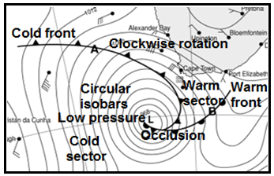
NB The following:
- Cold front (air behind front cold)
- Warm front (air behind front warm)
- Circular isobars
- Warm sector
- Cold sector
- Clockwise movement of air
- Low pressure in centre
- Value of isobars decrease
Towards centre
- Moves from west to east

NB you must be able to identify these characteristics on weather maps and diagrams

-Distinguish between a warm and a cold front
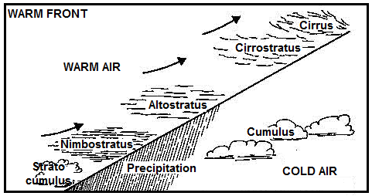

Warm air is forced to override cold air

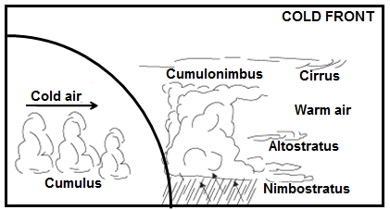

Cold air undercuts a body of warm air

1.1.2 Weather changes
Key question
What weather changes occur when a cold front moves over an area?
NB You must be able to apply this content on synoptic weather map as well.
- Sudden decrease in temperature.
- Air pressure increases.
- Wind direction changes from northwest to southwest.
- Wind speed very strong to gale force.
- Cloud cover very thick, cumulonimbus and cumulus clouds
- Rainfall heavy showers
- Humidity starts to decrease

1.1.3 Development stages
-Identify the stages of the MLC on the weather map.
Give a reason for your answer.

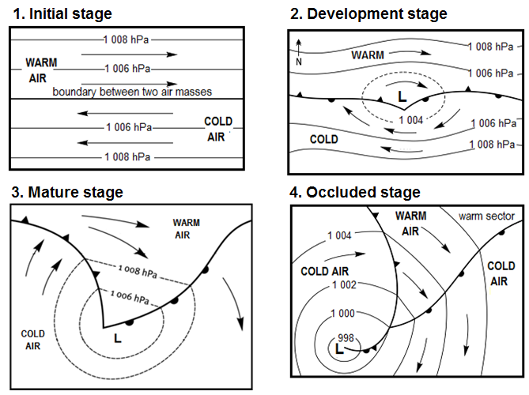

1.2 TROPICAL CYCLONES (TC)
    - General characteristics
You must know ALL General characteristics of tropical cyclones
and identify them on synoptic weather maps and diagrams.
- Intense low pressures.
- Named in alphabetical order.
- During late summer or autumn.
- Move from EAST to WEST. AWAY from the equator. Turns EAST at 30°.
- Causes destruction by hurricane force winds, storm surges and heavy rainfall.

    - Development stages
Identify the stages of tropical cyclones. Give reasons for your answer.
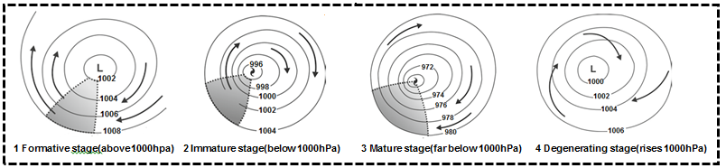

1.2.3 Management of tropical cyclones
How can tropical cyclones be managed NB Paragraph-type question
- Good weather forecasts.
- Keep public informed by tracking storm
- Early warning systems.
- Medical- and rescue services on alert.
- Build houses with strong materials.
- Evacuation routes and procedures
- Avoid crossing strongly flowing rivers

  - SUBTROPICAL ANTICYCLONES (HIGH PRESSURES)
    - Give the names and location of the three high pressures.

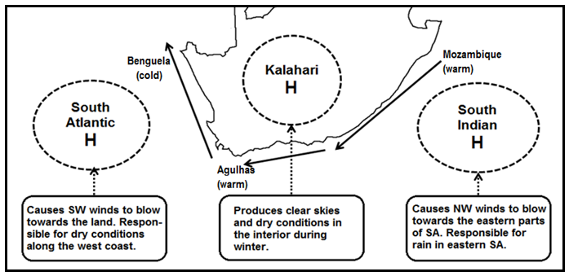

    - Explain how line thunderstorms are formed.

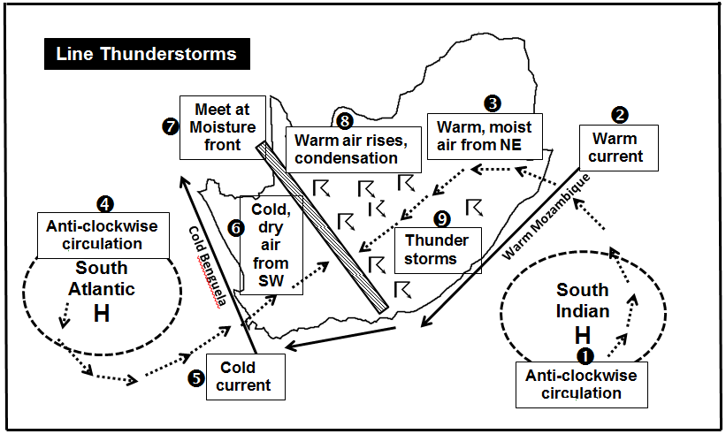

1.3.3 South African Berg wind

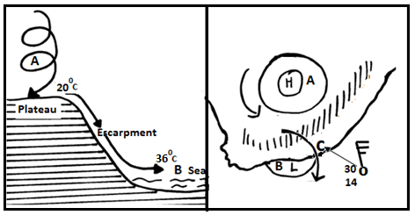

- In what season does the SA berg wind occur?: Winter
- How formed: -High pressure in interior
-Low pressure at sea
-Wind blows from interior(HP) to sea(LP)
-Warmed as it decends over plateau
-Reaches coast as warm dry wind
- Why warm and dry?: Blow from land to sea
- Danger: Veld fires
- How wind stops: Cold front moves over.

  - VALLEY CLIMATES
    - What slope is warmer? Why? (NH and SH)
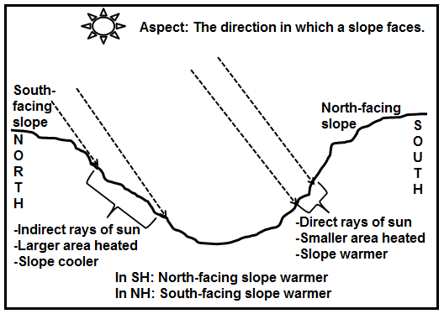

    - Explain how anabatic and katabatic winds are formed
Discuss the influence on settlements and farming
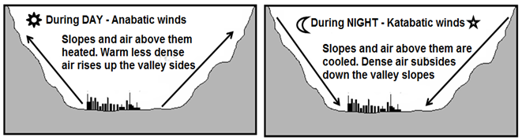

1.4.3 INVERSIONS

-How are inversions formed? What is the influence of inversions on pollution?

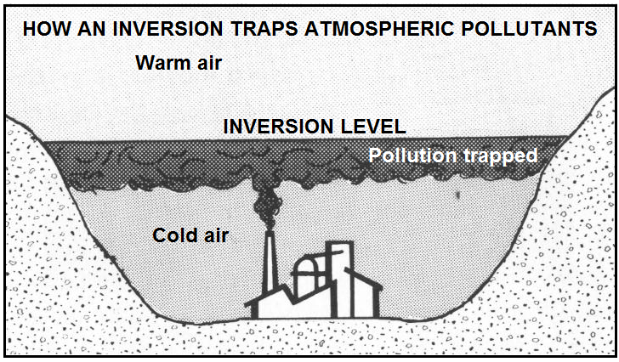

- Inversions form when the normal pattern
of air temperature is reversed.
- Air closer to the ground is cooler than the
air above it.
- Happens on calm cloudless winter nights.
- Upper slopes cool rapidly.
- Cold air sinks down slopes to the valley.
- The colder air is trapped under warmer air
- Temperature increases with altitude in
The valley
- Polluted air gets trapped and cannot rise.

1.5 URBAN CLIMATES
-Why are cities warmer than rural areas?

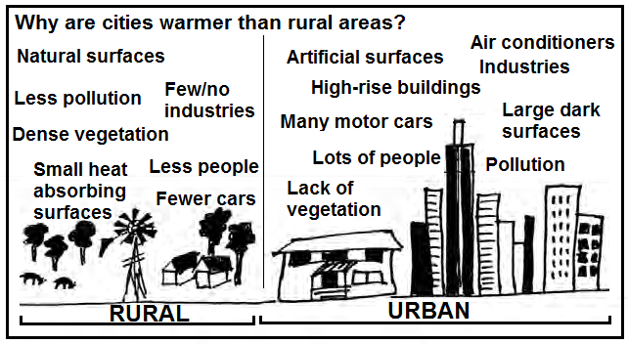

- Building materials: Concrete, tar,
brick absorb heat.
- Tall buildings trap heat.
- Air pollution helps to trap heat.
- Burning of fuels.
- Transport
- Industries release heat.
- Central heating from shops.
- Large concentration of people.

CAUSES
- Building materials: Concrete, tar, brick absorb heat.
- Tall buildings trap heat.
- Air pollution helps to trap heat.
- Burning of fuels.
- Transport
- Industries release heat.
- Central heating from shops.
- Large concentration of people.
CAUSES
- Building materials: Concrete, tar, brick absorb heat.
- Tall buildings trap heat.
- Air pollution helps to trap heat.
- Burning of fuels.
- Transport
- Industries release heat.
- Central heating from shops.
- Large concentration of people.
-Define heat island and pollution domes.
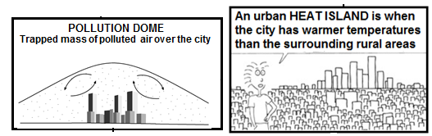

-Ways to reduce influence of heat islands
- Energy saving strategies
- Green belts
- Roof gardens
- Public transport
- Use lighter-coloured materials

GEOMORPHOLOGY

- DRAINAGE SYSTEMS

1.1 Define all concepts.

C O N C E P T S
Catchment area | Area over which rain falls and is caught by a drainage basin | Watershed | High lying area separating two drainage basins
Infiltration | Movement of water through soil into the ground | Water table | Upper level of underground saturated rock
Confluence | Place where two rivers join | Run-off | The surface flow of water
Tributary | A river that joins a larger river | Groundwater | Water found under the ground
River mouth | Sea or lake where river ends | Interfluve | High lying are between two river valleys
Source | Where river begins | River system | Main river with all its tributaries

1.2 Identify and describe ALL drainage patterns.

Pattern | Dendritic | Trellis | Radial | Rectangular
Diagram | 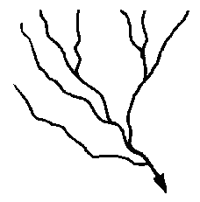 | 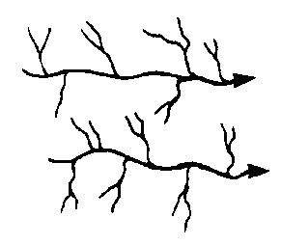 |  | 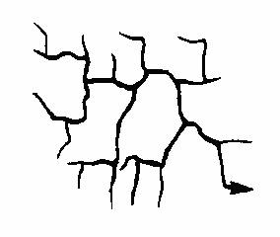
Description | Looks like branches of a tree. Tributaries join at acute angles. | Strong main stream joined by short tributaries at right angles | Looks like spokes of a wheel when viewed from above | Tributaries join at right angles and have bends of 90°
Underlying  structures | Uniform rocks of similar hardness | Gently sloping alternating layers of hard and soft rock | Rivers flow away from a high central point such like a butte or mesa | In areas with hard rock that is well jointed.

1.3 Distinguish between a high and a low drainage density
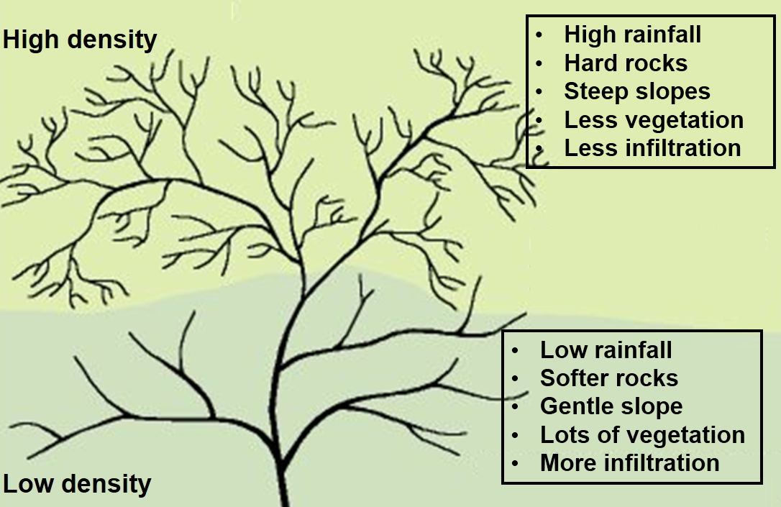

1.4 How do you determine stream order?
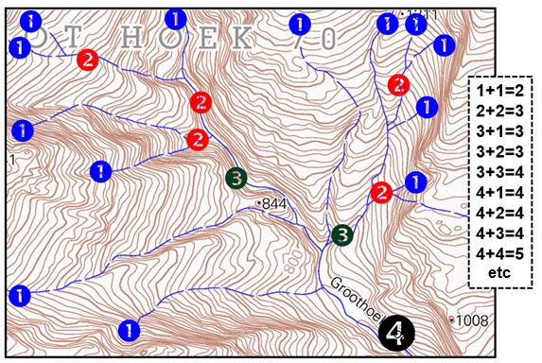

1.5 Distinguish between Laminar and turbulent flow

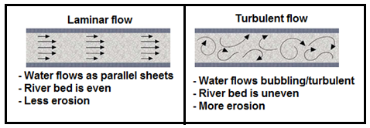

2 FLUVIAL PROCESSES
2.1 Stages (courses) of a river Key Questions
-In what stage is the river + reasons (upper, middle & lower course)
-Identify/draw cross profiles (in 3 stages)

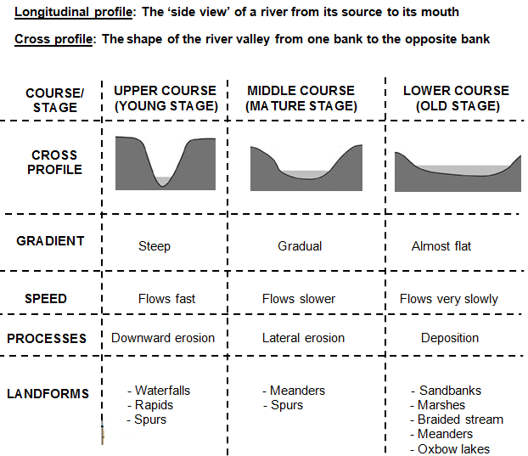

2.2 Identify/describe all Fluvial landforms
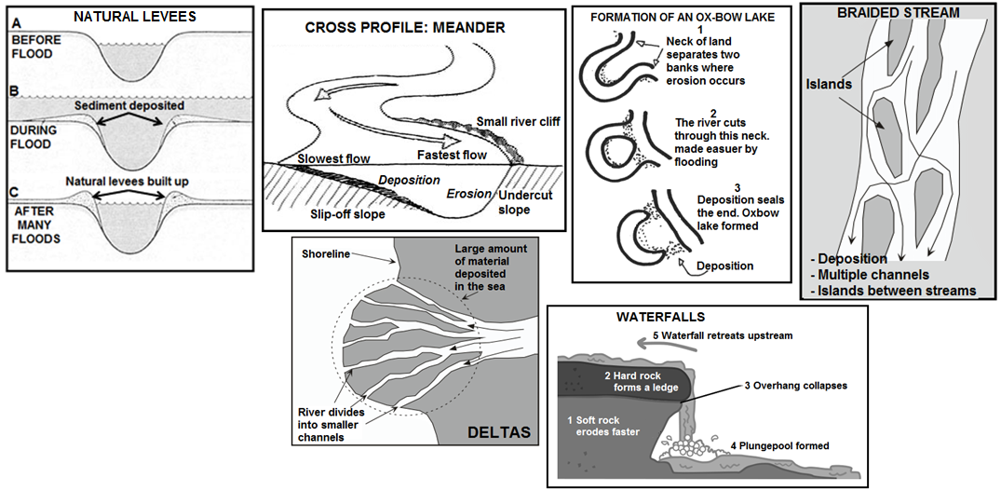

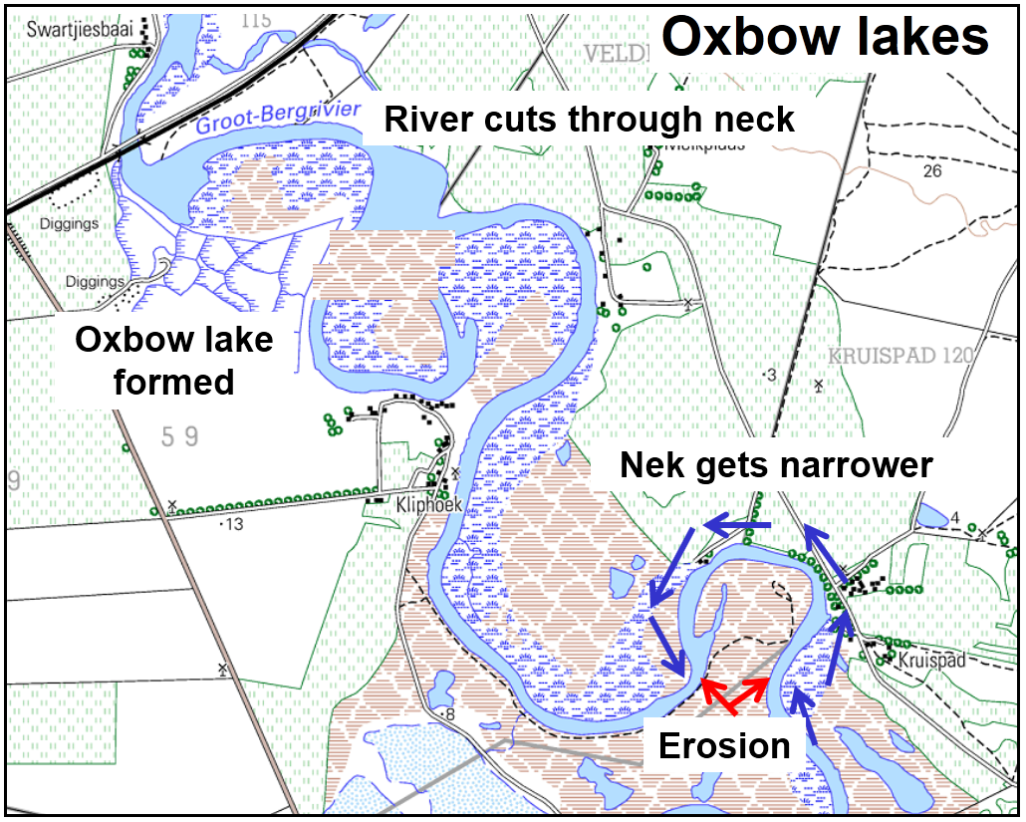

2.3 River capture (Stream piracy)

Key questions:
- How does river capture (stream piracy) occur?
- Name the landforms features of stream piracy
- (NB must be able to identify on diagrams or
- draw and add labels)

Stream piracy (river capture) takes place when the energetic stream (captor stream) cuts back and intercepts (takes) the water from the other river (captured/beheaded river).

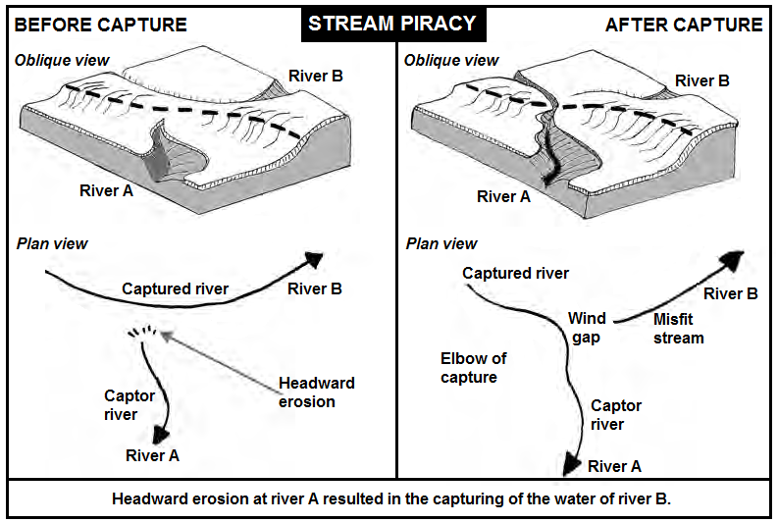
FEATURE | EXPLANATION
Captor river | The energetic stream that intercepts (takes) the water of the other river.
Captured river | The river which water was intercepted (taken) by the captor river.
Misfit stream | The river that has lost its water. (Also called beheaded stream)
Elbow of capture | The place where stream piracy has taken place
Wind gap | The dry river valley between the elbow of capture and the misfit stream
Waterfall | May form at the point where the captured river flows into the captor river

2.4 Rejuvenation
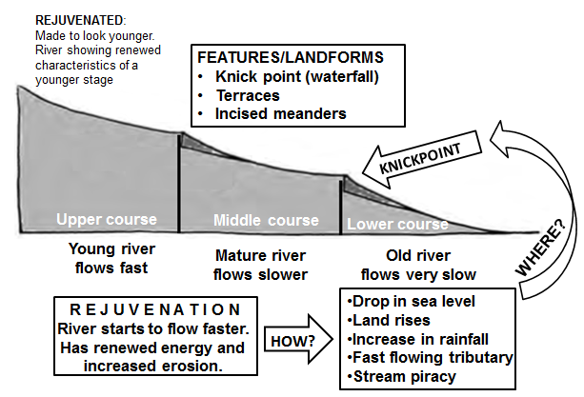
-How does rejuvenation occur? Name/identify features.

You must be in a position to do/answer the following:
- Identify the process of rejuvenation on a diagram.
- Define the concept, rejuvenation.
- Explain how rejuvenation occurs.
- Identify/describe the features/landforms of rejuvenation.

3 RURAL AND URBAN SETTLEMENT

3.1 RURAL SETTLEMENTS
3.1.1 Nucleated and dispersed patterns

Key questions:
- Identify the pattern + reason
- What factors caused the type of pattern?
- Give advantages/disadvantages of nucleated and dispersed patterns.

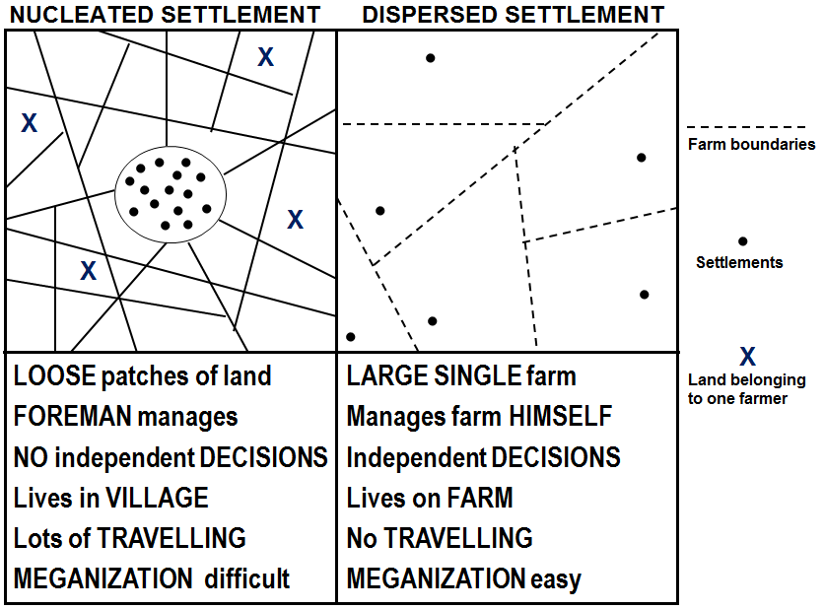

3.1.2 Rural and urban settlements
Distinguish between rural and urban settlements

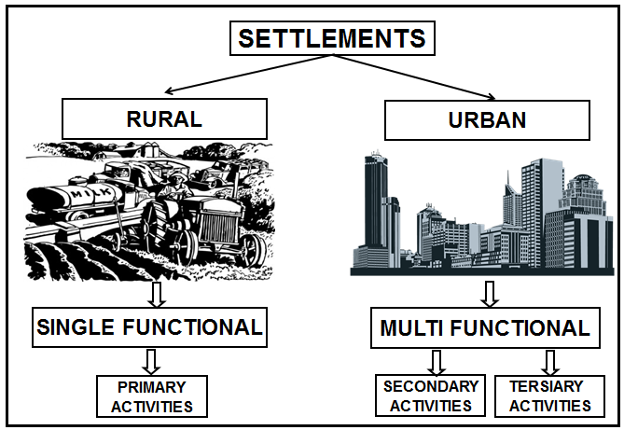
3.1.3 Round, linear and cross road shapes

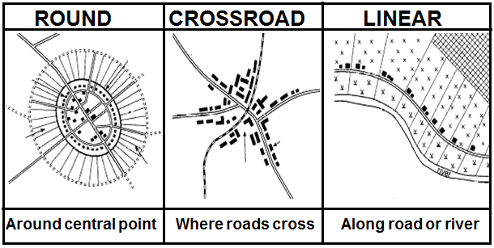

3.2 RURAL SETTLEMENT ISSUES

Key questions:
- Define rural-urban migration.
- Discuss the causes of rural-urban migration
(Pull/push factors).
- Discuss the consequences of rural-urban migration.
- What can be done to get people to stay in rural areas?

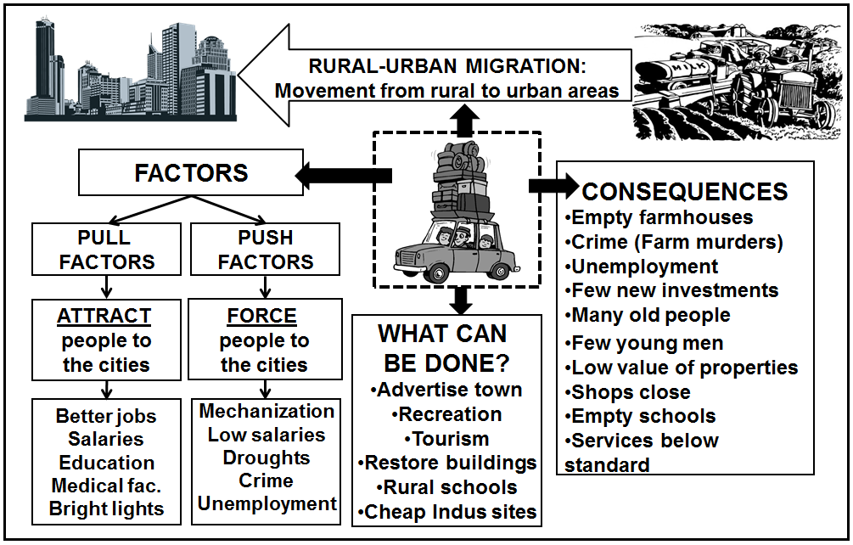

  - URBAN SETTLEMENTS
3.3.1 How site and situation affect location of urban settlements
A combination of physical and human factors determine where urban settlements are located

Physical factors: Fresh water, underlying rock and structure, relief, drainage
aspect, resources
Social factors: Transport routes, harbours, defensibility, building materials,
food supply
3.3.2 Types of urban settlements

The three types of urban settlements

- CENTRAL PLACES
Towns supplying urban goods and services to surrounding rural area
Low order/good service  - Need often (bread, milk, doctor)  - Smaller threshold population  - Several shops/services |  |  |  | High order good/service  - Don’t need or need less often (health spa)  - Larger threshold population  - Few shops/services
- TRADE AND TRANSPORT TOWNS/CITIES
Established due to trade and transportation
Break of bulk  - Transport changes (e.g. from sea to land.  - Example: Cape Town |  | Junction  - Intersection of two main transport routes.  - Example: De Aar |  |  |  | Gap town  - Point of access at physical barrier.  - Example: Worcester
- SPECIALISED TOWNS/CITIES
Mining  Example: Welkom | Education  Example: Stellenbosch |  | Industrial  Example: Secunda |  | Resort  Example: Margate |  | Commuter  Example: Soweto

Study the map and complete the table
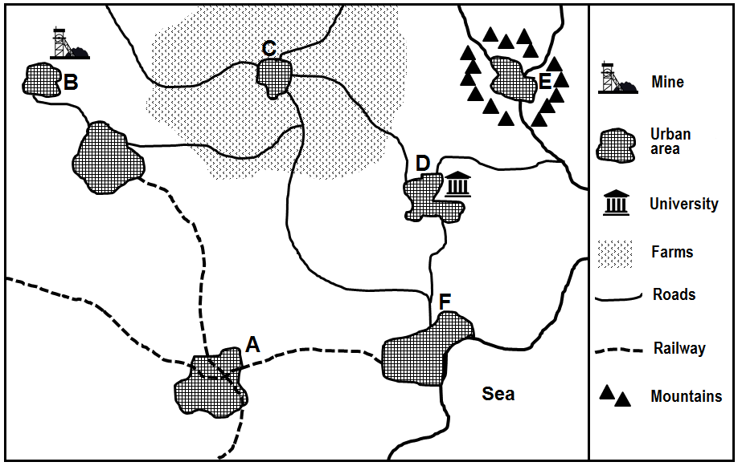

 | Type of settlement | Reason
A
B
C
D
E
F

3.4 URBAN STRUCTURE
3.4.1 Land use zones

Key Questions
- Identify land use zone
- Where found
- Describe characteristics

Land use zone |  | Where? | Characteristics
CBD |  | - Most accessible  - Where transport routes meet  - In the city centre | - Highest land values  - Highest building density  - Tallest buildings  - Concentration of shops and offices  - High-order commercial functions
Industries | (a) Light  industry | - Often near CBD or residential areas  - In planned industrial estates  - Near road transport | - Little noise and air pollution  - No heavy machinery
 | (b) Heavy  industry | - On outskirts of the city on cheap land  - Near major road and rail networks  - On flat land  - Near water source | - Lots of air and noise pollution  - Dangerous
Residential | (a) Middle to  high income | - Found away from CBD  - Good view | - Larger properties  - Good services  - Recreational areas
 | (b) Low income | - Closer to CBD | - Houses close together  - Fewer facilities  - Poor services  - Smaller properties
 | (c) Informal  settlement | - On the city outskirts | - Houses built out of plastic, wood, zinc  - Unhealthy conditions  - No service delivery  - Poverty  - Crime
Zone of decay  (Transition zone) |  | - Just outside the CBD | - Mixed functions (residential, commercial, light industry)  - Decayed buildings  - Renewal  - Valuable land
Rural-urban fringe |  | - On edge of urban area | - Urban functions invade rural area  - Both Urban and rural functions  - Large properties because of cheaper land  - Plots and small holdings  - Airports, cemeteries, power stations, golf courses, sewage works
Green belt |  | - In/around CBD | - Parks and sports fields  - No buildings in this area  - Cleans air in urban areas  - For recreation purposes  - Very dense housing

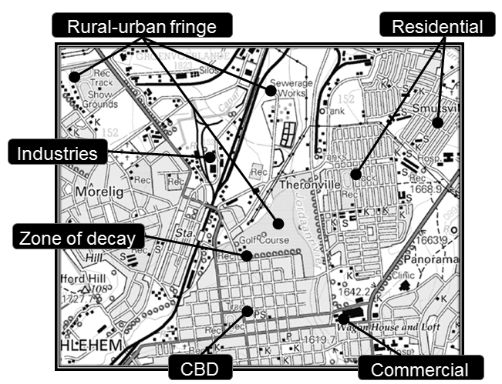

    - Street patterns

Key questions (1st and 2nd paper)
- Identify the street patterns
- Discuss the advantages of all 3 street patterns
- Discuss the disadvantages of all 3 street patterns

Name | Gridiron/Rectangular | Radial | Irregular
Characteristics | Roads intersect at right angles | Roads radiate outwards from central point like spider’s web | - No clear structure  - Can be planned or unplanned
Advantages | - Easy to plan  - Land divided easily  - Easy to find way | - Easier flow of traffic  - All roads lead to central point | - Improves traffic flow  - Fewer intersections  - Accommodates topography
Disadvantages | - Traffic congestion  - Monotonous  - Accidents | - Traffic jams  - Traffic is slow  - Wasted space | - Difficult to plan  - Easy to get lost  - Not easy to expand or subdivide

    - Urban profile
Key questions:
- What is urban profile?
- Describe how the buildings change as you move away from the CBD.
- Why does the height and density of the profile change?

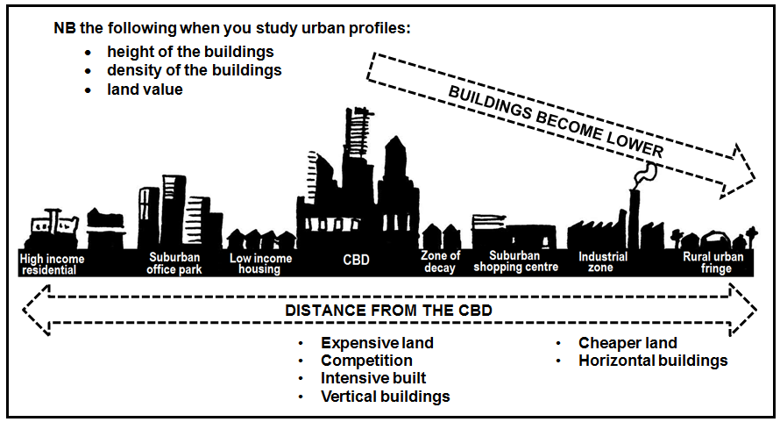

  - URBAN SETTLEMENT ISSUES/PROBLEMS
Key questions
- Describe causes of each issue
- What are the effects of each issue?
- How can issues be managed?

 | CONGESTION | URBAN DECAY | SENTRALISATION
CAUSES | - Too many people using own cars  - Not enough public transport  - Old street pattern | - Too many people living in the city  - Empty buildings | - High demand for land in city  - Too many people living in the city
EFFECTS | - Air pollution  - More accidents  - Stress, health problems  road rage | - Slums develop  - Services decline  - Increased pollution  - Area becomes dirty | - Increased pollution  - Health problems  - Destruction of environment  - Production of too much waste
SOLUTIONS | - Improve public transport  - Lift schemes  - Decentralisation of businesses  - Synchronise traffic lights | - Renovation  - Renewal  - Reduce housing density  - Improve services | - Decentralisation of functions  - Green belts  - Stricter control of pollution

4 ECONOMIC GEOGRAPHY OF SOUTH AFRICA

4.1 ECONOMIC SECTORS
Key question: Define Primary, secondary, tertiary activities
PRIMARY ACTIVITIES
Extraction and exploitation of raw materials

ECONOMIC
SECTORS
SECONDARY ACTIVITIES
Processing and manufacturing of primary materials

TERTIARY ACTIVITIES
Provides services to the consumer

QUARTERNARY ACTIVITIES
High level expertise, eg research, information

4.2 AGRICULTURE

Key questions:
- Discuss the favourable factors that impact on agriculture in South Africa
- Discuss the unfavourable factors that impact on agriculture in South Africa
- What is food security?
- Why do people not have enough food security?
- What measures could prevent food insecurity?
A
G
R
I
C
U
L
T
U
R
E

UNFAVOURABLE FACTORS
- Low rainfall
- Soil erosion
- Natural disasters – droughts
- Subsistence farming
- Pests decrease production
FAVOURABLE FACTORS
- High demand for products
- Fertile floodplains
- High summer temperatures help crops grow
- Availability of labour

FOOD SECURITY

DEFINITION
When all people have enough food to sustain a healthy lifestyle
HINDERING FATORS
- Lack of fertile land
- Natural disaster – droughts
- Poverty
- Subsistence farming
MEASURES
- Prevent soil erosion
- Efficient ways of storing food
- Reduce water wastage

4.3 MINING

Key questions:
- Discuss the favourable factors that impact on mining in South Africa
- Discuss the unfavourable factors that impact on mining in South Africa

M
I
N
I
N
G

FAVOURABLE FACTORS
- SA has different minerals
- Lots of unskilled labour
- Benefits from foreign skilled miners
- Many countries invested money in our mines
- Well-developed infrastructure
UNFAVOURABLE FACTORS
- High underground temperatures
- High costs in training of miners
- Mine worker strikes
- Large distances between mines and harbours
- Water shortages
- Mining is a dangerous activity

4.4 SECONDARY SECTOR
Key question:
- Discuss/identify factors industrial development.

4.4.1 Factors affecting the location of an industry

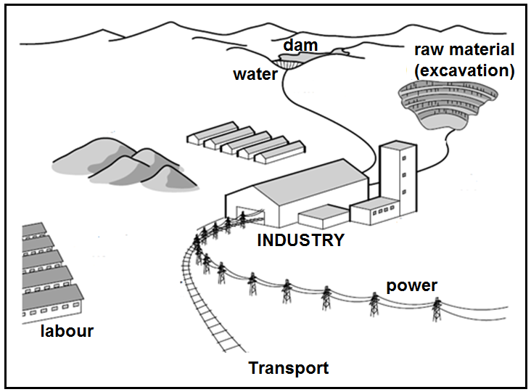

4.4.2 Main industrial regions in South Africa
PWV OR GAUTENG
Factors of location
- In Gauteng most important industrial region
- Largest industrial region in South Africa
- Large markets
- Plenty skilled and unskilled labour
- Many different kinds of raw material
- Well-developed transport routes
- Access to money
Kinds if industries
- Chemical
- Iron and steel
- Motor vehicles
- Machinery

Key questions
- Discuss unfavourable factors of four industrial regions.
- Discuss favourable factors of four industrial regions.
- Name the industries

DURBAN-PINETOWN
Factors of location
- Durban harbour largest and busiest
- Large labour force
- Many different raw materials
- Well-developed transport routes
- Good water supply
Kinds if industries
- Chemical
- Food processing
- Sugar refining
- Motor manufacturing
- Oil refining

SOUTHWESTERN CAPE
Factors of location
- Cape Town harbour
- Historical reasons
- Plenty skilled and unskilled labour
- Availability of farming products
Kinds if industries
- Food canning
- Fish canning and packing
- Wine making
- Textiles, clothing and footwear
PORT ELIZABETH-UITENHAGE
Factors of location
- Access to shipping port
- Historical reasons
- Plenty skilled and unskilled labour
- Availability of farming products
Kinds if industries
- Motor vehicle factories
- Industries relating to fruit, sheep and cattle
- Leather goods factories

4.5 INFORMAL SECTOR

Key questions:
- Define informal sector.
- Describe the characteristics of the informal sector.
- Why so many people in the informal sector?
- Challenges people face in the informal sector.
- What can be done to improve the informal sector?

DEFINITION
- People not employed in the formal sector
- Hawkers, parking guards, casual labourers
- Not registered, do not pay tax
CHARACTERSITICS
- Workers are self-employed
- Casual labour
- Semi-skilled and unskilled workers

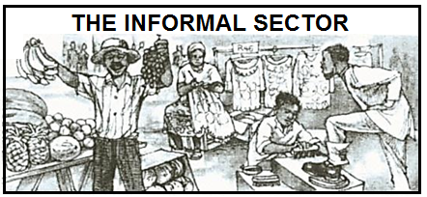
IMPORTANCE
- Provides income
- Decreases unemployment
- Lower prices for goods
- People develop entrepreneurial skills

HOW IMPROVED?
- Local authorities can provide specific areas for trading
- Can provide infrastructure such as hawker stalls
- Access to bank loans.
PROBLEMS/CHALLENGES
- Harassed by local authorities
- No access to proper trading facilities
- Exposed to the weather
- Do not get loans from banks
- Unreliable income

