Province of the
EASTERN CAPE
EDUCATION

DIRECTORATE SENIOR CURRICULUM MANAGEMENT (SEN-FET)
HOME SCHOOLING SELF-STUDY WORKSHEET ANSWER SHEET
SUBJECT | LIFE SCIENCES | GRADE | 12 | DATE | 05 June 2020
TOPIC | NEGATIVE FEEDBACK MECHANISMS | TERM 1  REVISION |  | TERM 2 CONTENT

1.1 | 1.1.1 | 0.25mg/cm³ |  | (1)
 | 1.1.2 | 15minutes |  | (1)
 | 1.1.3 | - Blood glucose level of a person with diabetes mellitus is higherthan that of a normal person at all times  - There is a greater increase in the blood glucose level of a person with diabetes mellitus after ingestion of glucose compared to the normal person  - It takes longer for the blood glucose level to stabilise for the person with diabetes mellitus compared to a normal person Any (2x2)  (Mark first TWO only) |  | (4)
 | 1.1.4 | - Because the person with diabetes mellitus does not produce insulin/is insulin resistant  - therefore blood glucose is not converted to glycogen |  | (2)
 | 1.1.5 | Glucagon/ Adrenalin |  | (1)  (9)

2.1 | 2.1.1 |  | Pancreas
 | 2.1.2 |  | 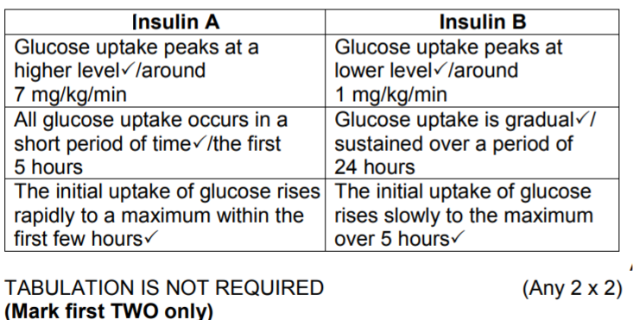 |  |  |  |  | (4)  (5)
2.2 |  | 2.2.1 |  | Comparison of the blood glucose level of two people over 5 hours/before and after ingesting glucose |  |  | (2)
 |  | 2.2.1 |  | (145 – 125) (Accept numbers in range 144 -146 for the first value and 124 -126 for the second value)  = 20 mg/100 cm3 (Accept answer according to the values given by learner) |  |  | (2)
 |  | 2.2.3 |  | Accept any answer from 1,7 to 1,9 hours /102 – 114minutes/ 1h42min – 1h54min |  |  | (1)
 |  | 2.2.4 |  | (a) Thabiso |  |  | (1)
 |  |  |  | (b) - His glucose level is higher than the normal range  - It takes longer for his glucose level to come down to its original  level (Any 1)  (MARK FIRST ONE ONLY) |  |  | (1)
 |  | 2.2.5 |  | - When his glucose level is high/ 99/98mg/100cm3  - insulin is secreted into the blood  - to convert excess glucose into glycogen in the liver  - and to stimulate the cells to absorb more glucose  - thus decreasing the blood glucose level (Any 4) |  |  | (4)  (11)
3.1 | 3.1.1 |  | Blood |  |  |  |  | (1)
 | 3.1.2 |  | - The pituitary gland/hypophysis is malfunctioningand secretes large amount of TSH  - Thyroid gland secretes less thyroxinand this will not have a negative feedback effect on the pituitary gland to secrete less TSH  (Mark first TWO only) (2 x 2) |  |  |  |  | (4)  (5)

3.2 | 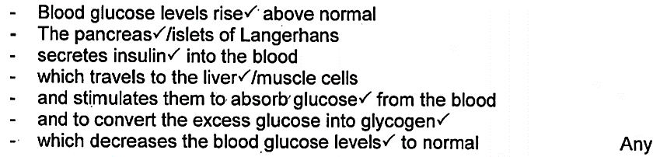 |  | (5)

3.3 | 3.3.1 | To maintain an internal balance/set point/homeostasis/regulate metabolism |  |  |  | (1)
 | 3.3.2 | TSH/thyroid-stimulating hormone |  |  |  | (1)
 | 3.3.3 | When Y/thyroxin is released at higher levels than normal:  - Metabolism will be higher than normal/cellular respiration increases - Heart rate increases  - thus all the energy from food eaten will be used  - leaving nothing to be utilised for storage/therefore could lead to a  person being underweight  - can also lead to anxiety |  |  |  | (3)  (5)  [40]

