Province of the
EASTERN CAPE
EDUCATION

DIRECTORATE SENIOR CURRICULUM MANAGEMENT (SEN-FET)
HOME SCHOOLING SELF-STUDY WORKSHEET
SUBJECT | ECONOMICS | GRADE | 12 | DATE | 10/06/2020
TOPIC | MICROECONOMICS & CONTEMPORARY ISSUES | TERM 1  REVISION |  | TERM 2 CONTENT | X
TIME ALLOCATION | 30 MINUTES MARKS: 40 | TIPS TO KEEP HEALTHY  1. WASH YOUR HANDS thoroughly with soap and water for at least 20 seconds. Alternatively, use hand sanitizer with an alcohol content of at least 60%.  2. PRACTICE SOCIAL DISTANCING – keep a distance of 1m away from other people.  3. PRACTISE GOOD RESPIRATORY HYGIENE: cough or sneeze into your elbow or tissue and dispose of the tissue immediately after use.  4. TRY NOT TO TOUCH YOUR FACE. The virus can be transferred from your hands to your nose, mouth and eyes. It can then enter your body and make you sick.  5. STAY AT HOME.
INSTRUCTIONS | INSTRUCTIONS AND INFORMATION  - Answer ALL questions in the ANSWER BOOK  - Number the answers correctly according to the numbering system used in this question paper.  - Write the question number above each answer.  - Leave 2–3 lines between subsections of questions  - Write neatly and legibly.

QUESTION 1 MICROECONOMICS AND CONTEMPORARY ECONOMIC ISSUES 40 MARKS − 30 MINUTES
DBE/Feb.–Mar. 2018
1.1 | Answer the following questions.
 | 1.1.1 | Give any TWO reasons why governments levy tax on tourism. (2 x 1) |  | (2)
 | 1.1.2 | Why does the government sometimes set minimum prices (price floors) for certain products? (1 x 2) |  | (2)
1.2 | Study the information below and answer the questions that follow.
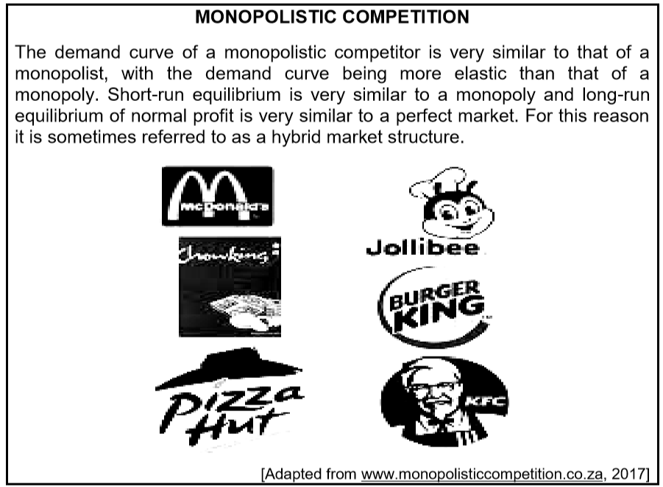
 | 1.2.1 | Identify ONE example of a monopolistic competitor in the information above. |  | (1)
 | 1.2.2 | Which word in the information above suggests that a monopolistic competitor is a combination of two market structures? |  | (1)
 | 1.2.3 | Briefly describe the term normal profit. |  | (2)
 | 1.2.4 | Why is the demand curve of a monopolistic competitor more elastic than that of a monopoly? |  | (2)
 | 1.2.5 | How does branding play a key role in a monopolistic competitive market structure? (2 x 2) |  | (4)
1.3 | Study the information below and answer the questions that follow.
THE UNITED NATIONS CLIMATE CHANGE CONFERENCES
The UN has yearly conferences which serve as a formal meeting of parties that are known as the Conference of the Parties (COP). The meetings assess the progress made in dealing with climate change. The first conference was held in Berlin, Germany, in 1995 and the third meeting was held in Kyoto, Japan, in 1997, where the reduction of greenhouse gases was discussed.
In 2011 the 17th meeting was held in Durban, South Africa. The emphasis was on the creation of a green climate fund. The Kyoto conference outlined the reduction of greenhouse gas emissions. In 2016 the 22nd conference (also known as COP 22) was held in Morocco. Despite these numerous meetings, global temperatures are still increasing.
[Adapted from 222.wikipedia.com]

 | 1.3.1 | Give the name of ONE city in the extract where climate change conferences were held. |  | (1)
 | 1.3.2 | Identify the international organisastion in the extract above that initiates climate change conferences. |  | (1)
 | 1.3.3 | Describe how greenhouse gases contribute to global warming. |  | (2)
 | 1.3.4 | How can a green fund help to reduce global warming? |  | (2)
 | 1.3.5 | Why is global warming increasing despite the many international conferences on climate change? (2 x 2) |  | (4)
1.4 | Briefly describe the fiscal measures that can be used to combat demand-pull inflation. (4 x 2) |  |  | (8)
1.5 | Draw a well-labelled graph to illustrate economic profit in a monopoly market. |  |  | (8)
 |  |  |  | [40]

