Province of the
EASTERN CAPE
EDUCATION

DIRECTORATE SENIOR CURRICULUM MANAGEMENT (SEN-FET)
HOME SCHOOLING SELF-STUDY ANSWER SHEET
SUBJECT | ECONOMICS | GRADE | 12 | DATE | 04/06/2020
TOPIC | MICROECONOMICS | TERM 1  REVISION |  | TERM 2 CONTENT | X

QUESTION 1 30 MARKS − 20 MINUTES

1.1 | 1.1.1 | List any TWO types of monopolies.  - Artificial monopoly √  - Natural monopoly √ |  | (2)
 | 1.1.2 | What will the effect be if a firm in a perfect market decides to increase the price of its product?  - Firm will make a loss, because all firms in the perfect market are price takers and cannot influence the market price. √√ |  | (2)
1.2 | Study the information below and answer the questions that follow.
THE DEMAND CURVE OF AN OLIGOPOLISTIC FIRM
The demand curve of an oligopolistic firm was developed in 1939 by the American economist Paul Sweezy.
The kinked demand curve illustrates the importance of interdependence and uncertainty in an oligopolistic market and explains why there is a degree of price stability in such a market.
Each firm will face a market demand curve with two segments for its product. The two segments are elastic and inelastic.

 | 1.2.1 | Who developed the theory on the demand curve of an oligopolistic firm?  - Paul Sweezy √ |  | (1)
 | 1.2.2 | What is the demand curve of an oligopolist firm called?  - Kinked demand curve √ |  | (1)
 | 1.2.3 | Briefly explain an inelastic demand.  - Demand is not sensitive to a price change. √√  - A change in price causes a small change in demand. √√ (1 x 2) |  | (2)
 | 1.2.4 | Explain mutual dependence as a characteristic of oligopoly.  - One seller’s action will influence the other sellers   - Each firm is aware of each other’s actions since the market is dominated by a few firms, e.g. cars.  (1 x 2) |  | (2)
 | 1.2.5 | Draw a fully labelled kinked demand curve.
 | 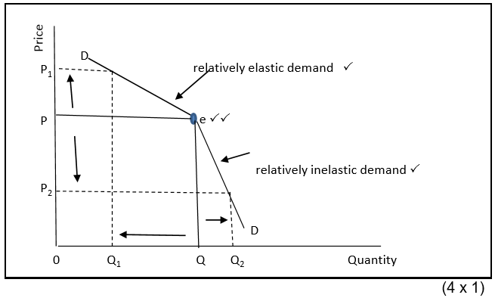 |  |  | (4)
1.3 | Study the information below and answer the questions that follow.
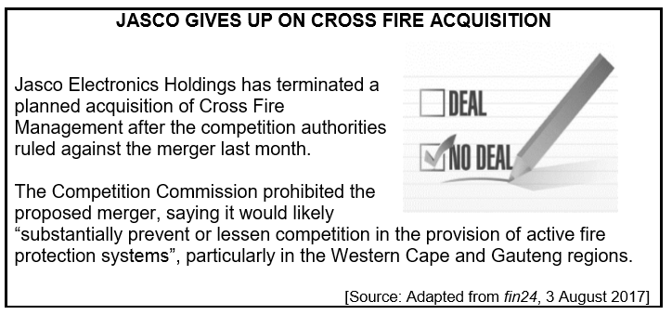
 | 1.3.1 | Which authority did not allow the merger of Jasco and Cross Fire?  - Competition Commission √ |  | (1)
 | 1.3.2 | What was the reason for the denial of the merger?  - The merger will prevent or lessen competition in the provision of active fire protection systems. √ |  | (1)
 | 1.3.3 | Explain any other TWO objectives of the Competition Policy, other than the one in the extract.  - To prevent monopolies and other powerful businesses from abusing their power √√  - To stop firms from using restrictive practices like fixing prices, √ dividing markets etc. √√  - Improve the efficiency in the market through legislation √√  - Protect the consumer against unfair prices and inferior products for example through the Competition Act √√ (2 x 2)  Do not accept ‘preventing mergers and acquisitions’ and ‘promoting healthy competition’. |  | (4)
 | 1.3.4 | In your opinion, how will the economy benefit from fair competition?  - Open up opportunities for more entrepreneurs to join in to businesses √√  - Create more job opportunities √√  - Lead to higher standard of living √√  - Contribute to lower prices √√  - Contribute to better quality goods and services √√  (Accept any other relevant response.) (2 x 2) |  | (4)
1.4 | Distinguish between the short and long term/run.  Short term/run  - The short run is the period of production where only the variable factors of production can change. √√  - The time period is too short to enable the number of firms in the industry to change. √√  (2 x 2)  Long term/run  - The long run is the period of production where all factors can change. √√  - The time is long enough for variable and fixed factors to change. √√  - It allows enough time for new firms to enter the industry and/or existing firms to exit. √√  (2 x 2)  (2 x 4) |  |  | (8)
1.5 | Explain with the aid of a well-labelled graph, the effect of providing subsides to producers as a form of government intervention during market failure.
 | 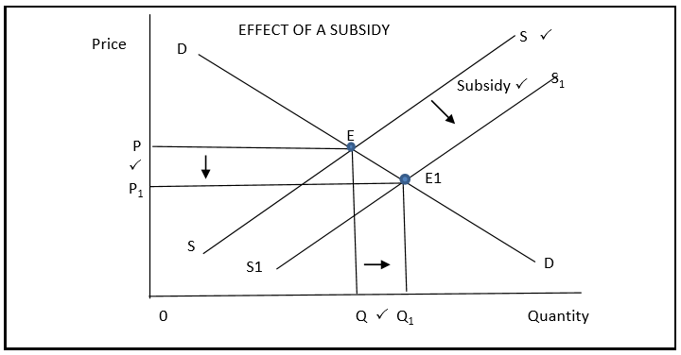(4)
 | Providing producer subsidies  - The government provides subsidies to producers in order to encourage them to increase the production of goods. √√  - Supply increases from SS to S1S1 √√  - Subsidies lower the cost of producing goods and thus the market price of these goods is lowered/decreased from 0P to 0P1 √√  - The lower price allows people to buy more at Q1 √√ (Max. 4) |  |  | (8)
 |  |  |  | [40]

