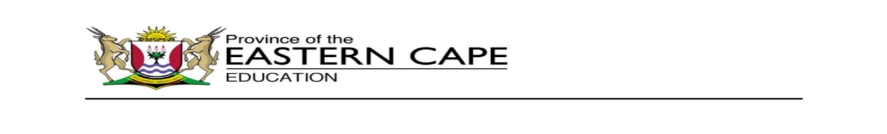

**DIRECTORATE: PRIMARY CURRICULUM MANAGEMENT**



|  |  |  |
| --- | --- | --- |
| **31 - 4 September KEREITI 1** | | |
| **Ho mamela le ho bua** | Titjhere o balla bana, bona ba bolele modumo o hlahellang hangata  1. Pule o bona pere pela palo.  2. Lerato o lelekisa katse.  3. Ngwana o ngola ka mongolo o motle. | |
|  |  |  |
| **Medumo** | Bala mantswe ana, ho latele pitsetso    1. lelwala  2. lesapo  3. lesokwana  3. lebese  4. lerole  5. lebone  6. lelwala | |
|  | | |
| **Mongolo** | Qetela paterone ena:  **p p p**  **s s s**  **l l l l**  **lesapo sefate, lerole.** | |
|  | | |
| Ho ngola | 1. Taka tlhaku ka mmala o mokgubedu le bokoseng ka medumo- **p**   |  |  |  |  |  | | --- | --- | --- | --- | --- | | p | p | d | p | d | | a | b | q | b | | d | q | d | b | | p | d | p | q |   2. Kenya ditlhaku tse latelang.  **o, e, i**  1. b_ l_  2. l _ r_  3. p_ n | |
|  | | |
| Ho bala | Ho bala   |  | | --- | | Ha ke bone buka ya ka. Keya kgolwa malome o e behile pela bethe ya ka. Ke yena ke e fumana. Keya leboha malome. | | |
|  | | |