Name:
Date:
Grade: 1
Topic: Plants
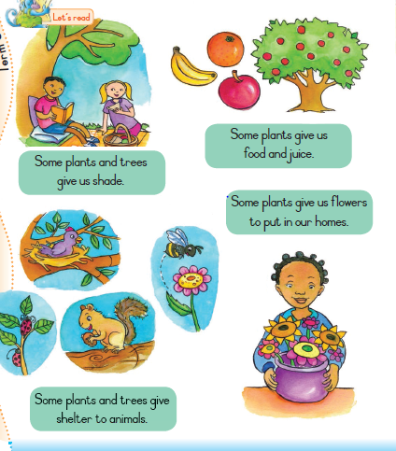
Complete the following sentences
1. We get food and j……… from plants
2. Some plants and seeds give s…………. to the animals.
3. F ………..that we put on our tables at home come from plants
4. Some plants give us s……………

