

**GRADE 1**

**ENGLISH FIRST ADDITIONAL LANGUAGE WORKSHEET**

**TERM 3 WEEK 17-21 August 2020**

**Theme: Reading is fun**

**Name ----------------------------------------------------**

**Grade ----------------------------------------------------**

**Date -----------------------------------------------------**



1. **Listening & Speaking**

Think about the book Bohlale got and the great pictures it had. Talk about the picture BOhlale saw in the book.

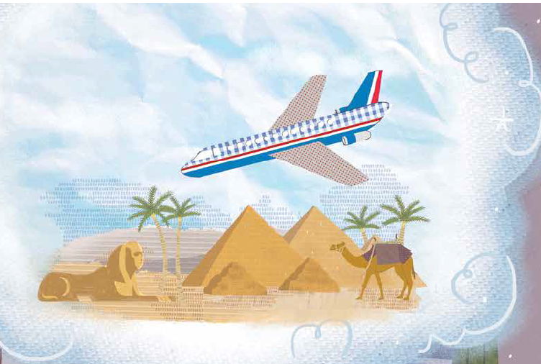

1. **Phonics**

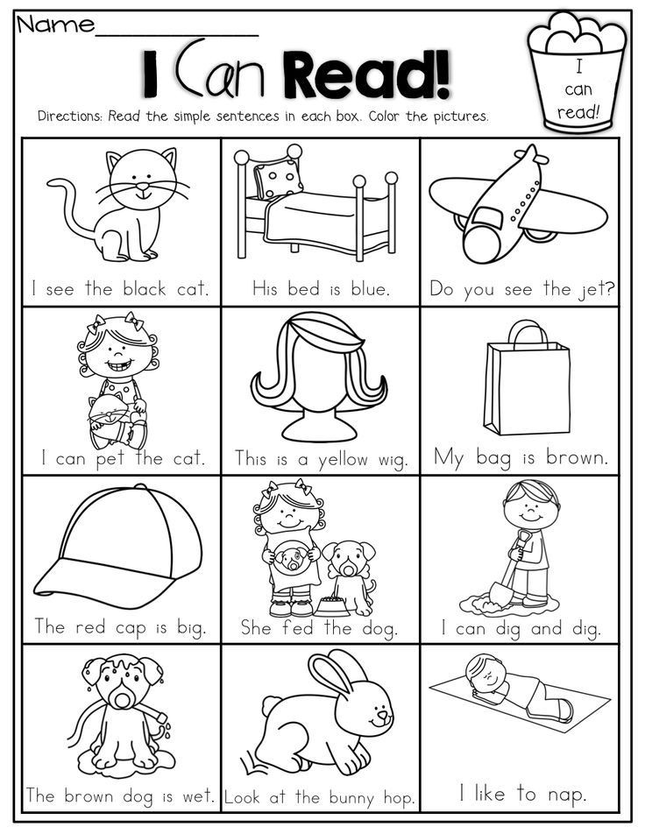

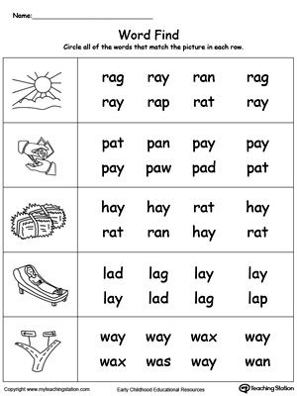

Writing

Think about books you read. Write about which book you like.



I like a book about ----------------------------------------------------------------------------------------------------------------------------------------------------------------------.

Reading

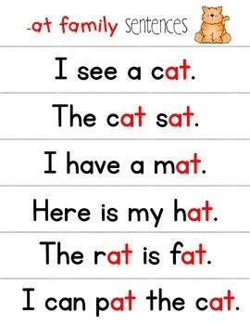

Sounds

|  |  |  |  |
| --- | --- | --- | --- |
| f | m | r | p |
| e | n | g | ck |
| a | u | b | h |

Phonics word list

|  |  |  |  |  |
| --- | --- | --- | --- | --- |
| fat | hut | lot | net | foot |
| gun | man | pot | six | sick |

|  |
| --- |
|  |

Vocabulary words list

|  |  |  |  |
| --- | --- | --- | --- |
| book | fun | read | parents |
| page | turn | title | page number |
| gift | in love | dream | carry |

**Sight words list**

|  |  |  |  |
| --- | --- | --- | --- |
| next | work | pull | beetroot |