

**Grade 2**

**ENGLISH FIRST ADDITTIONAL LANGUAGE WORKSHEET**

**Term 2 Week 24-28 August 2020**

**Theme: Worried and afraid**

**Name -----------------------------------------------**

**Grade -----------------------------------------------**

**Date -------------------------------------------------**



1. **Listening &Speaking**

Retell the story ‘**Zweli is worried** ‘. Tell what happened first, next and last.



1. **Phonics**
   1. **Activity 1: DBE WORKBOOKS, PAGE 17,** Write these words into the correct places on the merry-go-round.
   2. Build up the words. Use the words to write sentences in a question form

**th-e-n = then**

**(then what happen after that?)**

**th-a-t =**

**th-i-s =**

**th-o-se =**

**th-e-m =**

**th-a-n =**

2.3 Build the words. Write all the you build words below

|  |  |  |
| --- | --- | --- |
| th | u | n |
| or | mb | i |
| nk | e | f |
| t | ck | a |

1. ------------------------
2. ------------------------
3. -------------------------
4. -------------------------
5. -------------------------
6. -------------------------
7. -------------------------
8. -------------------------
9. -------------------------
10. -------------------------
11. Writing

Think about all the things Zweli was worried about. Completes the sentences by also writing what you are worried about.

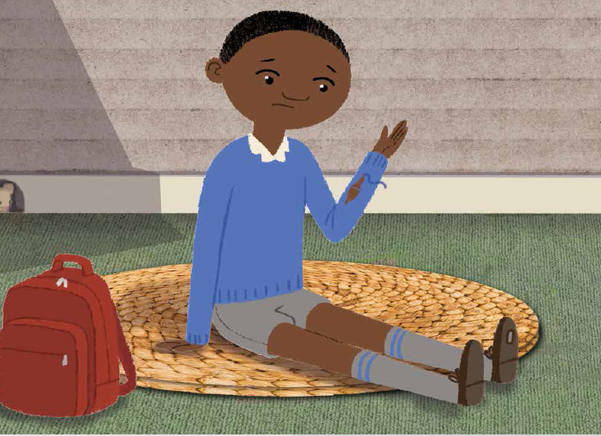

**Zweli was worried about---------------------------------------------------------------------.**

**He was also worried about---------------------------------------------------------------------. I am worried about -----------------------------------------------------------------------------------------I am also worried about ----------------------------------------------------------------------------.**

* 1. **Use she, he, it to replace the word written in red.**

1. **Zethu** is wearing my favourite colour.
2. **My dog** barks at the strangers all day long.
3. **Our father** washes the car after rain.
4. **Rain** comes from the clouds.
5. She likes to eat **oranges.**

**Rewrite the sentences below**

**------------------------------------------------------------------------------------------------------------------------------------------------------------------------------------------------------------------------------------------------------------------------------------------------------------------------------------------------------------------------------------------------------------------------------------------------------------------------------------------------------------------------------------------------------------------------------------------------------------------------------------------------------------------------------------------------------------------------------------------------------**

Vocabulary list

|  |  |  |  |
| --- | --- | --- | --- |
| shake | cry | scream | shoulder |
| exam | meet | people | sports |
| comfort, | buy | money | kiss |

Sight words

|  |  |  |
| --- | --- | --- |
| heard | voice | how |
| couldn’t | paid |  |

