Name:
Date:
Grade: 1
Topic: Plants
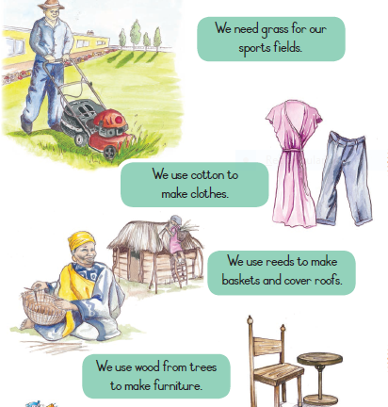
Match A with B
A B
Cotton furniture
Reeds clothes
Trees fields
Grass roofs

