Name:
Date:
Grade: 2
Topic: Plants need good soil to grow
Read the passage and answer the following questions:
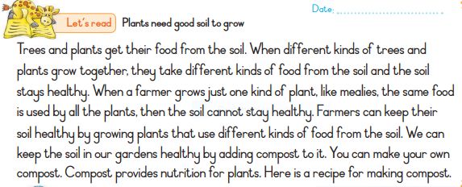

1. Where do plants get their food?
…………………………………………………………………………………………………………………………………..
2. How do farmers keep their soil healthy ............................................................................................................................................
3.What can we add to our garden to make it healthy?
.................................................................................................................................................
4. Can you make your own compost?
...............................................................................................................................................
5. What does compost provide for plants?
...................................................................................................................................................

