Date: 11 to 15 May 2020

SUBJECT | MATHEMATICS | GRADE | 2 | TERM 2
TIME ALLOCATION  1 hour | 5 minutes for counting each day  10 minutes for mental mathematics each day.  45 minutes for the concept each day | TIPS TO KEEP HEALTHY  1. WASH YOUR HANDS thoroughly with soap and warm water for at least 20 seconds. Alternatively, use hand sanitizer with an alcohol content of at least 60%.  2. PRACTICE SOCIAL DISTANCING keep a distance of 1m away from other people.  3. PRACTISE GOOD RESPIRATORY HYGIENE: cough or sneeze into your elbow or tissue and dispose the tissue immediately after use.  4. TRY NOT TO TOUCH YOUR FACE. The virus can be transferred from your hands to your nose, mouth and eyes. It can then enter your body and make you sick.  5. STAY AT HOME.
INSTRUCTIONS | Use worksheets below  Use DBE workbook  Use relevant resources from home with caution

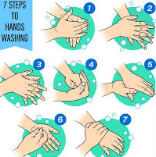

Day 1 and 2 Time
Activity 1 Counting
Count real objects up to 100 (use any objects from home)
Count forwards in 1s and 2s from 0 to 100
Count backwards in 1s, 2s and 5s from 100 to 0
Activity 2 Mental Mathematics

 | What is? | Answer
1. | 1 more than 15?
2. | 3 more than 12?
3. | 5 more than 14?
4. | 2 more than 27?
5. | 0 more than 1?
6. | 4 more than 20?
7. | 5 more than 13?
8. | 7 more than 1?
9. | 10 more than 0?
10. | 9 more than 21?

Activity 3
O’ clock: long hand at 12
7 o’ clock
12
1
2
3
4
5
6
7
8
9
11
10
What time is it?
12  1  2  3  4  5  6  7  8  9  11  10  ______ O’ clock | 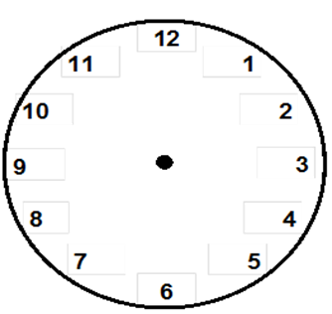  ___ O’ clock
_____ O’ clock | ______ O’ clock
_______ O’ clock | ________ O’ clock

Activity 4
Use the clocks to show the given time
3 O’ clock | 5 O’ clock
1 O’ clock | 10 O’ clock

Activity 5 What do you do?
Time | Day | Night
1 O’ clock | At school | Sleeping
8 O’ clock
5 O’ clock
12 O’ clock

Activity 6
DBE Workbook pages 120 to 123

Day 3 Addition and Subtraction
Activity 1 Counting
Count real objects up to 100 (use any objects from home)
Count forwards in 1s and 2s from 0 to 100
Count backwards in 1s, 2s and 5s from 100 to 0
Activity 2 Mental mathematics

 | What is? | Answer
1. | 1 more than 15?
2. | 3 more than 22?
3. | 6 less than 44?
4. | 2 more than 17?
5. | 0 more than 31?
6. | 4 less than 50?
7. | 5 less than 5?
8. | 7 more than 39?
9. | 10 less than 40?
10. | 9 more than 41?

Activity 3
34 = 30 + 4
Complete the following
- 42 = ____________
- 31 = _____________
- 27 = ____________
- 49 = _____________
- 20 = _____________
Activity 4
DBE Workbook pages 76 and 50

Activity 5
Use breaking down method to solve
23 + 12 = _________
(20 + 3) + (10 + 2) =
(20 + 10) + (3 + 2)
30 + 5 = 35
- 37 + 13 = _________

- 23 + 18 = ________

- 48 _ 24 = _________

36 _ 19 = _________

Activity 6
DBE Workbook pages 78 and 79

Day 5 Geometric patterns
Activity 1 Counting
Count real objects up to 100 (use any objects from home)
Count forwards in 1s and 2s from 0 to 100
Count backwards in 1s, 2s and 5s from 100 to 0
Activity 2 Mental mathematics

Which numbers are missing that add up to the total given?

4 |  |  | = 15
 | 5 |  | = 20
3 | 1 |  | = 10
= 14 | = 8 | = 23

Activity 3 Geometric patterns

1.
- How is the pattern growing? __________________
- How many triangles will be in the next pattern? ___________
- Draw the next pattern _____________________________________
2. What is next? Put a tick
________

_________

______

