GRADE: 2 MATHEMATICS Name: _______________________

Date: 18 to 22 May 2020

TIME ALLOCATION (1 hour)  - 5 minutes for counting each day  - 10 minutes for mental mathematics each day.  - 45 minutes for concept of the day. | TERM 2 CONTENT
TIPS TO PARENT  - Use worksheets below  - Use DBE workbook  - Use relevant real objects from home with caution.  - Use correct mathematical language as indicated in the worksheets and DBE Workbook.  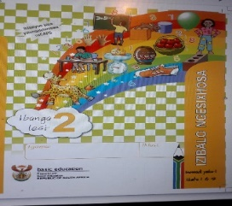 | TIPS TO KEEP HEALTHY  1. WASH YOUR HANDS thoroughly with soap and warm water for at least 20 seconds. Alternatively, use hand sanitizer with an alcohol content of at least 60%.  2. PRACTICE SOCIAL DISTANCING keep a distance of 1m away from other people.  3. PRACTISE GOOD RESPIRATORY HYGIENE: cough or sneeze into your elbow or tissue and dispose the tissue immediately after use.  4. TRY NOT TO TOUCH YOUR FACE. The virus can be transferred from your hands to your nose, mouth and eyes. It can then enter your body and make you sick.  5. STAY AT HOME.  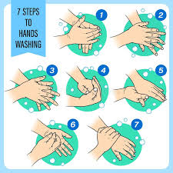

Day 1 and 2 SUBTRACTION PROBLEMS
Activity 1 Counting
Count real objects up to 20 (use any objects from home like beans, stones, bottle tops etc.)
Count forwards in 3s from 0 to 30
Count backwards in 1s and 3s from 60 to 0
Count in 4s from 84 to 0
Activity 2 (a) Mental Mathematics
Complete the following
99, 96, ____, ______, _______, _______, _______
37, 40, ______, ______, _______, ________, ______
12, 15, _______, ______, ______, _________, _______

Activity 2 (b) Mental Mathematics

- What is 3 more than 31? ______
- What is 4 less than 54? _________
- What number comes between 97 and 99? _______________
- What is 2 less than 54? ______________
- What number comes before 87 when counting in 1s?

Activity 3
Use real objects like beans, bottle tops to solve the following word sums.
You must also write the correct number sentence.
Grade 2 learners were required to collect 36 buttons for a class project. They only collected 23.
How many buttons are they short of now?

Activity 4 DBE Workbook pages 76 and 77
Activity 5
Break down both numbers to subtract.
Write the correct number sentence to complete the sum.
Example: 77 - 35 =
(70+7) - (30=5)
(70-30) + (7 – 5)
40 - 2
= 38
There were 89 passengers in a bus. 26 passengers get off.
How many passengers are now left in the bus?
Activity 6
Break only one number to subtract
Example: 99 - 73 = _______
99 - (70 + 3) =
29 - 3 = 26
Nomsa collected 86 bottle tops for a maths lesson. Luvo collected 27.
What is the difference between the coins they collected?

Use counting back strategy to subtract.
Example: 96 - 45 =
96 -10 =86 -10 =76 -10 = 66 -10 = 56 -10 = 46 -5= 41
There were 65 coins in the purse. Nomsa took 19 coins to buy bread.
How many coins does she have now?

DAY 4 PICTOGRAPH (collect, organise in tallies and represent in pictograph)
Activity 1 Counting
Count real objects up to 20 (use any objects from home like beans, stones, bottle tops etc.)
Count forwards in 3s from 0 to 30
Count backwards in 1s and 3s from 60 to 0
Count in 4s from 84 to 0

Activity 2 Mental Mathematics

- 11 + ________ = 18
- 19 - _________ = 7
- 45 + ________ = 54
- 61 - ______ = 60
- 20 - ______ = 1

Activity 3
Learners of Sacred Heart JSS collected sweets of different colours for their indoor competition.
Their collection is as follows

Put all the sweets according to their colours to make a pictograph

- Which colour had the most sweets? ---------
- Which colour had the least number of sweets? --------------
- What is the difference between the least collection and the more? ---------
- How many sweets were collected altogether? _______
- Double the number of the blue sweets ----------
Activity 4
DBE Pages 63 and 137

DAY 5 2- D shapes
Activity 1 Counting
Count real objects up to 20 (use any objects from home like beans, stones, bottle tops etc.)
Count forwards and backwards in 2s and 10s from 0 to 100
Activity 2 Mental Mathematics
What number comes between?
- 98 and 100
- 29 and 27
- 55 and 56
- 15 and 17
- 87 and 83
- 38 and 40

Activity 3 Names of 2- D shapes
Give the names of the shapes below

________ _______ ______

Activity 4 Colour all squares red, circles yellow and triangles blue

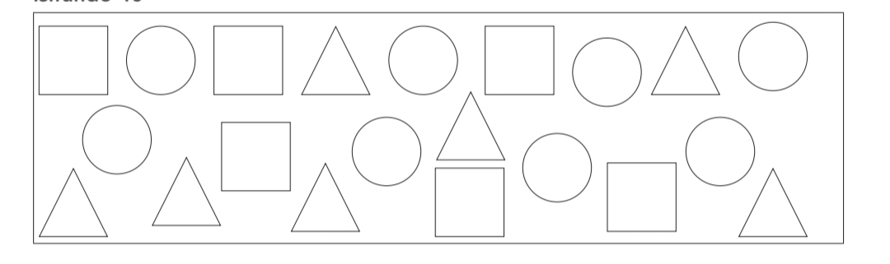

Activity 5
DBE Workbook pages 76 and 77

