

Grade 2 Worksheet

Term 2 Week 25-29 May 2020

Name _____________________________________

Grade -----------------------------------------------

Date -------------------------------------------------

Look at the picture and talk about what children are doing.

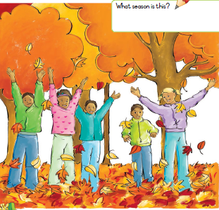

1. How many ducks are there?
2. How many chicks are there?
3. How many frogs are there?
4. How many children are there in both pictures?
5. How many children are wearing green jackets?
6. How many pink flowers?
7. What is the season in each picture and why?

Sound and read the ‘ee’ words and make a sentence using a picture.

 tree

 green

 sheep

 see

sleep

Now let us build up the words together

s /ee/ d

f/ee/d

s/ee/n

j/ee/p

b/ee

Replace the last sound with the letter in the bracket, then read the new word

feed (l)

seen (m)

teen (th)

seed (k)

Writing

Look at the pictures and talk to your friend about all the things you learned about each animal. Think about another animal you would like to know more about. Use the sentence frame to complete your own story



I like learning about---------------.

I think this is interesting because-----------------------------------------------------------------------------------------------------------.

I want to learn more about--------------------------------------------.

One thing I want to know is------------------------------------------.

