

**Grade 3**

**ENGLISH FIRST ADDITIONAL LANGUAGE WORKSHEET**

**Term 3 Week 17-21 August 2020**

**Theme: Learning New Things**

**Name --------------------------------------------------**

**Grade -------------------------------------------------**

**Date --------------------------------------------------**



1. Listening and Speaking

Read the story Zandile uses the internet. Answer questions that follow.



1. What did Zandile get at the shop?
2. Why did she want to buy strawberry seeds?
3. What do plants need to grow?
4. How does Zandile get the data to use internet
5. Write the sentence in past tense

|  |
| --- |
| She plant te seeds in a sunny part of the yard |

1. Give one words of the source where Zandile where finds the information
2. Write 3 things that Zandile learn from the experience
3. **Phonics**

2.1 a.Sound out and read the ‘ou’ words

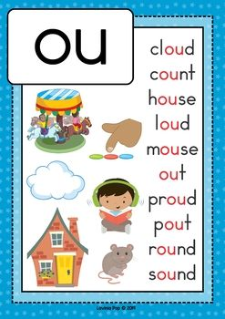

b. Pick 5 words from the list and make your own sentences

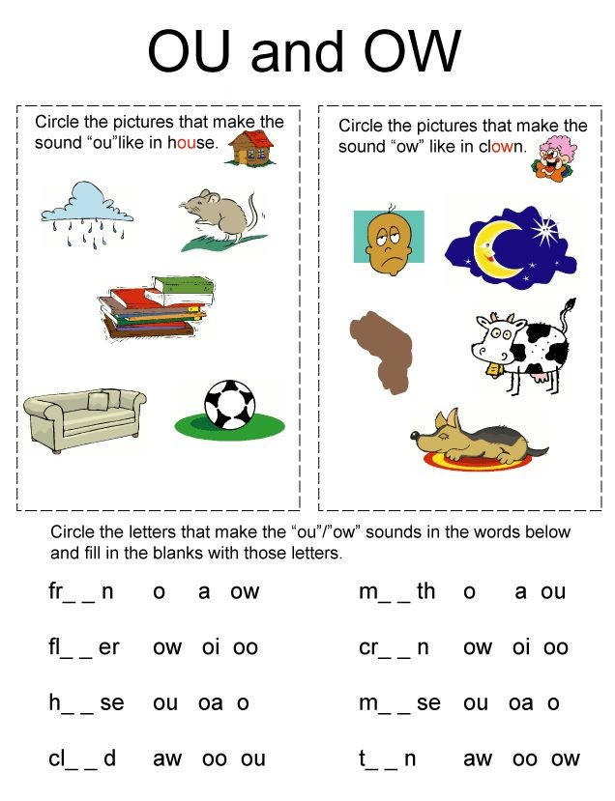

2.3 Complete the sentences by filling in the phonic

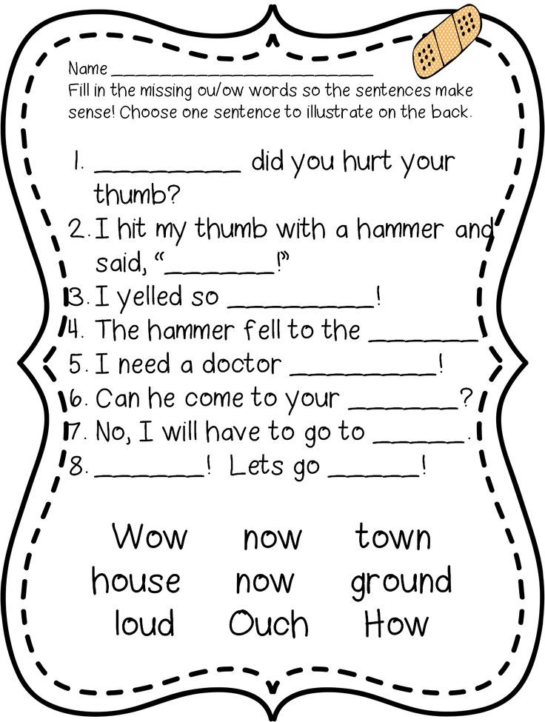

3.Writing

Future Tense

In future we use **‘will’** before the verb. The verb must be on present tense. i.e. Sipho **will go** home. My mother **will sleep** at night.

**Rewrite the paragraph in future tense**.

Zandile loved strawberries. But, strawberries were always so expensive in the shop! One day, Zandile’s mother was looking for pumpkin seeds. Mama turned the rack around, searching for the seeds. Then Zandile saw a packet of strawberry seeds! ‘Mama, please can we buy these seeds?’ she asked. Mama looked at the price: R28. ‘Eish! They’re not cheap!’ she said. But she nodded her head and took the seeds.

----------------------------------------------------------------------------------------------------------------------------------------------------------------------------------------------------------------------------------------------------------------------------------------------------------------------------------------------------------------------------------------------------------------------------------------------------------------------------------------------------------------------------------------------------------------------------------------------------------------------------------------------------------------------------------------------------------------------------. 4. Reading 

Vocabulary words

|  |  |  |  |
| --- | --- | --- | --- |
| tablet | computer | search | read |
| computer | learn | phone | watch |
| video | article | question | internet |

Phonic words

|  |  |  |  |
| --- | --- | --- | --- |
| pouch | round | found | sound |
| ground | plough | bound |  |

Sight words

|  |  |  |  |
| --- | --- | --- | --- |
| loved | seeds | how | properly |
| different |  |  |  |