GRADE R WEEK 2 T-3 THEME: MY FAMILY DATE: 13-17 JULY 2020

MATHEMATICS | ACTIVITY | RESOURCES
 | ACTIVITY 1 COUNTING NUMBERS, OPERATIONS & RELATIONSHIPS
- Rote count from 1-10 (rhymes and songs)
- Count objects up to 5.
- Count forwards and backwards from 1-5 and from 5-1.

 | ACTIVITY 2 ADDITION AND SUBTRACTION (orally solved word problems)
Let the child show up 1 finger in one hand and four fingers in another hand. How many fingers are altogether?
Othembela has 4 sweets. Gerald gives her one more sweet. How many sweets does Othi have altogether?
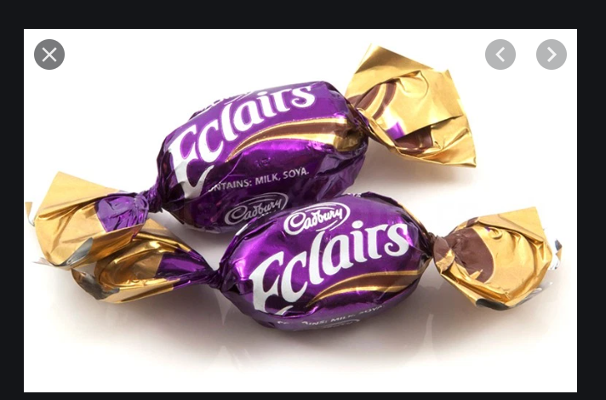

Tom has 5 marbles and loses 2. How many marbles does he have now?
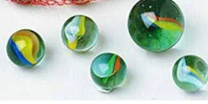

 | ACTIVITY 3 PATTERNS, FUNCTIONS AND ALGEBRA
Copy and extend the pattern.

Use the following to create your own pattern.

HOME LANGUAGE | LISTENING AND SPEAKING
Activity 1
Story: Tell the story of Mila’s family
Mila has 6 people in her family. She has 2 sisters, her mom, dad, granny and grandpa. They all live together. At home Mila’s mom asks her to help granny with her supper and make sure she has a fork to eat with. Her and her sisters help their mom to hang the washing on the line. Mila’s father often comes home tired; he works in a factory. She likes to bring him some water when he gets home. They have chickens and each day she must go and collect any new eggs. It is Mila’s sister’s job to feed their dog each day.

Ask the following questions to check the child’s understanding.
- Who are the people in Mila’s family?
- What does Mila do to help her family?
- What is her father’s job?
Activity 2
Families are special
Family is people
Family is love
That’s a family
They can be very different, you will see.
And mine’s just right for me, yes!
Mine’s just right for me

 | ACTIVITY 3 PHONEMIC AWARENESS
The (h) sound:
- The child must make the sound /h/ clearly and tell her /him to watch your mouth as you make the sound.
- Teach the child an action associated with the sound /h/ (she must use her/his body)
- Let the child give 3 examples of the words that start with ‘’h’’.
- Identify the ‘’h’’ sound from the environment.
LIFE SKILLS | ACTIVITY 1 MY FAMILY
Talk about the picture and ask some questions to encourage the child to participate.

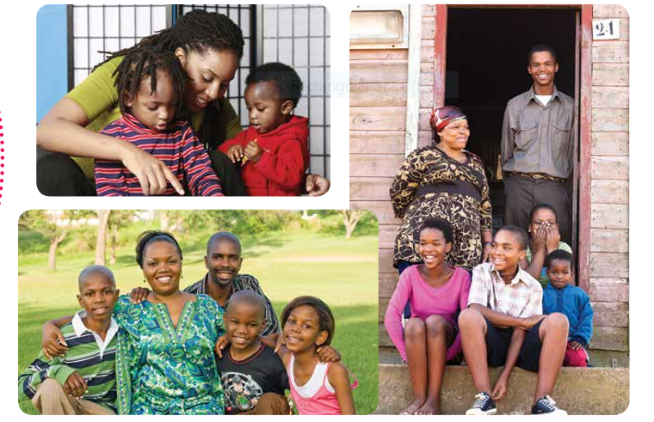

- Explain that all families are different.
- Some might live with their parents, others might not, some might be adopted/ fostered and they might not know.
- But we all have people who care for us and they are our family. This could be a sensitive for some children. Be careful, gentle and reassuring about each of their situations
 | ACTIVITY 2 VISUAL ARTS
Help the child to colour in ‘’ Mila’s family’’.
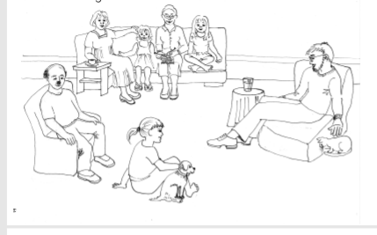

 | ACTIVITY 3 PERFORMING ARTS
Help the child in doing the following song and include action.
Families are special
Family is people
Family is love
That’s a family
They can be very different, you will see.
And mine’s just right for me, yes!
Mine’s just right for me

MATHEMATIKA | UMSEBENZI | IIZIXHOBO
 | UMSEBENZI 1 UKUBALA AMANANI, IOPAREYISHINI NOLWALAMANO
- Bala ngokucengceleza usuke ku-1 uyokuma ku-10(sebenzisa isicengcelezo neengoma)
- Bala izinto eziphathekayo uyokuma ku-5.
- Bala usiya phambili usuke ku-1-5 uphinde ubuye umva usuke ku-5-1.

 | UMSEBENZI 2 UKUDIBANISA NOKUTHABATHA(Ukusombulula iingxaki zomlomo)
Umntwana makaphakamise umnwe omnye (1) wesandla esinye, makaphinde aphakamise iminwe emine yesinye isandla. Mingaphi iminwe iyonke?
UOthembela unee lekese ezine. UGerald uphinde wamnika ilekese enye. Zingaphi iilekese zika Othembela zizonke?
UTom unamabhastile ama-5 waza walahlekwa ngamabini. Unamabhastile amangaphi ngoku?

 | UMSEBENZI 3 IPATENI, IFAKSHINI NE ALJEBRA
Kopa wandise le pateni.

Sebenzisa le mifanekiso ilandelayo ukwakha eyakho ipateni.

ULWIMI LWASEKHAYA | UKUPHULAPHULA NOKUTHETHA
Umsebenzi1
Ibali: Balisa ibali losapho luka Mila.

Usapho lukaMila lunamalungu ama 6. Oodade wabo ababini, umama wakhe,utata,umakhulu notatomkhulu.
Bahlala bonke kokwabo. Ekhayeni umama wakhe uyalela uMila ukuba aphe umakhulu isidlo sakhe sasemvakwemini aqinisekise ukuba unayo ifolokhwe yokutya. UMila noodade wabo bancedisa umama wabo ekuxhomeni impahla ecingweni. Utata kaMila ubuya ediniwe. emsebenzini; usebenza efekitri. Uyakuthanda ukumphathela amanzi xa ebuyela ekhaya. Baneenkukhu ,usuku nosuku uyahamba aqokelele amaqanda.Ngumsebenzi wodade bomila ukondla inja yabo yonke imihla.
Ungabuza lemibuzo ilandelayo ukuqonda ulwazi lomntwana.
- Ngobani abantu bosapho luka Mila?
- UMila wenza ntoni ukuncedisa usapho lwakhe?
- Uyintni umsebenzi katata ka Mila?
Umsebenzi 2
Usapho lwam
Ndinomama, ndinotata ndonwabile
Xa ndibon’ubuso babo
Bencuma benditeketisa

Tyhini wethu Mama noTata
Hayi ukundithanda kwenu
Ngase iNkosi iniphe amandla
Niphile ubomi obude
Kwaye sinoxolo
 | UMSEBENZI 3 IZANDI
Isandi u-h.
- Umntwana makenze isandi u/h/ ngokucacileyo ekuqwalasele emlonyeni indlela osibiza ngayo isandi.
- Fundisa umntwana indlela engqinelana nesandi /h/ (makasebenzise umzimba wakhe)
- Makanike imizekelo emithathu yamagama aqala ngo ‘’h’’.
- Makaqaphele isandi u ‘’h’’ kwintlalo yakhe.
IZAKHONO ZOBOMI | UMSEBENZI 1 USAPHO
Xoxa ngalomfanekiso uze ubuze nemibuzo ukwenzela ukuba umntwana athathe inxaxheba kwingxoxo.

- Chaza ukuba zonke iintsapho zohlukene.
- Ezinye zinganabazali, abanye bangabinabazali, abanye abantwana babafumane koonontlalontle(adopted) babe bengazi.
- Kodwa sonke sinabo abantu abasinakekelayo kwaye balusapho lwethu.Lento ingangavakali kamnandi kwabanye abantwana kodwa ifuna ukubekwa kakuhle ukulungiselela iimeko zabantwana ezohlukeneyo.

 | UMSEBENZI 2 UBUGCISA OBUBONWAYO
 | Nceda umntwana afake umbala kwimifanekiso yosapho luka‘’ Mila’’.
 | UMSEBENZI 3 UBUGCISA OBENZIWAYO/EQONGENI
Ncedisa umntwana ekwenzeni esi sicengcelezo nikwafakela nentshukumo zomzimba.
Usapho lwam
Ndinomama, ndinotata ndonwabile
Xa ndibon’ubuso babo
Bencuma benditeketisa

Tyhini wethu Mama noTata
Hayi ukundithanda kwenu
Ngase iNkosi iniphe amandla
Niphile ubomi obude
Kwaye sinoxolo

