GRADE R WEEK 3 THEME: MY FAMILY DATE: 20-24 APRIL 2020

MATHEMATICS |  | ACTIVITY | GRADE R  DBE WORKBOOK 2
 |  | ACTIVITY 1 COUNTING NUMBERS, OPERATIONS & RELATIONSHIPS
- Rote count from 1-7 (rhymes and songs 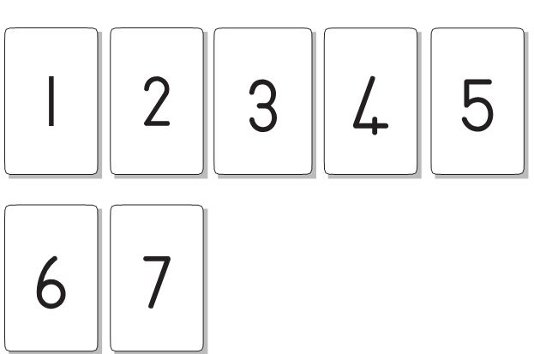
- Revise numbers 1,2 & 3
- Count backwards from 4-1.

- Recognizes numbers in familiar context –let the child count the family members
- Count the four objects /match sticks/spoons/bowls.

 |  | ACTIVITY 2 FEW AND MANY NUMBERS ,OPERATIONS & RELATIONSHIPS
Reinforce or emphasize concepts of “many” and “few”.
- When assisting the child, first use his/her own body to do the activities and later use any concrete material available at home.
- Use 3D objects, own body and 2D shapes /pictures.
Use the following picture and tick with a crayon the block with ‘’few’’ items.

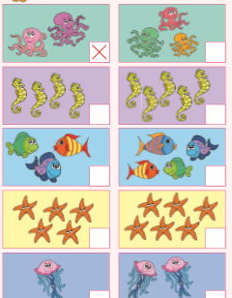

 |  | ACTIVITY 3 NUMBERS, OPERATIONS & RELATIONSHIPS
 |  | Turn to page 30 of DBE workbook 2.  - Match the numbers to the picture showing the same number of items with your finger.  - Match the numbers to the picture showing the same number of items with a crayon. | 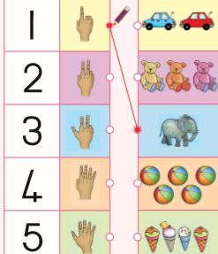
 |  | ACTIVIY 4 PUZZLE SPACE AND SHAPE
 |  | Use page 30 of the DBE workbook.  - Let the child cut the puzzle on page 31 of the DBE workbook.  - Put it together again. | 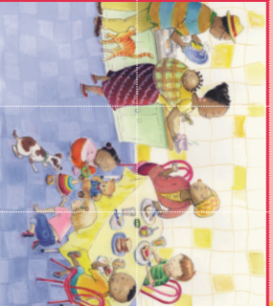
 |  | ACTIVITY 5 SPACE AND SHAPE
 |  | Use page 27 of the DBE workbook  - Let the child identify each item and trace the circles with fingers.  - Trace each shape with a crayon.  - Colour in each shape. | 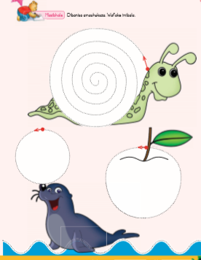
HOME LANGUAGE |  | ACTIVITY 1 LISTENING AND SPEAKING
 |  | Discussion  The theme of the week is My Family.  - Look at the picture in DBE Workbook Page 25 and different families.  - Talk about the family members and give the child an opportunity to mention his/her family members.  - In your discussion include words like, mother, father, sister, brother, grandmother etc.  - Discuss few roles done by each family member.  - Say the words e.g. mother, father, etc. Ask the child to clap out for each word and ask the number of claps for each. | .  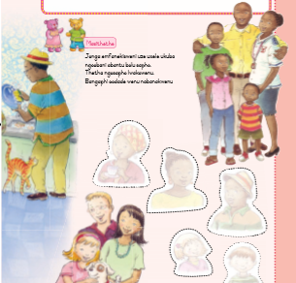
 |  | ACTIVITY 2 EMERGENT WRITING
 |  | - Let the child draw her/his own picture and other family members referring to page 25 of the DBE workbook.  - Write his /her own name on the space provided below the frame.  - Guide to start from the top to bottom and from left to right. | 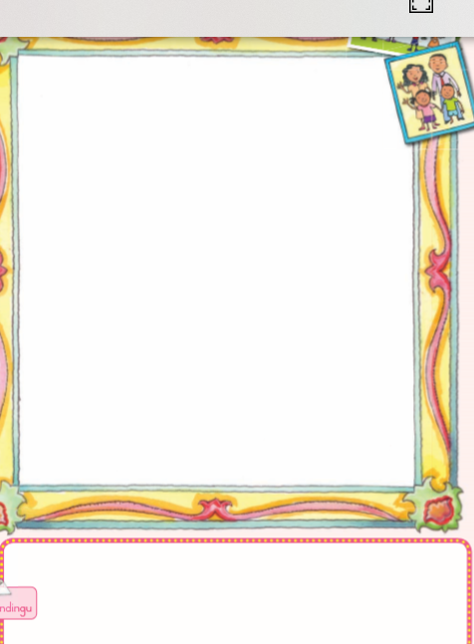
 |  | ACTIVITY 3 PHONEMIC AWARENESS
- Let the child say her/his name three times emphasizing the beginning sound.
- Ask her/him to suggest two more friends names that start with the same sound.
- Look around the house and name the objects that start with the same initial sound.

LIFE SKILLS |  | ACTIVITY 1 MY FAMILY
 |  | Talk about the picture and facilitates the discussion with questions. Pages 24 and 25 of DBE workbook.  - Who are the members of your family?  - How many members in your family?  - Name the activities that you celebrate together as a family e.g. birthdays, Christmas, picnics, etc. | 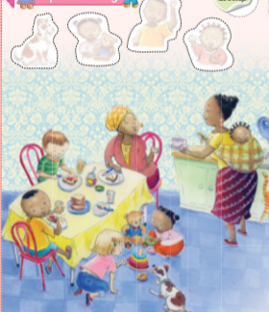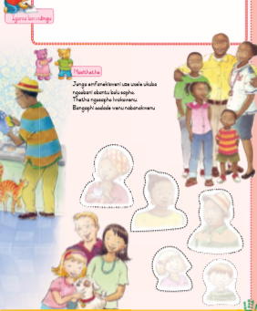
 |  | ACTIVITY 2 VISUAL ARTS
Pages 24 and 25 of the DBE workbook.

- Find the stickers and paste them on pages 24 and 25 of the DBE workbook.
- Define the activities done by each family member.

