GRADE R WEEK 8 THEME: TOUCH DATE: 25 - 29/05/2020

Keep yourself healthy
- Wash your hands before you eat with soap and water for at least 20 seconds.
- seconds.
- Frequently clean the toys/resources used by children.
- Practice social distancing at all times.
- When sneezing /coughing use your elbow/tissue and dispose it.

MATHEMATICS | ACTIVITY | GRADE R  DBE WORKBOOK 2
 | ACTIVITY 1 COUNTING NUMBERS, OPERATIONS & RELATIONSHIPS
- Estimate and Rote count from 1-7 (rhymes and songs)
- Knows the number symbols and recognize number names 1 to 4
- Count backwards and forwards from 1 to 4

Activity 1:

Cut out the number symbols 1 to 4. Let child identify a number and clip the correct number of pegs onto the number symbol.

Activity 2:

Write the number 1 to 4 on a blank page. Ask the child to pack out the correct number of bottle tops next to each number symbol. (Recognize numbers 1 to 4)

 | ACTIVITY 2 FEW AND MANY NUMBERS ,OPERATIONS & RELATIONSHIPS
Reinforce or emphasize concepts of “many” and “few”.

Turn to page 10 of DBE Workbook 2
Discuss the pictures and ask the child how many trees, butterflies, balloons are in the picture?
Use different questions to emphasize “many” and “few”.

 | ACTIVITY 3 PATTERNS FUNCTIONS AND ALGEBRA
 | Activity: use different colour bottle tops to copy patterns.  Draw a colour pattern with dots. Ask the child to copy the pattern using bottle tops.  The child can copy and extend own patterns. (See example below) | 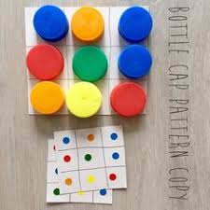
 | ACTIVIY 4 MATCHING AND SORTING
 | - Use any picture from a magazine and cut it into 12 blocks.  - Let the child build the puzzle.  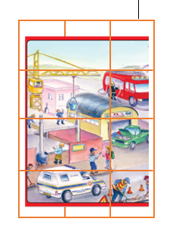 | Use page 61 of the DBE Workbook.  Cut out the pictures and play a matching game “SNAP”
HOME LANGUAGE | ACTIVITY 1 LISTENING AND SPEAKING
 | Discussion  Read the Ant and the Apple story and discuss:  Ask questions about the story:  Ask the child to identify the beginning sound of Ant, Apple, Aligator.  What was the colour of the apple?  Who was the ant’s friend? | .
 | ACTIVITY 2 EMERGENT WRITING
Turn to page 16 of the DBE Workbook 2

- The child traces the sound first with his/her finger and then with a crayon.
- The child can use playdough to form the sound.

 | ACTIVITY 3 PHONEMIC AWARENESS
Use page 16 & 17 of DBE Workbook 2
The (a) sound:
- Introduce the s sound to the child.
- Let the child name word that starts with a sound like: ant, apple, axe
- The child traces the sound first with his/her finger and then with a crayon.
- The child can fill in the letter a and listen to the sound as he/she say the words aloud

LIFE SKILLS | ACTIVITY 1 BEGINNING KNOWLEDE AND PERSONAL WELL-BEING
 | Discussion  - Discuss with the child different things feel different.  - Use words hard, soft, smooth, rough, cold, hot, warm cool. | 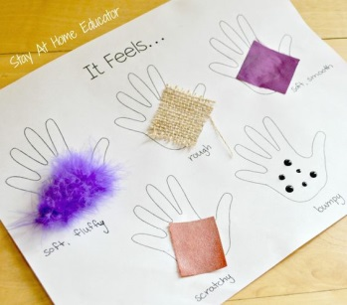
ACTIVITY 2 CREATIVE ARTS
- Use different material to create a picture.
- Different textures like wool, cotton wool, paper, stones, buttons, sand can be used to be creative. (tearing and pasting)
- During this activity use the words like, hard /soft to develop the child’s vocabulary.

ACTIVITY 3 PHYSICAL EDUCATION
Play outside:
- The child can run walk outside on a line and to balance on low level objects.
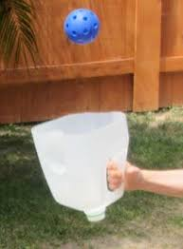
- Throw ball in containers. (throw and catch)

IBANGA LABAQALAYO ISIHLOKO: UKUBAMBA
Ukuzigcina ukhuselekile
- Hlamba iizandla rhoqo ngamanzi nesepha phambi kokutya
- Ngalo lonke ixesha coca izinto zakho zokudlala/izixhobo zokufunda.
- Gada umgama phakathi kwakho nomntu okufutshane kuwe.
- Xa uthimla/ukhohlela sebenzisa itshefu/iphepha lokufinya uze ulilahle wakuqiba.

MATHEMATIKA | UMSEBENZI | INCWADI YOKUSEBENZA YESI-2
 | UMSEBENZI 1 UKUBALA AMANANI IOPERAYISHINI NOLWALAMANO
Ukubethelela ulwazi olufunyenweyo oluquka amanani u- 1,2,3 no 4
- Ukubala ngentloko ngokungenantsingiselo usuke ku-1 ukuya ku-7
- Bala izinto eziphathekayo usuke ku 1-4
- Bala usiya phambili usuke ku-1-4, ubale ubuya umva usuke ku 4ukuya ku 1.

Umsebenzi 1:
Nika ithuba umntwana ukukhetha inani elililo aze afake inani elichanekileyo leepegis(pegs).

Umsebenzi 2 :

Bhala iisimboli zamanani kwiphepha elingenamigca.Umntwana makasebenzise iziciko zebhotile azingqamanise nenani ngalinye ukusuka ku-1-4.

 | UMSEBENZI 2 UMBALWA NO NINZI
 | Incwadi yokusebenzela yesi-2, iphepha 21.  Bala izinto ezikwibhokisi nganye, xela ukuba yeyiphi ibhokisi enezinto ezininzi iyeyiphi enezinto ezimbalwa.Sebenzisa uphawu u-x- | 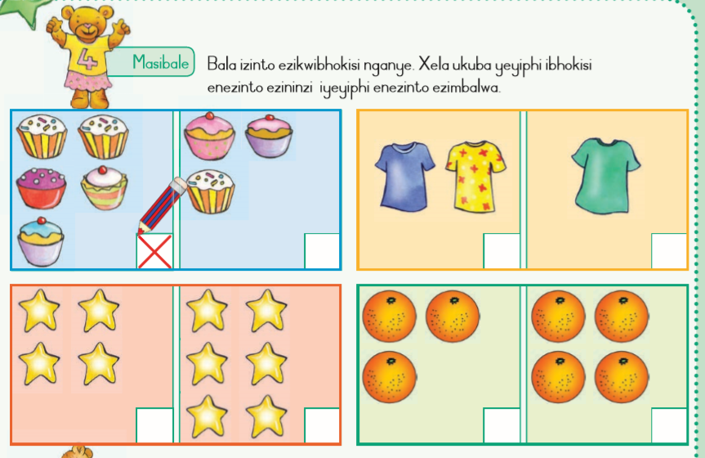
 | UMSEBENZI 3 IPATENI IPATENI, IFANKISHINI NE ALJIBRA
- Sebenzisa iziciko ezinemibala eyohlukeneyo ukukopa ipateni.
- Zoba ipateni enombala ngamachokoza.
- Yalela umntwana akope ipateni esebenzisa iziciko ezineibala eyohlukeneyo.
- Kopa ipateni ayandise aphinde azenzele eyakhe(qwalasela lomfanekiso ungezantsi we AB pateni).

 | UMSEBENZI 4 UKUTSHATISA NOKUCWANGCISA (matching &sorting)
 | - Sebenzisa nawuphi na umfanekiso owuthathe kwimagazini uze uwusike ube ziibhloko ezi-12.  - Yakha iphazile enamaceba angama-12. | Sebenzisa iphepha 60 lencwadi yokusebenzela.  Sika imifanekiso uze udlale umdlalo ka ‘’Snap’’.  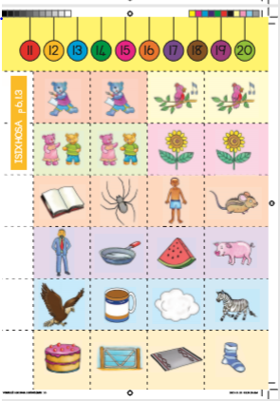
ISIXHOSA | UMSEBENZI 1 UKUPHULAPHULA NOKUMAMELA
 | Ingxoxo  - Funda ibali lika Viwe nekati yakhe.  - Khokhela umntwana ngemibuzo enje:  - Ngubani umnikazi wekati?  - Ngubani isandi sokuqala samagama alandelayo Viwe/Vava/Vuvuzela/Vili?  - Sebenzisa ingalo yakho ukubonisa isandi u-v-.  - Unjani umbala we vuvuzela?  - Ngubani umhlobo wekati? | 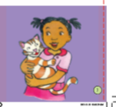  UViwe nekati yakhe  Igama lam ndingu Viwe umhlobo wam yikati yam egama lingu Vava.  Sithanda ukudlala endleleni.Sithe sidlala ndeva ngesandi se vuvuzela.Watsiba uVava wayokutshona phantsi kwe vili lebhayisekile.  Ndamkhuha phantsi kwe vili ,ndamfunqula ndamthuthuzela.
 | UMSEBENZI 2 UKUBHALA OKUPHUHLISWAYO
 | - Nika umntwana ithuba lokujonga amanye amagama aqala ngo ngesandi u-V- endlini nakwimagazini.  - Makacinge amagama abantu aqala ngo-V-.  - Mnike imicinga /amakhuni/amatye /iziciko akhe unobumba u-V-.  - Sebenzisa umdongwe ukakha isandi u-V-.  - Makalinganise ukubhala unobumba u-V- esantini/ebaleni nalo njalo. | 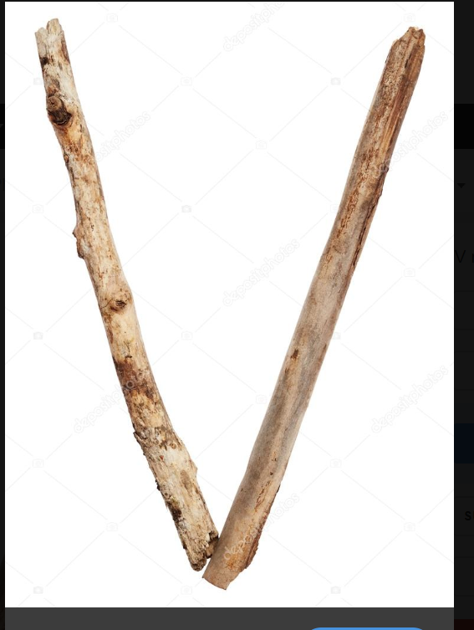
 | UMSEBENZI 3 IZANDI
Isandi u (v):
- Umntwana makenze isandi u/v/ ngokucacileyo ekuqwalasele emlonyeni indlela osibiza ngayo isandi.
- Fundisa umntwana indlela yokusebenzisa umzimba ukwakha unobumba u /v/ (makasebenzise umzimba wakhe)
- Yalela umntwana amamele isandi asiva ekuqaleni kwalamagama:
Vula,Vuvuzela,Velile.
- Makanike imizekelo emithathu yamagama aqala ngo ‘’v’’.
- Makaqaphele isandi u ‘’v’’ kwintlalo yakhe.

IZAKHONO ZOBOMI | UMSEBENZI 1 ISIHLOKO: UKUBAMBA  ULWAZI OLUSISISEKO, UKUZIPHATHA NENTLALO
Ingxoxo
- Makaqwalasele emfanekisweni atsho into ayibonayo.
- Ingaba isandla osibonayo sisisebenzisa enini?
- Xoxa nomntwana ngezinto ezohlukeneyo oziva ngesandla xa uzibambile.
- Sebenzisa amagama anje ngo
iqinile/ithambile/irhabaxa/iyabanda/ishushu/ipholile.

UMSEBENZI 2 UBUGCISA
- Sebenzisa izixhobo ezohlukeneyo ukwenza lo mfanekiso.
- Ubunjani bezinto ezohlukeneyo ezifana nezi,iwulu,iphepha,amatye,amaqhosha,Isanti,njalo njalo,zingaseteyenziswa ebuchuleni bokwenza umfanekiso(Ukusika nokuncamathelisa).
- Xa usenza lomsebenzi sebenzisa isigama esinje ngo,iqinile/ithambile/irhabaxa ukukhulisa isigama somntwana.

UMSEBENZI 3 EZEMITHAMBO
Dlala ngaphandle kwendlu:
- Umntwana makabaleke ejikeleza iziphawuli zendlela ezibini esebenzisa izinto eziphathekayo.
- Sebenzisa isikhongozeli ukubamba bhola
(ukujwila nokubamba)

