Province of the
EASTERN CAPE
EDUCATION

NATIONAL
SENIOR CERTIFICATE

GRADE 11

HISTORY – FIRST PAPER

(ADDENDUM)

NOVEMBER 2009

MARKS: 150

TIME: 3 hours

This addendum paper consists of 9 pages.

QUESTION 1: WHAT WERE LENIN’S ECONOMIC POLICIES AND TO WHAT EXTENT DID THEY FOLLOW A SOCIALIST MODEL?
SOURCE 1A
The following extract described War Communism:

Lenin described it as follows: [the policy] was dictated, not by economic, but by military needs, considerations and conditions.”
The main feature of War Communism was the establishment of centralised control over all production and distribution, including the compulsory delivery of grain. The following measures were introduced:
- All private ownership was abolished and industry was brought under state control.
- Discipline in factories was re-established, with a return to ‘one-man management’ rather than workers’ control.
- Internal passports were introduced to prevent factory workers from returning to the countryside.
- Food patrols were sent out into the rural areas to extract grain from the peasantry.
- Rationing was introduced, and the bulk of the food was given to the Red Army.
Source: Friedman, M. et al, Looking into the Past, Grade 11, p.115, 2006.
SOURCE 1B
The consequences of War Communism:
Some peasants burnt their crops and destroyed their livestock rather than hand it over to the state. As a result, food shortages got even worse. There were violent clashes in the countryside between peasants and armed requisitioning squads. Starving workers left the cities to search for food which meant that industrial production also declined. There was also a severe famine and drought in the Lower Volta region in 1921. Approximately five million Russians died from starvation.

Source: Friedman, M. et al, Looking into the Past, Grade 11, p.116, 2006.

SOURCE 1C
Starving peasant children in 1921.

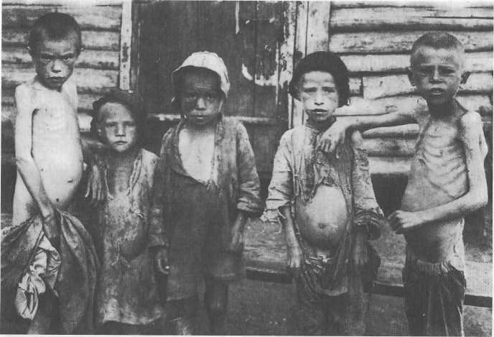
Source: Shuters History Grade 11, p. 127
SOURCE 1D
Lenin’s NEP was a compromise between capitalism and socialism. Its main features included:

- Forced requisitioning of grain was ended. It was replaced by a 'tax in kind' in which peasants had to hand over a fixed proportion of their grain to the state. They could then sell the surplus for profit on the market. Moreover, farmers were allowed to hire out their lands. This led to the emergence of a new breed of independent, wealthy farmers; the Kulaks.
- All industries with less than twenty workers were denationalised. This gave rise to a new class of traders and factory owners, the Nepmen.
- The state retained control of the most important sectors of the economy.
- The State Bank was established in 1921 and gave loans and credit facilities.
- NEP led to economic recovery.
Source: Friedman, M. et al, Looking into the Past, Grade 11, p.117, 2006.

QUESTION 2: WHAT WAS THE IMPACT OF THE GREAT DEPRESSION OF 1929 ON THE LIVES OF PEOPLE IN THE UNITED STATES OF AMERICA?
SOURCE 2A
This source outlines how companies, government and the Americans were affected by the Great Depression.

On 29 October the market collapsed as worthless speculative shares dragged down the shares of even the great corporations like Du Pont and General Motors. All this was bad enough, but the effects could not be limited to Wall Street and the ruined financiers. Holding companies collapsed, factories closed their doors and banks stopped business. Millions were thrown out of work. Taxes could not be collected and funds for the welfare services or schoolteachers’ salaries could not be found. The Great Crash had turned into the Great Depression. By 1932 share prices had fallen by 82 per cent, output by 40 per cent, wages by 60 per cent. Twelve million men were out of work.
Source: Britain, Europe and the Modern World, 1972, p.54
SOURCE 2B
The following 2 extracts explained the affect of the Great Depression on the lives of the American people:

Extract 1:
Taken from: Looking into the Past, Grade 11, p.149

Famous firms went bankrupt. Brokers jumped to their death from the top of skyscrapers…People I knew were down and out. Some put up their houses for sale, a useless act as no one was buying anything, or boarded them up and left because they could no longer afford to live…An old couple who lived not far from us lost everything in the Crash…so they committed suicide.

Extract 2
Taken from: Oxford in Search of History, Grade 12, p. 273

Thousands of working-class families have been thrown out of their homes because they can no longer pay the rent. In the streets of every large city, workers are dropping, dying and dead from starvation and exposure. Every newspaper reports suicides of these workers, driven by desperation and starvation.

SOURCE 2C
As unemployment soared, more and more people were forced onto the breadlines where people queued for free bread. Karl Monroe, an unemployed reporter, describes his experience in a breadline:

Written source

Tired, hungry and cold, I stretched out on the bench, and despite the lack of downy mattress and comforter eventually fell asleep. The soles of my feet were swollen with blisters, because my shoes had not been removed in at least seventy-two hours and I had tramped the sidewalks for three days…
Finally, I stood in the breadline in Twenty-Fifth Street, where the women’s section of the Socialist Party daily distributed soup, coffee and bread. To my surprise, I found in the line all types of men – the majority being skilled craftsmen unable to find work. One of them told me he had been a civil engineer and had earned $8 000 a year. Since losing his job almost a year ago, he had drifted from bad to worse, occasionally picking up jobs, until he had sunk to the breadline…

Visual source
This is a photograph of a typical queue of unemployed workers queuing for bread in New York in 1930.

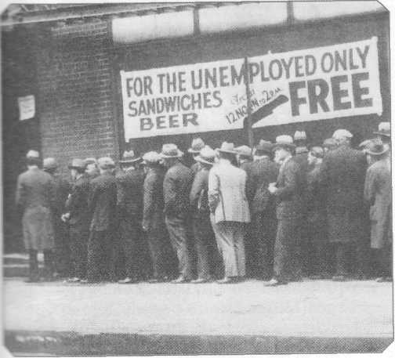
Source: New Africa History, Grade 11, p. 89

QUESTION 3: WHAT WERE THE ROOTS AND NATURE OF AFRIKANER AND AFRICAN NATIONALISM AND IDENTITIES IN SOUTH
AFRICA DURING THE 1930s TO 1950s?
SOURCE 3A
An excerpt of the origin of the concept of Afrikaner nationalism to the Afrikaner
nationalist party coming to power in 1948.

Afrikaner nationalism was more like a European form of nationalism in that it was based on uniting people of a particular language group. Unlike nationalisms in Europe, however, Afrikaner nationalism was racially based. It accepted, as members of the Afrikaner nation, not all who spoke Afrikaans (for a majority of those that spoke Afrikaans were people of mixed descent), but only those who were white. Afrikaner nationalism, therefore, was an exclusive nationalism, forged first in opposition to Britain and to British rule of the Afrikaner people. In the South African (Anglo-Boer) War of 1890 − 1902, Afrikaners were unsuccessful in their attempt to their freedom and avoid British rule.
Source: Friedman, M. et al, Looking into the Past, Grade 11, p.198, 2006.

SOURCE 3B
PHOTOGRAPH 1
The emphasis of the Van Riebeeck Festival was on a common white history,
rather than the Afrikaner Nationalist heritage, which the Eeufees had stressed.
The float procession ended with ‘We Build a Nation’. The two horses represented
the coming together of the two white nations.

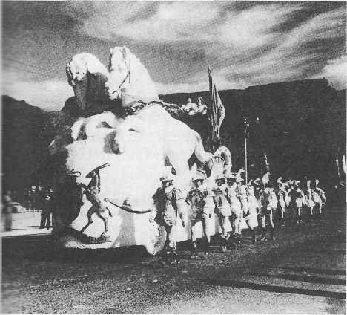
Source: Botarro, J. et al, In Search of History, Grade 11, p.175, 2006

PHOTOGRAPH 2
A protest rally of Blacks, Coloureds and Indians against the official Van Riebeeck celebrations in 1952. A popular slogan was ‘Nothing to celebrate’.

Source: Botarro, J. et al, In Search of History, Grade 11, p 176, 2006

SOURCE 3C
Nelson gives testimony about Lembede’s belief in the philosophy of Africanism.
Lembede and Mandela were part of the Youth delegation to meet Dr Xuma, the ANC president.

Lembede said that Africa was a Black man’s continent, and it was up to the Africans to reassert themselves and reclaim what was rightfully theirs. He hated the idea of black inferiority complex and castigated what he called the worship and idolisation of the West and its ideas. The inferiority complex he affirmed, was the greatest barrier to liberation. He noted that wherever the African had been given the opportunity, he was capable of developing to the same extent as the white man, citing such African heroes as Marcus Garvey, W.E.B.Du Bois and Haile Selasie. “The colour of my skin is beautiful,” he said, “like the black soil of Mother Africa.” He believed that blacks had to improve their own self-image before initiating successful mass action. He preached self-reliance and self-determination, and called his philosophy ‘Africanism’.
Source: Deftereos, R. et al, Making History, Grade 11, p 206, 2006
SOURCE 3D
Yengwa (a member of the ANC Youth League) gives his position about the militancy of the Africanists.

‘It was not an anti-white thing. We became more and more aware that our struggle is not against the white man – our struggle is against apartheid. Of course, generally, our whole thrust was African Nationalism. African Nationalism was, as we saw it, a unifying force and driving force towards overthrowing white oppression. As we developed our own philosophy of African Nationalism, we discovered that we had common goals – it didn’t matter whether you are black or white. In other words, we evolved towards non-racialism.

Source: Deftereos, R. et al, Making History, Grade 11, p 210, 2006

