**GRADE 4 SOCIAL SCIENCES – GEOGRAPHY TERM 2**

**TOPIC: SYMBOLS AND KEYS MARKS: 25**

**WORKSHEET 1**

1. How is the bird’s eye view different from the side view?

______________________________________________________________________________________________________________________________________________________________________________________________________________________________________________________________________________________(4)

1. Look at the objects below and draw a plan view for each object in your exercise book.

**  **

(3)

1. Look at the objects below and draw a side view for each object in your exercise book.

  

**Table motor car briefcase**

(3)

1. Look at the objects in the source below. The objects on the left were drawn from the side, the same objects were drawn from above to give you a “plan” on the right view. See if you can link the two views together. (5)



**(Pictures taken from Oxford Successful Social Sciences Gr 4)**

1. Draw a plan view of a classroom with the following objects inside :Teacher table at the front, six learner desks from each side of the classrooom, a chalkboard , a bookshelf/cupboard. (5)

**The plan view of a classroom**

|  |
| --- |
|  |

1. Draw a key to indicate all physical features/objects you have shown on the above plan.

(5)

**WORKSHEET 2**

**GRADE 4 SOCIAL SCIENCES – GEOGRAPHY TERM 2**

**TOPIC: SYMBOLS AND KEYS MARKS:30**

1. What is a map?

__________________________________________________________________________________________________________________________________________________________________________________________________________________________________(2)

1. Who uses maps and what do they use maps for ?

_________________________________________________________________________________________________________________________________________________________________________________________________________________________________________________________________________________________________________________________________________________________________________________________ (4)

1. Look at the picture below. Cut out or photocopy the picture and paste it in your class workbook. Draw and label the map key to interpret this picture. (5)



1. Below is a map key of a small town with houses, trees, a river, a road, shops, a school, a hospital, a church and a lake. Now look at the “key” which uses **symbols** (simple pictures) to inform us what each item is.



4.1 Now, according to the symbols, list what items 1 – 9 are. Spell the words correctly.



1.___________2.___________3___________

4.___________5.___________6____________7._________

8____________9____________ (9)

4.2 Look at the above picture of a farm and make your own symbols (simple drawings)

for the items listed below.

**KEY**

|  |  |
| --- | --- |
| House |  |
| Dam |  |
| Wind pump |  |
| Tree |  |
| Road |  |

(5)

4.3 Now redraw the plan of the farm using the symbols you have drawn. (5)

GRAND TOTAL = 30 MARKS

**WORKSHEET 3**

**GRADE 4 SOCIAL SCIENCES – GEOGRAPHY TERM 2**

**TOPIC: GRID REFERENCES MARKS: 10**

1. Look at the plan below which has been divided into grids. Use the key and the grids to help you name a feature in each grid. The 10 items found in this block are the: *Fire station, Police station, Post office, Hospital, Shops, School, Library, Station, Houses, Church*

Place them in the correct places on the worksheet provided.



|  |  |  |  |  |  |
| --- | --- | --- | --- | --- | --- |
| Grid A1 | ____________ | Grid A2 | _____________­ | Grid A3 | ______________ |
| Grid B1 | ____________ | Grid B2 | _____________ | Grid B3 | ______________ |
| Grid C1 | ____________ | Grid C2 | _____________ | Grid C3 | ______________ |

1. Draw a symbol that shows that smoking is not allowed in a certain place. (1)

**WORKSHEET 4**

**GRADE 4 SOCIAL SCIENCES – GEOGRAPHY TERM 2**

**TOPIC: COMPASS DIRECTIONS MARKS: 25**

1. Draw and label a four cardinal point Compass. (4)
2. Which group of people usually uses a Compass Rose? Name at least four groups.

(i)………………….(ii)…………………. (iii)………………………. (iv)………………… (5)

1. Study these pictures and use the cardinal points of a compass to answer questions that follow:



  



* 1. The traffic circle is ______of the house (1)
  2. From the house, to the church what direction will you take using a compass? __ (1)
  3. The park is _____ of the house. (1)
  4. The garage is _____ of the house. (1)
  5. If you are standing in front of the house, the park will be_______ of the house. (1)
  6. The house is ___________ of the church (1)

1. Complete the following activity

|  |  |  |  |  |
| --- | --- | --- | --- | --- |
| 1) I am facing North and make a ¼ turn clockwise, where am I facing now?                **E**  **N**  **S**  **W**    +  Answer |  | 2) I am facing North and make a ¾ turn clockwise where am I facing?                **E**  **N**  **S**  **W**    +  Answer |  | 3) I am facing North and turn ½ a turn clockwise, where am I facing now?      **E**  **N**  **S**  **W**    +  Answer |
| 4) I am facing North and I turn a full turn clockwise, where am I facing now?                **E**  **N**  **S**  **W**    +  Answer | 5) I am facing South and I turn a ¼ turn clockwise, where am I facing now?                  **E**  **N**  **S**  **W**    +  Answer | 6) I am facing East and I turn a full turn clockwise, where am I facing now?      **E**  **N**  **S**  **W**    +  Answer |

**(6)**

1. Imagine you are an official from a Tourism Information Centre guiding a tourist who wants to visit Mthatha, Qunu village, Nelson Mandela’s birthplace in the Eastern Cape. The tourist will be flying from Gauteng’s O R Tambo International Airport t via East London airport then drive straight to Mthatha. Write five sentences using the four cardinal points of a compass to guide the tourist.

____________________________________________________________________________________________________________________________________________________________________________________________________________________________________________________________________________________________________________________________________________________________________________________ (4)

**WORKSHEET 5**

**GRADE 4 SOCIAL SCIENCES – GEOGRAPHY TERM 2**

**TOPIC: MAP OF SOUTH AFRICA MARKS: 25**

1. Below are the names of the provinces and oceans found near South Africa. Shade the provinces on the map in different colours. Cut out the above names and paste them to their correct positions. (12)

|  |  |  |  |
| --- | --- | --- | --- |
| **WESTERN CAPE** | **LIMPOPO** | **KWAZULU-NATAL** | **INDIAN OCEAN** |
| **NORTHERN CAPE** | **MPUMALANGA** | **EASTERN CAPE** | **ATLANTIC OCEAN** |
| **NORTH WEST** | **GAUTENG** | **FREE STATE** |  |

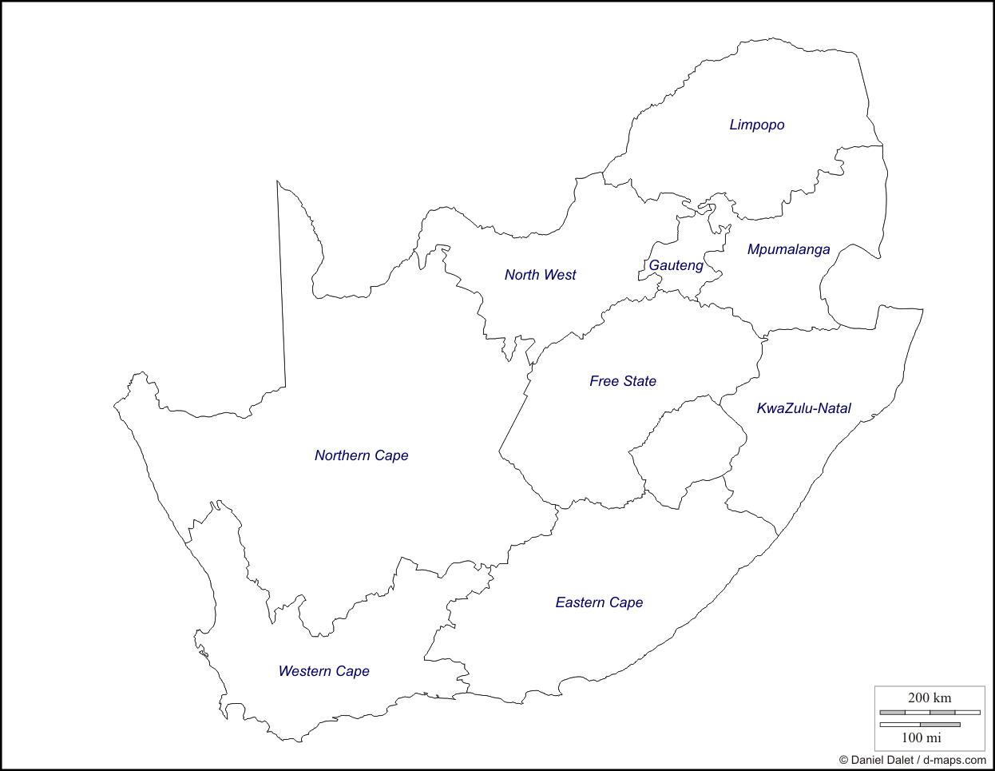

1. Use different colours to mark the sea and land on the above map. The colour that shows the sea is ________ and the colour used to show the land is _______ (2).
2. Write the capital cities in each province and indicate that by placing a dot. (9)
3. Estimate the location of your own settlement on the above map by putting an X (2)

**GRADE 4 SOCIAL SCIENCES – GEOGRAPHY TERM 2**

**TOPIC: MAP OF THE WORLD MARKS: 10**

**WORKSHEET 6**

The world map has been drawn in other way round to check if you really understand the position of each continent. Identify the continents on the World map below. Make sure you “shade” them in different colours. The oceans must be “shaded” in light blue (9)



2. Locate the country South Africa on the world map and indicate it with the letter S. (1)