ISIGABA ESIPHAKATHI
IBANGA LESI-6
UMSEBENZI -7
2020
ISIXHOSA ULWIMI LWASEKHAYA
UHLOLO OLUSESIKWENI

IXESHA: 2 IYURE
AMANQAKU: [50]
LO MSEBENZI UQULETHE AMAPHEPHA AMA-5

UMBUZO 1: IZICATSHULWA (20 amanqaku.)
UMBUZO 2: EZIBONWAYO (10 amanqaku)
UMBUZO 3: ISISHWANKATHELO (5 amanqaku)
UMBUZO 4: IZAKHI NEMIGAQO YOLWIMI (15 amanqaku)

Phendula yonke le misebenzi isesikweni ibhalwe apha ngasezantsi

UMBUZO 1
Funda esi sicatshulwa ngononophelo wandule ukuphendula imibuzo
Elandelayo.
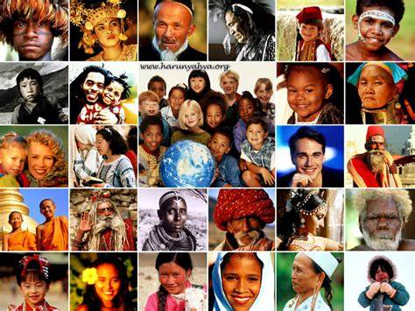
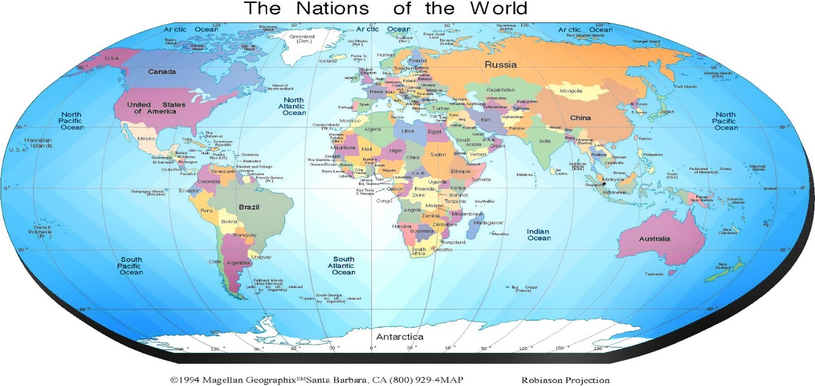
SONKE SINGABANTU ABAKWIPLANETHI YOMHLABA.

Sonke singabantu basemhlabeni.Sihlala kuzo zonke iindawo,kwizixeko esizinikiweyo nakwiidolophana ezincinane.Sihlala kwiindawo ezinomkhenkce nezithe tyaba okanye kumahlathi ashinyeneyo ashushu.Sihlala entlango,ezintabeni,nakwiziqithi eziselwandle.
Siyimibala ngemibala.Abanye bethu bafudumele,abanye ulusu lwabo lufuna ilanga esantini .Abanye bethu banolusu oluntsundu ngathi yitshokolethi.Abanye banolusu olupinki ngokungathi kukuvela kokusa,Abanye bethu banolusu olubomvu.
Amehlo ethu neenwele zethu ziyimibala engafaniyo.Sinamehlo abhulowu,amehlo amdaka ngebala namehlo angwevu okanye aluhlaza.Iinwele zigwangqa okanye zimdaka ngebala okanye zibomvu okanye zimnyama.zinokoluka okanye ziphothane.
Asifani ngeziqu nokumila.Abanye bade abanye bafutshane.Abanye banciphile ukanti abanye bathe futhu.Asifani ngendlela yokuphila,ngeenkolo nangamasiko ethu.Sithanda ukutya okungafaniyo.Sivela kwiintsapho ezahlukeneyo,singamaqela ,izizwe,neentlanga ezingafaniyo
Kodwa siyafana ngezinto ezininzi.Sonke sifuna ukutya.Sifuna ukukhuseleka,ukuhlala ngokukhululeka nokonwaba .Sonke sifuna uthando nobuhlobo.Sonke sifuna izinto ezintle.Sonke siyinxalenye yosapho olukhulu. usapho lwabantu abamalunga neebhiliyoni ezisi-7.Sonke sinookhokho abasele bombatha ingubo kaqaqaqa.Ewe, sonke singabantu abakwiplanethi yomhlaba,kwaye sonke siphuma apha eMzantsi Afrika.

UMBUZO 1

1 | Kuthethwa ngantoni kweli bali | (1)
2 | Nika iindawo zibe mbini abantu abahlala kuzo ngokwalapha kweli bali. | (2)
3 | ‘Siyimibala ngemibala” wena unjani owakho umbala ?Xhasa impendulo yakho. | (3)
4 | Ingaba bonke abantu bayakwazi ukuzibopha iinwele zabo ngokwanamhlanje? Xhasa impendulo yakho. | (2)
5 | Uthi umbhali siyohluka ngokumila.Kha ucacise gabalala ukuba sohluka njani omnye komnye. | (3)
6 | Nika izinto zibe -3 esifana ngazo apha emhlabeni. | (3)
7 | Xa kuqikelelwa kunokuba sibangaphi apha kweli lizwe kuthethwa ngalo? | (2)
8 | Yeyiphi le planethi sikuyo? | (1)
9 | Anjani amehlo akho ngokombala ?Nxulumanisa nale ibhalwe apha imibala yamehlo. | (2)
10 | Ngabantu bakuliphi ilizwe aba kuthethwa ngabo apha ? | (1)
11 | Nika intsingiselo yesi saci “ abasele bombatha ingubo kaqaqaqa. | (2)
12 | Umbhali usixelela ukuba abanye banombala opinki,de awufanise.Chaza ke ngoko ukuba uwufanisa nantoni lo mbala upinki. | (1)
 | AMANQAKU EWONKE | [20]

UMBUZO 2 : Imifanekiso
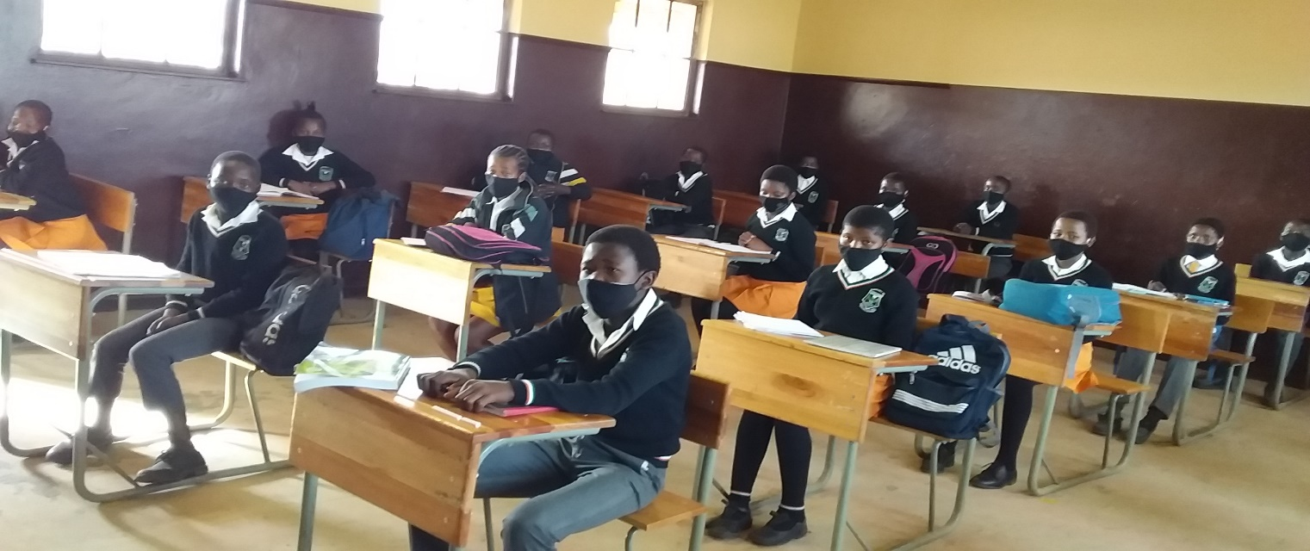
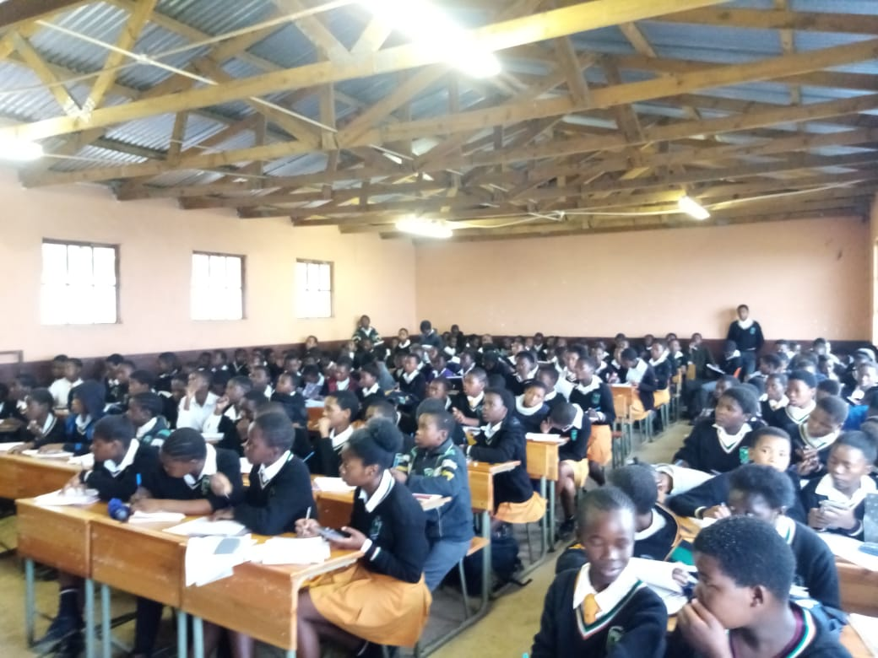
- Krwaqula imifanekiso engasentla uze uthelekise okubonayo kule mifanekiso mibini (2)
- Nika isizathu sokuba kumfanekiso wokuqala banxibe ngolu hlobo ? (1)
- Ilizwe lomzantsi Afrika liphantsi kwemeko yokumiswa ngxi kweentshukumo ,yintoni unobangela? (1)
- Ungazikhusela njani kule meko eyenziwe kukumiswa ngxi kwentshukumo? nika iimpendulo zibe mbini (2)
- Zaqala kweyiphi inyanga ukumiswa kwezi ntshukumo, zimiswa ngobani? (1)
- Nika iimpawu zibe mbini zomntu ohlaselwa yi (Covid) (2)
- Sisigaba sini sentetho eli gama likwizibiyeli zama (ngxi) intshukumo (1)
UMBUZO 3
Funda imbali ka Mark Shuttleworth azibhalele ngokwakhe uze ushwankathele ka ngangezi zivakalisi ezintlanu.Sebenzisa amagama 60-70
Ndingu Mark Shuttleworth . Ndingummi wase Mzantsi Afrika . Ndithanda ukwenza ezi zinto : ukuqala iinkampani zamashishini ,utshintsho ukuya enyangeni kwakunye nobuchwepheshe . Ndihlala kwindawo ebizwa ngokuba yi Isle of man.Ndineenkampani ezenza ubuxhaka xhaka bekhompyutha. Ndikwangumnini we Shuttleworth Foundation,iqumrhu elijongene nokuphuhliswa kwabantu .
Eli qumrhu alenzi mali koko iinjongo zalo kukuphucula imfundo eAfrika ,ngakumbi imfundo yezobuchwepheshe .Ndizalelwe e Welkom kwi Phondo lase Freystata ndaza ndakhulela e Kapa . Ndifunde kwi Yunivesithi yase Kapa. Ndifunde izifundo ze khompyutha nezokuphathwa kwemali .Ndibe nomdla kakhulu kwi intanethi , ndaqaphela utshintsho enokuza nalo ngakumbi kushishino nase kuhlaleni ngokubanzi .
Ndaye ke ndavula ushishino olucebisa nge intanethi . ngonyaka wama 2002 ku Epreli ndazalisekisa iphupho lam lokuya enyangeni. Ndathatha unyaka wonke ndilungiselela olu hambo. Ndiye ndafumana uqeqesho phesheya. Ndihambe neqela Labantu. Ndithe ndenza uphando nge phrojekthi yenzululwazi yoMzantsi Afrika ndaza ndazonwabisa. Ndihleli apho iintsuku ezisibhozo. Ekubuyeni kwam ndihambe kulo lonke ndixelela abantwana bezikolo ngamava am asenyangeni kwakunye nezifundo ze Nzululwazi neziBalo.
Ibonwe ngabantwana abangamakhulu amawaka kwizikolo ezingamakhulu amabini. Injongo yam yeyokuba abantwana bazithande ezi zifundo ezikolweni. Ngalo ndlela bendisebenzela ukuphuhlisa ezi zifundo. Izinto endizithandayo ziquka ukutyelelela iindawo ezininzi , ukuqubha ,iimpahla ezintle , ukuphupha ngezinto nekhaya lam ukanti kuluhlu lwezinto endingazithandiyo ndingabala ukuthetha esidlangalaleni nokuxoxa ngemivuzo
AMANQAKU (5)

UMBUZO 4: IZAKHI NEMIGAQO YOKUSETYENZISWA KOLWIMI
Funda lo mhlathi ungezantsi uze uphendule imibuzo ebuziweyo.
YINTONI ICOVID-19?
ICovid-19 sisigulo esihamba nokuphefumla esineempawu ezibumkhuhlane (ukukhohlela,ifiva,ukudinwa kakhulu nomzimba/ izihlunu ezibuhlungu). Lo mkhuhlane ungaphaya komkhuhlane oqhelekileyo, uza ngamandla ubangele inyumoniya enevayirasi (ukufumana ubunzima ekuphefumleni). Abantu abane kwabahlanu bangangaguli kakhulu yaye bakhawuleze ukuphila ngaphandle konyango. Abantu abadala kunye nabo baneemeeko zempilo ezibuthathaka, ngabo abasesichengeni sokugula kakhulu. Zinqabile iimeko zolu suleleko ebantwaneni. Hlamba izandla rhoqo. Kubalulekile ke ukuba siziphulaphule sizenze zonke iingcebiso ezimalunga neCovid-19 kaloku inyathi ibuzwa kwabaphambili.

IMIBUZO
4.1 Khetha isibizo kwesi sivakalisi.
Abantu bangangaguli kakhulu. (1)
4.2 Guqula isibizo esibhalwe ngqindilili sibe kwisinciphiso.
Abantu abadala ngabo abasesichengeni.
(1)
4.3 Bhala esi sivakalisi sibe kwisinye.
Zinqabile ezi meko ebantwaneni.
(2)
4.4 Khetha isimelabizo kwesi sivakalisi uze uxele nodidi lwaso.
Lo mkhuhlane uza ngamandla.
(2)
4.5 Bhala esi sivakalisi sibe kwimo elandulayo.
Zinqabile ezi meko ebantwaneni.
(2)
4.6 Xela okokuba igama elibhalwe ngqindilili lisisigaba sini sentetho/ liyintoni?
Abantu abadala ngabo abasesichengeni.
(1)
4.7 Bhala isichasi segama elibhalwe ngqindilili.
Zinqabile ezi meko ebantwaneni.
(1)
4.8 Bhala intsingiselo yeli qhalo.
Inyathi ibuzwa kwabaphambili.
(2)
4.9 Khetha isiyaleli esifumaneka kulo mhlathana ungasentla.
(1)
4.10 Bhala esi sivakalisi sibe kwixesha eladlulayo.
Zinqabile iimeko zosuleleko.
(1)
4.11 Khetha isivumelanisi sentloko kwesi sivakalisi.
Isigulo (icovid-19) sihlasela abantu
(1)
Amanqaku (15)

