Province of the
EASTERN CAPE
EDUCATION

Steve Vukile Tshwete Education Complex • Zone 6 Zwelitsha 5608 • Private Bag X0032 • Bhisho 5605
REPUBLIC OF SOUTH AFRICA

CHIEF DIRECTORATE – CURRICULUM MANAGEMENT

GRADE 12 LEARNER SUPPORT PROGRAMME

REVISION AND REMEDIAL TEACHING INSTRUMENT:
ANSWERS

SUBJECT: MUSIC – FIRST PAPER
(COMPREHENSION)

June 2009

This document consists of 39 pages.

SECTION A: THEORY OF MUSIC

QUESTION 1

Study the Trio from the last part of J.S. Bach’s Brandenburg Concerto no. 1, and answer the questions that follow.

1.1 | Identify the intervals marked 1.1.1 to 1.1.3.

Answer:

 | 1.1.1 | Compound minor 3rd / minor 10th ✓ | (1)

 | 1.1.2 | Minor 6th ✓ | (1)

 | 1.1.3 | Perfect 4th ✓ | (1)

1.2 | Rewrite bars 4 and 5 of the bassoon part at the same pitch in the tenor clef.

Rubric | - ½ for each error (e.g. clef, key signature, notes, stems)

 | 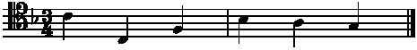 | (2)

1.3 | Write the solfa notation equivalent of bar 20 of the oboe 1 and oboe 2 parts.

Rubric | - ½ for each error (pitch or rhythm)

 | Oboe 1 | {r : - . d,r : m} ✓ | (1)

 | Oboe 2 | {d' : t . l : t} ✓ | (1)

1.4 | Your ensemble group has to perform this piece at a prestigious fundraising event, but a day before the event your 1st oboe player breaks her hand. Luckily you find a clarinettist player who is willing to stand in for her, on condition that the music is transposed into the correct key for a B-flat clarinet. Transpose bars 5 − 7 of the 1st oboe part so that it will sound at concert pitch when played by the clarinettist player.

Rubric
  Description | Learner’s marks | Maximum marks
  Correct key signature |  | 1 mark
  Errors (notes, rhythm, stems) |  | - ½  (maximum of 4 errors)

(3)
[10]

QUESTION 2

2.1 | Study the excerpt from Haydn’s Piano Sonata in D, Hob XVI: 37, and identify the compositional techniques marked at A and B.

Answer:

 | A | Sequence ✓ | (1)
 | B | Repetition ✓ | (1)

 | 2.2.1 | Study the excerpt from J. S. Bach’s Chorale, BWV 40/8 and identify the compositional technique used at C.

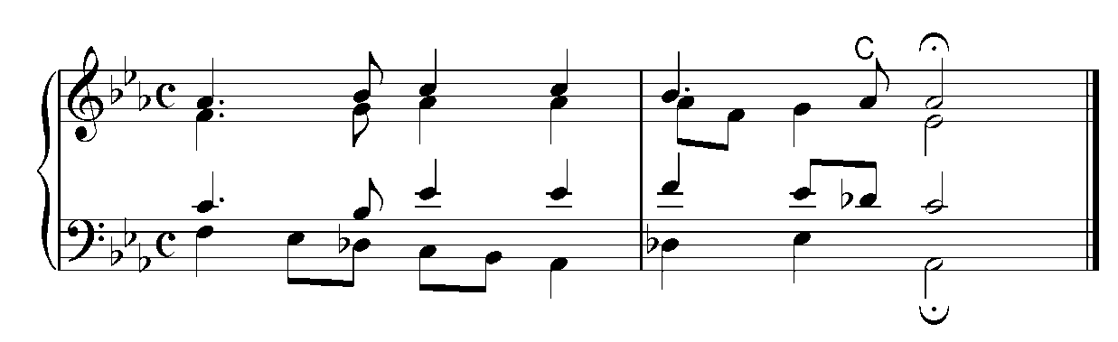

Answer:

 | C | Anticipation ✓ | (1)

2.2.2 | Study the excerpt from J. S. Bach’s Chorale, BWV 184/5 and identify the compositional technique used at D.

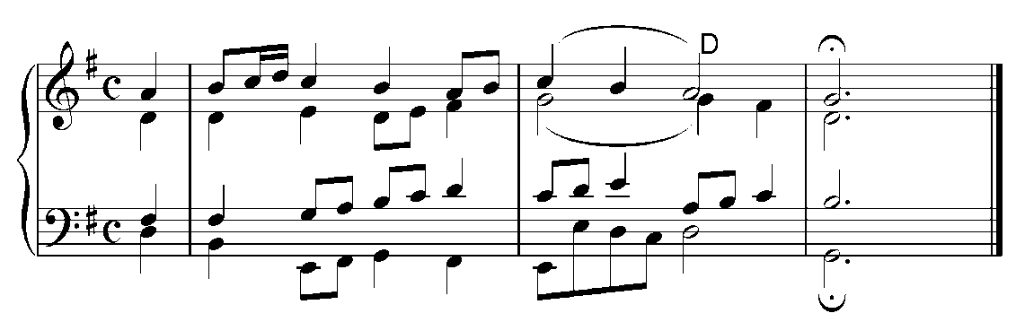

Answer:

 | D | Suspension ✓ | (1)
 |  |  | [4]

QUESTION 3

Study the excerpt from J. S. Bach’s Chorale, BWV 269, and follows the instructions.

- Figure the chords marked A and B
- Identify the cadences marked C and D.

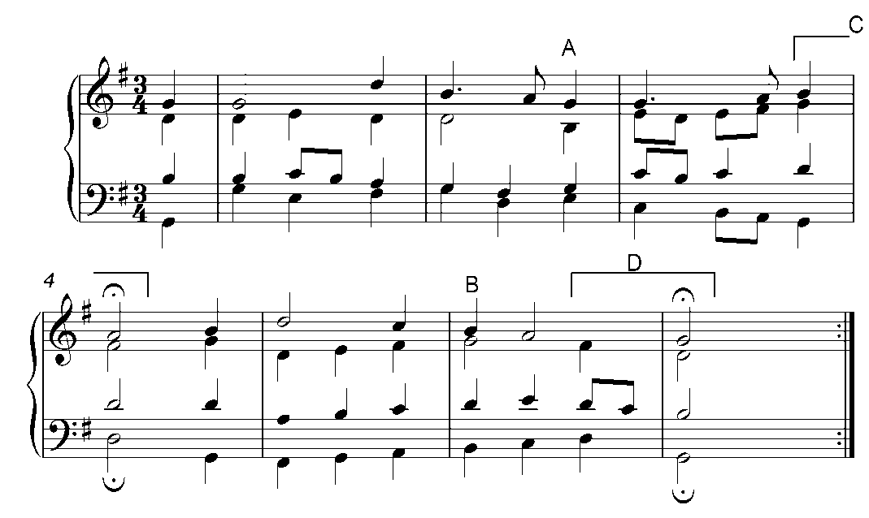

Answer:

 | A | vi ✓ | (1)
 | B | I⁶ ✓ | (1)
 | C | Imperfect ✓ | (1)
 | D | Perfect ✓ | (1)
 |  |  | [4]

QUESTION 4

Answer:

4.1 | Write the following triads without key signature.

 | 4.1.1 | D Major: IV 6/4

Rubric
  Description | Learner’s marks | Maximum marks
  Correct note |  | 1 mark
  Errors (accidentals omitted) |  | - ½  (maximum of errors)

 | 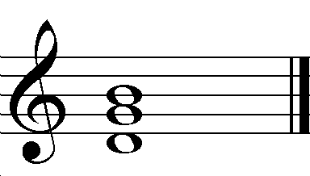 | (3)

 | 4.1.2 | C minor: III+

Rubric
  Description | Learner’s marks | Maximum marks
  Correct note |  | 1 mark
  Errors (accidentals omitted) |  | - ½  (maximum of errors)

 | 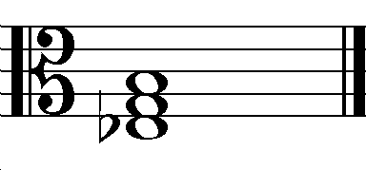 | (3)

4.2 | Write the following scale.

Whole tone scale starting on A, descending, in simple triple time. Add the necessary accidentals.

Rubric
  Description | Learner’s mark | Mark allocation
  Correct time signature |  | 1
  Correct grouping according to time signature |  | 1
  Correct starting note |  | 1
  Correct accidentals |  | 1
  TOTAL |  | 4

Answer:

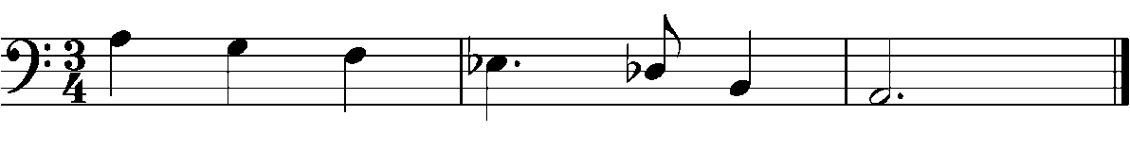

4.3 | Identify the following scales.

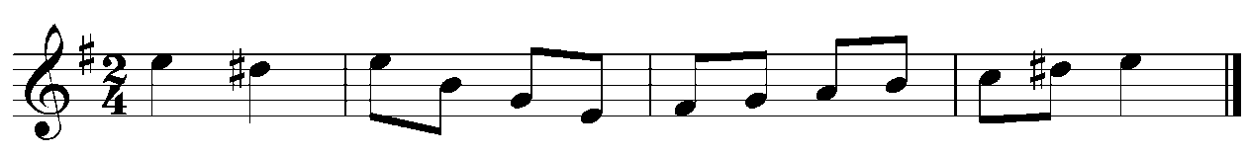

 | 4.3.1 | E Harmonic Minor ✓ | (1)

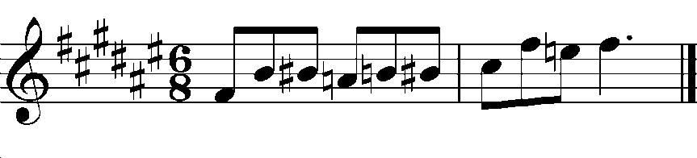

 | 4.3.2 | Blues scale built on F sharp ✓ | (1)

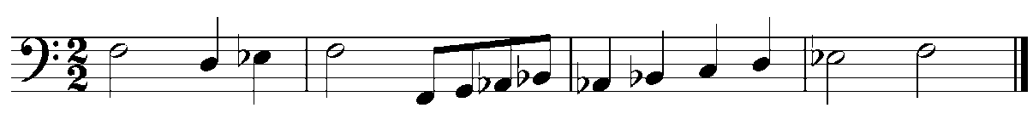

 | 4.3.3 | Dorian scale of E flat major ✓ | (1)

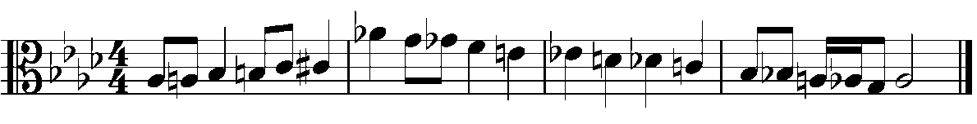

 | 4.3.4 | Chromatic scale ✓ | (1)
 |  |  | [14]

QUESTION 5

Answer either QUESTION 5.1 or QUESTION 5.2.

5.1 | Write a 12-bar melody including the following:  - Ternary form  - D Minor key signature  - Make use of any TWO of the following rhythmic motifs  - Use a simple quadruple time signature

OR OR


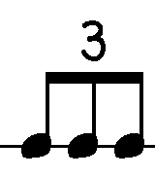
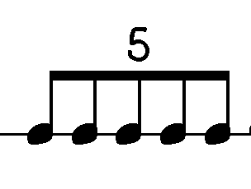

Indicate your choice of instrument and add appropriate dynamics, phrasing and articulation. Follow the rubric below as a guide.

Instrument: ________________________________________________

Description | Learner’s mark | Mark allocation
Choice of instrument |  | ½
Correct use of time signature |  | ½
Correct use of rhythmic motifs |  | 1
Correct use of key signature |  | ½
Performance interpretations |  | ½
Form (½ mark each per A B A’) |  | 1½
Cadences (1/2 mark per correct cadence) |  | 1½
Grammar and Melody |  | 6
TOTAL MARK |  | 12

Answer: | See Grammar and Melody marking rubric below.

PERCENTAGE % | RAW MARK | DESCRIPTION FOR GRAMMAR AND MELODY MARK ALLOCATION
100 | 6 | Excellent use of given motifs with imaginative use of compositional devices such as sequences, inversions, etc. Shows understanding of form with repetition of opening motif. Melody shows good melodic curve with a clearly defined climax. Suited to the chosen instrument.
83 | 5 | Very good use of given motifs and other compositional devices such as sequences, inversions, etc. Shows understanding of form with repetition of opening motif. Melody has a good melodic curve with an obvious climax. Fairly well-suited to the chosen instrument.
67 | 4 | Fairly good use of given motifs, but not much use of other compositional devices such as sequences, inversions, etc. Shows an understanding of form with a repetition of the opening motif. Melody has a fairly good melodic curve and shows a climax. Suitable for the chosen instrument.
50 | 3 | Makes use of given motifs. Shows some understanding of form with repetition of the opening motif. Melody has some sort of curve, but the climax point is a little uncertain. Not really suitable for the chosen instrument.
33 | 2 | Makes use of given motifs. The melody has some sort of curve, but the climax point is ineffective. There is little sense of form and the melody is not well-suited to the chosen instrument.
17 | 1 | Motifs used, but no logical sense of development of melody taking place. Melody has no climax and tends to ramble along. There is little (if any) sense of form.

OR

5.2 | Complete the given opening motive to form a 12-bar melody, consisting of three 4-bar phrases.
Your melody must include the following:
- Suitable rhythmic and/or melodic composition techniques
(e.g. imitation, repetition and sequences).
- Indicate your choice of instrument in the space provided.
- Add phrasing, performance interpretations and a suitable tempo
indication.
- Cadences

Follow the rubric below as a guide.

Instrument: ______________________________________________

(12)

Description
Learner’s mark | Mark allocation
Choice of instrument |  | ½
Rhythmic and/or melodic compositional techniques |  | 2
Performance interpretations |  | ½
Form |  | 1½
Cadences (1/2 mark per correct cadence) |  | 1½
Grammar and Melody (See rubric on page 11) |  | 6
TOTAL MARK |  | 12

[12]

Answer: | Grammar and Melody marking rubric

PERCENTAGE % | RAW MARK | DESCRIPTION FOR GRAMMAR AND MELODY MARK ALLOCATION
100 | 6 | Excellent use of opening motif with imaginative use of compositional devices such as sequences, inversions, etc. Shows understanding of form with repetition of opening motif. Melody shows good melodic curve with a clearly defined climax. Suited to the chosen instrument.
83 | 5 | Very good use of opening motif with the use of sequence and/or inversion, etc. Shows understanding of form with a repetition of the opening motif. Melody has a good melodic curve with an obvious climax. Fairly well-suited to the chosen instrument.
67 | 4 | Fairly good use of opening motif, but not much use of compositional devices like sequences, etc. Shows an understanding of form with a repetition of the opening motif. Melody has a fairly good melodic curve and shows a climax point. Quite suitable for the chosen instrument.
50 | 3 | Makes use of the opening motif, but not always logically. Shows some understanding of form with repetition of the opening motif. Melody has some sort of curve, but the climax point is a little uncertain. Not really suitable for the chosen instrument.
33 | 2 | Although use has been made of the opening motif there is little logic to the development of this motif. The melody shows a melodic curve, but the climax point is rather ineffective. There is little sense of form and the melody is not really well-suited to the chosen instrument.
17 | 1 | Although the melody is complete there is no logical development of the opening motif. The melody has no climax and tends to ramble along. There is little (if any) sense of form.

QUESTION 6

Answer either QUESTION 6.1 or QUESTION 6.2.

6.1 | Harmonise the following melody for four parts.

Use the following:
- Second inversion (6/4) progressions (minimum of ONE)
- A vii°6 chord at a suitable place
- Passing or auxiliary notes (NOT in the soprano voice)
- Cadential 6/4 progression where the chords have been inserted.

Indicate the chord figuration below the stave.

Answer: KINDLY NOTE THAT THIS IS A POSSIBLE ANSWER.

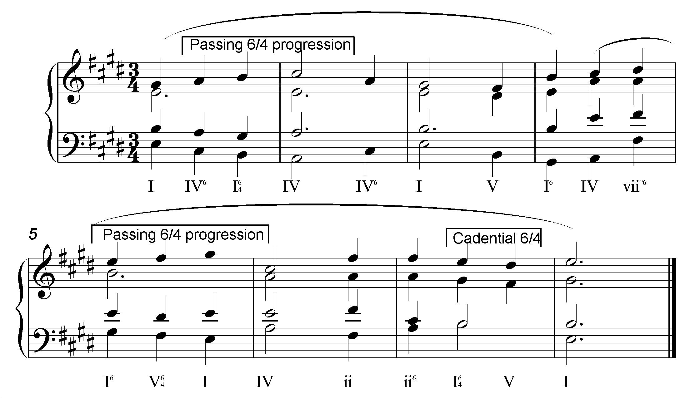

Rubric
  Description | Learner’s  mark | Mark allocation
  Correct use of second inversion progressions. |  | 2
  Correct use of vii°6 chord. |  | 1
  Correct use of passing or auxiliary notes. |  | 1
  Correct usage of notes at cadential 6/4 progression. |  | 1
  Correct use of cadence at first phrase ending. |  | 1
  Inclusion of chord figuration. |  | 1
  Grammar: i.e. correct writing of notes, correct spacing between voices, and correct writing of stems.  Calculate on percentages:  -0 for very little or no mistakes  -1 for third of mistakes  -2 for two thirds of mistakes  -3 many mistakes |  | 3
  General impression: i.e. use and application of chords, inversions, progression, leading voice |  | 6
  TOTAL MARK |  | 16

OR

6.2. | Study the following bass line and harmonise the following 8 bars as indicated in the first bar:  - Notate ONE or TWO chords per bar on the top staff following the example in bar 1.  - Indicate the chord symbols above the stave.  - Use any harmonic device known to you. The use of advanced  harmonies will count in your favour.  - Add TWO passing notes (mark with an ‘A’ and ‘B’) in the bass line.

Answer:

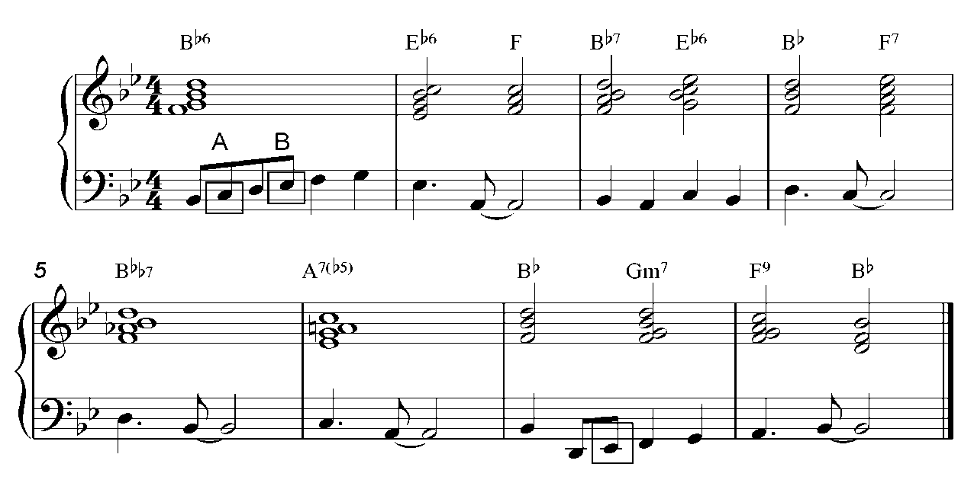 | [16]

Rubric
  Description | Learner’s  mark | Mark allocation
  Correct use of second inversion progressions. |  | 2
  Correct use of vii°6 chord. |  | 1
  Correct use of passing or auxiliary notes. |  | 1
  Correct usage of notes at cadential 6/4 progression. |  | 1
  Correct use of cadence at first phrase ending. |  | 1
  Inclusion of chord figuration. |  | 1
  Grammar: i.e. correct writing of notes, correct spacing between voices, and correct writing of stems.  Calculate on percentages:  -0 for very little or no mistakes  -1 for third of mistakes  -2 for two thirds of mistakes  -3 many mistakes |  | 3
  General impression: i.e. use and application of chords, inversions, progression, leading voice |  | 6
  TOTAL MARK |  | 16

TOTAL SECTION A: | 60

SECTION B

QUESTION 7

You have studied the fourth movement of Brahms’s 4th Symphony. Answer the following questions.

Answer:

7.1 | Provide a definition for the term ‘Symphony’.

 | A large work for symphony orchestra (✓) with three or four movements (✓) in the order of fast – slow – (minuet and trio) – fast (✓). | (3)

7.2 | In which key is the fourth movement?

 | e minor ✓ | (1)

7.3 | The fourth movement is marked Allegro energico e passionato. Give the meaning of these musical terms.

 | Fast ✓, energetic ✓ and with passion. ✓ | (3)

7.4 | The theme and variation form of the fourth movement is similar to a form used in the Baroque period. Give the name of this form.

 | Passacaglia ✓ | (1)

7.5 | How many variations does the fourth movement consist of?

 | 30 Variations ✓ | (1)

7.6 | Describe where the theme is heard in the following variations, regarding register.

 | 7.6.1 | Variation 1 – 3

 |  | Middle and high registers. ✓ | (1)

 | 7.6.2 | Variation 4 – 11

 |  | Melody in bass, with other melodies in upper registers. ✓ | (1)

 | 7.6.3 | Variation 12 – end

 |  | Theme appears in any register. ✓ | (1)
 |  |  | [12]

QUESTION 8

You have studied ONE of the following Romantic compositions:

8.1 | Polonaise in A flat major, Op. 53

8.2 | Der Erlkönig

8.3 | La Bohème

8.4 | Violin Concerto in e minor (First movement)

8.5 | The Moldau

Name the genre of your composition and list FOUR characteristics relevant to your chosen composition.

Answer:

 | 8.1 | Polonaise in A flat major, Op. 53

 | Genre: | Character piece ✓ | (1)

 | Characteristics: | - Composed in the Romantic period.  - Polish origin.  - Composition for solo instrument that communicates a specific atmosphere.  - Polonaise is in triple time.  - Makes use of ternary form with a short coda.  - Requires high technical command from the pianist.  - Fast tempo.  - Fast runs.  - Powerful and majestic work.  - Stately, processional dance. (Any 4) | (4)

 | 8.2 | Der Erlkönig

Genre: | Art song ✓ | (1)

Characteristics: | - One of earliest examples of Romantic music.  - Through composed song.  - German text (poem by Goethe).  - Piano and voice forms an integral part of each other.  - Piano accompaniment contributes to the character of the song.  - Tells of a father riding on a horseback through a storm with his sick child in his arms.  The child dies in his arms before arriving home.  - Piano parts’ rapid octaves, rapid triplet rhythms and bass motif conveys the horse  ride. (Any 4) | (4)
 | 8.3 | La Bohème

Genre: | Opera ✓ | (1)

Characteristics: | - Composed in the Romantic period.  - Story unfolds with singing, décor, costumes and movement.  - Takes place in the Latin Quarter of Paris round about 1830.  - Main characters are Rudolfo and Mimi.  - Everyday life story for ordinary people.  - Story about Bohemian life seen through romantic scenes.  - Drama accompanied by an orchestra.  - Divided into four acts.  - Beautiful and sensuous melodies.  - Music of an improvisatory nature.  - Instruments contribute to the emotions and actions. (Any 4) | (4)

 | 8.4 | Violin Concerto in e minor (First movement)

Genre: | Concerto ✓ | (1)

Characteristics: | - Composed in the Romantic period.  - Work for symphony orchestra and solo violin.  - Consists of three parts.  - First part is in sonata form.  - Performer has opportunity to display their technical and musical abilities.  - First movement begins with the soloist who  presents the first theme above the murmuring  strings.  - These unusual uses of instruments create a very intimate and delicate sound.  - Cadenza is written out.  - Another difference Mendelssohn demonstrates is that the cadenza comes only at the end of the development; through this the cadenza becomes part of the whole and not simply an addition that demonstrates the technical skills of the performer.  (Any 4) | (4)

 | 8.5 | The Moldau

Genre: | Symphonic Poem ✓ | (1)

Characteristics: | - Composed in the Romantic period.  - Orchestral composition relating a particular story, picture or idea through the use of sound.  - The Moldau was inspired by the composer’s view of the landscape in Bohemia.  - Part of the cycle Má Vlast (My Country).  - Romantic representation of nature.  - Display of Czech nationalism.  - Contrasting musical sections that represent  different scenes and episodes.  - Recurring folk like theme symbolises the river.  - Fast running notes portray the running river.  (Any 4) | (4)
 |  | [5]

QUESTION 9

Answer BOTH question 9.1 and 9.2

9.1 | Compare any TWO of the following jazz styles:

 | 9.1.1 | Ragtime

 | 9.1.2 | Bebop

 | 9.1.3 | Swing

 | 9.1.4 | Blues

Include tempo and rhythm; melody and form; and instrumentation used in your comparative notes.

Answer: | See choice below and compare answers  (Selected Jazz styles)

Ragtime | Tempo and rhythm: (Any 1)  - Music generally in duple time.  - Performed at a moderate march tempo.  - Syncopated rhythm in right hand.  Melody and form: (Any 1)  - Consists of several melodies that are similar in character.  - Form = AA BB A CC DD.  - Syncopated melody in right hand.  Instrumentation: (1)  - Piano | (3)
Bebop | Tempo and rhythm: (Any 1)  - Extremely fast beat.  - Pizzicato bass and ride cymbal marks this fast steady beat.  - Drummer supplies irregular accents (“bombs”).  Melody and form: (Any 1)  - Complex harmonies.  - Intricate melodies.  - Begins and ends with the statement of the main theme by one  soloist.  - Other parts made up by solo improvisations.  Instrumentation: (Any 1)  - Group (4 – 6 players),  - That might include a saxophone and a trumpet,  - Supported by a rhythm section of piano, bass and percussion. | (3)

Swing | Tempo and rhythm: (Any 1)  - Bass drum maintains pulse,  - While percussionist stresses the second and fourth beats.  Melody and form: (Any 1)  - Swing melodies often performed by entire sections, either in  unison or in harmony.  - Solo improvisations restricted in length.  Instrumentation: (Any 1)  - Group that has:  - 14 – 15 musicians grouped into three sections.  - Group 1 = 3 – 5 Saxophones, sometimes with clarinet;  - Group 2 = 3 – 4 Trumpets and trombones;  - Group 3 = Piano, percussion, guitar and double bass. | (3)

Blues | Tempo and rhythm: (Any 1)  - Almost always in quadruple time.  Melody and form: (Any 1)  - Music set to harmonic framework, usually 12 bars in length.  - Pattern involves only three basic chords (Tonic, Sub Dominant  and Dominant).  - Divided into three phrases. (AAB structure)  - Each phrase has four bars.  Instrumentation: (Any 1)  - Soloist sings two bars of each phrase. (There are three phrases)  - Remainder of phrase filled with instrumentalists. | (3)

9.2 | Answer the following multiple-choice questions, about African Jazz, by circling the correct answer.

9.2.1 | Complete the following sentence:

Jazz in Africa has a similar origin to that of …

 | A | Great Britain.

 | B | Cuba.

 | C | America. ✓

 | D | Brazil. | (1)

 | 9.2.2 | The first jazz recording (‘The Original New Orleans Dixieland Band’) was also released in South Africa. When was it released?

 | A | 1915

 | B | 1917 ✓

 | C | 1921

 | D | 1971 | (1)

 | 9.2.3 | Indicate which ONE of the following is one of the first jazz musicians in South Africa.

 | A | William Mbali’s Big Four ✓

 | B | Count Basie Orchestra

 | C | Alexandria Jazz Band

 | D | Duke Ellington | (1)

 | 9.2.4 | Choose the one that best describes Marabi music.

 | A | Melody is composed.

 | B | Mixture of Ragtime and Bebop.

 | C | Mixture of Dixieland and Ragtime. ✓

 | D | The chords are played with a guitar. | (1)

 | 9.2.5 | Choose the one that best describes Mbaqanga music.

 | A | Mixture of Xhosa music with an African-American style.

 | B | Very strong bass that pushes the music forward. ✓

 | C | Includes elements of Kwela.

 | D | Includes Marabi singing tradition. | (1)

 | 9.2.6 | Choose the one that best describes an African stomp dance.

 | A | Zulu dance style with repetitive Mbaqanga and Swing elements.

 | B | Zulu dance style with repetitive Marabi and Swing  elements. ✓

 | C | Zulu dance style with repetitive Marabi and Bebop elements.

 | D | Zulu dance style with repetitive Marabi and Blues elements. | (1)

 | 9.2.7 | Indicate one of the best-known jazz musicians of South Africa.

 | A | Mandoza

 | B | Mike Oldfield

 | C | Nataniel

 | D | Abdullah Ibrahim ✓ | (1)
 |  |  | [13]

QUESTION 10

You have studied ONE of the following styles. Specify the one that you have studied and write programme notes on the style and representative work.

10.1 | Style | (2)

10.2 | Work(s) | (3)

- Impressionism: Debussy – Voiles, from Preludes Book 1
- Neo-Classicism: Stravinsky – The rite of Spring
- Musical Theatre: My Fair Lady, West Side Story, Phantom of the Opera

Answer: | Impressionism: Debussy – Voiles, from Preludes Book 1

10.1 | Programme notes on the style:

 | - Music evokes fleeting moods and misty atmospheres.  - Inspired by literary and pictorial ideas.  - Most compositions have descriptive titles.  - Music sounds free and spontaneous – almost improvised.  - Emphasis on tone colour and atmosphere.  - Fluidity is characteristic of Impressionism in music.  - Debussy weakened the tonality, by not affirming any key. (Any 2) | (2)

10.2 | Programme notes on the work or works:

 | - Written for piano.  - Exploits the blurred and tonally vague quality of the whole-tone scale  to suggest the gentle rocking of sails in the wind.  - Subdued in dynamics.  - Moderate in tempo.  - Consists of three sections.  - Uses piano’s damper pedal to create lingering vibrations that  suggest a misty atmosphere.  - Use chords moving in parallel motion.  - Middle section moves to pentatonic scale.  - Concluding section returns to whole-tone scale.  - No sense of harmonic resolution at end. (Any 3) | (3)

Answer: | Neo-Classicism: Stravinsky – The rite of Spring

10.1 | Programme notes on the style:

 | - Music genre marked by emotional restraint, balance and clarity.  - Musical forms and stylistic features of the 18th century were used.  - This style reacted against Romanticism and Impressionism.  - Composers turned away from program music and the large orchestras.  - They preferred non-programmatic music and chamber groups.  - Favours polyphonic textures, composed fugues, concerti grossi, etc.  - Music was tonal and used major and minor scales. (Any 2) | (2)

10.2 | Programme notes on the work or works:

 | - Ballet  - Broke with conventional use of regular phrase structures – created  irregular phrases.  - The work concerns primitivism, but is not primitive.  - Rhythm, harmony and melody used on a very advanced level.  - Uses dissonances, percussive orchestration, and fast changing pulses, strong accents and ostinato figures. (Any 3) | (3)

Answer: | Musical Theatre: My Fair Lady, West Side Story, Phantom of the Opera

10.1 | Programme notes on the style:

 | - A musical is in two acts, of which the second is shorter and brings back  some of the melodies already heard.  - A variety of styles are used, including simple harmonies, melodies and forms.  - They also contain spoken dialogue.  - Contains music, singing, dancing, scenery and costumes. (Any 2) | (2)

10.2 | Programme notes on the work or works:

Mark relevant musical mentioned in pupil’s indication of choice (Any 3)

My Fair Lady:

- Based on a play called Pygmalion.  - Set in 1912 London where social class differences were very pronounced.  - A learned professor (Professor Higgins) wants to prove that he is an excellent  teacher, and can transform a poor flower-girl (Eliza) into an upper-class lady.  - The song The Rain in Spain shows the breakthrough the flower-girl has made  when she sings it with correct pronunciation.  - The song is in the style of a habanera and a fandango dance is included. | (3)

West Side Story:

- A contemporary version of Shakespeare’s Romeo and Juliet set against the  background of the New York slums.  - The story concerns the conflict between two immigrant gangs: those born in  America, and the immigrants from Puerto Rico.  - Compared to other Broadway musicals, West Side Story has much more  complex and unusual music. Examples of Vaudeville, Latin American rhythms,  Bebop fugues and opera-like songs.  - Songs: Tonight, Maria, I feel Pretty, Gee Officer Krupke, Cool. | (3)

Phantom of the Opera:

- Musical based on novel with same title by Gaston Leroux.  - Story about a man with a scarred face who lives beneath the opera house of  Paris.  - He is in love with Christine Daaé, and terrorises everybody who works there  to enable her to sing the leading parts in the operas.  - Composed by Andrew Lloyd Webber, composer of several well-known  musicals.  - Highest-grossing entertainment event of all time.  - Songs: Phantom of the Opera, The Angel of Music, Music of the Night. | (3)
 | [5]

QUESTION 11

You have studied ONE of the following popular music styles. Mention the style in the relevant space provided and answers the questions that follow.

Heavy Metal

R&B Pop

Glam Rock

Brit Pop

Girl/Boy Bands

Answer: | Heavy Metal  (Selected popular music style)

11.1 | Name ONE artist/group relevant to your selected choice above.

 | Metallica ✓ | (1)

11.2 | Name TWO characteristics of this style.

 | - Sharp and loud approach to music.  - Thick, heavy guitar and drum centred sound.  - Highly amplified distorted sound.  - Fast guitar/instrumental solos.  - Extremes in volume, machismo and theatricality.  - Style includes elements of punk and British metal style music.  - Fast tempos.  - Complex arrangements.  - Social and politically charged lyrics. (Any 2) | (2)

11.3 | Name ONE relevant hit/album.

 | - Kill ‘Em All  - Ride the Lightning  - Master of Puppets  - And Justice for All  - Metallica (The black album)  - Load  - Re-Load  - Garage Inc.  - Saint Anger  - Metallica, Nothing Else Matters  - No Life ‘Till Leather (Any 1) | (1)

Answer: | Rhythm and Blues  (Selected popular music style)

11.1 | Name ONE artist/group relevant to your selected choice above.

 | Michael Jackson ✓ | (1)

11.2 | Name TWO characteristics of this style.

 | - Music contains funky disco-pop,  - Smooth soul,  - Sentimental pop ballads.  - Original dance movements (robot, moonwalk).  - High tenor voice.  - Sexual dynamism.  - Revolutionised transformation of music videos (mini-movies).  - Prowling bass figures, whip-crack downbeat, and multitrack vocals.  - Paradoxes – mixing melodious and comfortable with the haunting  and terrible. (Any 2) | (2)

11.3 | Name ONE relevant hit / album.

 | - Off the Wall  - Thriller  - Bad  - Dangerous  - History  - Blood on the dance floor  - Invincible  - Billie Jean  - Don’t stop ‘til you get enough  - Beat it  - Say say say  - Bad  - The way you make me feel  - Man in the mirror  - Dirty Diana  - Black or white  - You are not alone  - Earth song (Any 1) | (1)

Answer: | Glam Rock  (Selected popular music style)

11.1 | Name ONE artist/group relevant to your selected choice above.

 | David Bowie ✓ | (1)

11.2 | Name TWO characteristics of this style.

 | - Theatrical style of rock music.  - Wild outfits.  - Elements of humour.  - Visual impact (fashion trend).  - Lyrics on teen revolution.  - Sexuality, sensuality.  - Decadence.  - New Romantic movement in contrast with the Punk movement.  - Music had a hard rock edge with many innovations. (Any 2) | (2)

11.3 | Name ONE relevant hit/album.

 | - The Man who sold the World  - The rise and fall of Ziggy Stardust and the Spiders from Mars  - Diamond Dogs  - Low  - Scary Monsters  - Never let me Down  - Earthling  - Hours ...  - Heathen  - Reality (Any 1) | (1)

Answer: | Brit Pop  (Selected popular music style)

11.1 | Name ONE artist/group relevant to your selected choice above.

 | Oasis ✓ | (1)

11.2 | Name TWO characteristics of this style.

 | - Part of second phase (British pop phase) which differed from the  strong influence of the Beatles, during the first phase.  - Simplicity – barre chords, root position bass chords.  - Basic rhythms.  - Without finesse and complexity.  - Amplified distorted sound.  - Take lyrics and riffs from other artists.  - Arrogance. (Any 2) | (2)

11.3 | Name ONE relevant hit/album.

 | - Definitely Maybe  - Wonderwall  - Blur  - (What’s the Story) Morning Glory  - Be Here Now  - Heathen Chemistry (Any 1) | (1)

Answer: | Girl/Boy Bands  (Selected popular music style)

Answer either on Girl bands or Boy bands

11.1 | Name ONE artist/group relevant to your selected choice above.

 | Spice Girls ✓ | (1)

11.2 | Name TWO characteristics of this style.

 | - Cheerful and encouraging style.  - Lively and energetic music.  - Songs of feminism.  - Easy to sing along.  - Easy listening, energetic and fresh.  - Dance routines.  - Move away from Britpop to pure international pop music idiom.  - Lyrics concern love, sex and an expression of the strong bond  between female friends. (Any 2) | (2)

11.3 | Name ONE relevant hit/album.

 | - Spice, Say you’ll be there  - Wannabe  - Mama  - Who do you think you are?  - Coast to Coast  - Together Girl Forever (Any 1) | (1)

OR

11.1 | Name ONE artist/group relevant to your selected choice above.

 | Westlife ✓ | (1)

11.2 | Name TWO characteristics of this style.

 | - Easy listening.  - Energetic and fresh.  - Their genre of sound attracts a wide range of audiences.  - Style of music is a blend of ballads and mid-tempo tunes.  - Occasional up-tempo songs and their vocals are always passionate  and memorable.  - Rich harmonic sounds and beautiful arrangements.  - Dance routines. (Any 2) | (2)

11.3 | Name ONE relevant hit/album.

 | - Swear it Again  - Flying without Wings  - My Love  - Mandy  - When you looking like that  - You Raise Me Up (Any 1) | (1)
 |  | [4]

QUESTION 12

Write a brief account of ONE of the following artists.

12.1 | Mandoza

12.2 | Lucky Dube

12.3 | Steve Hofmeyr

Include any THREE of the following guidelines in your report. Each topic should consist of at least ONE fact.

- Biography
- Achievements
- Music characteristics
- Album
- Contribution to South African music

Answer: | Mandoza  (Selected artist)

 | Biography:  - Born in Zola, South of Soweto.  - Shared house with grandparents and two sisters.  - At sixteen he was charged with stealing a car.  - He received a one-and-a-half year sentence, which he served at  - Diepkloof prison.  - He formed a group Chiskop, after being released from prison, with  three childhood friends.  - His talents were first discovered by Arthur Mafokate, known as the  King of Kwaito. (Any 1) | (1)

 | Achievements:  - Released top-selling album 9115 Zola South.  - He gained a 2000 FNB South African Music Awards Best Newcomer  nomination.  - Released album Nkalakatha in 2000 which won multi-platinum status.  - Mandoza also won in five of the ten categories at the 2001 Metro  Music Awards; Best Kwaito Artist (Best Male Vocalist, Best Album,  Best Styled Artist and Song of the Year).  - 2001: Won the Best Artist – Southern Africa category at the Kora All  Africa Music Awards.  - Voted 77th in the Top 100 Great South Africans in 2004. (Any 1) | (1)

 | Music characteristics:  - Inspiration for his poems and music come from his lifestyle.  - His continuous fight against the addiction to alcohol and  drugs is expressed in his music. (Any 1) | (1)

 | Album:  - Klaimer  - Nkalakatha  - Nkalakatha (The Boss Remixes)  - 9115 Zola South  - Godoba  - Tornado  - S’gelekeqe  - Same Difference – with Danny K  - Phunyuka Bamphethe  - Ngalabesi  - Champion (Any 1) | (1)

 | Contribution to South African music:  - Mandoza’s music tries to “put a more constructive message into  Kwaito.”  - Mandoza was voted 77th in the Top 100 Great South Africans in 2004. (Any 1) | (1)

Answer: | Lucky Dube  (Selected artist)

 | Biography:  - Lucky Dube was born in Ermelo, Mpumalanga (Eastern  Transvaal).  - Born on 3 August, 1964.  - Parents separated before his birth, raised by mother.  - She named him Lucky, because she considered his birth to  be fortunate after a number of failed pregnancies.  - He had two siblings.  - He spent most of his childhood with his grandmother (“his  greatest love”).  - Worked as a gardener as a child, but decided to attend school  after realising he was not earning enough to feed his family.  - He discovered the Rastafari movement.  - Joined his cousin’s band, The Love Brothers, who played  Mbaqanga.  - He started writing some lyrics for the band and also learnt  English.  - Lucky tried a new music genre, reggae, and he became famous.  - He was shot dead by carjackers in Johannesburg on 18 October  2007. (Any 1) | (1)

 | Achievements:  - Won four OKTV Awards for Prisoner.  - Won one OKTV Award for Captured Live.  - Won two OKTV Awards for House of Exile.  - “Best Selling African Recording Artist” at World Music Awards.  - “International Artist of the Year” at the Ghana Music Awards. Three  albums each won “South African Music Awards”. (Any 1) | (1)

 | Music characteristics:  - Music contains stirring lyrics, with background voices above  soaring instrumental sound colours.  - Dube’s singing voice is soft and can be compared to Peter Tosh  - He expresses protest relating to religious and political matters.  - Reggae style. (Any 1) | (1)

 | Album:  - Serious Reggae  - House of Exile  - Slave  - Prisoner  - Victims  - Trinity  - Captured Live  - Tax man  - The Way It Is  - The Rough Guide to Lucky Dube  - Soul Taker  - The Other Side  - Respect  - The Best of Lucky Dube  - Lucky Dube Live in Uganda  - Together As One  - Think About The Children  - Rasta Never Die  - Help My Krap (Any 1) | (1)

 | Contribution to South African music:  - Regarded as one of the most famous serious reggae artists.  - His music questioned the actions of the apartheid regime  in South Africa.  - His music created political awareness.  - His songs were the voice of the voiceless oppressed people.  - His songs spoke about the people and wanted everyone to live together  as one.  - Internationally well known. (Any 1) | (1)

Answer: | Steve Hofmeyr  (Selected artist)

 | Biography:  - Born 29 August 1964 in Pretoria.  - Matriculated in 1982 at Grey College.  - Attended Pretoria Technikon’s Drama School, after spending  nineteen years in the army.  - He is a songwriter. (150 songs recorded locally and nationally  by others)  - Toured and performed in New Zealand, 2007.  - Acted in stage plays, films and television.  - Released three books to date. (Any 1) | (1)

 | Achievements:  - Broke into international music scene when he recorded the  duet You Don’t Bring Me Flowers with Belgian singer Dana  Winner, for his album True to You.  - Seven records reached gold status.  - Also received platinum awards. (Any 1) | (1)

 | Music characteristics:  - Tributes to popular contemporary artists.  - Revival of old traditional folk tunes.  - Own compositions – Afrikaans and English.  - Variety of ballads and up-tempo songs.  - Inspiration for own compositions from daily life experiences.  (Any 1) | (1)

 | Album:  - Beautiful Noise  - Decade of Steve Hofmeyr  - Desertbound  - Die Bok Kom Weer  - Die Treffers – The Hits  - Engele Om Ons  - Grootste Treffers Vol. 2  - Laurika Rauch and Steve Hofmeyr  - No Hero  - Only Me  - Southern Cross  - Steve  - Toeka  - Toeka 2  - Tribute  - Tribute Vol. 2  - True To You  - Grootste Platinum Treffers (Any 1) | (1)

 | Contribution to South African music:  - Compose ‘Blou Bulle’ song contributes towards rugby culture.  - Influences young artists with their music style.  - Creates opportunities for artists to perform with him.  (Al Debbo performed with him in, “Van Toeka tot Nou”) (Any 1) | (1)
 |  | [5]

QUESTION 13

Select ONE of the choral works listed below.

13.1 | Plea from Africa

13.2 | Gabi, Gabi

13.3 | Monna e motenya

Match the corresponding statement to your choice by writing only the relevant letter in the blocks provided.

A | Call and response

B | Parallel movement of voices

C | Composed by J. K. Bokwe

D | Praise Poem

E | Folk song

F | Text consists of four lines

G | Key is F major

H | Composed by B. Gcisa

I | Words by a Glasgow Lady

J | Arranged by William C. Powell

K | Verse and chorus

L | Key is G major

M | With instrumental accompaniment

N | Repetition

Answer: | Plea for Africa

 | (5)
  C | G | I | K | M

Answer: | Gabi, Gabi

Any FIVE | (5)
  A | D | F | J | L | N

Answer: | Monna e montenya

 | (5)
  B | E | G | H | N
 | [5]

QUESTION 14

You have recently been to a local concert, involving ONE of the following South African music styles listed below. Write a short e-mail to your friend discussing the concert. Include the following:

- Who performs the music?
- Why do they perform the music?
- Characteristics of the music.

14.1 | Kwaito

14.2 | Music for social and cultural occasions

14.3 | Moppies and Gomma songs

Answer: | Kwaito  (Selected music style)

Who? | Generally males. ✓ | (1)

Why? | Black South African youth of the post-apartheid era. ✓ | (1)

Characteristics:  - Music based on ‘house music’.  - Slow tempos.  - Percussive.  - Typical African element – repetition.  - Music consists of deep bass lines and often ‘singing’,  which was shouted or sung-talked, rather than sung or rapped.  - Lyrics are normally in urban languages from South Africa,  though more than one language could be present in the same song.  - Language of kwaito was Isicamtho, South African township slang. (Any 1) | (1)

Answer: | Music for social and cultural occasions  (Selected music style)

Who? | All members of the certain communities participate daily in music activities. ✓ | (1)

Why? | - In Africa, music forms part of our daily lives.  - It is part of religious ceremonies, festivities and social rituals.  - Songs are used for every phase of people’s lives: at birth, when  adolescence starts, marriages, death and burials.  - Music is also present during hunting expeditions, looking after cattle  and normal farm work.  - Songs are also used to cure illness, to bring rain, for political purpose  and in religious dances.  - Some people believe that one can communicate with the spirits of the  ancestors through song. (Any 1) | (1)

Characteristics:  - Short simple melodies which are used incessantly and which singers  and instrumentalists may change at will are typical of African music.  - Any person may start improvising upon the melodies while  the others simply continue singing during performances.  - Happens often that many different melodies can be heard.  - Mostly exercised by local native cultures. (Any 1) | (1)

Answer: | Moppies and Gomma songs  (Selected music style)

Who? | The Malay choirs are renowned for their performances of these songs. ✓ | (1)

Why? | - These mostly Afrikaans songs are meant to liven-up social occasions.  - Traditional New Year’s celebrations had their origin in the moppies  and gomma song traditions. (Any 1) | (1)

Characteristics:  - Moppies and gomma songs are accompanied by dance  movements, the gomma drum, banjo and guitar.  - Traces of other cultures are apparent in the songs.  - Mixture of the styles and content of the Khoi-Khoi, African slaves  and Indonesians are also evident.  - Indian and Madagascan all formed part of the development of the  songs.  - Contents of the texts are mostly funny and light-hearted.  - There are some songs with political content, which were sung during  the apartheid period, to express then opposition to the system. (Any 1) |  | (1)
 |  | [3]

QUESTION 15

You have studied ONE of the following South African composers.

A | Mzilikazi Khumalo

B | S J Khosa

C | Niel van der Watt

Indicate if the following statements are TRUE or FALSE relating to your chosen composer.

Answer: | Mzilikazi Khumalo  (Selected composer)

15.1 | Composed Kwadedangendlale.

Answer: | True ✓ | (1)

15.2 | Composes for choirs.

Answer: | True ✓ | (1)

15.3 | Composed Missa de Meridiana Terra.

Answer: | False ✓ | (1)

15.4 | Uses knowledge of African music in his compositions.

Answer: | True ✓ | (1)

15.5 | Composed Famban’ Kahle.

Answer: | False ✓ | (1)
 |  | [5]

OR

Answer: | S. J. Khosa  (Selected composer)

15.1 | Composed Kwadedangendlale.

Answer: | False ✓ | (1)

15.2 | Composes for choirs.

Answer: | True ✓ | (1)

15.3 | Composed Missa de Meridiana Terra.

Answer: | False ✓ | (1)
15.4 | Uses knowledge of African music in his compositions.

Answer: | True ✓ | (1)

15.5 | Composed Famban’ Kahle.
Answer: | True ✓ | (1)
 |  | [5]
OR

Answer: | Niel van der Watt  (Selected composer)

15.1 | Composed Kwadedangendlale.

Answer: | False ✓ | (1)

15.2 | Composes for choirs.

Answer: | True ✓ | (1)

15.3 | Composed Missa de Meridiana Terra.

Answer: | True ✓ | (1)

15.4 | Uses knowledge of African music in his compositions.

Answer: | True ✓ | (1)

15.5 | Composed Famban’ Kahle.

Answer: | False ✓ | (1)
 |  | [5]

QUESTION 16

Your friend is becoming a well-known composer and his works are regularly performed, but his works are not registered with SAMRO.

Give him some reasons why it is important for him to register with SAMRO.

Answer:

- Registration with SAMRO ensures that the artist will never lose control over  his/her compositions.  - They will receive the appropriate recognition for his works.  - SAMRO will ensure that members receive payment of royalties for their  compositions.  - SAMRO will manage the payment of royalties to him when his works are  performed.  - They will also administer pensions that he has accumulated. | [5]
TOTAL SECTION B: | 60

 | TOTAL: | 120

