PHSC

MEMORANDUM

ISEBE LEMFUNDO LEMPUMA KOLONI
EASTERN CAPE EDUCATION DEPARTMENT
OOS-KAAP ONDERWYSDEPARTEMENT

IIMVIWO ZEBANGA LESHUMI ELINANYE
GRADE 11 EXAMINATIONS
GRAAD 11-EKSAMEN

NOVEMBER 2008

PHYSICAL SCIENCES – FIRST PAPER (PHYSICS)
FISIESE WETENSKAPPE – EERSTE VRAESTEL (FISIKA)

This memorandum consists of 10 pages.

SECTION A
QUESTION / VRAAG 1 : ONE-WORD ITEMS / EEN-WOORD ITEMS
1.1 | Fulcrum  / Draaipunt {2.1 A} |  | (1)
1.2 | Accommodation / Akkommodasie {2.1 A} |  | (1)
1.3 | Resonance / Resonansie  {2.1 A} |  | (1)
1.4 | Capacitor / Kapasitor  {2.3 A} |  | (1)
1.5 | Coulomb  {2.1 A} |  | (1)
 |  |  | [5]

QUESTION / VRAAG 2: MATCHING ITEMS / PAS-ITEMS
2.1 |  | C | {2.1 A} |  |  |  | (1)
2.2 |  | J | {2.1 A} |  |  |  | (1)
2.3 |  | D | {2.3 A} |  |  |  | (1)
2.4 |  | I | {2.3 A} |  |  |  | (1)
2.5 |  | B | {2.3 A} |  |  |  | (1)
[5] |  |  |  |  |  |  |  |  |  |  |  | [5]

QUESTION / VRAAG 3: TRUE - FALSE / WAAR - ONWAAR
3.1 | FALSE. All objects  ONWAAR. Alle voorwerpe {2.3 A} |  |  |  |  | (2)
3.2 | FALSE. Diverging lens  ONWAAR. Divergerende lens {3.2 A} |  |  |  |  | (2)
3.3 | TRUE / WAAR  {2.3 A} |  |  |  |  | (2)
3.4 | FALSE. Coulomb’s Law   ONWAAR. Coulomb se Wet {2.3 A} |  |  |  |  | (2)
3.5 | TRUE  WAAR {3.2 A} |  |  |  |  | (2)
 |  |  |  |  |  | [10]

QUESTION / VRAAG 4: MULTIPLE-CHOICE / MEERVOUDIGEKEUSE-VRAE
4.1 | A  |  |  | {2.3 C} | (3)
4.2 | D |  |  | {2.1 A} | (3)
4.3 | D |  |  | {2.1 A} | (3)
4.4 | C |  |  | {2.3 B} | (3)
4.5 | A |  |  | {2.1 A} | (3)
 |  |  |  |  | [15]
 |  |  |  | TOTAL SECTION A: | 35

SECTION B/AFDELING B

QUESTION /VRAAG 5
5.1 | 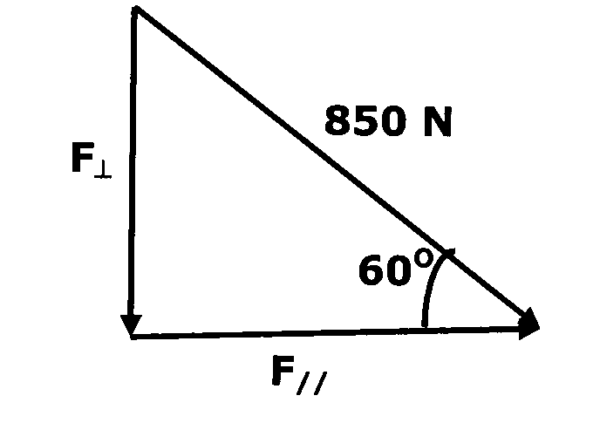  …………………………………………………………………………{1.3 C})   |  | (3)
5.2
 (3)
{1.3 C }
5.3
(4)
{ 1.3 C } [10]

QUESTION /VRAAG 6
6.1 | Class 1 / Klas 1  {2.1 A} |  | (1)
 | 
6.2 | Mechanical advantage = length of effort arm Meganiese voordeel = lengte (mag)  length of load arm lengte (las)  = 3 m  0,25 m  = 12  {2.3 C} |  | (4)
 | 
6.3 | Mechanical advantage = effort Meganiese voordeel = mag  load las     12 = 1500 12 = 1500  load las  load = 125 N  las = 125 N {2.3 C} |  | (4)
 |  |  | [9]

QUESTION / VRAAG 7
7.1 | Newton’s Second Law / Newton se Tweede Wet  {2.1 B} |  | (1)
 |  
7.2 | As the mass increases, the acceleration decreases if force remains constant.  Soos die massa toeneem, verminder die versnelling as krag konstant bly. {1.4 B} |  | (2)
7.3 | m = = 10 kg  {1.2 B} |  | (2)
7.4 | Resultant force/ Resulterende krag  {1.2 C} |  | (1)
 |   
7.5 | F = gradient of graph = 5/0,25 = 20 N   F = gradiënt van grafiek = 5/0,25 = 20 N {1.3 C} |  | (4)
7.6 | a  m   {1.4 C} |  | (2)  [12]

QUESTION 8 /VRAAG 8

Assume the distance from the centre of the earth to the spaceship = R
Aanvaar dat die afstand vanaf die middelpunt van die aarde na die
ruimtevaartuig = R

∴ Distance from moon to spaceship = (3,82 x 10⁸ – R)
∴ Die afstand vanaf die maan na die ruimtevaartuig is = (3,82 x 10⁸ – R)

When F_{R} = 0
Wanneer F_{R} = 0

F_{Earth} = F_{moon}
F_{Aarde} = F_{Maan}

[7]
{2.3 D }

QUESTION / VRAAG 9

 | 9.1 | Concave lens produces virtual images OR   Concave lens produces real images OR  Convex lens produces virtual images OR  Convex lens produces real images  Konkawe lens vorm virtuele beelde OF  Konkawe lens vorm reële beelde OF  Konvekse lens vorm virtuele beelde OF  Konvekse lens vorm reële beelde {1.1 C} | (2)
 | 9.2 | Concave lens / Konkawe lens  {2.1 A} | (2)
 | 9.3 | Investigation 2 (At 2F) / Ondersoek 2 (By 2F)  {2.1 B} | (1)
 | 9.4 | No image formed / Geen beeld gevorm nie  {1.1 A} | (2)
9.5 |  |   {2.1 B} (2) |  | (2)
 |  | 
 | 9.6 | Investigation 5 (Between F and lens) / Ondersoek 5 (Tussen F en lens) {3.2 C} | (2)
 | 9.7 | A magnifying glass / Vergrootglas  {3.3 C} | (2)
 |  |  | [13]

QUESTION / VRAAG 10
10.1.1 |  |  | {2.3C}  (3)
10.1.2 | 59 mm (2 cm)  {2.3 C} |  | (2)
10.1.3 | Magnification = D_{i}  = 120 mm  Vergroting D_{o} 40 mm   = 3  {2.3 C} |  | (4)
10.2 | The eye consists of a convex lens which converge light rays. This can endanger the eyes.  Die oog bestaan uit ŉ konvekse lens wat ligstrale konvergeer.  Dit kan die oë beskadig. {3.2 C} |  | (2)
 |  |  | [11]

QUESTION / VRAAG 11
11.1  11.2 | Decreases / Verminder { 2.3 C } { 2.3 C }  Decreases  / Verminder { 2.3 C } |  | (2)  (2)
11.3 |     Distance between ship and submarine = 1 522 m.s⁻¹ x ½(12 s)  Afstand tussen skip en duikboot = 9 132 m   = 9,132 km {3.3 C} |  | (4)
11.4 | Sound intensity near jet aircrafts is very high (130 dB) and the threshold pain is 120 dB. At 120 dB the ossicles vibrate so strongly that they strike the wall of the middle ear causing pain.  Wear ear muffs to prevent ear damage. { 3.3 C }
 | Die intensiteit van die klank naby die straalvliegtuig is baie hoog (130 dB) en die pyndrumpel is 120 dB. By 120 dB sal die oor die beentjies so erg vibreer dat hulle die wand van die middel-oor sal tref en pyn veroorsaak.  Oor-mofs moet gedra word om oor skade te verhoed. |  | (3)  [11]

QUESTION / VRAAG 12
12.1
Conduction band / Geleidingsband

Energy gap / Energie gaping

Valence band / Valensband

{ 2.3 D }

Conduction and valence band overlaps.
Die geleidingsband en valensband oorvleuel.
Small energy gap.
Klein energie gaping.
Electrons can cross this gap for small potential differences
Elektrone kan die gaping kruis vir klein potensiaalverskille. (5)

12.2 The higher the temperature, the more the electrons that can reach the
conduction band and better the conductivity.
Hoe hoër die temperatuur, hoe meer elektrone kan die geleidingsband
bereik en hoe beter sal die geleiding wees. (2)

{ 2.3 C } [7]

QUESTION / VRAAG 13
13.1
{ 2.3 C } (4)
13.2 
 
 {2.3 C } (4)

13.3
{2.3 C } (5)
[13]

QUESTION / VRAAG 14
14.1 | Step down / Verlagings  {2.3 C} |  | (1)
14.2 | Mutual induction / Wedersydse induksie  {2.3 B} |  | (2)
14.3 | a.c / w.s  {3.2 B} |  | (1)
14.4 | N_{s} = V_{s}   N_{p} V_{p}  N_{s} = 5  900 220   N_{s} = 20,45  = 20 or/of 21 turns / draaie {2.3 C} |  | (5)
14.5 | To reduce power loss / Om verlies aan drywing te verminder  {3.2 C} |  | (2)
 |  |  | [11]

QUESTION / VRAAG 15
15.1 | Temperature / Temperatuur  {1.1 C} |  | (1)
15.2 |   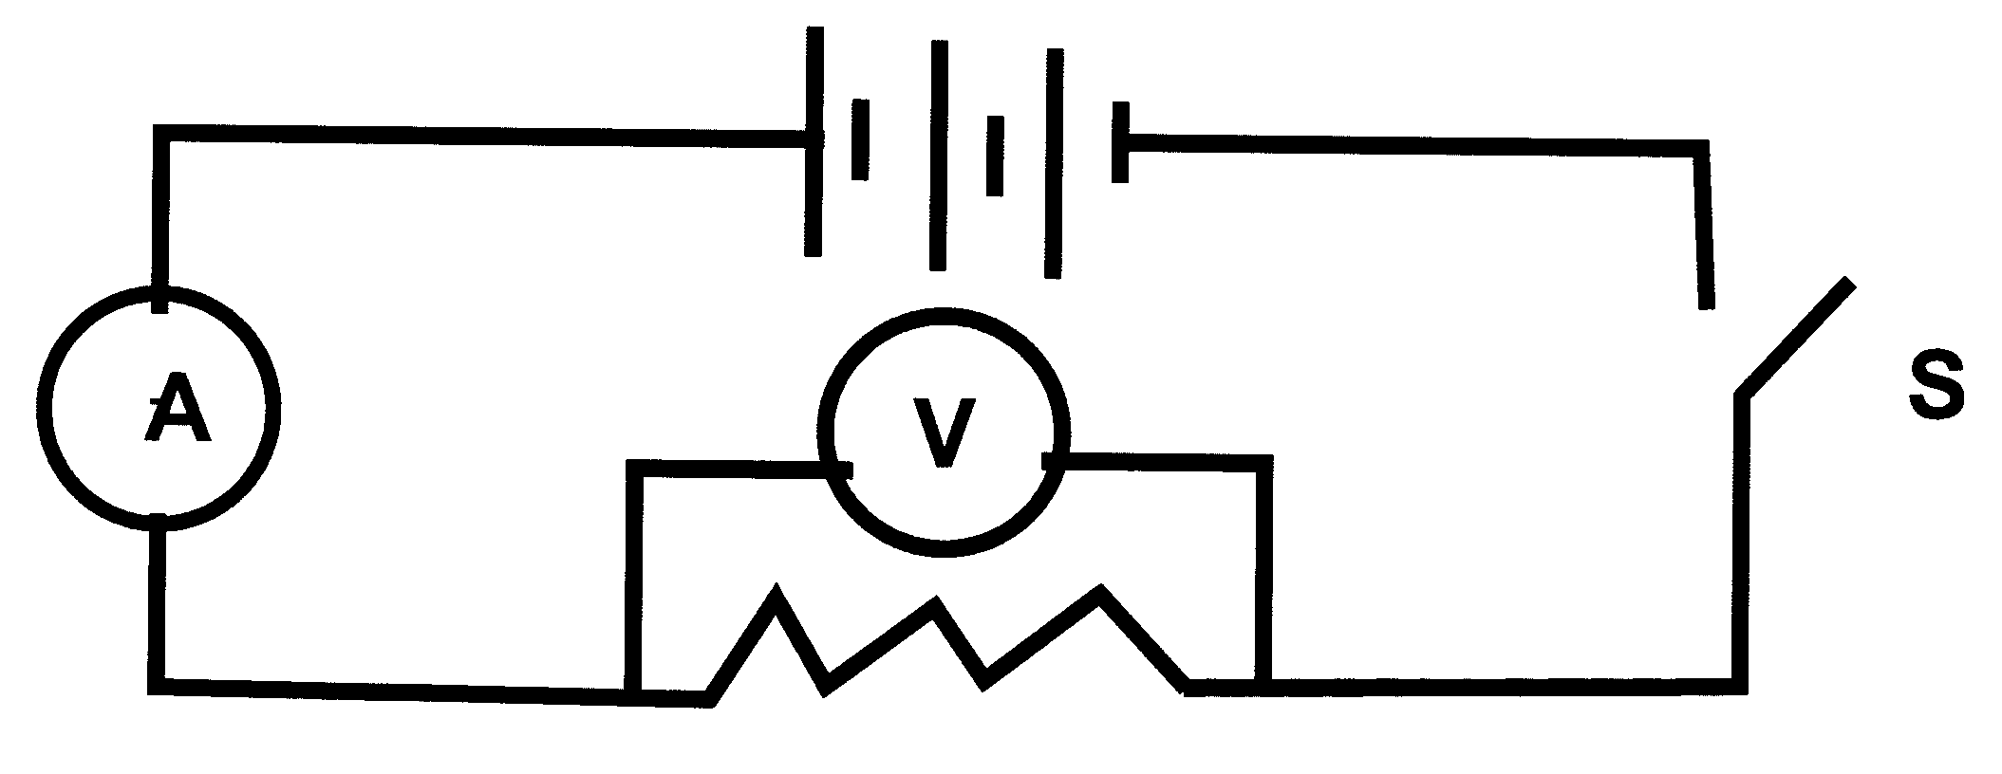  {1.1 C} |  | (2)
15.3.1 | {a} 4  {b} 3   {c} 2  {d} 1 {1.2 B} |  | (2)
15.3.2 | R (Ω)  L (cm)  Axis ✓/As  Straight line ✓/Regint lign  At least 3 /Ten meeste 3 puntepoint✓  {1.3 C} |  | (4)
15.3.3 | Straight line graph R is directly proportional to L   As the length of resistance wire increases, resistance also increases  Reguitlyn grafiek: R is direk eweredig aan L  As die lengte van die weerstandsdraad toeneem, neem die weerstand toe {1.4 B} |  | (2)
 |  |  | [11]
 | TOTAAL AFDELING B/TOTAL SECTION B: |  | 115
 | GROOTTOTAAL/GRAND TOTAL: |  | 150

