Province of the
EASTERN CAPE
EDUCATION

NATIONAL
SENIOR CERTIFICATE

GRADE 11

PHYSICAL SCIENCES – FIRST PAPER

NOVEMBER 2009

MARKS: 150

TIME: 3 hours

This question paper consists of 14 pages, a data sheet of 3 pages, graph paper
and an answer sheet.

INSTRUCTIONS AND INFORMATION
1. | Write your name and/or examination number (and centre number if applicable) in the appropriate spaces on the ANSWER SHEET and ANSWER BOOK.
2. | Answer ALL the questions.
3. | Answer SECTION A on the attached ANSWER SHEET and place the completed ANSWER SHEET inside your ANSWER BOOK.
4. | Answer SECTION B in the ANSWER BOOK.
5. | Non-programmable calculators may be used.
6. | Appropriate mathematical instruments may be used.
7. | Number the questions correctly according to the numbering system used in this question paper.
8. | Start each question on a NEW page.
9. | Datasheets are attached for your use.
10. | Give brief motivations, discussions, etcetera where required.

SECTION A
Answer this section on the attached ANSWER SHEET.
QUESTION 1: ONE-WORD ITEMS
Give ONE word/term for EACH of the following descriptions. Write only the word/term next to the question number (1.1 – 1.5) on the attached ANSWER SHEET.
1.1 | The type of semi-conductor that forms when silicon is doped with phosphorous. |  |  |  |  |  | (1)
1.2 | The ratio of the force of friction to the normal force. |  |  |  |  |  | (1)
1.3 | The ability of the lens of the eye to change its focal length. |  |  |  |  |  | (1)
1.4 | The law used to determine the direction of the induced current when a magnet is moved relative to a coil. |  |  |  |  |  | (1)
1.5 | A build-up of electric charge on the surface of an object. |  |  |  |  |  | (1)
 |  |  |  |  |  |  | [5]

QUESTION 2: FALSE ITEMS
The following statements given in QUESTIONS 2.1 to 2.5 are FALSE. Write the correct statement next to the question number (2.1 – 2.5) on the attached ANSWER SHEET.
2.1 | An example of a class-3 lever is when you push a wheelbarrow filled with sand. |  |  |  |  |  | (2)
2.2 | Newton’s Second Law defines the relationship between force, mass and velocity of an object. |  |  |  |  |  | (2)
2.3 | You hear dogs bark clearer at night due to the resonance of sound waves. |  |  |  |  |  | (2)
2.4 | The voltage increases and the charge decrease while a capacitor discharges. |  |  |  |  |  | (2)
2.5 | Direct current is induced during electromagnetic induction. |  |  |  |  |  | (2)
 |  |  |  |  |  |  | [10]

QUESTION 3: MULTIPLE-CHOICE QUESTIONS
Four possible options are provided as answers to the following questions. Each question has only ONE correct answer. Choose the best answer and make a cross (X) in the correct block (A – D) next to the question number (4.1 – 4.5) on the attached ANSWER SHEET.
3.1 | Julius stands on a bathroom scale in a lift. His weight is 637 N. The reading on the scale will be 637 N …
 | A |  | only if the lift is accelerating upwards.
 | B |  | only if the lift accelerates downwards.
 | C |  | if the lift moves downwards with a constant velocity or if it stands still.
 | D |  | only if the lift stands still. |  |  |  | (2)
3.2 | The gravitational force of attraction between two objects is F. If the distance between the objects is doubled, the force between the objects then changes to …
 | A |  | 4 F.
 | B |  | ¼ F.
 | C |  | 2 F.
 | D |  | ½ F. |  |  |  | (2)
3.3 | Which ONE of the following graphs is the best representation of the relationship between the electric field E due to a point charge and the distance d from the point charge?
E
0 d
E
0 d
E
0 d
E
0 d

A |  |  |  | B | C | D | (2)

3.4 | Which of the following statements is true?
 | A |  | The resistance of a piece of gallium decreases as the temperature decreases.
 | B |  | The resistance of a piece of nichrome wire decreases as the temperature increases.
 | C |  | The resistance of a piece of silicon decreases as the temperature increases.
 | D |  | As the element of a kettle heats up, the resistance decreases. |  | (2)
3.5 | Two astronauts are doing a space walk outside a spaceship. One astronaut sees that the other one is ringing a bell, but cannot hear it. This means that …
 | A |  | light waves can travel through a vacuum but not sound waves.
 | B |  | sound waves can move through a vacuum but not light waves.
 | C |  | both light and sound waves can move through a vacuum.
 | D |  | neither light nor sound waves can move through a vacuum. |  | (2)
 |  |  |  | [10]
 |  | TOTAL SECTION A: |  | 25

SECTION B
INSTRUCTIONS AND INFORMATION
1. |  |  | Answer SECTION B in the ANSWER BOOK.
2. |  |  | The formulae and substitutions must be shown in ALL calculations.
3. |  |  | Round off your answers to TWO decimal places.
4. |  |  | Start each question on a NEW PAGE.
QUESTION 4
A minibus-taxi travels at 30 m.s⁻¹. When the driver sees a group of learners crossing the street, he immediately applies the brakes and brings the minibus-taxi to a stop in 7,5 s. The mass of the minibus-taxi and the passengers is 3 600 kg.
4.1 |  |  | Calculate the force that is required to bring the minibus-taxi to a stop. |  |  |  | (7)
4.2 |  |  | The force that you calculated in QUESTION 4.1 is the maximum force that can be applied by the brakes. The number of passengers is increased so that the total mass of the minibus-taxi and the passengers is now 4 000 kg
Using this information, state how the following will be influenced:
(Use only INCREASES, DECREASES or REMAINS THE SAME as your answer.)
 |  |  | 4.2.1 |  | The time taken to stop the minibus-taxi. |  | (2)
 |  |  | 4.2.2 |  | The magnitude of the acceleration. |  | (2)
 |  |  | 4.2.3 |  | The stopping distance of the minibus-taxi. |  | (2)
4.3 |  |  | By referring to your answers in QUESTION 4.2, what advice would you give to minibus-taxi drivers concerning the number of passengers and safety? Give a reason for your advice. |  |  |  | (2)
 |  |  |  |  |  |  | [15]

QUESTION 5
Andile, his sister Nomi and their baby sister, Zuki, play on a seesaw in the park. Andile’s mass is 60 kg, Nomi’s mass is 40 kg while Zuki’s mass is 9 kg. Consider the following diagram and answer the questions that follow:
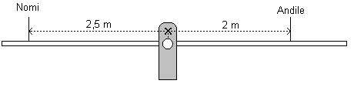
Nomi sits 2,5 m from the fulcrum (pivot), while Andile sits 2 m from the fulcrum.
5.1 |  | Determine the weights of each of Andile, Nomi and Zuki. |  | (3)
5.2 |  | Use calculations to indicate in what direction the seesaw will turn while Andile and Nomi sit on it. |  | (4)
5.3 |  | How far from the fulcrum and on whose side (Andile’s or Nomi’s) must Zuki sit to balance the seesaw? |  | (4)
 |  |  |  | [11]

QUESTION 6
During a police investigation into a car accident, the forensic unit reconstructs the accident. Car A, mass 1 800 kg, collides head-on with car B, mass 1 600 kg, which is travelling in the opposite direction as shown in the sketch. During the collision, the cars connect and move together as a combination and eventually come to a standstill. The graph of the velocity of car A during the collision is given.
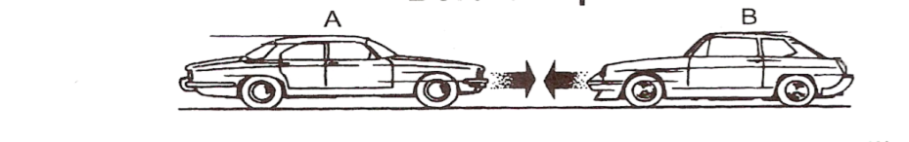
Velocity (m.s⁻¹)

Use the information given above and on the graph to do the following:
6.1 | Calculate the momentum of car A before the collision. |  | (3)
6.2 | Determine the velocity of car A immediately after the collision. |  | (2)
6.3 | Calculate the velocity of car B just before the collision. |  | (6)
6.4 | Name THREE safety measures that car manufacturers use in modern cars to make it safer for the passengers in the car during a collision like this. |  | (3)
6.5 | Which one of your answersin QUESTION 6.4 is based on Newton’s First law? |  | (2)
 |  |  | [16]

QUESTION 7
In the diagrams below, A, B and C represent elements that can be conductors, semi-conductors or insulators.

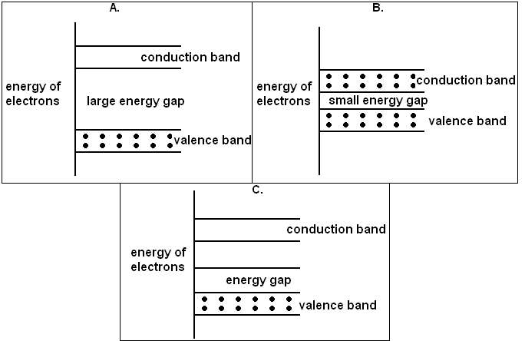
7.1 |  | Identify only the conductor. (Write only A, B or C). Give a reason for your answer. |  | (2)
7.2 |  | Name TWO ways to increase the conductivity of a semi-conductor. |  | (2)
7.3 |  | Name ONE device in which semi-conductors are used. |  | (1)
 |  |  |  | [5]

QUESTION 8
Dr. Muller, an optometrist, tests people’s vision and finds out whether they have problems with their sight. She then prescribes glasses in order to improve vision.

Jenny together with her daughter, Helen, and her mother, Aunty Barbara, decide to have their eyes tested by Dr. Muller. Jenny tells Dr. Muller that she enjoys knitting and sewing and has no problems while doing this. However, when she drives the car, she has problems to see the road signs clearly.

Helen, who is still at school, tells Dr. Muller that she can see clearly when her teacher writes on the board, but struggles to read from her textbook when she wants to study.

Aunty Barbara tells Dr. Muller that she can see clearly when she watches the cows walk in the field, but when she wants to read a magazine, her eyes start to water. She experiences a sharp pain in her eyes, which then disappears when she holds the magazine further from her eyes.
8.1 |  | Name the most probable eye defects that EACH of the three family members have. |  |  |  | (3)
8.2 |  | Describe the possible causes of EACH of the eye problems. |  |  |  | (6)
8.3 |  | Make separate sketches to indicate each of the following:
 |  | 8.3.1 | The eye defect known as short-sightedness. |  |  | (2)
 |  | 8.3.2 | How the defect in QUESTION 8.3.1 can be corrected by using a suitable lens. |  |  | (3)
 |  |  |  |  |  | [14]
QUESTION 9
Alice is given a convex lens to study the type of images that it can form. She then sets the lens up and finds that when she places an object, of height 25 mm, a distance of 85 mm from the lens, she obtains an inverted image exactly 55 mm from the lens.
9.1 |  | Draw an accurate ray-diagram and determine:
 |  | 9.1.1 | The focal length of the lens. |  |  | (5)
 |  | 9.1.2 | The height of the image. |  |  | (1)
9.2 |  | Calculate the magnification. |  |  |  | (2)
9.3 |  | Name THREE properties of the image if the object is placed 30 mm from the lens. |  |  |  | (3)
 |  |  |  |  |  | [11]

QUESTION 10
After the Air France Flight 447 plane went missing over the Atlantic Ocean on 1 June 2009, the French government sent a submarine to the area where they suspected that the accident happened. The submarine helped to find the wreckage of the plane and the so-called “black box”.

The submarine dived to a depth of 1 015 m below the surface of the ocean. A pulse was sent from the submarine’s SONAR instruments and it reflected off the wreckage at the bottom of the sea. The pulse returned 4,30 s after leaving the submarine. The speed of sound in seawater at that point in the ocean is 1 522 m.s⁻¹.
10.1 | What is the distance from the submarine to the wreckage of the plane? |  | (4)
10.2 | What is the depth of the ocean at that specific point? |  | (1)
 |  |  | [5]

QUESTION 11
Consider the following graph concerning the speed of sound in different mediums:
v (m.s⁻¹)

Speed of sound in different mediums

concrete

Seewater
Oil
Air at
sealevel
Carbon
dioxide
11.1 |  | In which phase does sound travel the fastest? |  | (1)
11.2 |  | Give an explanation for your answer in QUESTION 11.1. |  | (2)
11.3 |  | The value of the speed of sound in seawater is the value at 0 °C. If it were found that the temperature of the seawater is 17 °C, how would the speed of sound in the seawater change?  (Choose from INCREASES, DECREASES, STAYS THE SAME). |  | (2)

11.4 | Briefly explain your choice in QUESTION 11.3. | (2)
11.5 | While standing on mountain, 3 000 m above sea level, Thumi measures the speed of sound. She does not obtain the same value as in the above table. Which of the following values is the most probable that she obtained? 352 m.s⁻¹ or 325 m.s⁻¹? | (1)
11.6 | Briefly explain your choice in QUESTION 11.5. | (2)
 |  | [10]

QUESTION 12
A small, conducting sphere, X, with a charge of +2 x 10⁻⁶ C and with an unknown mass, m, is suspended by an inelastic thread of negligible mass which is tied to point P. Another small conducting sphere, Y, on an insulated stand, with a charge of -6 x 10⁻⁶ C, is moved towards X until their centres are 120 mm apart.
P
Y
-6 x 10-6 C
X m

+2 x 10-6 C
120 mm

12.1 |  | Calculate the magnitude and direction of the electrostatic force that sphere Y exerts on sphere X. | (6)
12.2 |  | Sphere Y is moved until it touches sphere X and it is then moved back to its original position.
 |  | Calculate the new charge on each sphere after they touched. | (3)
12.3 |  | In a thunderstorm, charges build up in clouds due to different movements of air, raindrops and ice. When the potential difference between a collection of positive charges and negative charges becomes big enough, a lightning-flash occurs.  Name THREE precautions that one can take in order to protect oneself against lightning strikes. | (3)
 |  |  | [12]

QUESTION 13
In an attempt to verify Ohm’s Law, a group of learners investigate the relationship between potential difference and electric current. They are provided with the following apparatus to set up the circuit:
- Ammeter
- Voltmeter
- Resistor
- Rheostat (variable resistance)
- Connecting wires
- Battery/Power source

The table below shows the results obtained during the investigation.
Potential Difference (V) | 1,0 | 2,0 | 3,0 | 4,0 | 5,0 | 6,0 | 7,0
Current (I) | 0,16 | 0,32 | 0,48 | 0,64 | 0,76 | 0,82 | 0,84

13.1 | Draw a circuit diagram of the correct set-up of the apparatus for this investigation. | (3)
13.2 | Formulate an investigative question for the above investigation. | (2)
13.3 | Which variable must be kept constant during the above investigation? | (1)
13.4 | Draw a graph of potential difference versus current on the attached graph paper. Draw the axes and choose an appropriate scale. Plot and then join the points. | (4)
13.5 | From the graph, write down the mathematical relationship between potential difference and current. | (2)
13.6 | Mark on your graph the point X beyond which Ohm’s Law no longer applies. | (1)
13.7 | Does the resistance INCREASE or DECREASE beyond this point? | (1)
 |  | [14]

QUESTION 14
A common use of transformers is in cell-phone chargers which operate between
6 V and 12 V. A learner is given a transformer that has 550 turns on the primary coil and 25 turns on the secondary coil. It is plugged into a wall socket of 220 V.
14.1 | What type of transformer is given to the learner? Give a reason for your answer. | (3)
14.2 | Show by calculation if it could be possible to use this transformer in a cell-phone charger. | (4)
14.3 | What change must be made to the secondary current to make the current suitable for use in cell-phone chargers? | (2)
14.4 | Name and explain the principle on which a transformer works. | (3)
 |  | [12]
 | TOTAL: SECTION B: | 125
 | GRAND TOTAL: | 150

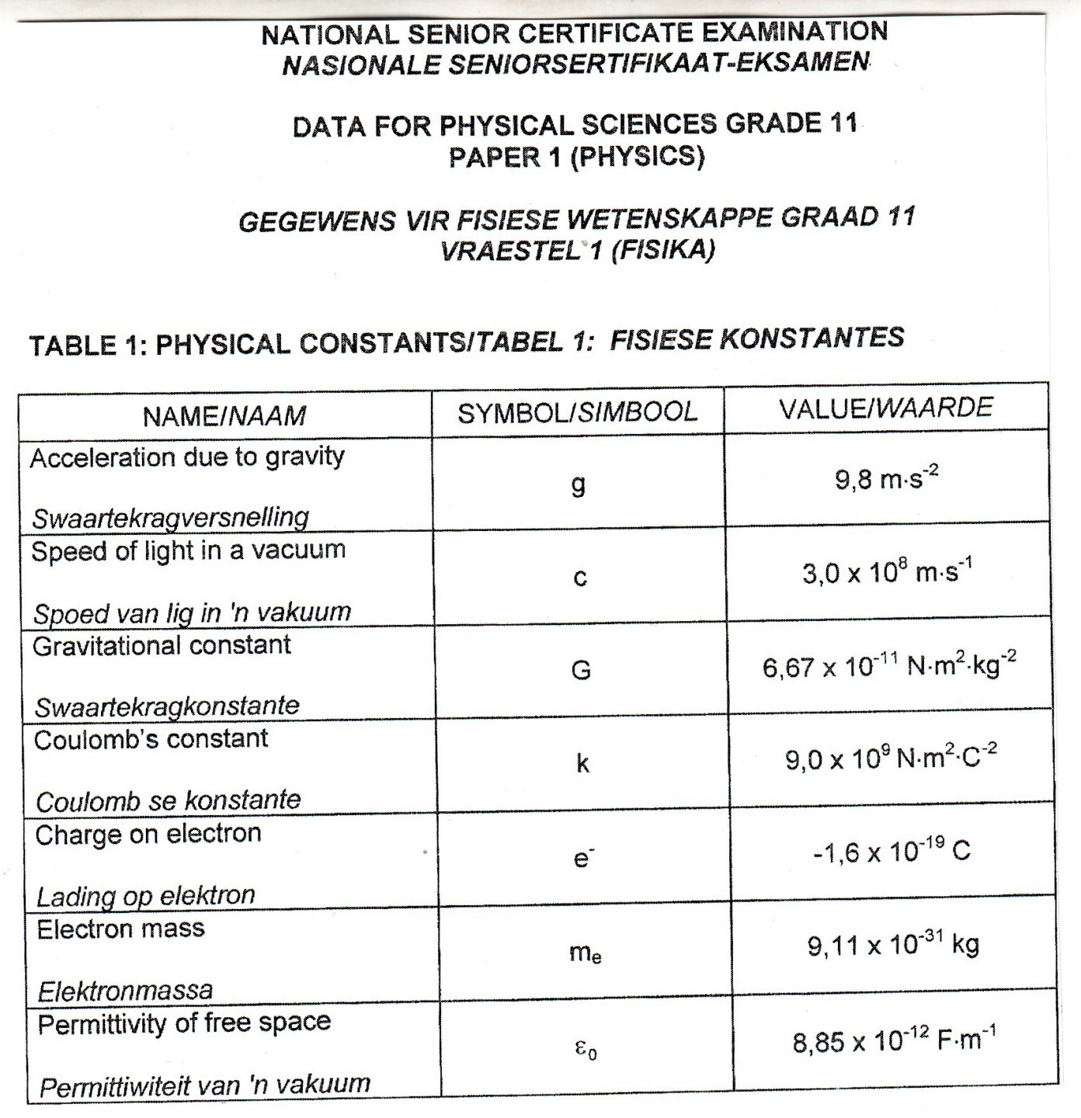

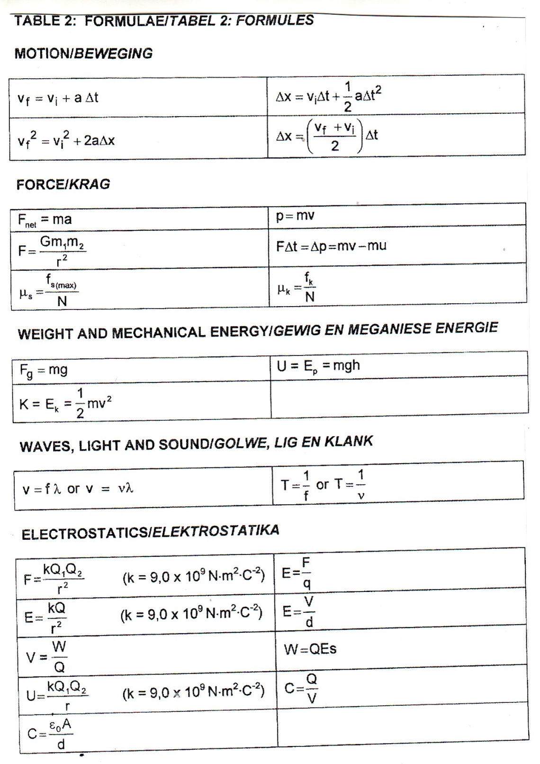

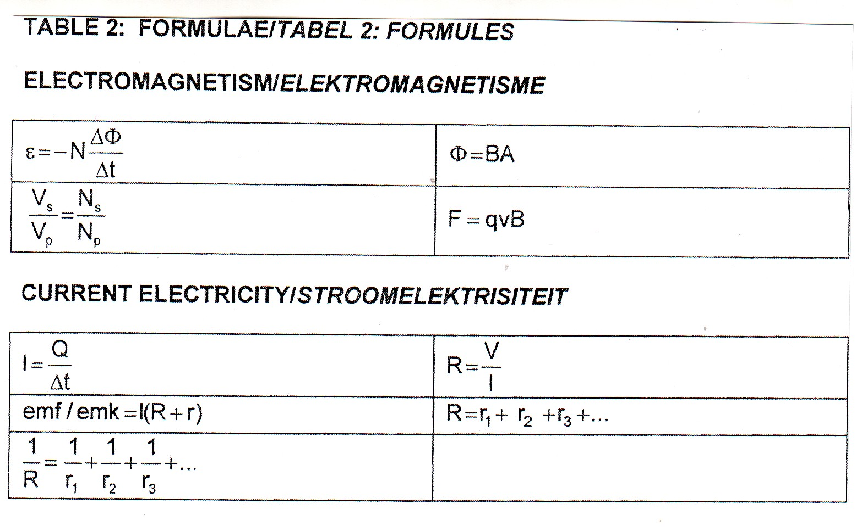

NAME/EXAMINATION NUMBER:
ANSWER SHEET

QUESTION 1

1.1 |  | (1)
1.2 |  | (1)
1.3 |  | (1)
1.4 |  | (1)
1.5 |  | (1)
 |  | [5]

QUESTION 2
2.1  2.2  2.3  2.4  2.5 |  |  | (2)  (2)  (2)  (2)  (2)  [10]

QUESTION 3
 | TOTAL SECTION A: |  | 25
  3.1 | A |  | B | C | D
  3.2 | A |  | B | C | D
  3.3 | A |  | B | C | D
  3.4 | A |  | B | C | D
  3.5 | A |  | B | C | D
   |  | (5 x 2) [10]

