Subject: Natural Sciences
Strand: Matter and materials
Topic: Atoms, sub-atomic particles, compounds, pure substances, mixtures of elements and compounds: CAPS p 41
Grade: 8
Low order questions | Middle order questions | High order questions
1 – 10

Assessment task 1

Choose the correct answer and write down only the symbol of the answer.

- The three basic components of an atom are________
- protons, neutrons and ions
- protons, neutrons and electrons
- protons, neutrinos and ions
- protium, neutroninos and electrons

- An atom is determined by the number of_________
A. atoms
B. electrons
C. neutrons
D. protons

- The nucleus of an atom consists of ___________
- electrons
- neutrons
- protons and neutrons
- protons, neutrons and electrons

- What is a charge of a proton?
- None
- Positive
- Negative
- Either a positive or negative

- Which particles have approximately the same size and mass as each other?
- Neutrons and electrons
- Electrons and protons
- Protons and neutrons
- None – they are all very different in size and mass

- Which two particles would be attracted to each other?
- Electrons and neutrons
- Electrons and protons
- Protons and neutrons
- All particles are attracted to each other

- The atomic number of an atom is________
- the number of electrons
- the number of neutrons
- the number of protons
- the number of protons plus the number of neutrons

- The mass number of an atom is _______
- the number of electrons
- the number of neutrons
- the number of protons
- the number of protons plus the number of neutrons

- According to the atomic theory, electrons are usually found___________
- in the atomic nucleus
- outside the nucleus, yet very near it because they are attracted to the protons
- outside the nucleus and often far from it – most of an atom’s volume is its electron cloud
- either in the nucleus or around it – electrons are readily found anywhere in an atom

- Which particles carry opposite charges? :
- Protons and neutrons
- Neutrons and electrons
- Protons and electrons
- Neutrons and ions
(10)

Answers
- B
- D
- C
- B
- C
- B
- C
- D
- C
- C

(10)

Assessment Task 2

Subject: Natural Sciences
Strand: Matter and materials
Topic: Chemical formulae, molecules, atoms: CAPS pp40 - 41
Grade: 8
Low order questions | Middle order questions | High order questions
Part 1: 2-9 | Part 2: 1-9  Part 3: 1-9  Part 4: 1-9

Molecule models

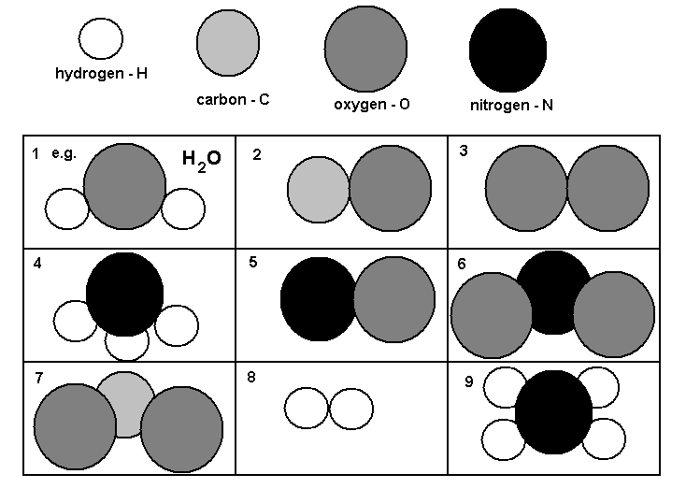
Part One: Write the chemical formulas

Use the model key for each element and write the chemical formula for each molecule.

[16 marks]

Part Two: Draw the model for the molecules

Use the same model key and draw the model for each of the molecules given.

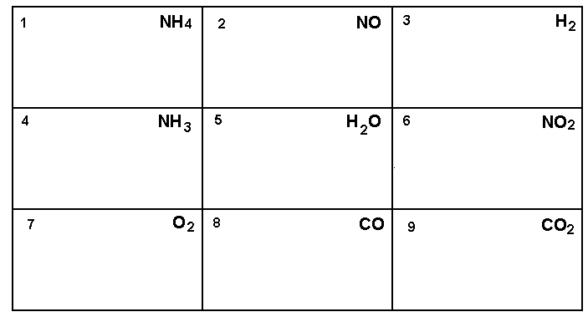
Part Three: Create 3D models of molecules

The above drawings are all 2dimensional (2D) models of the actual molecules.
Use different coloured jelly tots and toothpicks and create 3D models of the above molecules.
Your partner will assess your models and you will assess your partner’s.
[20 marks]

Checklist for assessing jelly tot models
Criteria | Yes [1] | No [0]
Learner has used colours of jelly tots consistently to represent each element.
Learner has created 3D models using jelly tots to represent elements and toothpicks to represent bonds.
Learner’s models are accurate and correct. | Allocate 2 marks per completely correct model; 1 mark if partially correct; 0 if wrong.  Total: /18

Part Four: Research on the names of the molecules

Find out the names of each of the molecules you have made models of.
[16 marks]

[Total: 50 marks]

Suggested Solutions

Question number | Possible marks | Solution
1 | 16 | 2. CO  3. O₂  4. NH₃  5. NO  6. NO₂  7. CO₂  8. H₂  9. NH₄
2 | 18 | See table in Appendix of Assessment Tools.
3 | 20 | See checklist in Appendix of Assessment Tools – peer assessment.
4 | 16 | 1. H₂O - water  2. CO – carbon monoxide  3. O₂ – oxygen  4. NH₃ – ammonia  5. NO – nitrogen oxide / Nitric oxide / Nitrogen monoxide  6. NO₂ – nitrogen dioxide  7. CO₂ – carbon dioxide  8. H₂ – hydrogen

Appendix of Assessment Tools

Table for drawing the models of the formulae given

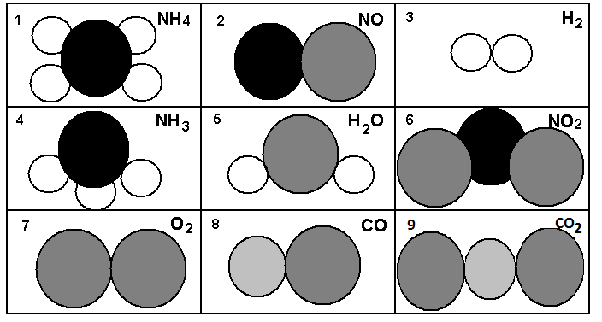

Checklist for assessing jelly tot models
Criteria | Yes [1] | No [0]
Learner has used colours of jelly tots consistently to represent each element.
Learner has created 3D models using jelly tots to represent elements and toothpicks to represent bonds.
Learner’s models are accurate and correct. | Allocate 2 marks per completely correct model; 1 mark if partially correct; 0 if wrong.  Total: /18

Subject: Natural Sciences
Strand: Matter and materials
Topic: Atoms – building blocks of matter: CAPS p 40
Grade: 8
Low order questions | Middle order questions | High order questions
  - – 1.6

Assessment task 3
Atoms
1. Look at the table below; indicate with a tick (√) in the correct box if the substance is made of a single atom or more than one atom.
Substance | Formula | Single atom | More than  one atom
1.1 Oxygen | O₂
1.2 Carbon monoxide | CO
1.3 Helium | He
1.4 Water | H₂O
1.5 Carbon dioxide | CO₂
1.6 Sodium chloride | NaCl
(6)
Answers
Substance | Formula | Single atom | More than  one atom
1.1 Oxygen | O ₂ | √
1.2 Carbon  monoxide | CO |  | √
1.3 Helium | He | √
1.4 Water | H₂O |  | √
1.5 Carbon  dioxide | CO₂ |  | √
1.6 Sodium  chloride | NaCl |  | √

