GRADE SIX FORMAL TEST TERM 3
LEARNING AREA :SOCIAL SCIENCES {HISTORY}
DURATION :
WEIGHT :
LO3 :EXPLORING ISSUES and HISTORICAL INTERPRETATION
ASSESSMENT STANDARDS : GEO LO 3 AS 1, 2 ,3
:HIST LO 3 AS 1 , 2 ,3
CONTENT :History of medicine
QUESTION 1
1 .Mention 2 types of traditional healers 2X2=4
2.Give the characteristics of each 2X2=4
3.Mention at least 2 plants from which traditional healers get their medicines 2X2=4
4.Give examples of medicinal mixtures we get from the two above 2X2=4 {16}
QUESTION 2
Compare the ways in which the Western medicine and traditional medicine treat the following
1.Mental sickness
2.Driving flies away
3.Coughing
4.Stomach ache
5.Bone fracture
6.Boosting the immune system { 4X6=24}
QUESTION 3
Match the sickness with the scientist who discovered it e.g A cure for Anthrax was discovered by Koch.
TYPE OF SICNESS | PERSON WHO DISCOVERED IT
LEPROSY | Frankael
TYPHOID | Koch
TUBERCULOSIS | Eberth
CHOLERA | Koch
PNEUMONIA | Hansen
{2X5 = 10}

QUESTION 4

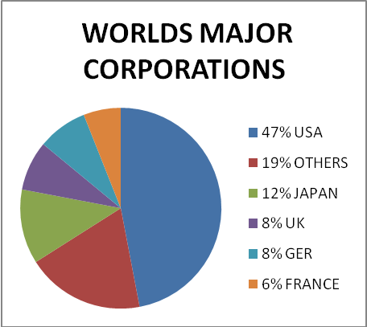
Refer to the pie chart above to answer questions that follow
1Looking at the pie chart provided list 5 multinational owning countries.{2x5=10 }
2.Are these countries from the richer North or the poorer South .{ 2}
3.Name 2 multinational countries operating in S A { 2x2=4 }
4.Give 2 requirements that these multinational companies need before investigating in S A ? {2x2=4 ]
{TOTAL MARKS 70}

