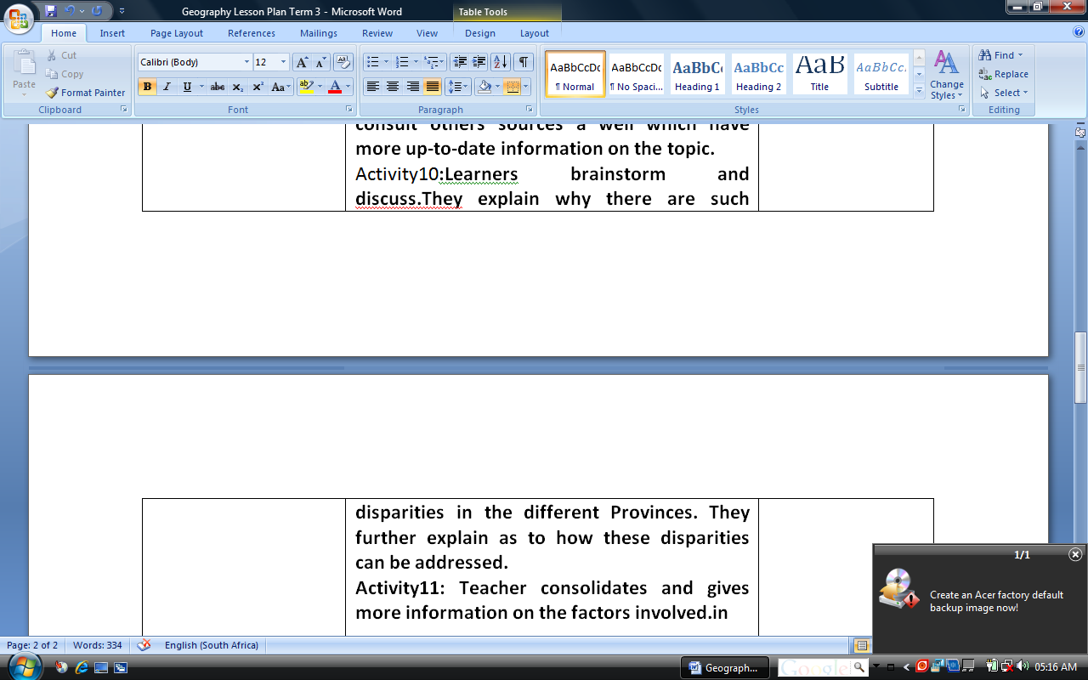Geography Lesson Plan Term 3
Grade : 8
Duration : 18 hours(6 weeks)
Topic : Patterns of Social Inequalities in South Africa.
Key Questions: Which factors affect the status of women?
Exploitation of labour(cheap labour and its socio-economic consequences)
Access to education and training.
Access to housing ,other services and resources.
Los and Ass Standards | Learner and Teacher Activities | Details of Assess...
LO1 Historical Enquiry  Ass1: Identifies and selects a variety of historical and archaeological sources relevant to enquiry.  Ass2: Compiles and organises information from a number of sources o obtain evidence about aspects of the past.  ASS3;Interprets and finds information from simple graphical and statistical sources  Ass4:Use information from the sources to present well- thought answers to questions.  INTEGRATION(WITHIN)  LO1 GEO. Geographical Enquiry.  INTEGRATION(Across)  Languages:LO1 ,2 & 3 | Activity 1: Teacher brings to class a variety of information detailing how women are treated in SA and the world e g graphs,statistics etc ,inter alia, their involvement in education, politics, property ownership, society, economics, biological role.  ACTIVITY2: In groups learners study this information and then brainstorm and discuss.  Activity3; Teacher asks questions. In the process of responding to questions asked,  learners make reference to examples of known cases in their local environment  Activity4:Teacher then consolidates and brings in more information to fill up content gaps,which learners might have.  Activity5:Teacher brings information on use of women and children as cheap labour in SA and the World(Teacher together with learners will follow the same activities as in 2 ,3&4 above)These will be activities 6,7 and 8 of the lesson plan..  Activity9:Teacher will bring statisticts on the supply of water ,electricity, toilets,and telephones to schools in the nine provinces of  South Africa(for more information refer to Social Sciences Today Grade 8 p69)Teachers and learners are not limited to this but should consult others sources a well which have more up-to-date information on the topic.  Activity10:Learners brainstorm and discuss.They explain why there are such disparities in the different Provinces. They further explain as to how these disparities can be addressed.  Activity11: Teacher consolidates and gives more information on the factors involved on these basic needs and the consequences of the shortage of such needs.  Activty 12: The same process can also be followed when dealing with housing.Teacher designs appropriate activities for learners so that information is dealt with in an interactive manner using relevant and appropriate resources. | Research using a questionnaire on areas where women are still marginalised. (there should be evidence of local cases)  Case Study  Test
Resources: Maps ,Textbooks, Graphs ,Statistics
Barriers to Learning
Expanded Opportunities
Reflections

