Province of the
EASTERN CAPE
EDUCATION

DIRECTORATE SENIOR CURRICULUM MANAGEMENT (SEN-FET)
HOME SCHOOLING SELF-STUDY WORKSHEET
SUBJECT | ECONOMICS | GRADE | 12 | DATE | 03/04/2020
TOPIC | MACROECONOMICS | TERM 1  REVISION | X | TERM 2 CONTENT | (Please tick)
TIME ALLOCATION | 50 MINUTES MARKS: 70 | TIPS TO KEEP HEALTHY  1. WASH YOUR HANDS thoroughly with soap and water for at least 20 seconds. Alternatively, use hand sanitizer with an alcohol content of at least 60%.  2. PRACTICE SOCIAL DISTANCING – keep a distance of 1m away from other people.  3. PRACTISE GOOD RESPIRATORY HYGIENE: cough or sneeze into your elbow or tissue and dispose of the tissue immediately after use.  4. TRY NOT TO TOUCH YOUR FACE. The virus can be transferred from your hands to your nose, mouth and eyes. It can then enter your body and make you sick.  5. STAY AT HOME.
INSTRUCTIONS | INSTRUCTIONS AND INFORMATION  - Answer ALL questions in the ANSWER BOOK  - Number the answers correctly according to the numbering system used in this question paper.  - Write the question number above each answer.  - Leave 2–3 lines between subsections of questions  - Write neatly and legibly.

QUESTION 1 30 MARKS − 20 MINUTES

1.1 | Various options are provided as possible answers to the following questions. Choose the correct answer and write only the letter (A–C) next to the question number (1.1.1–1.1.8) in the ANSWER BOOK, for example 1.1.9 D.
 | 1.1.1 | To enjoy the advantages of efficient markets, countries should rely on the principle of ... advantage.
 |  | A | competitive.
 |  | B | convenient
 |  | C | comparative
 |  | D | relative
 | 1.1.2 | Goods which are regarded as socially harmful are known as ...
 |  | A | merit
 |  | B | demerit
 |  | C | capita
 |  | D | public
 | 1.1.3 | The banks are allowed by the SARB to occasionally change the minimum cash balance. This is known as …
 |  | A | interest rate
 |  | B | moral suasion
 |  | C | cash reserve requirement
 |  | D | open market transactions
 | 1.1.4 | When the demand is low and unemployment high, the government can ...
 |  | A | decrease taxes
 |  | B | decrease government spending
 |  | C | decrease government spending and decreasing taxes.
 |  | D | increase taxes.
 | 1.1.5 | Countries with fundamental balance of payments problems can apply for financial support from the ...
 |  | A | International Monetary Fund
 |  | B | Federal Bank.
 |  | C | World Bank
 |  | D | Reserve Bank.
 | 1.1.6 | Goods of which there is a complete supply or none, e.g. defence is called ... goods
 |  | A | collective
 |  | B | public
 |  | C | private
 |  | D | community
 | 1.1.7 | Which ONE of the following can cause a deficit on the balance of payments
 |  | A | Inward foreign investments
 |  | B | Increase in foreign currency reserves
 |  | C | Decline in mineral exports
 |  | D | Increase in exports
 | 1.1.8 | Economic integration where member countries agree on a common foreign economic policy is called a ...
 |  | A | free-trade area
 |  | B | customs union.
 |  | C | common market.
 |  | D | economic union (8 x 2) | (16)

1.2 | Choose a description from COLUMN B that matches the item in COLUMN A. Write only the letter (A−I) next to the question number (1.2.1−1.2.8) in the ANSWER BOOK, for example 1.2.9 K
 | COLUMN A COLUMN B  1.2.1 Economic growth A obtained when the effects of irregular events and seasons are removed from time series data  1.2.2 Bureaucrat B exchange rate system where the value of the currency is determined by market forces only  1.2.3 Monetary policy C a situation in the economy when leakages are more than injections  1.2.4 Economic equity D does not change until after the business cycle has changed  1.2.5 Real business cycle E An increase in the productive capacity of the economy over a specific period of time  1.2.6 Globalisation F uses interest rates to influence the level of expenditure  1.2.7 Free floating G an official in a government departmen  1.2.8 Disequilibrium H progressive tax scales are used  I interaction and interfacing of countries with trade as a common element  (8 x 1) | (8)
1.3 | Give ONE term for each of the following descriptions. Write only the term next to the question number (1.3.1–1.3.6) in the ANSWER BOOK. Acronyms and abbreviations will NOT be accepted.
 | 1.3.1 A document showing anticipated revenue and estimated expenditure  1.3.2 A deliberate increase in the value of a currency.  1.3.3 A phase associated with increased profits in the business cycle  1.3.4 This is paid to producers to reduce the costs of production and encourage the production of goods and  services.  1.3.5 A financing instrument distributed among countries of the International Monetary Fund.  1.3.6 A minimum level of consumption that takes place even if the consumer has no disposable income (6 x 1) | (6)
 | TOTAL MARKS | [30]
(EC/JUNE2019)

QUESTION 2 40 MARKS – 30 MINUTES
2.1 | Answer the following questions.
 | 2.1.1 | Name TWO demand reasons for international trade. (2 x 1) |  | (2)
 | 2.1.2 | Why does the government levy high taxes on demerit goods? (1 x 2) |  | (2)
2.2 | Study the cartoon below and answer the questions that follow.
 | 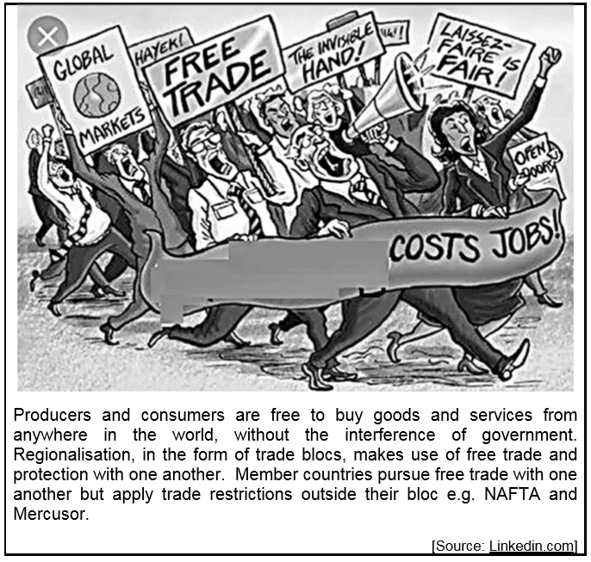
 | 2.2.1 | Which trade policy is referred to in the above cartoon? |  | (1)
 | 2.2.2 | Name any member country of the Mercusor trade bloc |  | (1)
 | 2.2.3 | Describe the term free trade. |  | (2)
 | 2.2.4 | Briefly explain innovation as an argument in favour of free trade. |  | (2)
 | 2.2.5 | How will protection of natural resources favour local industries? (2 x 2) |  | (4)
2.3 | Study the table below and answer the questions that follow  NATIONAL ACCOUNTS IN Rbn  At current prices 2016  Primary sector 371 268  Agriculture, forestry and fishing 84 662  Mining and quarrying 286 606  Secondary (A)  Manufacturing 452 326  Electricity, gas and water 125 377  Construction 138 917  Tertiary sector 2 316 605  Gross value added at basic prices 340 4493
 | 2.3.1 | Name the method used to calculate GVA in the above table. |  | (1)
 | 2.3.2 | Name any activity that falls under the tertiary sector. |  | (1)
 | 2.3.3 | Briefly describe the term GVA at constant prices. |  | (2)
 | 2.3.4 | Calculate the contribution of the secondary sector (A). Show all calculations |  | (2)
 | 2.3.5 | Highlight the importance of the national account aggregates (2 x 2) |  | (4)
2.4 | Differentiate between endogenous and exogenous reasons.. (4 x 2) |  |  | (8)
2.5 | How will corruption impact negatively on the efficiency of the government? |  |  | (8)
 |  |  |  | [40]
 | (EC/JUNE2019)
 | TOTAL MARKS [70]

