Province of the
EASTERN CAPE
EDUCATION

DIRECTORATE SENIOR CURRICULUM MANAGEMENT (SEN-FET)
HOME SCHOOLING SELF- STUDY WORKSHEET
SUBJECT | ECONOMICS | GRADE | 12 | DATE | 15/04/2020
TOPIC | MICROECONOMICS | TERM 1  REVISION |  | TERM 2 CONTENT | X
TIME ALLOCATION | 30 MINUTES MARKS: 40 | TIPS TO KEEP HEALTHY  1. WASH YOUR HANDS thoroughly with soap and water for at least 20 seconds. Alternatively, use hand sanitizer with an alcohol content of at least 60%.  2. PRACTICE SOCIAL DISTANCING – keep a distance of 1m away from other people.  3. PRACTISE GOOD RESPIRATORY HYGIENE: cough or sneeze into your elbow or tissue and dispose of the tissue immediately after use.  4. TRY NOT TO TOUCH YOUR FACE. The virus can be transferred from your hands to your nose, mouth and eyes. It can then enter your body and make you sick.  5. STAY AT HOME.
INSTRUCTIONS | INSTRUCTIONS AND INFORMATION  - Number the answers correctly according to the numbering system used in this question paper.  - Write the question number above each answer.  - Leave 2–3 lines between subsections of questions  - Write neatly and legibly.

QUESTION 1: MICROECONOMICS 40 MARKS – 30 MINUTES
1.1 |  | Answer the following questions.
 |  | 1.1.1 | Name any TWO characteristics of monopolistic competition. (2 x 1). |  | (2)
 |  | 1.1.2 | Why would a lack of information to entrepreneurs lead to market failure? |  | (2)
1.2 |  | Study the following information and answer the questions that follow.
 |  | 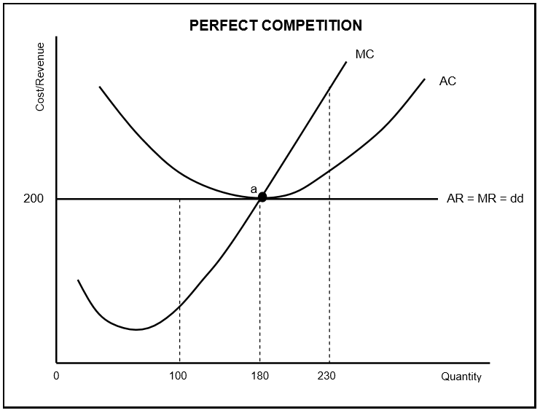
 |  | 1.2.1 | Identify the quantity the firm will produce at equilibrium point. |  | (1)
 |  | 1.2.2 | Which curve represents the market price for the perfect competitor? |  | (1)
 |  | 1.2.3 | Briefly describe the term normal profit. |  | (2)
 |  | 1.2.4 | What would the impact on the market be if many firms leave this industry? |  | (2)
 |  | 1.2.5 | Redraw the above graph and insert the average variable cost curve (AVC) to clearly indicate the shut-down point. |  | (4)

1.3 | Study the extract below and answer the questions that follow.
COST BENEFIT ANALYSIS (CBA)

We live in a world of scarce resources, so we need to set priorities and make choices about how to allocate resources. The CBA provides us with a tool that could be used in this decision-making process. Calculations in a CBA should be done by using market prices.

[Source: www.google.com]

 | 1.3.1 | In which sector is the cost benefit analysis generally used? | (1)
 | 1.3.2 | Give any ONE redress method used by government to enforce the redistribution of income. | (1)
 | 1.3.3 | Briefly describe the term cost-benefit analysis. | (2)
 | 1.3.4 | Why is it necessary to do a cost benefit analysis for large projects? | (2)
 | 2.3.5 | Why are some projects undertaken although the financial cost is very high? (2 x 2) | (4)
1.4 | 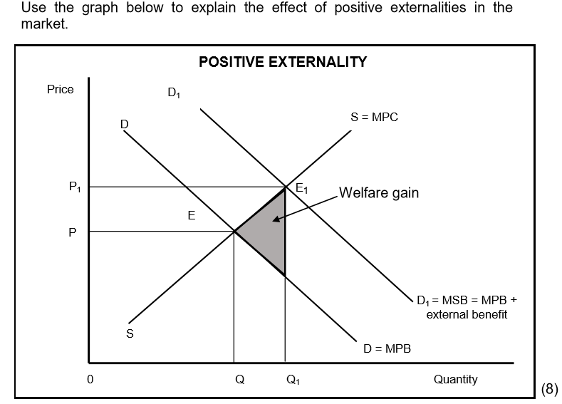 |  | (8)
1.5 | Discuss the challenges a monopolist will face if excessively high prices are charged for the products. |  | (8)
 |  |  | [40]
SC/NSC DBE/2019

