 Province of the

EASTERN CAPE

EDUCATION

**DIRECTORATE SENIOR CURRICULUM MANAGEMENT (SEN-FET)**

**HOME SCHOOLING SELF-STUDY WORKSHEET ANSWER SHEET**

|  |  |  |  |  |  |
| --- | --- | --- | --- | --- | --- |
| **SUBJECT** | Fitting and Turning | **GRADE** |  | **DATE** |  |
| **TOPIC** | Moments | **TERM 1**  **REVISION** | (Please tick) | **TERM 2 CONTENT** | (Please tick) |

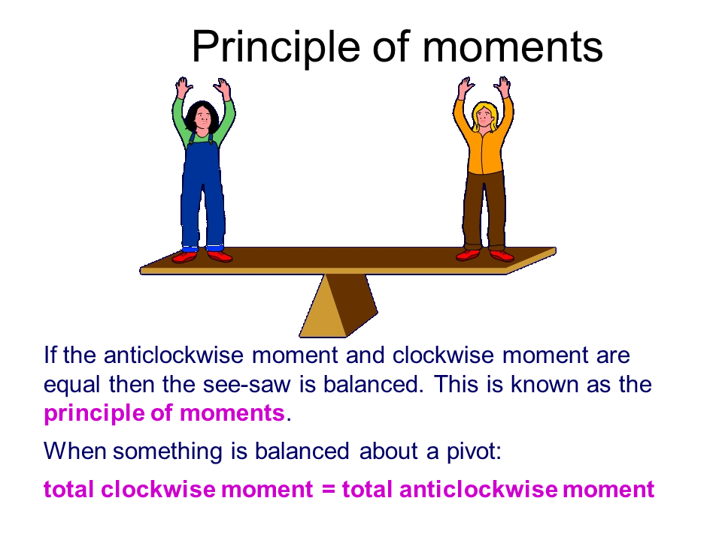

**DEFINITIONS**

* **The moment of a force** is a measure of its tendency to rotate an object about some point.
* **Fulcrum**: The support, or point of rest, on which a lever turns in moving a body.

**PRINCIPLE OF MOMENTS**

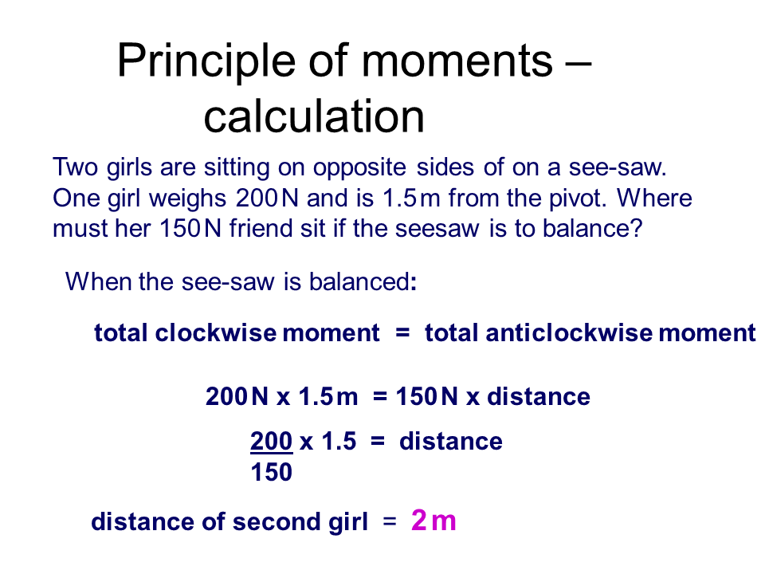**Calculation:**

**ACTIVITY 1**

A lever is 6 m long and its fulcrum is 1.5 m away from the left end of the lever. A force of 250 N acts downwards on the left end. It also carries two other concentrated loads, one being 60 N and 3,5 m from the left end and the other being 80 N.

Calculate the distance from the left end to the concentrated load of 80 N which will ensure that the lever is in equilibrium.



**SOLUTION**

Take moments about S  
∑ clockwise moments = ∑ anticlockwise moments  
 60 (2) + 80(x-1,5) = 250(1,5)  
 120 +80x -120 = 375  
 80x = 375  
 x = $\frac{375}{80}$  
 = 4,69 m

**CALCULATING REACTION FORCE**

An easier method to calculate reactions and forces, etc.

35 N 45 N 55 N

3 m 3 m 6 m

**A / LR *(76,67 N)* B / RR *(58,33 N)***

|  |
| --- |
| **TAKING MOMENTS AROUND A (all anti-clockwise moments are Positive +)** |
| $+ ↺{M }_{A}$ = (35 N x 3 m) + (- 45 N x 3 m) + ( -55 N x 9 m) + ( + B x 9 m) |
| = (105 Nm - 135 Nm - 495 Nm + B9M) |
| = (- 30 Nm - 495 Nm) + B9m |
| = - 525 Nm + B9m |
| = B |
| **58,33 N = B** |
|  |
| **TAKING MOMENTS AROUND B (all anti-clockwise moments are Positive +)** |
| $+ ↺{M }_{B}$ = (35 N x 12 m) + (- A x 9 m) + (45 N x 6 m) + ( - 55 N x 0 m) |
| = (420 Nm + 270 Nm – 0 Nm) – A9m |
| = 690 Nm – A9m 6 |
| A = |
| **A = 76,67 N** |
|  |
| **TEST: ∑ all UPward forces = ∑ all DOWNward forces** |
| LR + RR = 35 N + 45 N + 55 N |
| 76.67 N + 58,33 N = 135 N |
| **135 N = 135 N** |
|  |

**ACTIVITY 2**

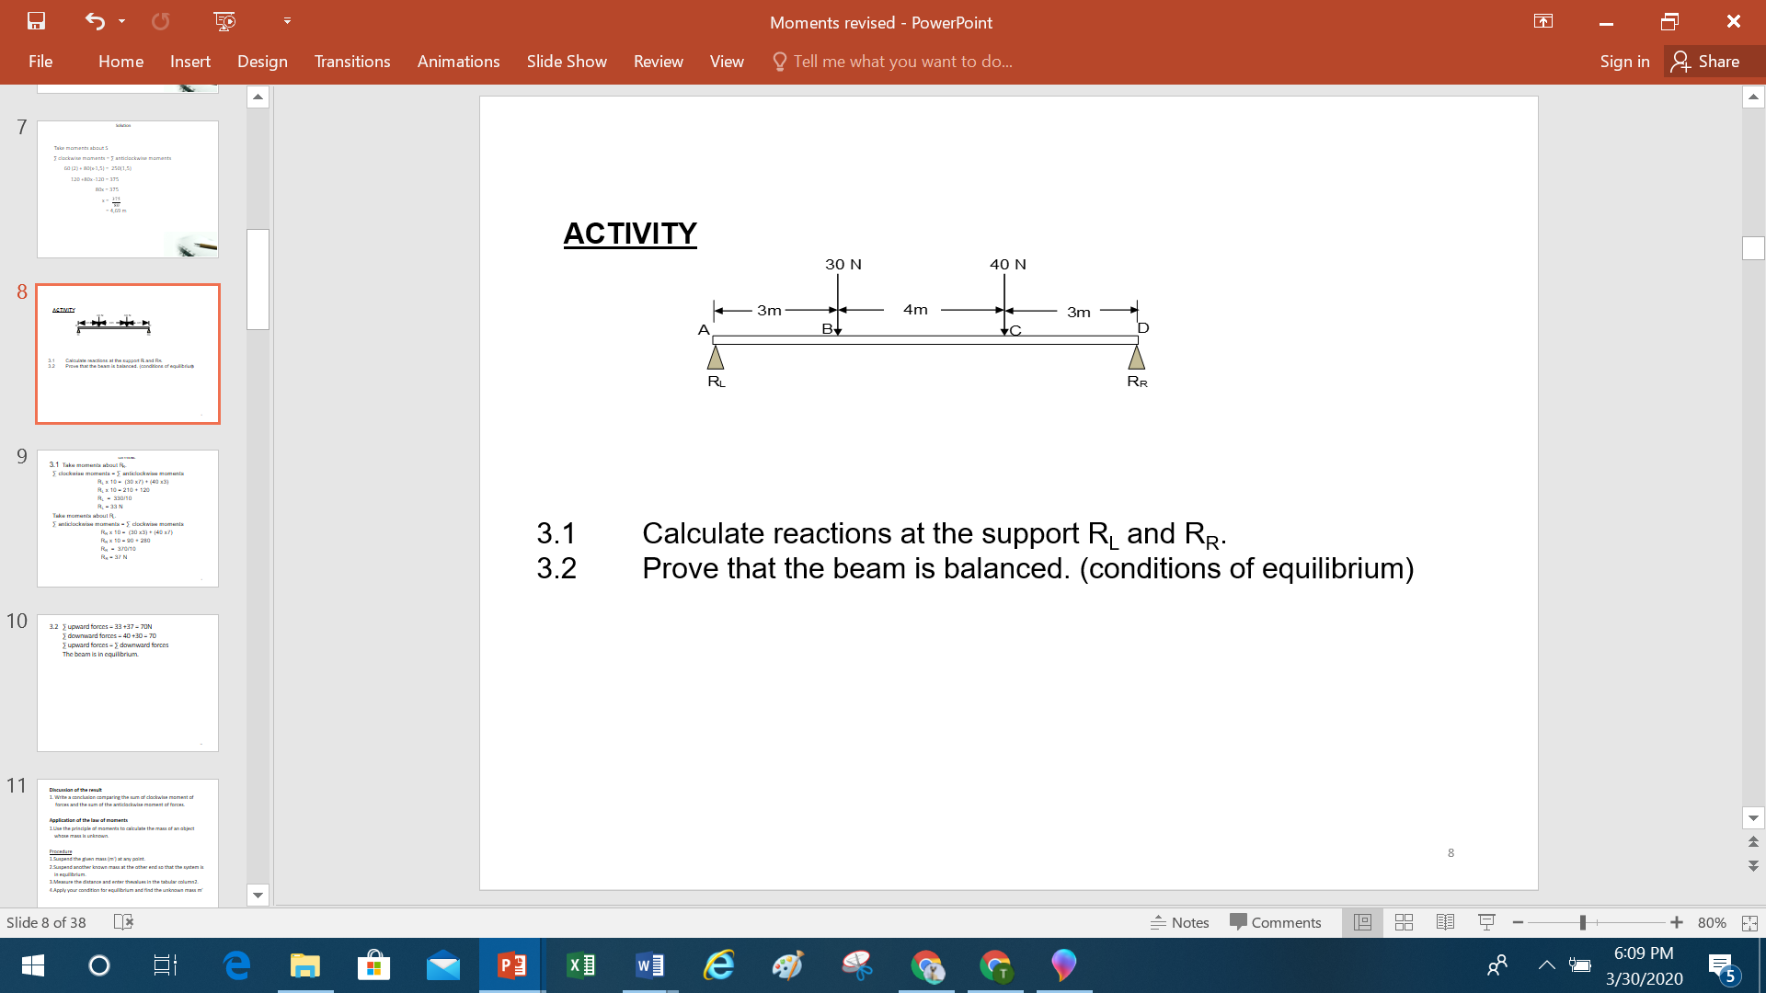

a) Calculate reactions at the support RL and RR.

b) Prove that the beam is balanced. (conditions of equilibrium)

**Solutions to Activity 2**

a) Take moments about RR.

∑ clockwise moments = ∑ anticlockwise moments

RL x 10 = (30 x7) + (40 x3)

RL x 10 = 210 + 120

RL = 330/10

RL = 33 N

Take moments about RL.

∑ anticlockwise moments = ∑ clockwise moments

RR x 10 = (30 x3) + (40 x7)

RR x 10 = 90 + 280

RR = 370/10

RR = 37 N

b) ∑ upward forces = 33 +37 = 70N

∑ downward forces = 40 +30 = 70

  ∑ upward forces = ∑ downward forces

  The beam is in equilibrium.

**UNIFORMLY DISTRIBUTED LOAD**

Definition:

A **uniformly distributed load** (UDL) is a load that is distributed or spread across the whole region of an element such as a beam or slab

Sometimes the load does not exist as point load, but as uniformly distributed across the length of the beam or slab.

**BEAM WITH UNIFORMLY DISTRIBUTED LOAD**

**BEAM WITH POINT LOADING**

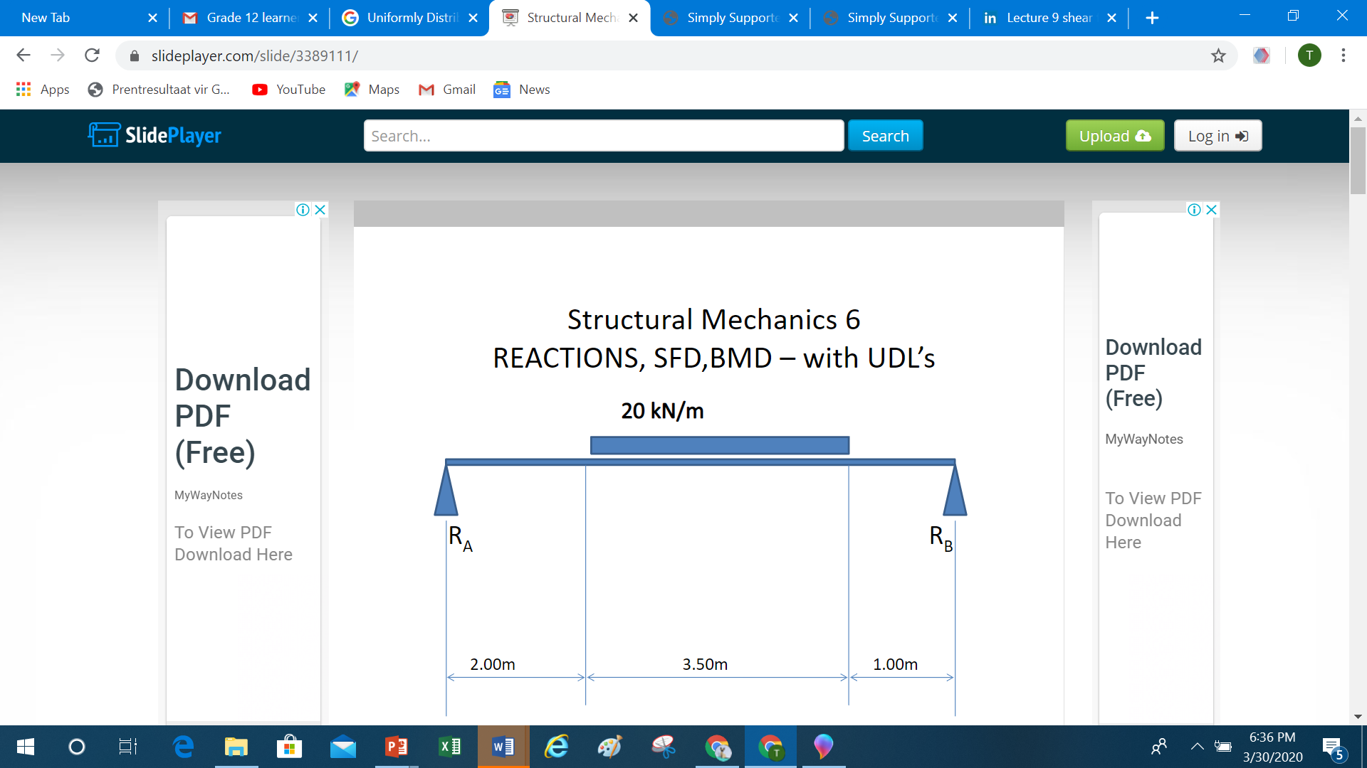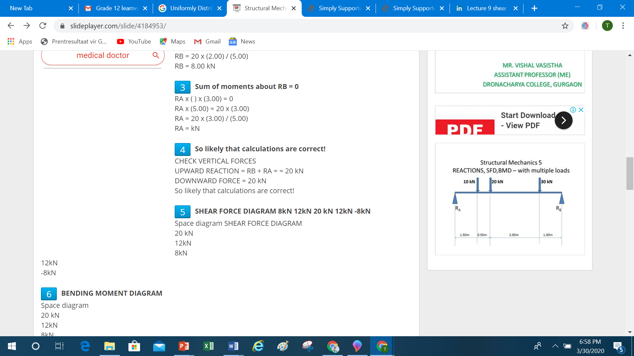

**EXAMPLE**

The diagram in figure below shows a beam supported by two vertical supports, **A** and **B**. Two vertical point loads of 800 N and 300 N as well as a uniformly distributed load of 70 N/m over the total length of the beam are exerted onto the beam.

Calculate the magnitude of the reactions in support **A** and support **B**.

*NB* Start by redrawing the diagram to replace the uniformly distributed load by the point load.

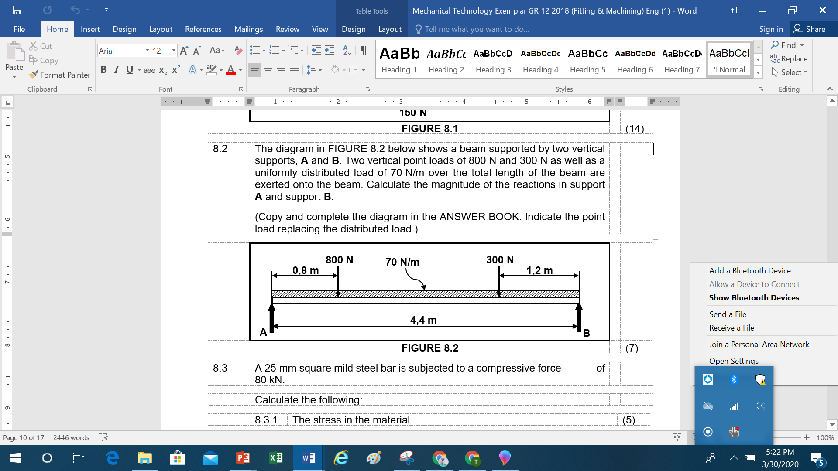

Solution:

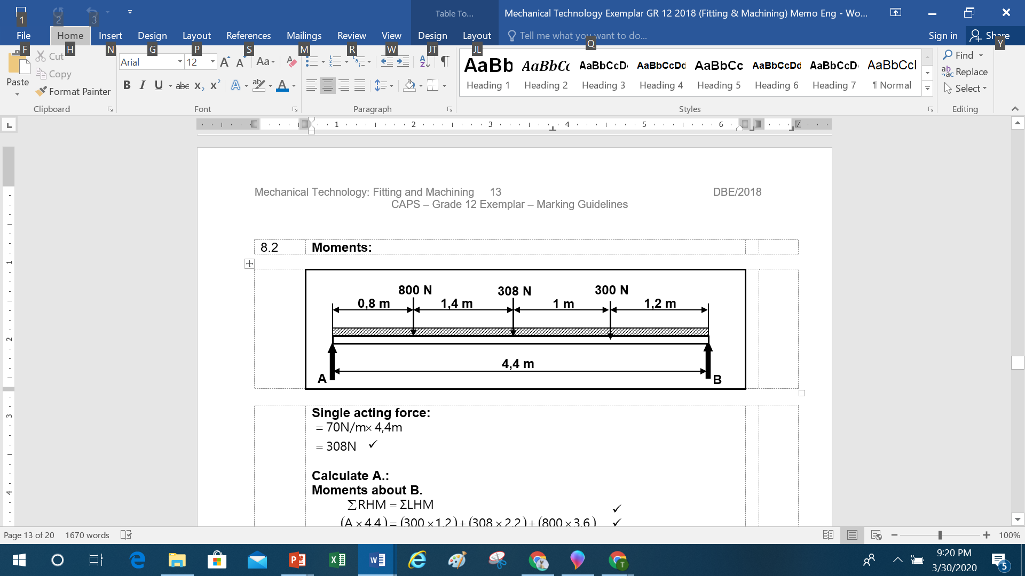

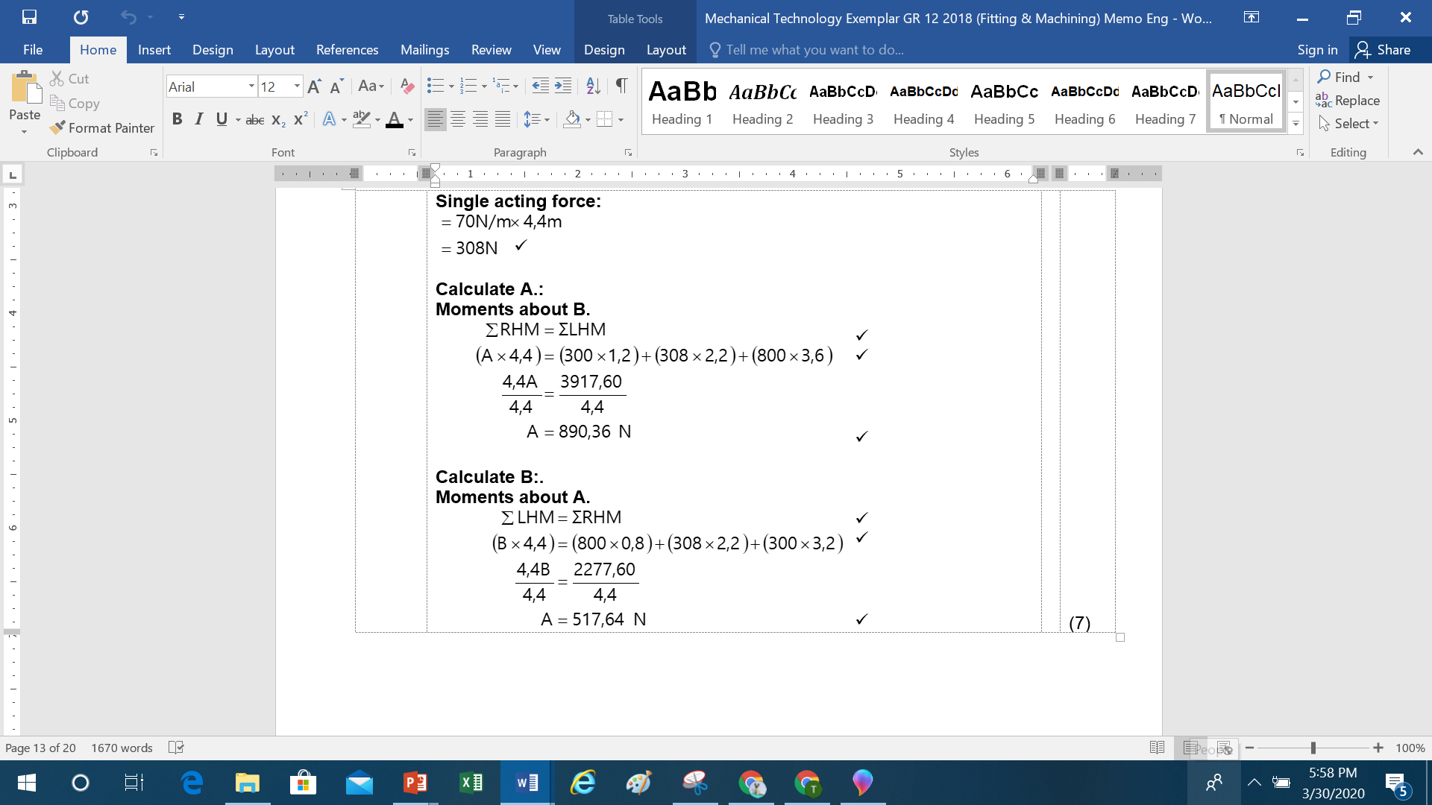

**ACTIVITY 3**

The diagram in Figure below shows a uniform beam supported by two vertical supports, **A** and **B**. Two vertical point loads, as well as a uniformly distributed force of 60 N/m over the distance between the two vertical point loads are exerted onto the beam.

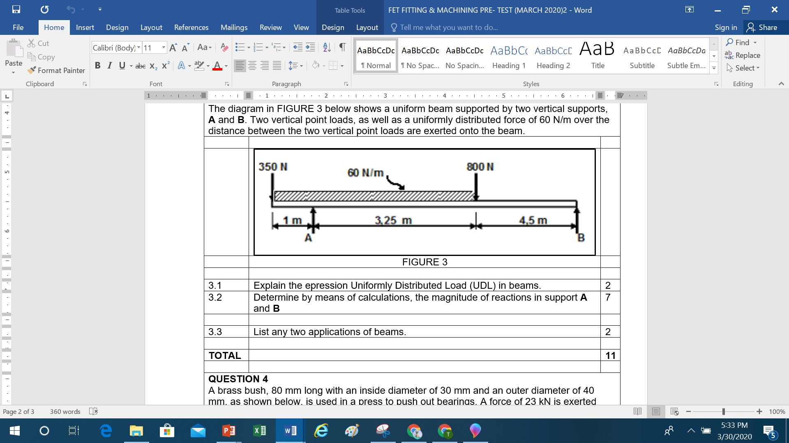

Explain the expression Uniformly Distributed Load (UDL) in beams.

Determine by means of calculations, the magnitude of reactions in support **A** and **B.**

Provide any two applications of beams**.**

**Solution to Activity 3**

**STEP 1** Convert UDL to a point load: 60 N/m x 4,25 m = 255 N ✓

**STEP 2** Taking moments around **A,**

(255 x 1,125) + (800 x 3,25) = (B x 7,75) + (350 x 8,75)

286,88 + 2600 = 7,758 + 350

B = 2536,88 $÷$ 7,75

B = 327,34 N

**STEP 3** Taking moments around **B,**

(A x 7,75) = (800 x 4,5) + (255 x 6,625) + (350 x 8,75)

= 3600 + 1689,38 + 3062,5

A = 8351,88 $÷$ 7,75

A = 1077,66 N

**Beam applications:**

* Bridges
* Truss
* Desks
* Railway lines

(Any 2 x 1)