DIRECTORATE SENIOR CURRICULUM MANAGEMENT (SEN-FET)
HOME SCHOOLING SELF-STUDY WORKSHEET
SUBJECT | Nautical Science | GRADE | 10 | DATE | 15/4/20
TOPIC | Seamanship | TERM 1  REVISION |  | TERM 2 CONTENT | X
TIME ALLOCATION | 20min | TIPS TO KEEP HEALTHY  1. WASH YOUR HANDS thoroughly with soap and water for at least 20 seconds. Alternatively, use hand sanitizer with an alcohol content of at least 60%.  2. PRACTICE SOCIAL DISTANCING – keep a distance of 1m away from other people.  3. PRACTISE GOOD RESPIRATORY HYGIENE: cough or sneeze into your elbow or tissue and dispose of the tissue immediately after use.  4. TRY NOT TO TOUCH YOUR FACE. The virus can be transferred from your hands to your nose, mouth and eyes. It can then enter your body and make you sick.  5. STAY AT HOME.
INSTRUCTIONS | This worksheet is to be completed in your MRTE exercise/activity book.

Question 4
Which ship terms are defined below
- ____: the watertight body of the ship. (1)
- ____: a part of the ship which drives the ship through the water. (1)
[2]
Question 5
Write down the terms relating to the arrows showing points of orientation on board an around the ship
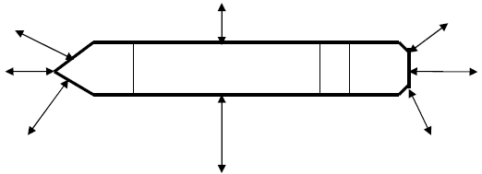
f
a
b
c
g
h
d
e
[8]

Question 6
Draw a simple line diagram depicting a single ship secured alongside a quay with ropes. Using arrows and appropriate labels, indicate the following:
- Head rope
- Stern rope
- Forward or Bow Spring
- Aft or Stern Spring
- Breast ropes
- Bollards
- Fenders
[7]
Question 7
Define the following terms
- Underway
- Adrift
- Aground
[3]

Question 8
Are the following statements TRUE or FALSE?
- During and/or after World War II air travel gradually replaced passenger ship travel as the main means of passenger transport. (1)
- Combination Carriers embark a combination of oil and dry cargoes in bulk at a given
time. (1)

