

**DIRECTORATE SENIOR CURRICULUM MANAGEMENT (SEN-FET)**

**HOME SCHOOLING SELF-STUDY WORKSHEET**

|  |  |  |  |  |  |
| --- | --- | --- | --- | --- | --- |
| **SUBJECT** | Nautical Science | **GRADE** | 10 | **DATE** | 14/4/20 |
| **TOPIC** | Seamanship | **TERM 1**  **REVISION** |  | **TERM 2 CONTENT** | X |
| **TIME ALLOCATION** | 20min | **TIPS TO KEEP HEALTHY**  1. **WASH YOUR HANDS** thoroughly with soap and water for at least 20 seconds. Alternatively, use hand sanitizer with an alcohol content of at least 60%.  2. **PRACTICE SOCIAL DISTANCING** – keep a distance of 1m away from other people.  3. **PRACTISE GOOD RESPIRATORY HYGIENE**: cough or sneeze into your elbow or tissue and dispose of the tissue immediately after use.  4. **TRY NOT TO TOUCH YOUR FACE.** The virus can be transferred from your hands to your nose, mouth and eyes. It can then enter your body and make you sick.  5. **STAY AT HOME.** | | | |
| **INSTRUCTIONS** | This worksheet is to be completed in your MRTE exercise/activity book. |

**Question 1**

In regards to diagrams A, B, C and D answer the following:

1. Type of ship (1)
2. Brief description of recognition or distinguishing characteristic or feature (1)
3. Function or purpose ship (1)

A.

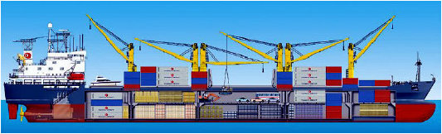

B.



C.



D.



**[12]**

**Question 2**

Write down in your answer sheet the labels indicating the parts of the ship following the arrows and alphabets from the bow to the stern:

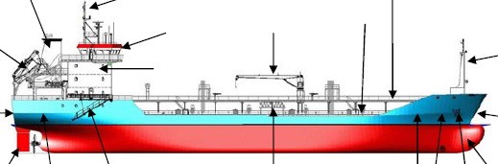

**[10]**

**Question 3**

Complete the following sentences:

1. When moving bow first, the vessel is said to moving _________________ (1)
2. When moving stern first, the vessel is said to moving _________________ (1)
3. The beam is _______________ (1)
4. The rudder is designed to ___________________ (1)
5. The bow thruster gives the ship _______________ (1)
6. The purpose of the bulbous bow is to __________________ (1)

**[6]**