Province of the
EASTERN CAPE
EDUCATION

DIRECTORATE SENIOR CURRICULUM MANAGEMENT (SEN-FET)
HOME SCHOOLING SELF-STUDY WORKSHEET
SUBJECT | WELDING & METALWORK | GRADE | 12 | DATE | APRIL 2020
TOPIC | MATERIALS NOTES | TERM 1  REVISION | (√) | TERM 2 CONTENT | ( )
TIME ALLOCATION |  | TIPS TO KEEP HEALTHY  1. WASH YOUR HANDS thoroughly with soap and water for at least 20 seconds. Alternatively, use hand sanitizer with an alcohol content of at least 60%.  2. PRACTICE SOCIAL DISTANCING – keep a distance of 1m away from other people.  3. PRACTISE GOOD RESPIRATORY HYGIENE: cough or sneeze into your elbow or tissue and dispose of the tissue immediately after use.  4. TRY NOT TO TOUCH YOUR FACE. The virus can be transferred from your hands to your nose, mouth and eyes. It can then enter your body and make you sick.  5. STAY AT HOME.
INSTRUCTIONS | Term 1 Revision notes

WELDING AND METALWORK GR12 NOTES ON MATERIALS
SOUND TEST
The metal type can also be determined by the sound it makes when it is tapped with a hammer or when it is dropped on the floor.
If the sound is loud and clear, the metal is a high-carbon steel (hard).
If the sound is a dull sound, the metal is a low-carbon steel (soft). SOUND TEST ON METALS

FILING TEST
Files can establish the relative hardness between two samples, as in the scratch test.
This method, however, requires skill.
Testing should be done on the tip or near the edge.
This is the oldest and one of the simplest methods of checking the hardness of material.
The file test is a method of determine hardness of a piece of material by trying to cut into the material with a file.
The hardness is indicated by the bite that the file will take.
The softer the material the bigger the bite into the material.
With the use of the file test no accurate record of results can be maintained.
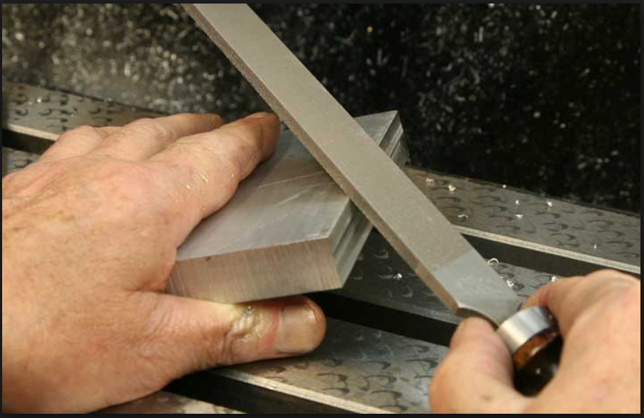
MACHINING TEST
Machinability can be 'sample-tested'.
For example, two unknown samples identical in appearance and size can be cut in a machine tool, using the same speed and feed for both.
The ease of cutting should be compared and the chips observed for heating colour and curl.
Different metals react differently under different workshop conditions and processes.

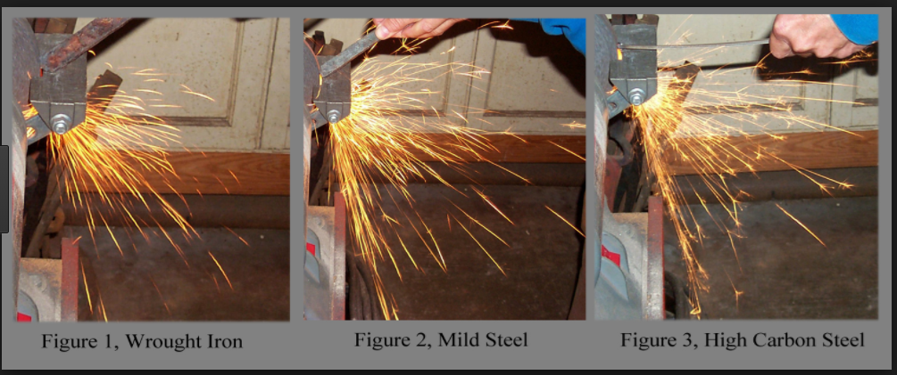
TYPES OF HEAT TREATMENT
Annealing
Normalizing
Hardening
Carburizing
Tempering
Annealing
Metals are annealed to relieve internal stresses that may have been set up during previous workings of the metal, to soften them in order to facilitate the machining processes, make them ductile, refine their grain structures and reduce brittleness.
Steel is annealed to reduce the hardness, improve machine ability, facilitate cold-working, produce a desired microstructure.
Full annealing is the process of softening steel by a heating and cooling cycle, so that it may be bent or cut easily.
In annealing, steel is heated above the transformation temperature to form austenite, and cooled very slowly, usually in the furnace.
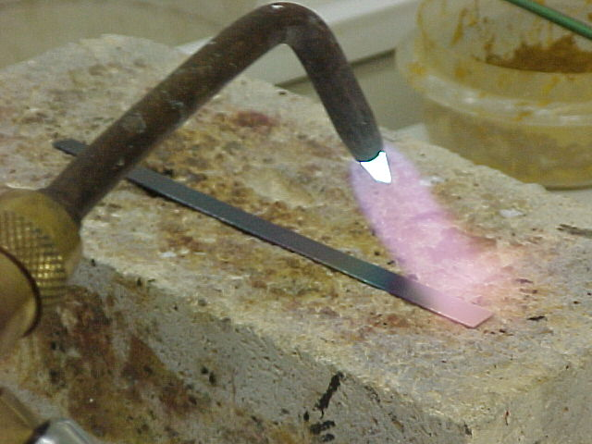

There are several types of annealing, like black annealing, blue annealing, box annealing, bright annealing, flame annealing, intermediate annealing, isothermal annealing, process annealing, recrystallisation annealing, soft annealing, finish annealing and spheroidizing.
These are practiced according to their different final product properties in the industry
Annealing application:
This heat treatment is commonly applied in the sheet and wire industries, and the tem­peratures generally used are from 550 to 650 0C.
Full annealing, where steel is heated 90 to 180 0C.
Normalising
Normalising is a process whereby iron base alloys are heated to approximately 56 °C above the upper critical temperature (which is higher than both hardening and tempering temperatures), soaking the metal until it is uniformly heated, followed by cooling it down to room temperature in still air, away from draughts.
This prevents the sudden cooling of a localised spot, which might cause distortion.
Soaking the metal
It is where metal is kept in a heated environment (furnace) at a predetermined temperature for a certain period of time
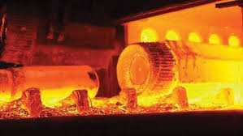

In normalizing steel is also heated above austenitizing temperature, but cooling is accomplished by still air cooling in a furnace.
Steel is normalized to refine grain size, make its structure more uniform, or to improve machinability.
When steel is heated to a high temperature, the carbon can readily diffuse throughout, and the result is a reasonably uniform composition from one area to the next.
The steel is then more homogeneous and will respond to the heat treatment in a more uniform way.

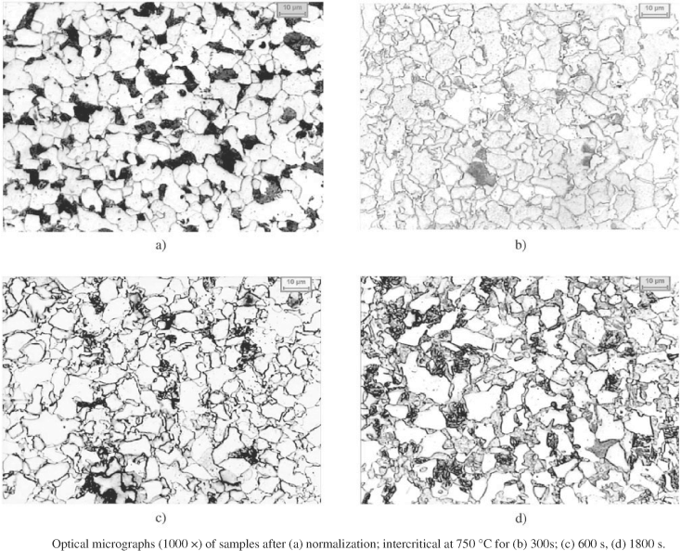

The normalizing process might be more accurately described as a homogenizing or grain-refining treatment.
Within any piece of steel, the composition is usually not uniform throughout.
That is, one area may have more carbon than the area adjacent to it.
These corn positional differences affect the way in which the steel will respond to heat treatment.
Because of characteristics inherent in cast steel, the normalizing treatment is more frequently applied to ingots prior to working, and to steel castings and forgings prior to hardening.

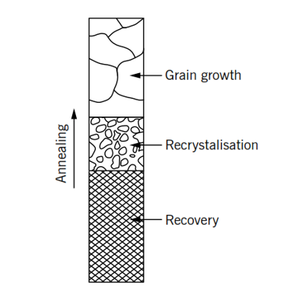

Changes in metal structures that take place during the annealing process

Hardening
Hardening is the first step in the production of high-strength steel.
Hardening causes a condition of extreme hardness in the steel to enable it to resist wear or cut other metals
Hardening is achieved by heating the work piece slightly higher than the critical temperature, and then rapidly cooling it by quenching the work piece in a medium such as water, brine or oil.
This treatment produces a fine grain structure, which is very hard and of maximum tensile strength and minimum ductility.
Usually, material in this condition is too brittle for most practical uses.
It is desirable that all work pieces be heated in a furnace or oven with a pyrometer (a high-temperature thermometer).
Factors for achieving Hardness:
• Work piece size
• Quenching rate (quenching means to cool rapidly in a quenching medium)
• Carbon content.
Carbon-Equilibrium Diagram
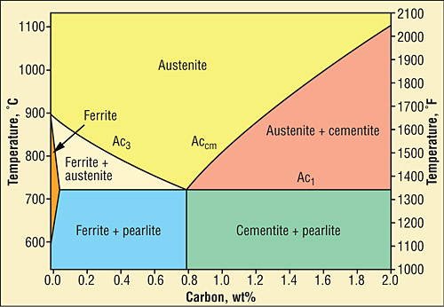

Carbon-Equilibrium Diagram Cont.…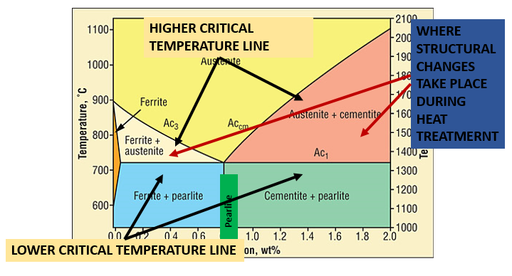
Changes during hardening
- When carbon steels in the fully annealed state is heated, usually to a temperature between 680°C and 720°C, the alternate bands of layers of Ferrite and Cementite form many alternating layers side-by-side.
- The Pearlite layers begin to merge into each other.
- The temperature at which this occurs is known as the lower critical point (AC₁).
- The merging process continues until the Pearlite is thoroughly dissolved, forming Austenite.
- If the temperature of the steel continues to rise, Pearlite and any excess Ferrite or Cementite will also begin to dissolve into Austenite until only Austenite will be present.
- The merging process continues until the Pearlite is completely dissolved to form Austenite.
- If the temperature of the steel continues to rise and there is any remaining Ferrite or Cementite present, it will also dissolve until only Austenite is present.
- The temperature at which the excess Ferrite or Cementite is completely dissolved into Austenite is called the upper critical point (AC₃).
CARBURIZING
Carburizing is a process used to harden low carbon steels that normally would not respond to quenching and tempering. This is done for economic reasons (utilizing less expensive steel) or design considerations to provide a tough part with good wear characteristics.
Carburizing introduces carbon into a solid ferrous alloy by heating the metal in contact with a carbonaceous material to a temperature above the transformation range and holding at that temperature.

TEMPERING
Tempering (formerly called drawing), consists of reheating a quenched steel to a suitable temperature below the transformation temperature for an appropriate time and cooling back to room temperature.
Freshly quenched marten site is hard but not ductile.
Tempering is needed to impart ductility to marten site usually at a small sacrifice in strength.
The effect of tempering may be illustrated as follows:
- If the head of a hammer were quenched to a fully marten­sitic structure, it probably would crack after the first few blows.
- Tempering during manufacture of the hammer im­parts shock resistance with only a slight decrease in hard­ness.
- Tempering is accomplished by heating a quenched part to some point below the transformation temperature, and holding it at this temperature for an hour or more, depending on its size.
CHANGES DUE TO TEMPERING
- The micro structural changes accompanying tempering include loss of acicular marten site pattern and the precipitation of tiny carbide particles.

- This micro structural is referred to as tempered martensite.
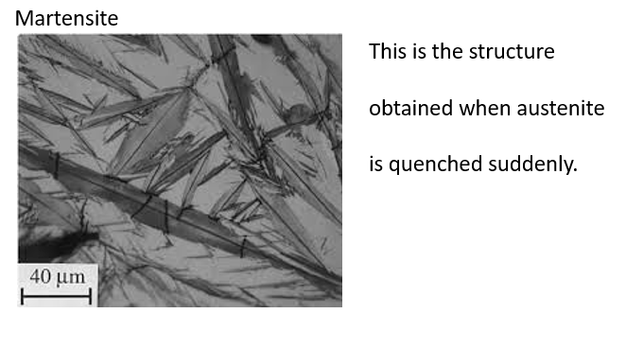

CASE HARDENING
Case Hardening is a process of hardening ferrous alloys so that the surface layer or case is made substantially harder than the interior or core.
The chemical composition of the surface layer is altered during the treatment by the addition of carbon, nitrogen, or both.
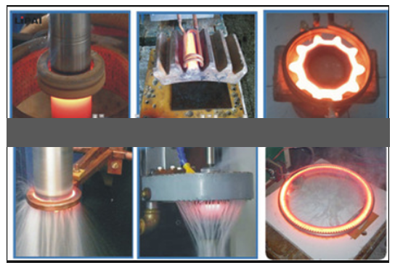
Steels best suited to case-hardening are the low-carbon and low-alloy steels.
If high-carbon steel is case-hardened, the hardness penetrates the core and causes brittleness.
In case-hardening, the surface of the metal is changed chemically by inducing a high carbide or nitride content.
The core is unaffected chemically. When heat-treated, the surface responds to hardening while the core toughens.
The common methods of case-hardening are carburising, nitriding and cyaniding.

